Ipswich Philatelic Society Coronavirus Lockdown Newsletter #4

Once again many thanks for your positive feedback about the newsletter and especially for your contributions as we all continue to be philatelically starved. It was good to hear from long term member and ex-president Ian Boreham especially as he told how he is copying the newsletter to another member who does not have access to email. Keeping everyone in touch with philately generally, the society in particular, and most importantly, each other, is what it’s all about.

Despite the next phase of easing of lockdown there is still no possibility of fairs or meetings in the near future given the social distancing rules and Autumn Stampex, planned for the end of September, has already been postponed to be replaced by an on-line ‘virtual Stampex’. Details to follow but it could be interesting!

********
With society business in mind following the postponement of the AGM, Bob Harvey, treasurer and packet secretary reports on club finances and the packet as follows:-

‘I have broken down and returned all the material to vendors for 14 boxes, leaving us with 21 boxes ready to release. Some of these boxes have had books removed as certain vendors wanted all their material back, but as soon as it is safe and you want to take boxes again we can restart the packet with 7 boxes for each circuit.
We have now finalised the accounts for last year and Mike Hole has completed the audit so we are ready for the AGM which will be held I suspect when we next meet.
Financially we are in a sound position as we did not spend as much as we thought due to the disruptions we are currently experiencing and stamp sales have been good.
Finally the society fair is still set for October but as you are aware there are many issues to be resolved before we can decide yes or no to it going ahead, if you have any views then please let me know.’
********
I’m sure I speak for everyone when I say thank you to the committee for their work in the last year and the difficult decisions they have had to make recently.

********
I am almost up to date with sorting out my stock (my own collection still needs work but I guess it always will) and I am looking to purchase more items for when the fairs start again. Auctions however are thin on the ground and the increase I expected in the number of lots for sale on both Ebay and Delcampe during the lockdown doesn’t seem to have happened yet (in respect of the countries I collect or sell anyway.) Have other members seen more items of interest than usual for sale on line and more importantly have prices risen?
********
Steve Teuma has pointed out to me that the Captain (or should I now say ‘Sir’) Tom Moore special cancellation is not the only Coronavirus theme item out there. My thanks to Steve for the ‘Stay home protect the NHS save lives’ slogan pictured below.

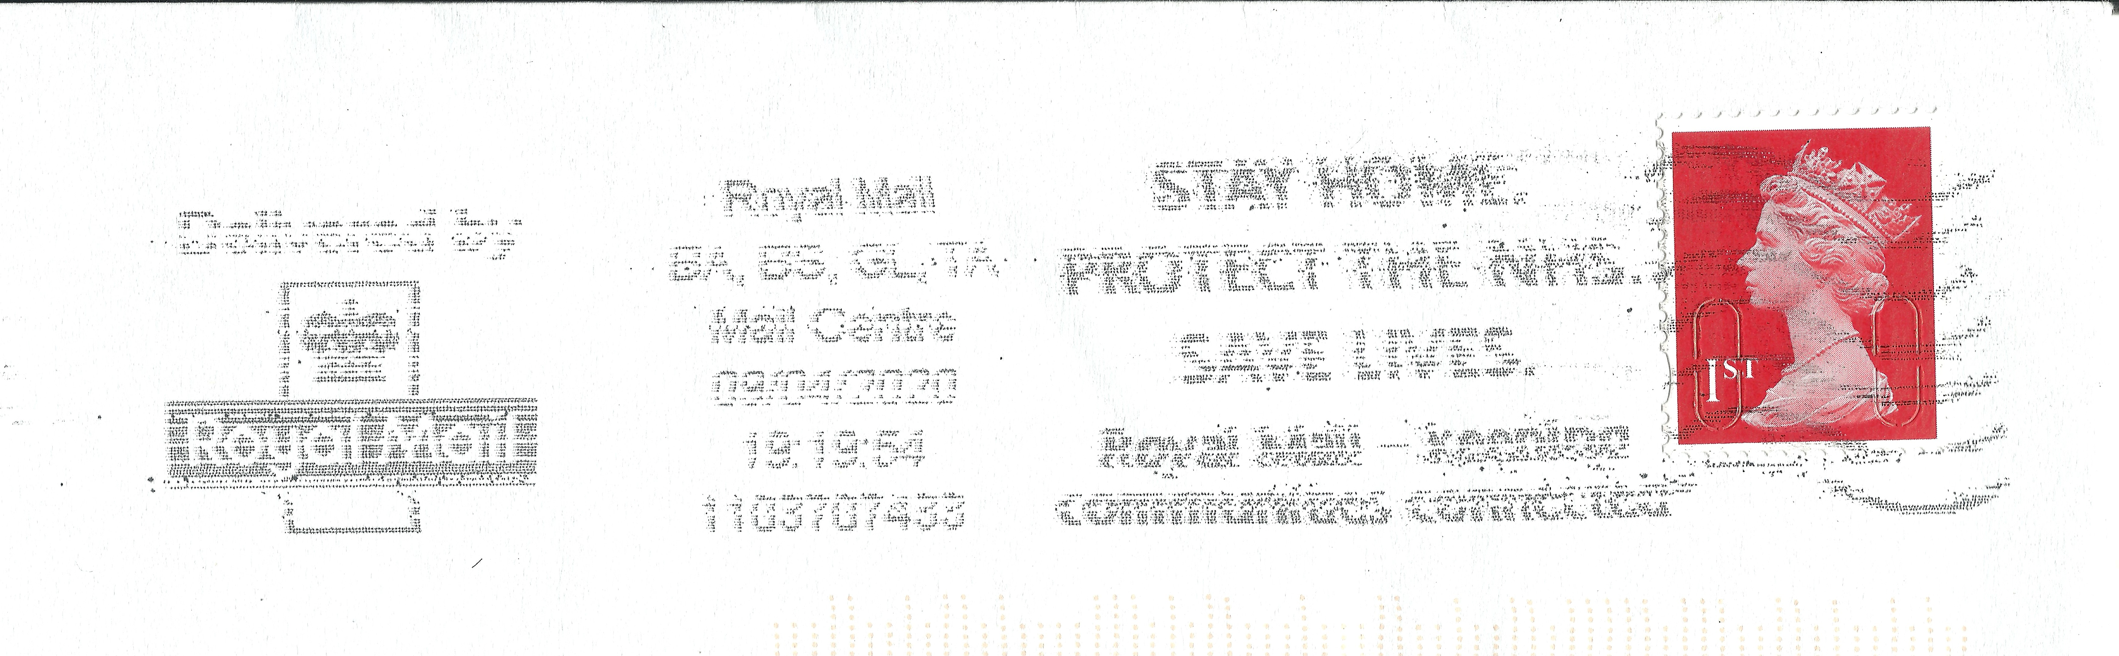

Continuing with member’s contributions my thanks firstly to Ray Deeks for an item of poetry. Part of a series of recent writings which Ray describes as ‘little pieces of nonsense on Art, Gardening and V.E. Day’, he thought this piece might explain why the hobby might be great for those with memories of their forces service perhaps.

(Incidentally I did try to warn Ray that trying to sort out the barred numeral cancels on the early Belgian issues would drive him to distraction, little did I expect poetry!)

Stamp, stamp, stamp.

By Ray Deeks

For some a good stamp will stir the blood in little toes and
Make the fingers glow noses red their breath will show
For others in smart uniform left right is the way
They march up or down to keep in line and then
Reverse on about turn they call it drill and think
How they must train to kill but Sergeant smiles
They are quite good but another go will make them better
Soon the G O C will come to check lines and faultless kit
Just like the matron on the ward who has a word for each poor
Girl who hopes to make the post of nurse her one desire
Not the geriatrics please something special where the young
Doctors come to check pulses or a day off too does my
Watch and buckle look the part another posting for a
Start might be abroad a chance to try a good tattoo might be ok
The stamps look different do they work with famous heads but
No tales of great events some collect them are they a folly
My old dad he stamps and sticks into a book magnifies the
Rarer ones I think he called it his best hobby

********

On now to a fascinating 1844 item of Transatlantic mail from Ipswich via Worcester, Leamington and Liverpool to Burlington New Jersey courtesy of Francis Dunn.

The item had already been partially researched by the previous owner as shown in the label below which accompanied the cover.

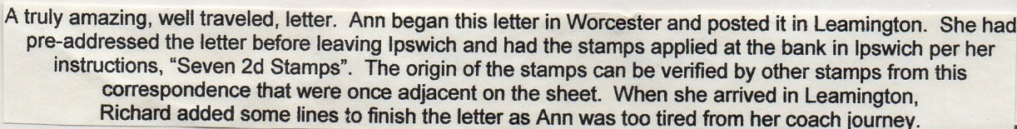

In his own inimitable style Francis has added much to the research of this item and its sender with his vast knowledge of Ipswich, where the journey of the cover began, I copy his additional information below. Many thanks Francis for this contribution.
Francis writes: ‘I purchased this cover earlier in the year. A number of covers from this family’s correspondence are recorded for the 1840’s, mainly sent from Ipswich to Burlington, New Jersey and written by Ann Alexander to her uncle John Cox who married her aunt (her father’s sister).

Ann, with her husband Richard Dykes Alexander, lived in St.Matthews Street and the front of their house is marked by an Ipswich Society blue plaque. Richard was a prominent banker in Ipswich at that time, his bank building standing in Bank Street, later becoming the lower end of Foundation Street.

Richard was something of a philanthropist, leading a group of local business men in building the Ipswich & East Suffolk Hospital in Anglesea Road. He also paid for the erection of the Temperance Hall in Crown Street which was an ironmongers shop in my youth in the 1950’s.’

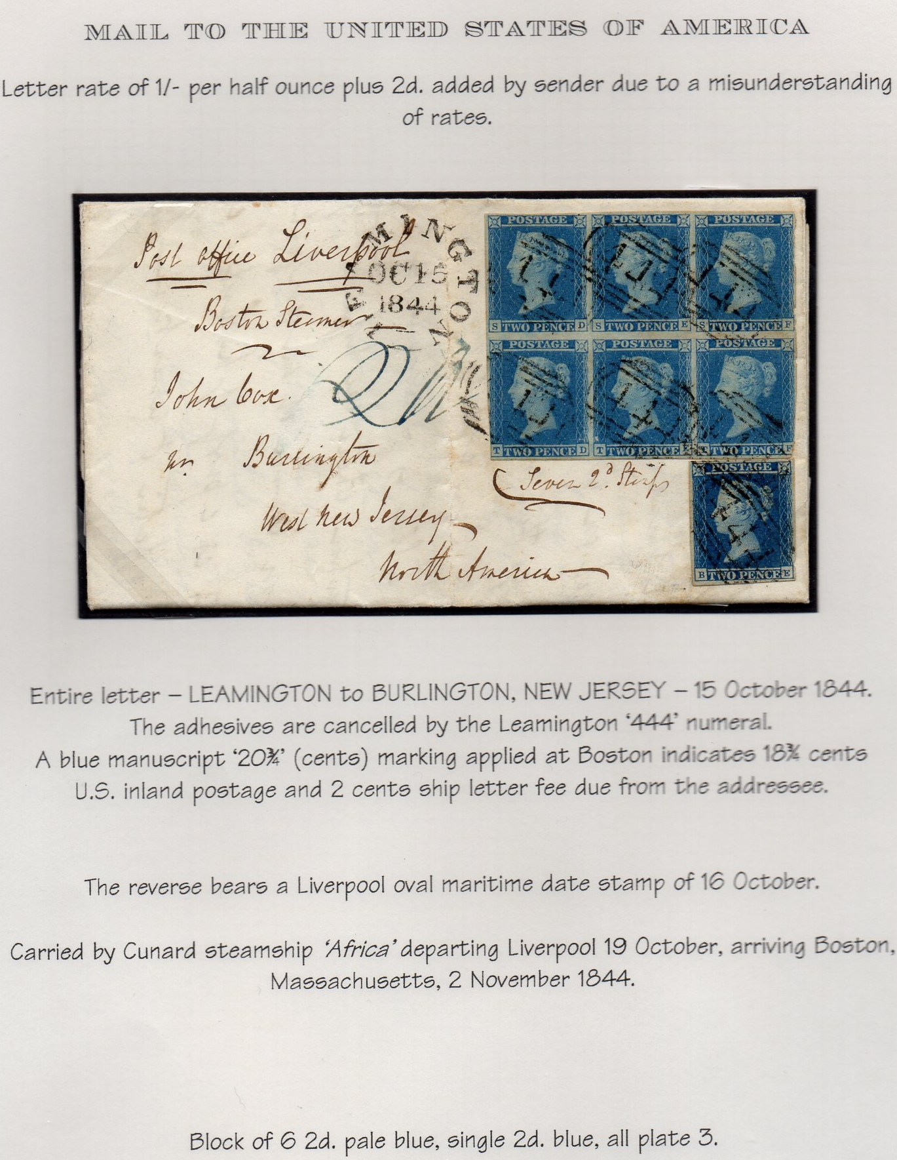

Ken Burr’s contribution in the last newsletter and our current problem with a virus is clearly catching (see what I did there?) and has brought forth another fine example of disinfected mail this time from our own society webmaster Steve Teuma. In the early 19th century when diseases were more prevalent, and less understood than they are today, mail coming from an infected area, be it with typhoid, cholera or TB, had to be disinfected en route, to ensure that the contagion didn’t spread.
Mail coming through the Mediterranean would be stopped and disinfected at Malta. This would normally be done by putting a number of slits in the letter so that the fumigant could penetrate both the outside and inside of the mail. It would then be stamped to show that it had been fumigated. This would be in the form of a handstamp ‘PURIFIE AU LAZARET/MALTE’. Between 1816 and 1844 wax seals were used denoting that the mail had been disinfected. Between 1819 and 1904 a number of different handstamps were used. The wax seal version is very hard if not impossible to find, with some handstamped versions more difficult to find than others.
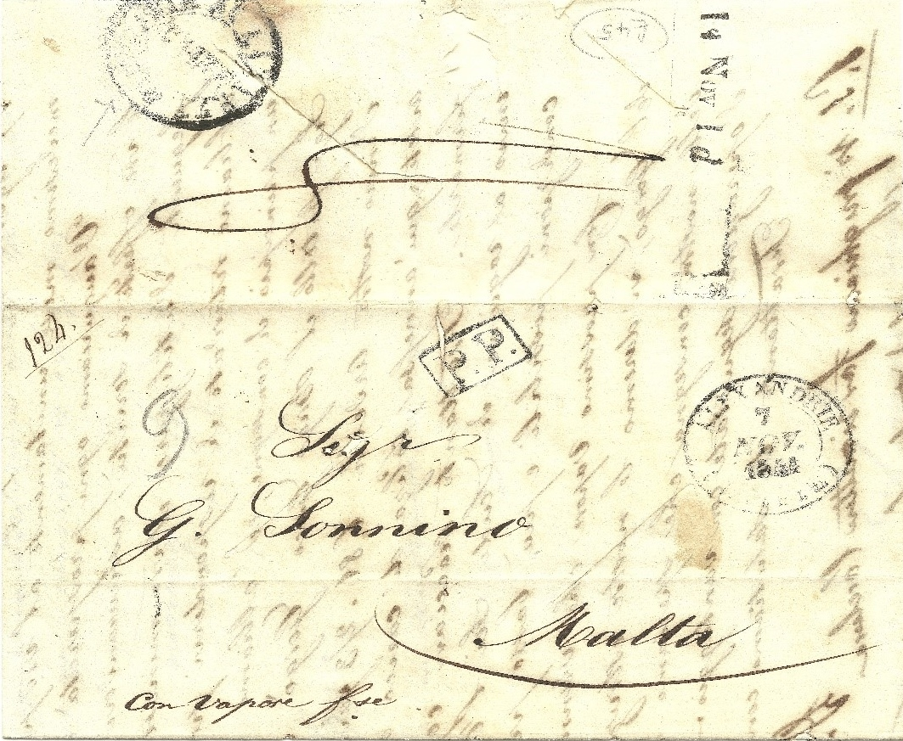

This item was sent from Alexandria in Egypt to Malta in 1841 and shows the disinfection mark at top left. The item also bears a clear early Malta postage due mark ‘14 Nov 1d’. The two slits can be seen running top left to bottom right in the top half of the image.
********
Don’t forget Lockdales June 18th postal and on-line sale. Although there appear to be fewer stamps than usual, for those of you who also have an interest in postcards, the lots look excellent. Detailed arrangements for booking viewing slots, delivering (larger?) items for auction and collecting any lots purchased are on their website.
I have had no response at all so far to the idea of a ‘my favourite stamp’ slot in the newsletter. Perhaps, like me when I thought about it, you simply couldn’t choose!
Finally Brian Thompson and a couple of others, who can’t attend meetings regularly and therefore don’t know fellow members that well, have asked if people would be willing to list their collecting interests here so they and others with similar interests might contact each other. What do you think? Stay safe everyone.

