**IPSWICH & DISTRICT PHILATELIC SOCIETY**

**ANNUAL AUCTION 2025.**

**2nd APRIL 2025** in

The CONFERENCE ROOM

KESGRAVE WAR MEMORIAL COMMUNITY HALL

TWELVE ACRE APPROACH, off BELL LANE, KESGRAVE, IP5 1JF

**VIEWING FROM 4.00pm to 6.30pm. Auction Commences at 7.00pm. REFRESHMENTS AVAILABLE**

**CONDITIONS OF AUCTION**

1. All descriptions, catalogue values and reserve prices are those stated by the Vendors. The Society accepts no responsibility for the accuracy or any errors.
2. Bids below the Reserve price will be respectfully declined.
3. In the event of a tied postal/telephone bid, the first bid received will be given preference.
4. There is no buyer’s premium on the hammer price.
5. Telephone and postal bids may be made to the following club members:

S Teuma, 24 Hercules Rd, Rendlesham, IP12 2GP. 01394 246224 or email: [**sateuma@gmail.com**](mailto:sateuma@gmail.com) or phone bids only to: Tony Blumfield 01473 611991

Telephone bids to be made after 6.00pm. Last bid by 6pm on 1st April 2025.

1. Bid increments will be

Up to £1.00 in 10p steps; (ii) £1 to £10 in 50p steps; (iii) £10 - £30 in £1 steps,

iv) £30 plus in £2 steps

1. Payment by postal bids are to be made by cheques drawn on a UK Bank account and to be signed and crossed. Made payable to**:**

**IPSWICH & DISTRICT PHILATELIC SOCIETY.**

1. Please avoid phoning for results for three days after the auction as we will be dispatching the successful postal bids.
2. Abbreviations used throughout this catalogue are as follows:

|  |  |  |  |  |  |
| --- | --- | --- | --- | --- | --- |
| M | Mint | R/B | Ring Binder | Cat. CV | Catalogue. Catalogue Value |
| MM | Mounted Mint | SG | Stanley Gibbons | A | Album |
| UMM | Un-mounted Mint | FDC | First Day Cover | S/B | Stock Book |
| MNH | Mint Never Hinged | PPC | Picture Postcard | PTSA | Priced to Sell at |
| U | Used | CDS | Circular date Stamp | Pkt | Packet |
| GU | Good Used | MS | Mini Sheet | AB | Approval Book |
| FU | Fine Used | E | Envelope | STC | Stated to Catalogue |
| VFU | Very Fine Used | P/B | Poly bag | CTO | Cancelled To Order |
| S/F | SpaceFiller | L/L | Loose Leaves | G/B | Glory Box |
| B | Box | A/P | Album Pages | SC | Stock Card |
| S | Small Lot | Bk | Book | H | Hagners |

**Lot No. Description Reserve**

|  |  |  |
| --- | --- | --- |
| 001 | **GB**Cinderella, De La Rue publicity, 4 stamps with portrait of ‘Thomas De La Rue’, mint, unusual | £1 |
| 002 | **GB**12th May 1937 ‘3 Kings’ cover to London with 1½d KG5, 1d KE8 & ½d KG6, clean | £1 |
| 003 | **GB**2003 ‘Extreme Endeavours’ PHQ cards and set um stamps, face is £5+ the cards cat £3 | £3 |
| 004 | **GB  `**2005‘Jane Eyre - Charlotte Bronte’ PHQ cards and set um stamps, face is £5+ the cards cat £5 | £3 |
| 005 | **GB**1970 ‘Dickens’ block of 4 x 5d stamps, SG827 5d very faint but not quite missing - would be £650! | £4 |
| 006 | **Austria**1948 ‘Costumes’ set of 37, um (1 stamp mm), SG1108-44, 10s slight gum adhesion, cat £450+ | £40 |
| 007 | **WITHDRAWN** |  |
| 008 | **Belgium**SC with 6 1920‘Malmedy’ overprints on Belgium, 5c,10,40c,50c,1F & 5F, fine used, cat £75+ | £12 |
| 009 | **China**collection in an SG 5 page stockbook, 1900 to modern but strong up to the 1950’s, inc many overprints, provinces, Taiwan, communist issues & PRC, m/u, this material often hard to find these days! | £30 |
| 010 | **China**packet containing a few 100’s from early to more modern, m/u, a good starter lot | £5 |
| 011 | **Croatia**SC with 14 ‘Hrvatska’ stamps with ‘1874-1949 UPU’, prepared by Government in Exile, in 2 designs, 6 x 10k values & 8 x 20k values, all different colours, not listed by SG, unusual! Look on eBay | £2 |
| 012 | **Denmark**SC with 1864 2,3 & 8sk with circle pmk’s & 1870 2,3 & 4sk, all good used, cat over £500 | £30 |
| 013 | **Denmark**SC with 1925 ‘Air’ 10,15 & 25o, SG224-6, good to vfu, cat £200+ | £20 |
| 014 | **Danish West Indies**SC with 1873 1, 3 & 5c & 1907 5 & 10b, good to vfu, cat £90+ | £15 |
| 015 | **‘Eastern Pacific’**SG catalogue 3rd edition 2015 for Cook Is, Pitcairn, Samoa etc in VGC, £19.95 new | £2 |
| 016 | **Faroe Islands**pack of 21 FDC’s 1985 to 2002 inc MS’s, clean unaddressed and attractive - convinced? | £2 |
| 017 | **France Colonies**SC general issues 1943 set of 5 um all top marginal with serial nos, SG82-86, cat £8+ | £2 |
| 018 | **Germany**2 Feldpost cards, 1914 photo of 7 German soldiers, purple ‘Res Infa Regt’ HS & 1915 couple looking at a poster saying ‘today we go for a stroll’ ?? red Feldpost label | £3 |
| 019 | **Germany**SC WW1 ‘Lost Territories’ Cinderella’s x 8 Danzig to Schleswig ‘used’ & 2 x 1916 Polish Legion 2h brown & 10h red imperf with eagle emblem, all unusual but most interesting! | £5 |
| 020 | **German Colonies East Africa**SC with SG10,11,13,15,16,30 & 34-37, mint, 20h slight faults, cat £50+ | £8 |
| 021 | **German Colonies Kiautschou**SC with SG11, 12, 17, 18 & 34-39, mint, cat £60+ | £8 |
| 022 | **German Colonies Mariana Islands**SC with 3m yacht, mint, SG24, cat £12 | £3 |
| 023 | **German Colonies**SC with 17 yacht issues mint inc Karolinen, Marianen (with 1m) & Samoa, cat £35+ | £7 |
| 024 | **India**12 pages with 1940’s - 1960’s issues, m/u, inc 1948 Gandhi 1½, 3½ & 12a mm, these cat £55 | £6 |
| 025 | **Indian States**a 4 page SB, Convention & Feudatory issues, 100’s duplication most used good starter lot! | £5 |
|  | **Following 7 India lots -**Are m/u on old circulated club book **PAGES**with nothing after KG6 |  |
| 026 | **India**35 club book pages, 200+ stamps with Bahrain, Burma, Kuwait & Pakistan overprints, duplication | £8 |
| 027 | **India Convention States**20 club book pages, 130+ stamps inc few mint Bahawalpur, some duplication | £5 |
| 028 | **India Feudatory States**50 club book pages, 250+ stamps, some duplication, some better remain | £8 |
| 029 | **India Cochin State**16 club book pages, 170+ stamps, some duplication | £6 |
| 030 | **India Indore State**14 club book pages, 100+ stamps, some duplication | £6 |
| 031 | **India Jaipur State**9 club book pages, 70+ stamps, some duplication | £5 |
| 032 | **India Sirmoor State**  12 club book pages, 70+ stamps, some duplication | £5 |
| 033 | **KUT**1927 ‘Thika’ to UK ‘Photograpic Letter Card’ with KG5 20c SG83, no photo but unusual | £2 |
| 034 | **Kuwait**SC with 1959 top values used, 5r & 10r SG142-3, cat £9+ | £2 |
| 035 | **Lundy**1988 2 long covers to Leicester, on front 13p & 18p meter pmks & ‘Lundy/Bristol Channel’ red oval cachet, on back 15p & 21p Lundy ‘Puffin’ stamps with Lundy/Bristol Channel CDS, clean | £3 |
| 036 | **Luxembourg**SC with set of 16 1940 surcharges, SG413-28, mm, cat £7.25 | £2 |
| 037 | **Montserrat**KG6 1938 original perf 13 values to 2/6d (9), SG101-09, mm, high cat of £170+ | £20 |
| 038 | **Mozambique**SC with 1951 ‘Fish’ set 23 (missing only 4ec), SG440-63, good to fu, cat £55+ | £7 |
| 039 | **New Hebrides**1978stampless official local ‘Port-Villa’ letter large bi-lingual cachet for ‘Public Works’ | £2 |
| 040 | **Rhodesia & Nyasaland**QE2 1s3d SG10 on letter to UK with oval ‘Royal Visit/Rhodesia & Nyasaland 2-17 July 1957’ & ‘Broken Hill’ N. Rhodesia pmk 16th July 57, clean | £1 |
| 041 | **Sudan**SC 1950 Air set of 8, 2p to 20p, mm, SG115-122, cat £28 | £4 |
| 042 | **Trinidad & Tobago**1927 registered letter to London with KG5 2d & 3d SG222 & 223, clean | £1 |
| 043 | **Tristan da Cunha**1973 letter to Ipswich per SS Chusan, 3p Machin & blue crayon cancel with circular ‘Tristan Da Cunha/1 Mar’ 73’ postmark clear of stamp, interesting | £2 |
| 044 | **1979 Rowland Hill**blue ring binder with selection of 1979 centenary issues, sets & miniature sheets, on 28 special printed pages, foreign & Com, um, some stamps removed, not checked for catalogue value | £5 |
| 045 | **Trieste**Stockbook, 7 x 9½in, ‘AMG FTT’ overprints on Italy, m/u, duplication inc few Yugoslav issues | £5 |
| 046 | **USA**SC of 10 early issues, Columbian Exposition 1,2,3,4,6,8,10 & 15c & Trans-Mississippi 2 & 5c, high cat, good space-fillers | £5 |
| 047 | **‘Life & Times of Queen Mother’. S**pecial printed album, many stamps Ascension to Vanuatu Complete? | £10 |
| 048 | **Gibraltar**3 stamp pres packs - ‘Europa’ 1983, (1984 on card only) & 1985 + 1984 ‘Royal Crests’, clean | £1 |
| 049 | **Germany Allied Mil Gov**  1945-6 1pg black top LH corner block 12 & block of 6, SGA16, um, cat £11+ | £1 |
| 050 | **Barbuda**  1976 US ‘Bicentenary of American Revolution’ 15c sheetlet with 5 x strips of 3 SG249-51 ‘Surrender of Cornwallis at Yorktown’ and 3 labels, attractive | £1 |
| 051 | **Italy**  1945 Democracy issue 10 cents red-brown bottom marginal block of 4, SG647, um | £1 |
| 052 | **Canada**1930’s interesting ‘COD’ cover with 2c KG5 SG290, to collect $132.20 & used within Toronto | £2 |
| 053 | **Iceland**February 1945 cover to UK with 12 x brown 5 aur stamps, SG244a, with PC90 censored tape | £3 |
| 054 | **Zanzibar**1913 50 rupee SG260e. Used with a strange postmark that might not Zanzibar. Used cat value is £1400! As the status of the postmark is unknown a low reserve. However a scarce stamp | £20 |
| 055 | **Cook Islands**1968 long OHMS cover to Greece with 1c,2c,3c,4c&5c 1967 flower stamps with a boxed cachet ‘3rd Anniversary Self Government August 1968’, nice clean item | £1 |
| 056 | **Campione (Italy)**4 ‘Campione’ stamps SG1B-4B each on a small piece with 1945 pmks & 25c Italy x 9 SG244 on large piece all with Campione/Como pmks, unusual | £4 |
| 057 | **Campione (Italy)**1947 letter to Switzerland with 3 Swiss 10c stamps pmk Lugano & complete set of 7 1944 ‘Campione’ stamps SG6-12, ‘Campione/D’Italia’ pmk on cover, sadly not on the stamps, still nice | £10 |
| 058 | **Postcards**packet of 30 coloured postcards all postally used from Europe in 80’s & 90’s, colourful | £1 |
| 059 | **Switzerland**17 items of postal history, inc 11 B/W early postcards & covers inc postage dues, a nice lot | £12 |
| 060 | **Switzerland**large SC with ‘Pro Juventude’ issues complete 1950-1963 SGJ132-J201 (no MSJ196a) all UM and cat over £130, a very nice colourful start to a new collection? | £20 |
| 061 | **Canada**2 SG red springback albums with 100’s of stamps, albums in boxes all in lovely condition | £25 |
| 062 | **Germany**1990-2003 in 2 Davo albums in VG condition the stamps look to be um mint as mounted in hingeless mounts, high cat value with lots of nice stamps and also inc many miniature sheets, a bargain!! | £35 |
| 063 | **Glory Box**. Worth a look | £4 |
| 064 | **Glory Box**. Worth a look | £4 |
| 065 | **Glory Box**. Worth a look | £4 |
| 066 | **Club Books** x 20. Some better | £5 |
| 067 | **Club Books** x 20. Some better | £5 |
| 068 | **Club Book Pages.** Some better | £4 |
| 069 | **Club Book Pages.** Some better | £4 |
| 070 | **Club Book Pages.** Some better | £4 |
| 071 | **DDR** Mini Sheets x 50 in FDC Album | £8 |
| 072 | **BC** Stamps in Blue Album. 100’s | £5 |
| 073 | **Brown** S/B. Various | £2 |
| 074 | **Big Brown** S/B. 100’s some better | £10 |
| 075 | **Big Red** S/B. 100’s. Germany – DDR | £8 |
| 076 | **Austria** in Blue folder. | £5 |
| 077 | **Green** S/B. Australia. 400+ | £3 |
| 078 | **GB Album**. 1979-91. Mint. Face value £90+. Postage? | £30 |
| 079 | **Czech** in Red Album. 500+. Good Selection | £4. |
| 080 | **1837 Wrapper** to Lincolnshire. IPSWICH CDS with mileage removed. SK198 | £10 |
| 081 | **1842 Wrapper** Ipswich to Saxmundham. Ipswich CDS and circular **PAID/1** UPP mark in red. SK213. | £10 |
| 082 | **1838 Entire** Woodbridge to Framlingham. ***Woodbridge/Penny Post*** twice. And manuscript ‘1’. SK404 | £15 |
| 083 | **Undated Entire**. Ringshall, Bildeston to Norwich. ‘P9’ in purple and Boxed ***Hadleigh/P.y Post****.* SK159 | £15 |
| 084 | **1821 Wrapper** Sudbury to Lincoln’s Inn. London Receivers for 13/10/1821. **SUDBURY/56** mileage mark with line above only. SFK669. | £20 |
| 085 | **1838 Entire**. 3 page letter from Newmarket Vicarage to Bishop’s Registry @ Norwich on Parish Matters. **STOWMARKET** UDC on reverse | £15 |
| 086 | **1816 Entire** to Lincoln’s Inn. London Receivers for G/23FE23/1816 and **STOWMARKET/82** mileage mark. SK328 | £20 |
| 087 | Undated Wrapper to (Kings) Lynn. **BUNGAY/107** mileage mark. SK67 | £15 |
| 088 | **UNUSUA**L card with HAND-DRAWN Head of Native American Indian. Sent to South Africa. QV Jubilee 6d stamp (SG208. CV£95 ON COVER), cancelled by Leiston Duplex for June 21 1887. RARE. Nothing on reverse | £40 |
| 089 | **Free Front. Circa 1783.** FREE in circle (L767) cancellation with 2 line **HALES/WORTH** handstamp. SK162. Signed **G W VANNICK** of HEVINGHAM HALL. RARITY F. | £60 |
| 090 | **1829 Entire** to Queen Anne’s Bounty. **SUDBURY/Penny Post** mark. And London receivers | £25 |
| 091 | **1795 Entire** from Aunt to Nephew in Bury. **NORWICH** town stamp in purple. NK298. | £20 |
| 092 | **1833 Entire** to Hampstead, Middx (now in London). Boxed **TP/RATE/2** and Boxed ***Ixworth/Penny Post***in BROWN. L690 and SFK397. Ixworth mark not noted in brown by W&J. London receivers on reverse. L457a. | £25 |
| 093 | **1750 Wrapper**. Marked FREE to Inner Temple. Too early for FREE handstamps so marked with a **‘P’ for ‘Privilege’**. Reverse has 2 line **SUD/BURY** (SK341) and 15mm Bishop Mark. **RARE. Signed Firebrace?** | £50 |
| 094 | **1834 Entire** sent to Solicitors in Norwich. **HOLT UDC** on reverse. NK211. Pd 8d | £5 |
| 095 | **1841 Entire**. **YARMOUTH – NORFOLK CDS** NK512 and **NORWICH CDS** in red NK312 | £5 |
| 096 | **1834 Wrapper** to Baldock, Herts. London **PAID Tombstone** on front and **WITHAM UDC** on reverse. EX469 | £8 |
| 097 | Undated Entire to Wymondham. **BUNGAY/107** mileage mark on reverse. SK67 | £15 |
| 098 | 1838 Wrapper with **BECCLES UDC.** | £10 |
| 099 | **1833 ENTIRE** LONDON to YOXFORD. London Date stamp | £5 |
| 100 | Undated INSURANCE LETTER TO NORWICH. POOR **BURY ST EDMUNDS/76** mileage mark | £5 |
| 101 | **1824 ENTIRE** TO WYMONDHAM. LARGE **EYE/93.** SK138 | £15 |
| 102 | **1829 ENTIRE** TO NORWICH. SMALL **EYE/93.** SK139 | £15 |
| 103 | **1834 ENTIRE** TO WYMONDHAM. **EYE UDC.** SK140 | £10 |
| 104 | **1833 ENTIRE** TO SAXMUNDHAM. **WICKHAM MK** STRAIGHT LINE. SK381 | £15 |
| 105 | **1815** INSURANCE LETTER TO NORWICH. **BURY ST EDMs/78** MILEAGE MARK. SK85 | £15 |
| 106 | **1834 ENTIRE** TO SAXMUNDHAM. **WICKHAM MK** STRAIGHT LINE. SK381 | £15 |
| 107 | **1828** INSURANCE LETTER TO NORWICH. **YOXFORD UDC**. SK452. Single arc | £10 |
| 108 | **1817 ENTIRE** TO WYMONDHM WITH POOR **EYE/93** MILEAGE MARK. DOUBLE RATE | £20 |
| 109 | **1838** WRAPPER TO MESSRS SOUTHWELL @ SAX. **LOWESTOFT UDC**. SK245 | £10 |
| 110 | **1843** ENTIRE. **IPSWICH/1D PAID** PENNY POST TO BECCLES. SK215 | £10 |
| 111 | **2 X COVERS**. NORWICH 111 MILEAGE AND **MILEAGE ERASED** MARKS. 1826/1835 | £10 |
| 112 | **1835 ENTIRE** TO WYMONDHAM. NORWCH CDS AND ‘**TOO LATE’** HANDSTAMP | £15 |
| 113 | WH SMITH ADVERTISING RINGS on piece x 2 WITH ‘**T.0.1’ & ‘T.0.6’** CXLS. **RARE.** | £50 |
| 114 | **1838 LOWESTOFT UDC** to LONDON. SK245 | £10 |
| 115 | 1816 ENTIRE TO NORWICH, **WOODBRIDGE/78** MILEAGE MARK. SK391 | £15 |
| 116 | Undated wrapper to Colchester. **CLARE/66** mileage mark. SK122 | £25 |
| 117 | 1958 POSTCARD w WILDINGS 1d &1½d | £2 |
| 118 | **1841 Entire** to Woodbridge. Ipswich PAID/1 UPP SK213. | £15 |
| 119 | 1924 RIGISTERED Long Cover with 3 X GV 1½d STRIP to Peterborough. RUGBY STATION CDS ON REVERSE | £4 |
| 120 | Wrapper to Stockton. Oval IPSWICH/1D/PAID. And tombstone PAID mark for 02/09/1842. SK215 | £10 |
| 121 | 1980 REGISTERED ENVELOPE. WOODBRIDGE TO IPSWICH | £2.50 |
| 122 | POST CARD. STOCKPORT VICARAGE TO LONDON. STOCKPORT 1908 DATESTAMP on EdVII ½d stamp | £1.00 |
| 123 | MANCHESTER ‘HORSESHOE’ M43. Circa 1795 on front only. | £15 |
| 124 | MACHIN SG X999. 20p x block of 6. | £5 |
| 125 | REGISTERED COVER FROM RAROTONGA TO WESTERN SAMOA. 21.04.52. COOK ISLANDS MULTI FRANKING. CV £21 USED OFF COVER | £10 |
| 126 | **GB** QEII Wilding 1st Day Cover. 1½d and 2½d. 5 Dec 1952. CV £28 | 5.00 |
| 127 | **GB** QEII Wilding 1st Day Cover.½d, 1d & 2d. 31 Aug 1953. CV £60 | 15.00 |
| 128 | 1842 Entire to Diss. Diss and Ipswich CDS’ plus **IPSWICH 1D PAID OVAL.** SK215 | £15 |
| 129 | 2 INSURANCE replies. Circa 1820s SUDBURY/56 Mileage mark. Poorly inked | £10 |
| 130 | EDWARD VII ½d stamp on piece, cancelled by MANCHESTER XMAS 1909 Special Machine CXL | £50 |
| 131 | GV 1½d BOOKLET STAMP (1) with NATIONAL FIXED INVESTMENT label. USED. CV £700 for complete pane | £20 |
| 132 | 1904 PPC. Boats on a river by Seppings Wright with HALESWORTH Squared circle, to Beccles | £5 |
| 133 | 1937 Hand Coloured Post Card of Roses. “To Greet Your Birthday”. Dennington CDS to Diss | £5 |
| 134 | Small pocket S/B with German Stamps x 80. WWII – 1970 | £5 |
| 135 | **1837** Entire Norwich to Saxmundham. **NORWICH/DE11/1837** Mileage removed CDS. NK311. Miles replaced by continuous arc. | £5 |
| 136 | **1845 Entire** with Plate 56 Penny Red, lettered JB, squared ‘J’. Reading to Holborn. London receivers for 18 Aug 1845. Almost 4 margin | £20 |
| 137 | **GVI COVERS** – FDC for SG491/2 Poor Quality envelope with CHELSEA postmark; FDC for SG493 and 1946 cover for SG491 only. | £15 |
| 138 | **FDC GVI** SG462/3 & 466. 2½D has torn corner. Addressed to Whitfield King with Ipswich P/M. CV £45 | £10 |
| 139 | 1952 Cover with 5 x GVI ½d Orange, SG503. Late use of GVI stamps. | £5 |
| 140 | **UNUSUAL** – 2 x QV Pre-Printed Post Cards from G.E.R Goods Depot to Mr Gooch at Halesworth. Squared circle p/m | £5 |
| 141 | 3 x PPC. All with different CDS of **Halesworth.** 1907/8; 1922 | £5 |
| 142 | 1967 **LADY GODIVA** 700th ANNIVERSARY PICTORIAL COVER. Coventry Philatelic Society with 3d Wilding. | £2 |
| 143 | Part Cover. **GIBRALTAR** REGISTRATION LABEL. CHARGE LABEL (OE 84 (spl) COD, with 2/6 , 1/- (blue) Postage Dues attached. Cxld by IPSWICH/*/2 FE/52 SUFFOLK CDS | £1 |
| 144 | **UNUSUAL** – 4 x Internationual Fisheries Investigations cards, different local datestamps. 1921/2. “No Stamp required from British ports” | £10 |
| 145 | **6 x Penny Pink envelopes**. Different cancellations. Mostly barred numerals | £5 |
| 146 | **1808 Free** Wrapper. Signed Euston. To Bury St Edmunds. Free frank on front and Boxed UNION/STREET RH on reverse | £10 |
| 147 | **1943 US War** and Navy Dept **V-MAIL** letter. GRAND CENTRAL/ ANNEX CXL. With contents | £5 |
| 148 | Glory Box/Tin. Small biscuit tin of Pre-Stamp cover to Modern Stamps. Needs a Look! | £5 |
| 149 | 1961 50th Anniversary of First Aerial Post of Allahabad. Pictorial Cover with all 3 Special Stamps and 2 postmarks. (India) | £5 |
| 150 | OHMS Entire from **OFFICE of WOODS**. CROWN/PAID handstamp for 21/11/1843. Sent to Fife. 2 x Scottish receiving marks on reverse. Royal Seal imprint on reverse also. | £20 |
| 151 | Great Britain SG561-6 1957 Graphite lines Cylinder Blocks of 6 (1 stamp MM others UM) | £20 |
| 152 | Great Britain SG593-4 1959 4d & 4 ½d Graphite lines Cylinder Blocks of 6 (1 stamp MM others UM) | £18 |
| 153 | Great Britain SG599-601 1959 ½d to 1 ½d Phosphor Graphite lines Cylinder Blocks of 6 (1 stamp MM others UM) | £30 |
| 154 | Great Britain SG631-3 1962 NPY Phosphor Cylinder blocks of 6 UM (5 blocks) both dot and no dot of the 2 ½d and 3d | £60 |
| 155 | Great Britain SG634-5 1963 FFH Phosphor Cylinder blocks of 6 UM (3 blocks) both dot and no dot of 2 1/2d | £60 |
| 156 | Great Britain SG636 1963 Paris Conference Phosphor Cylinder block of 6 UM | £10 |
| 157 | Great Britain SG636-7 1963 Nature Week Phosphor Cylinder blocks of 6 UM | £10 |
| 158 | Great Britain SG639-641 1964 Life-Boat Phosphor Cylinder blocks of 6 UM (slight faults in margin of 1/6) | £100 |
| 159 | Great Britain Silk FDCs in album STC £400+ in 2009 | £35 |
| 160 | Hungary used collection virtually complete to 1960 includes first issue complete with extras, but UPU MS missing | £500 |
| 161 | World Collection mainly up to 1950's including Canada | £20 |
| 162 | Hong Kong 1990's presentation packs (17) includes 1992 definitive pack to $50 | £25 |
| 163 | Australia UM lot including booklets and MS with exhibition overprints | £35 |
| 164 | British Solomon Is KGVI 1939 set MM SG60-72 some values with toned gum | £15 |
| 165 | Brunei 1895 SG10 $1 G-FU (one short perf) STC £120 | £30 |
| 166 | Cayman Is KGVI 1950 set MM SG 135-47 | £18 |
| 167 | Cyprus on album page (2 sides) includes Scouts MS MM and 1962 set (£1 is UM) STC £200 | £20 |
| 168 | Falkland Islands KGVI set MM SG146-163 (thin spot on 10/) | £90 |
| 169 | Hong Kong KGV $10 FU slight discolouration SG 116 STC £110 | £20 |
| 170 | Hong Kong KGV $3 FU SG 132 STC £80 | £25 |
| 171 | Hong Kong KGV $5 FU SG 131 STC £70 | £20 |
| 172 | India KGVI 3A UM marginal with inverted watermark SG272bw STC £200 | £60 |
| 173 | India QV 1R OHMS MM SGO47 STC £80 | £20 |
| 174 | Iran Birds set SG 2990-9b (12 values) UM STC £44 | £10 |
| 175 | Malaya Federated Malaya States $1 & $2 MM toned gum SG 48 & 49 STC £250 | £30 |
| 176 | Malaya Federated Malaya States $5 MM some gum toning SG 80 STC £200 | £40 |
| 177 | Malaya Johore 1938 Postage Dues SG D1-5 MM STC £200 | £60 |
| 178 | Malaya Trengganu 1937 Postage Dues SG D1-4 MM STC £170 | £50 |
| 179 | Monaco 1952 Olympics set MM STC £120 | £12 |
| 180 | Monaco Prince Rainer Definitives 1955-71 UM STC £134 | £18 |
| 181 | Northern Rhodesia 1 ½d Carmine & 2d Orange SG 29 & 31 MM STC £100 | £18 |
| 182 | Northern Rhodesia KGVI 1 ½d SG30b MM (tick flaw) STC £200 | £35 |
| 183 | Nyasaland KGVI 1945 set MM SG144-57 | £18 |
| 184 | St Helena Is KGVI 1938-44 full set MM SG 131-40 (includes 3d blue) | £28 |
| 185 | King Edward VII Cigar box packed with mostly used older c/wealth & foreign stamps including some revenues. | £5 |
| 186 | Hong Kong - Stock card with basic 16 values from 1992 QE2 definitive issue includes top values but no 'A' numbers. All u/m.  Cat. £28. | £5 |
| 187 | Strand Album from 1930's still with lots of stamps + Royal mail stamp album, lightly picked still many stamps. | £5 |
| 188 | Large Red S/B of JERSEY & GUERNSEY. 100’s Mint and Used | £45 |
| 189 | Red S/B Jersey. 11 Presentation Booklets | £2 |
| 190 | Guernsey Pkt. Mint and Used 100s. Inc HV | £3 |
| 191 | Jersey. Black S/B. Mint 150+ | £5 |
| 192 | Guernsey. Grey S/B. Mint inc Postage Dues Blocks (10) | £5 |
| 193 | Guernsey. Blue S/B. 200+ Inc Blocks and Minisheets | £10 |
| 194 | Black FDC Album. Jersey FDCs (39) Inc HV. | £5 |
| 195 | FDC Album. Guernsey FDCs (36) Inc HV | £5 |
| 196 | Guernsey. Black Lindner Album. 100s. Mint and Used | £8 |
| 197 | Isle of Man. Tesco bag – 2 x S/B. Albums/Loose. 100s. Have a look | £30 |
| 198 | 60 page stock book containing an extensive Belgian collection from 1865 to present day - 38 pages.  Plus USA, Egypt, Eire, British Commonwealth, Ecuador, Equatorial Africa and Ethiopia. | £10 |
| 199 | Small S/B of Thematics. Mainly Fish but also Planets and Space. Mainly Mint but some used. | £3 |
| 200 | 105 x Assorted East Anglia Post Cards. Some with local postmarks. Needs a look! | £5 |
| 201 | Glory Box. Worth a look? | £7 |
| 202 | British Guiana 1937 Coronation Set on cover | £1 |
| 203 | New Hebrides 1953 set 11 Mounted Mint | £6 |
| 204 | Norfolk Islands 1984 Flowers set 16 unmounted mint | £3 |
| 205 | Kiribati 1979 set 15 unmounted mint | £1 |
| 206 | Labuan SG117-128 1902-1903 minted mint | £8 |
| 207 | Belize 1980 seashells complete CTO | £2 |
| 208 | St Kitts SG011 -SG022 Birds officials unmounted mint | £3 |
| 209 | Jamaica SG344-358 set unmounted mint | £2 |
| 210 | Vanuatu SG331-344 1982 Flowers unmounted mint | £3 |
| 211 | Ghana 1957 SG170-181 unmounted mint | £3 |
| 212 | Cook Islands 1963 SG163-173 Lightly mounted | £5 |
| 213 | Narau SG53-56 on cover | £1 |
| 214 | Rhodesia selection 13 covers from 1970 | £2 |
| 215 | Canada Hagna Sheet 60 + Stamps unmounted mint 1950 - 1960s | £2 |
| 216 | 1937 Coronation 9 sets on part cover | £2 |
| 217 | New Zealand collection on leaves QE11 mint and used | £4 |
| 218 | Canada on leaves Edward VIII to QE11 mint and used | £4 |
| 219 | St Helena SG425 – 435 | £2 |
| 220 | Cayman Islands SG238-257 unmounted mint | £2 |
| 221 | Japanese Occupation of Sumatra SG015-26 in pairs mounted mint hinge remains + selection of SG7-13 | £15 |
| 222 | **GB** Penny Red Imperf wrapper to YORK. Cxld by 695 of Selby. Carlton UDC on reverse. 1853 | £10 |
| 223 | **GB Penny Red Perf 16.** Mis-perfed with part ‘ONE PENNY’ at top of stamp. Cancelled by **PITT STREET** Scots Local handstamp Dated 1 DEC 1854. SG17 C1. Brick Red colour. CV £150 | £30 |
| 224 | **GB ERROR OF POSTMARK. ‘FENCE HOUSES’. 1854.** On penny star. 958 Numeral sent in error. CV £150. **RARE.** Perf 16 | £30 |
| 225 | **GB QV** ½d postcard with Boston Liverpool =4 = Trial cancellation. 1901 CV £30+. Foxing | £5 |
| 226 | PPC of The Great Wheel at Earl’s Court. EdVII ½d green cxl by Fulham Duplex | £1 |
| 227 | WRAPPER sent from CHEADLE to London. T.P/RATE 2d on front and CHEADLE (ST139) mileage erased, on back. 2 date stamps in red, also on back for 19 June 1837. | £10 |
| 228 | **GB Davaar Island** 1971 Israel Philharmonic Orchestra Pictorial FDC with Cinderella stamp on reverse. Sent to Tel-Aviv. BY AIRMAIL, with strip of 4 Welsh 3d SG W1 | £2.50 |
| 229 | **HUNGARY**. 1954 Fruits definitives. 40filler – 2forint. MNH. SG1377 – 84 | £2.50 |
| 230 | **North Vietnam**. 1964 Quiet Sun Years. SG N297/8. MNH. Perforated | £1.50 |
| 231 | **ALLIED MILITARY POST GERMANY**. MH & USED. 5 Values S/C | £5 |
| 232 | **RUSSIA.** Birth of Lenin set of 3 plus others. | £5 |
| 233 | Free Front. Oct 1 1839. HADDINGTON/PENNY POST in blue to Duffryn. With handstruck ‘1’ | £20 |
| 234 | 1961 STAMPEX Pictorial Cover. 3d Wilding with special cancel | £1 |
| 235 | MAURITIUS – 1967 Birds in pairs. SG345-348 MNH | £3 |
| 236 | MAURITIUS – 1963 Birds. 2c – Re1. SG317-328. 12 STAMPS MNH | £5 |
| 237 | **QV JUBILEE STAMPS**. ½d – 1/- green & carmine. Plus others. USED. 20 stamps. High CV | 25.00 |
| 238 | **QV PENNY LILAC DIE I. 14 dot.** Manchester Squared Circle postmark for 1881. SG170. CV £45 | 5.00 |
| 239 | **SG GB CONCISE** Catalogue. 2000 Stamp World Edition. Excellent condition. | £3 |
| 240 | SUFFOLK POSTAL HISTORY and POSTAL MARKINGS to 1844. By Tom Slemons FRPSL. BOOK – A4 585 pages | £25 |
| 241 | STOCK BOOK – Green 8 page/16 side with QEII Commemorative stamps x 200. Used | £6 |
| 242 | **AUSTRALIA** 1993 year book. Hard back in slip case. Full Colour. NO STAMPS | 1.50 |
| 243 | 1965 Newspaper articles from Liverpool Post. **WINSTON CHURCHILL** memorial. Several pages. | 5.00 |
| 244 | GVI Cover with 2d & ½d Light colour stamps cxld by US ARMY POSTAL SERVICE No 636. 1945 HONINGTON. | £2 |
| 245 | SG 95 4d Vermilion Pl 8 on Cover Bolton to Paris 1866. Cat £140?? | £5 |
| 246 | Assorted 1d Reds & 2 d Blues -18 Stamps | £3 |
| 247 | SG89 -1/- Green with Malta A25 Postmark Plate 1 (Stamp Cat £500, P/Mark Cat £125) | £25 |
| 248 | SG114 - 10d Brown With Malta A25 Postmark Plate 1 (Stamp Cat £400, P/Mark Cat125) | £40 |
| 249 | SG152 - 4d Vermilion With Malta A25 Postmark Plate 15 (Stamp Cat £525, P/Mark Cat £125) | £10 |
| 250 | SG150 - 1/- Green With Valparaiso C30 Postmark Plate 13 (Stamp Cat £160, P/Mark Cat £300) | £30 |
| 251 | 3 - FDC's - 2 George VI SG462 & SG463 together , SG464, QE II SG519 | £3 |
| 252 | Stanley Gibbons Burgundy Multi Ring Album - Empty in Excellent Condition | £3 |
| 253 | 50 - Prinz Black Pages with 3 pockets – Used | £5 |
| 254 | 50 - Prinz Black Pages with 2 pockets – Used | £5 |
| 255 | 25 - Prinz Black Pages with 1 pocket – Used | £2.50 |
| 256 | Blue Banknote Album Good for 1st Day Covers with 16 Pages Excellent Condition | £3 |
| 257 | MAURITIUS – FLOWERS. Part set. 2009. SG1180-1183. MNH with Imprint bottom margin | £1.50 |
| 258 | GB 50th Anniversary of Air Mail Service British Forces Postal Service. Kohn – Folkestone 1969 | £3 |
| 259 | 50th Anniversary of RAF. PICTORIAL Flight Cover. 1968 | £2 |
| 260 | S/C with 20 x GV 1/- Bistre Brown SG449. Mainly parcel post cancels. Singles, pairs and triples. All used. CV £25 | £4 |
| 261 | S/C with 30+ x GV ½d green PUC SG434. Various shades and cancels. Singles, one pair. All used. CV £65+ | £5 |
| 262 | **GB**. 1987 British Architecture PHQ Cards. Full set. Mint | £1.00 |
| 263 | **GB.** PHQ cards. 33 individual cards inc 11 FDCs. Single cards. No sets. 1975-2002 | £2 |
| 264 | **GB GVI** Registered Letter. 5½d embossed plus ½d green and 3d 1940 stamp. ‘NBI’ wax seal. Plus QEII, 2/1 Registered envelope. RP53 + RP86. CV £25+ | £5 |
| 265 | Postal History x 3. 1 x privately carried from San Francisco, 1 x penny star with Yarmouth Duplex and 1 x Penny Red Imperf Entire to London with Ruthin 1844 cxl. CV £100 | £20 |
| 266 | 3 x PPC. Suffolk and Cambridge. EdVii ½d and 1d stamps. EYE Squared circle and Clare Duplex cxls | £5 |
| 267 | 5 x PPC. EdVII ½d stamps. Halesworth and Haverhill Squared circle cxls | £5 |
| 268 | 5 x PC – 4 x picture, 1 x plain. QV and EdVII ½d stamps. Felixstowe Squared circle or S.O. cxls | £5 |
| 269 | **GB GV** Block Cypher stamps. ½d – 1/-. No 5d or 10d. 41 stamps. PLUS Photogravure set, no 10d. CV £75+ | £10 |
| 270 | **GB GV** S/C with 30+ GV 1/- Bistre Brown SG449. Mainly parcel post cancels. Singles. All used. CV £25+ | £2 |
| 271 | **GB GV** 2 x S/Cs with 40+ GV 1d red SG357. Various shades and cancels. Singles. All used. CV £50+ | £3 |
| 272 | **ARGENTINA**. Eva Peron stamps. 1, 1.5, 2 pesos in strips of 5. MNH. SG846-848. High CV. | £5 |
| 273 | **USA**. ELVIS PRESLEY FDCs 1993. 5 Pictorial covers. All different | £5 |
| 274 | **GB QEII.** 15p Magenta Embossed Overseas Registered Envelope. Size H2. MINT. Huggins RP98 | £3 |
| 275 | **USA**. George Washington stamps. 2c, 3c, 5c. Various perfs, used. | £5 |
| 276 | **GB**. FDC GVI. Light colours and Festival of Britain on one long cover. CV £95 | £15 |
| 277 | Foreign Mini Sheets – 1966 1st Serbian Stamp anniversary, 1967 Hungary, 1996 China Exhibition – Fiji & St Vincent. MNHs x 4. | £5 |
| 278 | **GB**. 3 x Mini Sheets. 1 x 1980 Rowland Hill. 2 x Stamp World 1990. CV £7. MNH | £4 |
| 279 | **GB Air Mail** Exhibition. 1934. 2 x Post Cards flown by AutoGiro. Nos 769 & 1284. One signed by Passenger – John Davies. GV ½d stamp cxld by Special Winged Postmark. | £25 |  | |
| 280 | **GB Booklet**. Christmas 1995 Robin. Book of 20 x 19p. MNH. CV £8 | £4 |
| 281 | Glory Box of old Auction Catalogues – 10 x UPA, 2 x Cavendish and an Andrew Lajer Price List | £3 |
| 282 | Russia in packet includes Space thematics | £15 |
| 283 | Belgian Congo in small box from earlier issues | £25 |
| 284 | Germany West Berlin in stockbook includes 1948 set to 5DM, but without gum | £25 |
| 285 | Turkey in shoebox from earlies to 1980's includes stockcard of early newspapers stamp | £100 |
| 286 | France mint lot of singles from mainly MM 1950's STC £200 | £10 |
| 287 | Great Britain sg 641 1/6 1964 Life-Boat Phosphor marginal strip of 3 with Cylinder No. UM | £30 |
| 288 | Germany selection of mainly charity sets from 1960's to 2000 UM STC £800 | £50 |
| 289 | Germany Miniature sheets UM from 1959 (MS1233s) to 2000 (includes MS2321) STC £300 | £25 |
| 290 | Albania mint lot mainly 1920's to 1940's STC £500+ Odd faults | £25 |
| 291 | Great Britain 1960 Europa part sheets UM. Includes flaw blurred “E” R13/5 on 1/6 | £30 |
| 292 | Falkland Islands (and BAT) FDCs all signed (mostly Rex Hunt) slight toning on some (10) | £25 |
| 293 | A box containing miscellaneous Malta covers and stamp booklets. | NR |
| 294 | An envelope containing miscellaneous Aden covers and stamps | NR |
| 295 | Several large envelopes containing old auction catalogues – mainly Malta but also All World - dating back to the 1970s. | NR |
| 296 | Several large envelopes containing Gibraltar Study Newsletters (The Rock) dating back to the 1970s | NR |
| 297 | Several large envelopes containing Malaysian Study Circle Newsletters dating back to 1970s. | NR |
| 298 | A large box containing, among other things, Malta Circle Study Circle papers from no 1 onwards. | NR |
| 299 | A box containing Campbell Paterson (NZ) Newsletters going back to the 1970s | NR |
| 300 | **Belgium**. An A4 envelope containing a large collection of stamps, some on album pages, many loose, all mint. | £15 |
| 301 | **Vatican City**, a folder containing a collection of mint stamps. | £25 |
| 302 | **Italy**, collection of Italian stamps all mint in blocks of 4 mainly. | £10 |
| 303 | Postal History. Some interesting covers | £5 |  |
| 304 | **China**, several special booklets. | £10 |
| 305 | **China**, several commemorative booklets. | £20 |
| 306 | Packet of **island stamps**, covers and loose stamps from various islands around the world. | £10 |
| 307 | **Papua New Guinea**, mint bird stamps. | £12 |
| 308 | **USA**, several mint blocks. | £5 |
| 309 | **Hungary**, a packet of various commemoratives. | £10 |
| 310 | **Monaco**. Large collection in an album. | £20 |
| 311 | Glory Box, largest and best ever. | £25 |
| 312 | Postal History. **WW2** letters from India | £5 |
| 313 | Album containing stamps from various countries, including Spain, Iceland and Luxembourg | £25 |
| 314 | **Paraguay**. A large packet of mint stamps | £15 |
| 315 | **Netherlands**. A large packet of mint stamps | £8 |
| 316 | **Cuba**. A packet of mint Flora and Fauna stamps. | £5 |
| 317 | **Belgium**. A large collection in an album, all mint. | £50 |
| 318 | **Turkey**. A collection in a stock book, plus some odd stamps from other countries | £20 |
| 319 | **Greece**. A large collection in an album | £30 |
| 320 | **Cuba**. A cigar box full of mint stamps | £10 |
| 321 | **Cuba**. A collection in an album | £20 |
| 322 | Packet of stamps from various **Pacific Islands** | £12 |
| 323 | **Poland.** A packet of Polish Olympic stamps | £5 |
| 324 | Postal History. A packet of old Post Cards | £5 |
| 325 | S/B GB Stamps with good postmarks | £1.00 |
| 326 | **WITHDRAWN** |  |
| 327 | MALTA – Mint and Used. SG596-98, M&U; SG789-91M; SG1212/13, M. On album pages | £5 |
| 328 | A Packet of Covers with a Selection of SLOGAN POSTMARKS on a good range of Machin and Commemorative Stamps. 30+ covers | £3 |
| 329 | GB GVI Covers x 7. Inc Bank of England Label and Steinway & Sons Piano Maker Cachet. ½d -2½d rates | £2 |
| 330 | GB. QEII Pre-Decimal Postal Stationery. Envelopes up to 4d, Air Mail letter + Forces and 2 x Size H Registered - 3/4 & 3/5 values. 15 items. 1954-1970. All Mint. | £8 |
| 331 | GB GV. Block Cypher low values. ½d -2½d. 47 stamps inc 1d and 1½d inverted. With shades. Used. CV £50+ | £2 |
| 332 | Small Box of Cigarette Cards – Motor Cars, planes, wild flowers etc. Sets and part sets. Vintage 1950s and later. Needs a look! | £5 |
| 333 | Linder 18 ring Berlin album with clear mounts to 1982. Part colour illustrations. Used. No stamps | £5 |
| 334 | SG Catalogue Commonwealth & Empire 1840-1970. 2012 edition | £3 |
| 335 | GB - 1924-2009 approx 1096 different used commemoratives in two stock books (32 page and 16 page). | £20 |
| 336 | GB - EdVII. Concise colour chart guide To EVII stamps (been kept in the dark!). | £3 |
| 337 | Liechtenstein – 1993-2014 Davo album volume 2 with printed illustrated pages. | £8 |
| 338 | Romania – 1872-1960 approx 725 different used stamps, well catalogued, in a 32 page stock book. | £18 |
| 339 | Romania - 1858-1970 Schaubek springback album with printed pages, hingeless to 1956. | £18 |
| 340 | Russia/USSR – Russia 1880s-1920s, USSR 1954-1978, approx. 1307 different used stamps in a 32 page S/B | £22 |
| 341 | S-Z Countries used in a bag, little duplication. 100s and 100s. | £3 |
| 342 | **USA** - Mostly mid period, approx. 360 different on stock cards. | £5 |
| 343 | **USSR** - 1956-59 approx 323 different used stamps in a 16 page stock book. | £10 |
| 344 | **USSR** – 1960-1969 Schaubek springback album with printed pages. Approx 1322 different stamps. 93% complete. | £22 |
| 345 | **SWITZERLAND**—- 100yrs of stamps 1880– 1980 approx, 450+ used stamps ideal lot to start a new collection —completely unchecked. | £8 |
| 346 | **FRANCE** —- Mainly pre-war used stamps approx  350 completely unchecked | £7 |
| 347 | **CANADA** — Mainly—1940 —-1980’S— used approx 350 stamps completely unchecked. | £7 |
| 348 | **NEPAL**—OLD and NEW issues used and mint approx 280 stamps completely unchecked. | £3.50 |
| 349 | **FRENCH COLONIES**—. Over 12 colonies— used approx 260 stamps completely unchecked. | £4 |
| 350 | **ITALY—** Mainly pre-war used. 100 stamps approx unchecked. | £2 |
| 351 | **EGYPT** — Mainly pre-war used approx 120 stamps unchecked | £2 |
| 352 | **MALTA** — Mint and used— as unchecked mainly Independence issues. | £2 |
| 353 | **TRAINS**— Over 100 train and accessories stamps used | £2 |
| 354 | **USA** — Mainly pre-war used stamps some later issues unchecked approx 220 stamps. | £4.50 |
| 355 | **INDIA**— the sub-continent plus Ceylon, British India, and Indipendent India. On and off paper over. 700 stamps mainly used completely  unchecked | £2 |
| 356 | **BELGUIM**— from about 1895 to the 1950’s used/mint approx 250 inc railway parcel stamps completely  unchecked | £5 |
| 357 | A stock book of 1.000+ QEII GB unmounted mint stamps from 1952 to 1980. Many blocks traffic lights etc | £10 |
| 358 | A stock book of about 600 QEII GB used stamps  with just a few mounted mint stamps 1952 - 1970 | £5 |
|  | Notes: |  |
|  |  |  |
|  |  |  |
|  |  |  |
|  |  |  |
|  |  |  |
|  |  |  |
|  |  |  |
|  |  |  |

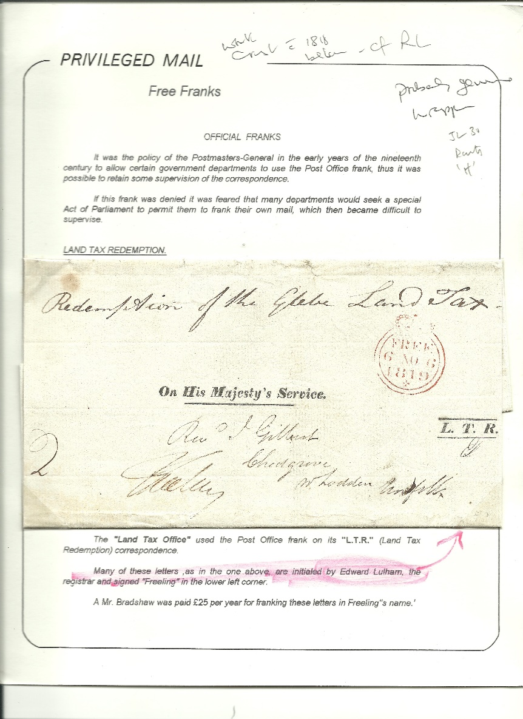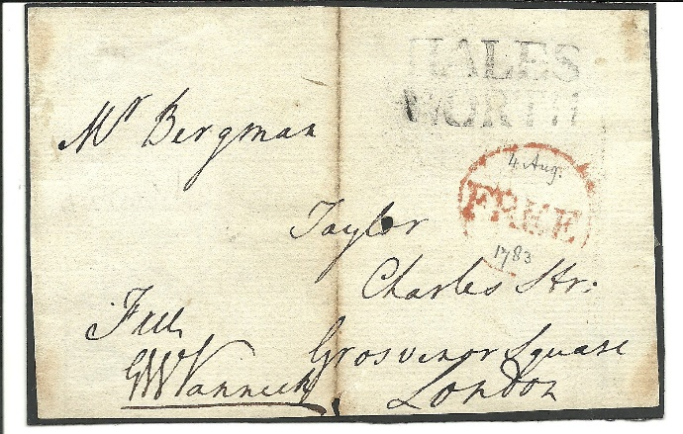

089

Ex 326

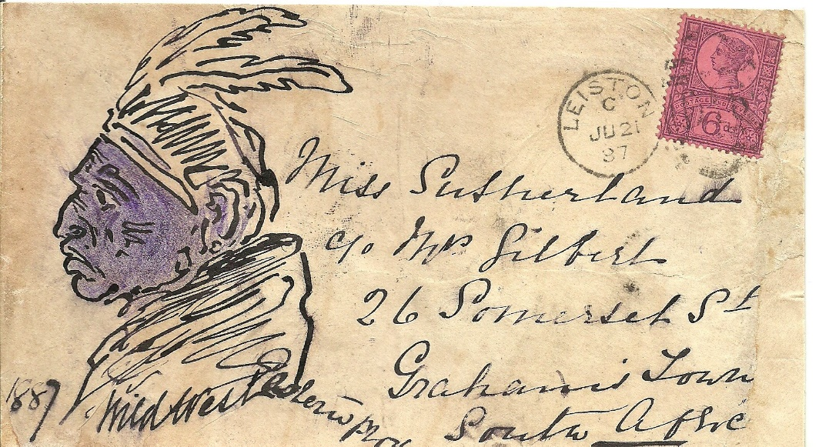

088

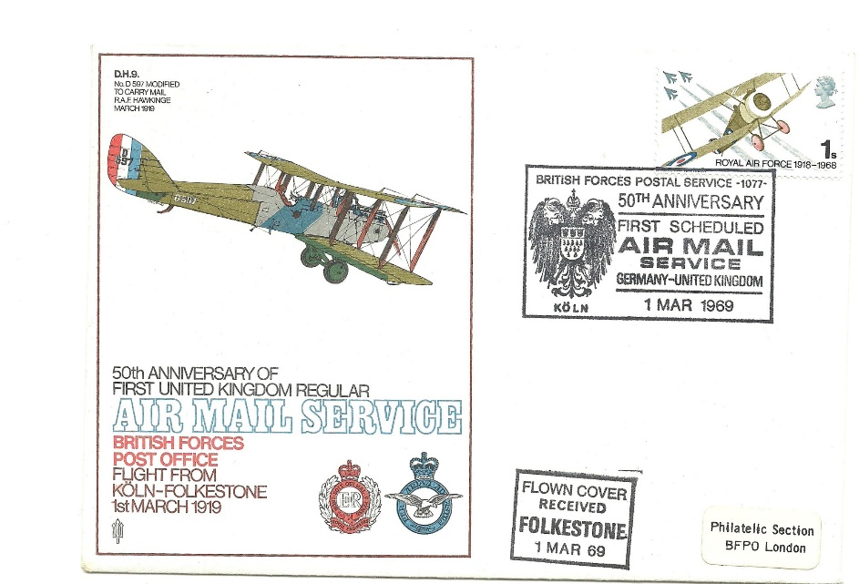

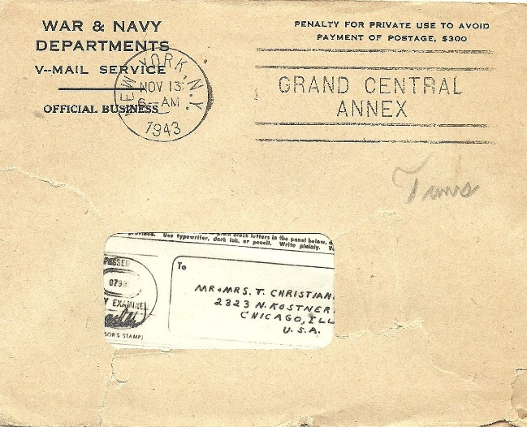 147  
 258

|  |
| --- |
| **THANK YOU FOR YOUR PARTICIPATION**  **REFRESHMENTS AVAILABLE WHILST WE COLLATE THE SALES.**  **PLEASE PAY BEFORE LEAVING. THANK YOU** |

**POSTAL BID SHEET**

Date and Time Received at Club:

**PLEASE FILL IN BLOCK CAPITALS**

Send to: Stephen Teuma, 24 Hercules Rd,

Rendlesham, IP12 2GP or email your bids: [sateuma@gmail.com](mailto:sateuma@gmail.com)

**Name:………………………………………………….…………...**

**Address…………………………………………………………….. Tel:......................................**

**………….…………………………………………………………. Post Code:….…..……………….......**

|  |  |  |  |  |  |
| --- | --- | --- | --- | --- | --- |
| Lot No | Description | Bid | Lot No | Description | Bid |
|  |  |  |  |  |  |
|  |  |  |  |  |  |
|  |  |  |  |  |  |
|  |  |  |  |  |  |
|  |  |  |  |  |  |
|  |  |  |  |  |  |
|  |  |  |  |  |  |
|  |  |  |  |  |  |
|  |  |  |  |  |  |
|  |  |  |  |  |  |
|  |  |  |  |  |  |
| Total | |  | Total | |  |

To avoid tied bids, please indicate in the box if you wish to

Increase your bids by 10%, 15% or 20%.

In the absence of postal instructions, lots will be sent by ‘Certificate of Posting’/Recorded Delivery up to £100 and Registered Delivery over £100.

All postage, packaging and insurance to be borne by purchaser.

Postal Instructions:…………………………………………………………………………………..

…………………………………………………………………………………………………………………

I enclose a crossed, blank cheque made payable to IPSWICH & DISTRICT

PHILATELIC SOCIETY

**SIGNED:……………………………………………………………………………………………………………………………………………**

**POSTAL BID SHEET**

Date and Time Received at Club:

**PLEASE FILL IN BLOCK CAPITALS**

Send to: Stephen Teuma, 24 Hercules Rd,

Rendlesham, IP12 2GP or email your bids: [sateuma@gmail.com](mailto:sateuma@gmail.com)

**Name:………………………………………………….…………...**

**Address…………………………………………………………….. Tel:......................................**

**………….…………………………………………………………. Post Code:….…..……………….......**

|  |  |  |  |  |  |
| --- | --- | --- | --- | --- | --- |
| Lot No | Description | Bid | Lot No | Description | Bid |
|  |  |  |  |  |  |
|  |  |  |  |  |  |
|  |  |  |  |  |  |
|  |  |  |  |  |  |
|  |  |  |  |  |  |
|  |  |  |  |  |  |
|  |  |  |  |  |  |
|  |  |  |  |  |  |
|  |  |  |  |  |  |
|  |  |  |  |  |  |
|  |  |  |  |  |  |
| Total | |  | Total | |  |

To avoid tied bids, please indicate in the box if you wish to

Increase your bids by 10%, 15% or 20%.

In the absence of postal instructions, lots will be sent by ‘Certificate of Posting’/Recorded Delivery up to £100 and Registered Delivery over £100.

All postage, packaging and insurance to be borne by purchaser.

Postal Instructions:…………………………………………………………………………………..

…………………………………………………………………………………………………………………

I enclose a crossed, blank cheque made payable to IPSWICH & DISTRICT

PHILATELIC SOCIETY

**SIGNED:……………………………………………………………………………………………………………………………**