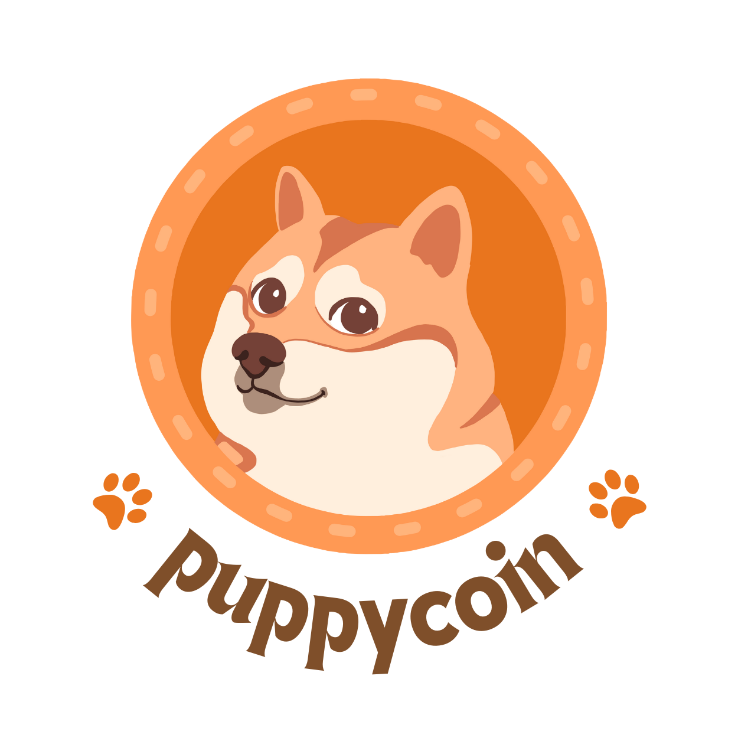

PuppyCoin White Paper

Abstract
The PuppyCoin project aims to revolutionize the pet adoption industry by leveraging blockchain technology and cryptocurrency to facilitate pet adoptions, increase transparency, and support animal shelters. This white paper provides a comprehensive overview of the project, its tokenomics, use cases, and roadmap.

Table of Contents

Introduction Project Overview

The PuppyCoin project is driven by a passion for pets and a commitment to addressing the challenges faced by the pet adoption industry. Our goal is to make pet adoption more accessible, affordable, and transparent.

Vision and Mission

Our vision is to create a world where every pet finds a loving home. Our mission is to use blockchain technology and PuppyCoin to achieve this vision by simplifying the adoption process and supporting animal shelters.

Objectives

PuppyCoin's primary objectives include promoting pet adoption, reducing adoption fees, increasing transparency, and providing financial support to animal shelters.

Tokenomics Token Name: PuppyCoin (PUPPY) Total Supply:

1,00,000,000 PUP PY

Distribution Breakdown:

Marketing: 25,000,000 PUPPY (30%)
DEX Liquidity: 20,000,000 PUPPY (20%)
Pets Adoption: 35,000,000 PUPPY (25%)
Community Rewards: 10,000,000 PUPPY (15%)
Governance: 10,000,000 PUPPY (10%)

Token Utility: PuppyCoin (PUPPY) will be used for:

Covering adoption fees
Participating in governance decisions
Earning rewards for active community members
Providing liquidity on decentralized exchanges (DEXs)

Initial Token Sale

The initial token sale will be conducted through a public sale, details of which will be released in subsequent announcements.

The Problem

The pet adoption industry faces several challenges, including:

Overcrowded shelters
High adoption fees
Lack of transparency in adoption processes

The Solution

PuppyCoin offers a solution by:

Reducing adoption fees through token incentives
Increasing transparency with blockchain technology
Supporting animal shelters financially

Technology and Implementation Blockchain Technology:

PuppyCoin is built on a secure and scalable blockchain platform that ensures transparency and data integrity

Adoption Platform Features

Our platform simplifies the adoption process, allowing users to browse adoptable pets, pay adoption fees in PUP, and access pet care resources.

Transparency and Security Measures

We implement the highest security standards to protect user data and funds, including regular security audits and encryption protocols.

Use Cases

Detailed Explanation

PuppyCoin can be used to cover adoption fees, pay for veterinary expenses, and purchase pet-related products.

Benefits to Adopters

Pet adopters can enjoy reduced costs, faster adoption processes, and greater trust in shelters.
Transparency and Security

Blockchain technology ensures transparency, while robust security measures protect user data and funds.

Roadmap

Development Milestones

Our roadmap outlines key milestones, including the launch of the adoption platform, marketing campaigns, and partnerships.

Adoption Campaigns

We will collaborate with animal shelters for adoption campaigns and community outreach.

Marketing Strategy

Our marketing plan includes social media campaigns, partnerships with influencers, and targeted advertising.

Expansion Plans

We plan to expand PuppyCoin's adoption platform to a global audience and explore partnerships with international shelters.

Community Engagement

Building a Strong Community

We aim to create an active and engaged community through forums, social media, and events.

Community Rewards

Active community members will be rewarded with PUP tokens for their contributions.

Governance

PUP token holders will have a say in project decisions through voting mechanisms.

Partnership Opportunities

We welcome partnerships with organizations that share our mission.

Token Sale and Fundraising

Fund Allocation

Funds raised will be allocated as follows: development (40%), marketing (30%), adoption support (20%), and legal/compliance (10%).

Public Sale Details

The public sale details, including dates, pricing, and contribution methods, will be announced soon.

Token Distribution

PUP tokens will be distributed according to the allocation percentages, with vesting schedules for team members and advisors.

Security and Compliance
We prioritize user data and fund security, conducting regular security audits and adhering to industry best practices.

Regulatory Compliance

PuppyCoin will comply with relevant regulations and work with legal experts to ensure compliance.

Team

Our team brings diverse expertise in blockchain, pet adoption, and marketing.

Advisors

Our advisors contribute valuable insights and guidance to the project.

Partnerships and Collaborations

We have established partnerships with animal shelters and organizations committed to pet adoption.

Conclusion

Summary of Key Points
PuppyCoin aims to transform the pet adoption industry by reducing fees, increasing transparency, and supporting shelters.

Future Vision

Our vision is to create a global platform that connects pet adopters with loving animals in need.

Call to Action

Join us in our mission to make pet adoption accessible to all and provide loving homes for pets in need.

Appendices

Glossary of Terms: A glossary of technical terms and concepts.

References and Resources: A list of sources and additional reading materials.

