|  |
| --- |
|  |
| A STRATEGIC ROADMAP FOR 2024-2027 |
| |  |  |  | | --- | --- | --- | | Nicole Criss | [Date] | [Course title] | |

**Building Recovery and Wellness in Rural South Carolina**

L

**CARPS SC**

Founded through a desire of two individuals in recovery to help people who are experiencing substance use disorder in rural parts of South Carolina. Our strength lies in the diversity and experience of our board and staff. We were formed based on the idea that we would provide support and education to rural communities that need additional resources and support.

**OUR MISSION IS TO** support communities in rural South Carolina impacted by substance use disorder in their wellness journey. We work with the community through advocacy, education, recovery support, and harm-reduction initiatives to achieve this mission.

**OUR VISION**

We envision a future where rural areas of South Carolina are recovery-ready communities where recovery is seen, welcomed, and celebrated. People who need support, including family members, will have a peer support specialist who will walk through their journey every step of the way supporting them however they feel they need.

**OUR VALUES**

We operate under SAMHSA’s 10 Guiding Principles of Recovery

* Recovery emerges from hope
* Recovery is person-driven
* Recovery occurs via many pathways
* Recovery is holistic
* Recovery is supported by peers and allies
* Recovery is supported through relationships and social network
* Recovery is culturally based and influenced
* Recovery is supported by addressing trauma
* Recovery involves individual, family, and community
* Recovery is based on respect

Additionally, we commit to acting with the following principles at the core of all we do:

* Integrity
* Inclusion
* Acceptance
* Humility
* Innovation
* Transparency
* Vulnerability



**PEOPLE IN RECOVERY SUPPORTING RECOVERY IN RURAL SOUTH CAROLINA**

As overdoses and substance use disorder continue to impact

rural communities in South Carolina, this strategic plan

will ensure that CARPS SC is working to support these

communities in their wellness journey. This strategic plan

reflects the voices and lived experiences of the founders.

We will be working to engage with and seek the support of the communities in

which we are working as we understand it will be core to the work of CARPS SC

in the community. Additionally, we will seek donations from the community and

stakeholders to enable CARPS SC to provide important recovery support and

harm-reduction services filling gaps and breaking down barriers experienced by

individuals seeking recovery support and harm-reduction services. Donations from

the community and stakeholders help bridge the gaps to achieve work that

otherwise would not be possible. We recognize the important role our community

will play in many of the strategic initiatives outlined in this plan.

Threaded in each part of this plan is our focus on SAMHSA’s Guiding Principles

of Recovery. We will be person-centered and strength-based in all our work and

interaction with the community. We will do our part to provide education to help

combat the stigma that is so prevalent in society and contributes to the barriers

experienced by those seeking support. We will remain open in our decision-making

process utilizing feedback we receive from the community and program participants

to inform programs, processes, and service provision.

Our commitment to the communities we serve is unwavering. Our culture of

inclusivity and unconditional love will continue to guide our work. Our dedication

to the values of humility, innovation, transparency, and vulnerability are at the core

of all our actions.

We are excited to share this strategic plan for 2024-2027 which builds the strength

of our mission and lays the groundwork for our innovative and unwavering

dedication to supporting the rural communities in South Carolina.

Nicole Criss

Executive Director

Greg Jacobs

Deputy Director

**Executive Summary**

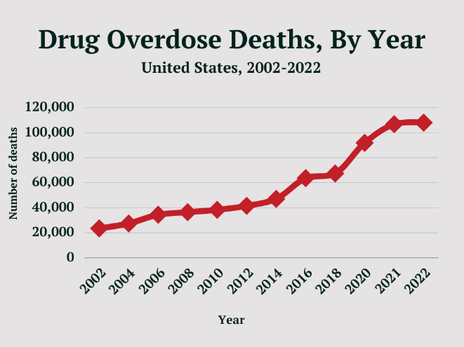 The CDC is reporting that there were 107,866

overdose-related deaths in the United States in 2023.

In the state of South Carolina, there were a reported

2,296 overdose-related deaths. Unfortunately, only 10.3%

of people with SUD receive treatment according to the

National Institute on Drug Abuse. This is a significant

issue that is impacting the wellness of communities

across the country, including right here in South Carolina.

Rural communities are not immune to the harms of SUD.

Dillon and Darlington

Counties,

two of the counties we are focusing on in the first two years have experienced “above average” overdose-related deaths

according to the Department of Health and Environmental Control (dph). The need is critical. One in three people in

the United States knows someone who has experienced SUD. **CARPS SC** works with the communities in

rural South Carolina through advocacy, education, recovery support, and harm reduction practices to provide support in

the journey of wellness.

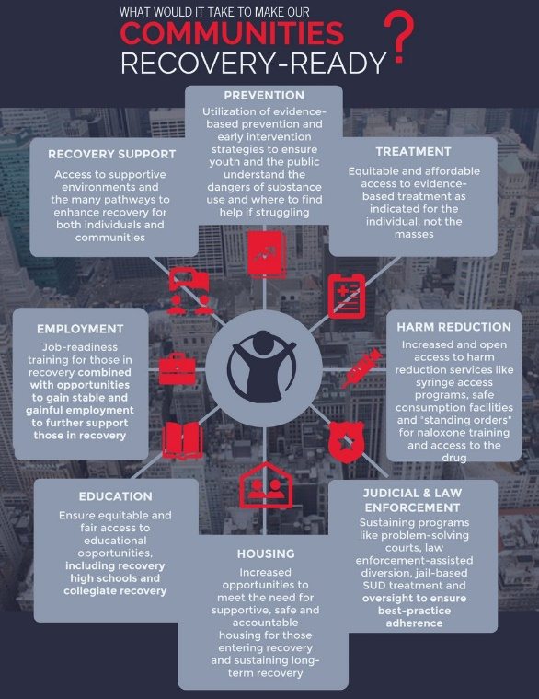 **CARPS SC** envisions communities in rural South Carolina

where recovery is seen, welcomed, and celebrated. Communities where

people who do need support can reach out to a peer support specialist who

will walk with them through their journey supporting them however they need to work toward wellness/recovery.

* This Strategic Plan was created by the Founders with the

support and approval of the Board of Directors.

* This plan will be reviewed annually. The review will be

included in the annual report at the end of each calendar

year. The annual review will include feedback provided by the

community and program participants through surveys. This

information will be used to inform any adjustments that need to be

made to the plan.

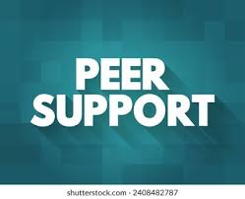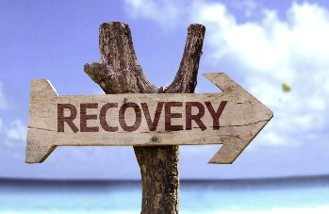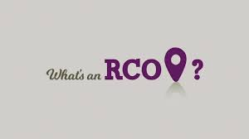

OUR PEER SUPPORT SPECIALISTS ARE:

People with lived experience and specialized training with a passion to share their transformational journey of wellness with someone who has a desire to improve their well-being and quality of life. Peer Support Specialists walk with the individual in their journey of wellness and provide resources to aid in that process, including, but not limited to, employment resources, connection to medical care, connection to mental health providers, information on different pathways of recovery, connection to safe and sober living homes, and other resources to support recovery and wellness.

WE BELIEVE RECOVERY IS:

“A process of self-directed change through which individuals improve their health and wellness, live self-directed lives, and strive to reach their full potential.”

*-SAMHSA*

WE ARE A

RECOVERY COMMUNITY ORGANIZATION (RCO)

“An RCO is an independent, non-profit organization led and governed by representatives of local communities of recovery. These organizations organize recovery-focused policy advocacy activities, carry out recovery-focused community education and outreach programs, and provide peer-based recovery support services. The broadly defined recovery-people in long-term recovery, their families, friends, and allies, including recovery professionals-includes organizations whose members reflect religious, spiritual, and secular pathways of recovery. The sole mission of an RCO is to mobilize resources within and outside of the recovery community to increase the prevalence and quality of long-term recovery from alcohol and other drug addiction. Public education, policy advocacy, and peer-based recovery support services are the strategies through which this mission is achieved.”

*-Valentine, P., White, W., & Taylor, P. (2007)*



**GOAL ONE:**

Build community relationships to allow for a stronger continuum of care by identifying and filling gaps.

SHORT-TERM ACTIONS:

1. Meet with law enforcement agencies, first responders, hospital systems, county agencies, FQHCs,

politicians, religious leaders, employers, social service agencies, community leaders, or anyone else work works with the target population to discuss who we are, what we do, and how we can work together (in Darlington, Dillon, and Marion Counties).

1. Table at community events hosted by our community partners. Our tables will include the distribution of harm-reduction tools, and literature providing information on substance use disorders to combat stigma, and we will provide HIV/HCV testing when appropriate. We will also provide education on all our services and how they can connect with us to receive any services they may need.
2. We will host a minimum of two events per year in each county we serve (Marion, Dillon, and Darlington) providing education and services. We will invite all our community partners who provide services to the target population to table at our events. We will highlight real stories during our events. We will invite all community members with the intention of educating and combatting stigma.
3. We will maintain our social media, marketing materials, and website to keep current, accurate, and informative.
4. We will utilize surveys during events and other community engagements to elicit feedback to inform our future events and to help further identify gaps that need to be filled and barriers that need to be broken.

LONG-TERM ACTIONS

* 1. In year 3 of this plan, we will focus on expanding the actions listed above into Lancaster, Lee, and Kershaw Counties.
  2. In year 4 of this plan, we will focus on expanding the actions listed above into Chesterfield, Marlboro, and Williamsburg Counties.

|  |  |
| --- | --- |
| **Category** | **Budget Amount** |
| Personnel | $11,000.00 |
| Fringe | $3,300.00 |
| Travel | $2667.00 |
| Supplies | $1376.10 |
| **TOTAL SHORT-TERM ACTIONS BUDGET** | **$18,343.10** |

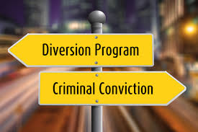

**GOAL TWO:**

Start a diversion program.

SHORT-TERM ACTIONS

1. Work with Darlington Pardon, Parole, and Probation (PPP) to start the diversion program with them.
2. Work with the City of Darlington Police Department to start the diversion program with them.
3. Once these programs are running effectively, reach out to other county PPP offices in Dillon and Marion Counties to provide the diversion program to them.
4. Reach out to other law enforcement agencies in Darlington, Dillon, and Marion Counties to provide the diversion program to them.
5. Collect data to inform the program and provide to potential partnering agencies in the future.
6. Once some program participants have completed, offer them the opportunity to become peer support specialists and work in the program.
7. Provide some alumni event opportunities to encourage continued engagement and celebration of accomplishments.

LONG-TERM ACTIONS

* 1. In year 3 of this plan, we will focus on expanding the actions listed above into Lancaster, Lee, and Kershaw Counties.
  2. In year 4 of this plan, we will focus on expanding the actions listed above into Chesterfield, Marlboro, and Williamsburg Counties.

|  |  |
| --- | --- |
| **Category** | **Budget Amount** |
| Personnel | $23,476.00 |
| Fringe | $7,042.80 |
| Travel | $1,334.00 |
| Supplies | $688.05 |
| **TOTAL SHORT-TERM ACTIONS BUDGET** | **$32,540.85** |



**GOAL THREE:**

Start an emergency department program.

SHORT-TERM ACTIONS

1. The Medical Director will reach out to hospital systems and meet with the Chief Medical Officer (CMO) to inform them about the program to begin building the relationship in Carolina Pines and Marion County hospitals.
2. The Medical Director will work with the CMO to set up a meeting with the Emergency Department (ED) staff and the staff from CARPS SC who will be involved in the program.
3. Provide education and training to ED staff related to SUD and MOUD
4. CARPS SC will hire a CPSS to provide services in the two Emergency Departments.
5. All details of the program will be finalized between CARPS and the two hospital systems including signing MOAs ensuring all parties involved understand their roles and responsibilities in the program to provide the best possible care to the individuals seeking help with SUD.
6. Provide ongoing peer support, peer navigation, and group/meeting facilitation to program participants.
7. Work with the hospital and individuals who could benefit from the Bridge Device to provide the device when appropriate.
8. Collect data to inform the program and provide to potential partnering agencies in the future.

LONG-TERM ACTIONS

1. Continue to foster relationships with the hospitals to help individuals who find themselves and the ED or in the hospital receive the best most effective care possible.
2. Continue providing ongoing peer support, peer navigation, and group/meeting facilitation for as long as people are interested in receiving the services.
3. Provide fun recovery-oriented events program participants may want to participate in to continue to be socially active.
4. Encourage individuals who meet the requirements to become peer support specialists to take our training to become certified.

|  |  |
| --- | --- |
| **Category** | **Budget Amount** |
| Personnel | $66,322.00 |
| Fringe | $19,896.00 |
| Travel | $5,334.25 |
| Supplies | $$2,752.20 |
| **TOTAL SHORT-TERM ACTIONS BUDGET** | **$94,304.45** |

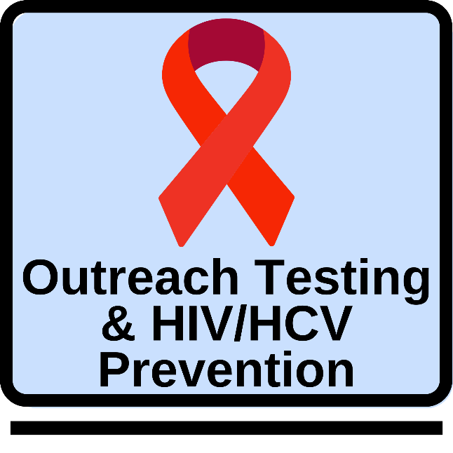

**GOAL FOUR**

Start rapid HIV/HCV testing programs that will include education and prevention tools.

SHORT-TERM ACTIONS

1. All staff get certified to perform HIV/HCV testing
2. Create a policy and procedure manual
3. Maintain all reporting requirements as prescribed by DAODAS and dhec.
4. Execute a minimum of one testing event per week
5. Develop a warm handoff process with the local FQHC who will be providing confirmatory testing and treatment.
6. Distribute any harm-reduction and recovery support tools/materials needed by individuals who test.
7. Provide education on safer sex practices along with condoms and other supplies to help people stay safe.
8. During the testing process, staff will also provide peer navigation if any is needed by the individuals who test.
9. All the short-term goals will cover work done in Darlington, Dillon, and Marion Counties.

LONG-TERM ACTIONS

1. In year 3 of this plan, we will focus on expanding the actions listed above into Lancaster, Lee, and Kershaw Counties.
2. In year 4 of this plan, we will focus on expanding the actions listed above into Chesterfield, Marlboro, and Williamsburg Counties.

|  |  |
| --- | --- |
| **Category** | **Budget Amount** |
| Personnel | $50,904.00 |
| Fringe | $15,271.20 |
| Travel | $4,001.00 |
| Supplies | $2,064.15 |
| **TOTAL SHORT-TERM ACTIONS BUDGET** | **$72,240.34** |

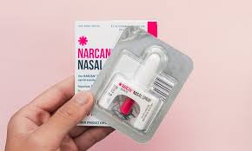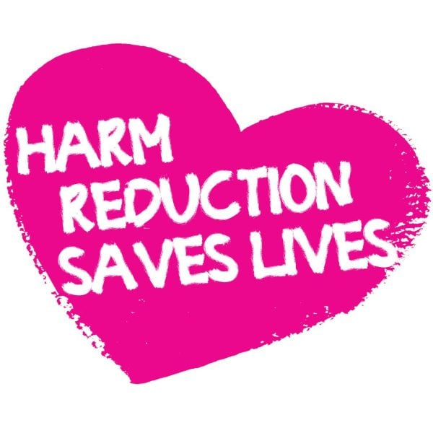

**GOAL FIVE**

Provide harm reduction supplies, support, and education to those in need.

SHORT-TERM ACTIONS

1. Have harm reduction supplies on display at all community events and distribute them when appropriate.
2. Identify high-risk areas in Marion, Dillon, and Darlington Counties, build relationships in those areas, and distribute harm reduction materials and education.
3. Provide harm reduction education in the community whenever possible
4. Provide harm reduction education to all individuals participating in all CARPS SC programs not only to help keep them safe should they have a return to use, but also to empower them to be able to help any family or friends who may still be actively using.
5. Maintain inventory of harm reduction materials and track distribution.
6. Work with program participants to educate them on the fact that recovery and recovery support does not require abstinence. If they are still using, they are still eligible to receive peer support or any other services they may need, including attending groups/meetings.
7. Distribute personal hygiene products during outreach when appropriate.
8. Complete all reporting requirements prescribed by DAODAS.
9. Collect data to inform the program and provide to potential partnering agencies in the future.
10. All actions above will be performed in Dillon, Darlington, and Marion Counties

LONG-TERM ACTIONS

1. In year 3 of this plan, we will focus on expanding the actions listed above into Lancaster, Lee, and Kershaw Counties
2. In year 4 of this plan, we will focus on expanding the actions listed above into Chesterfield, Marlboro, and Williamsburg Counties

|  |  |
| --- | --- |
| **Category** | **Budget Amount** |
| Personnel | $14,500.00 |
| Fringe | $4,350.00 |
| Travel | $5,334.00 |
| Supplies | $2,752.20 |
| FTS&XTS | $30,000.00 |
| Outreach Supplies | $10,000.00 |
| **TOTAL SHORT-TERM ACTIONS BUDGET** | **$66,936.20** |

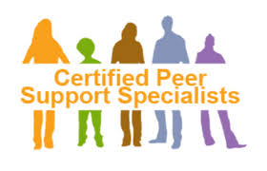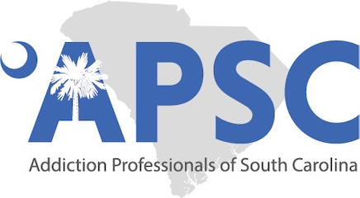

**GOAL SIX**

Provide Certified Peer Support Specialist Training in Rural Areas of South Carolina to encourage individuals who

live this those communities to work in their community.

SHORT-TERM ACTIONS

1. Become certified by the APSC to provide Certified Peer Support Training.
2. Provide two trainings in 2024-2025.
3. When training is scheduled, make sure program participants and community partners are aware of the opportunity to encourage people who live in rural communities to be certified so they can work/volunteer in their community.
4. Collect data to inform the program and provide to potential partnering agencies in the future.
5. The training team stays current on training materials.
6. The training team attends any training meetings as required by APSC or any internal requirements.
7. The training team keeps their state CPSS certification effective.

LONG-TERM ACTIONS

1. Continue training as CARPS SC expands into more rural counties.
2. Provide a minimum of two trainings per year starting in year three
3. The locations of the training will rotate throughout the counties being served to ensure opportunities for individuals in all the service areas to have access to training. In addition to rotating the locations, the days/times will rotate as well to try to accommodate as many schedules as possible.

|  |  |
| --- | --- |
| **Category** | **Budget Amount** |
| Personnel | $11,000.00 |
| Fringe | $3,300.00 |
| Travel | $2,667.00 |
| Supplies | $1,376.10 |
| **TOTAL SHORT-TERM ACTIONS BUDGET** | **$18,343.10** |

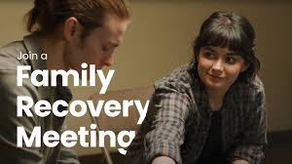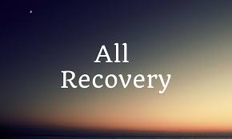

**GOAL SEVEN**

Facilitate All-Recovery, Family-Recovery, and Opioid-Focused meetings/groups that are accessible to as

many as possible.

SHORT-TERM ACTIONS

1. Build a community of individuals who are interested in attending the meetings.
2. Identify what day/time works best for the community members who are interested in attending the meetings in coordination with staff availability.
3. Develop educational materials and programming for the family and opioid-focused meetings.
4. Ensure the facilitator is qualified and prepared to facilitate the meetings.
5. Collect data to inform the program and provide to potential partnering agencies in the future.

LONG-TERM ACTIONS

1. Expand meetings into Lancaster, Lee, and Kershaw in year three.
2. Expand meetings into Chesterfield, Marlboro, and Williamsburg in year four.

|  |  |
| --- | --- |
| **Category** | **Budget Amount** |
| Personnel | $7,250.00 |
| Fringe | $2,175.00 |
| Travel | $0 |
| Supplies | $688.05 |
| **TOTAL SHORT-TERM ACTIONS BUDGET** | **$10,113.05** |



**GOAL EIGHT**

Open a recovery center in Dillon that will serve as the main office for CARPS SC.

SHORT-TERM ACTIONS

1. Identify the most appropriate and accessible area in Dillon to put the center.
2. Identify a property that falls within the budget.
3. Ensure the property owner will allow us to provide our services in the location (that they are recovery-friendly).

LONG-TERM ACTIONS

1. Open a recovery center that is central to Lancaster, Lee, and Kershaw counties in year three.
2. Open a recovery center that is central to Chesterfield, Marlboro, and Williamsburg counties in year four.

|  |  |
| --- | --- |
| **Category** | **Budget Amount** |
| Contractual (Rent) | $15,600.00 |
| Utilities | $1,500.00 |
| Furniture | $1,000.00 |
| **TOTAL SHORT-TERM ACTIONS BUDGET** | **$18,100.00** |

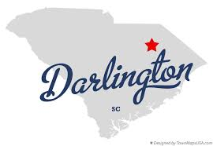

**GOAL NINE**

Identify and secure a location in Darlington where we can provide in-person services one day per week.

SHORT-TERM ACTIONS

1. Identify a location that is accessible to individuals in Darlington who need the services
2. Ensure the property owner is recovery-friendly and will allow us to provide our services to those who need them
3. Ideally, this property would be rent-free
4. Update all our materials with the location, day, and time
5. Update our community partners with the locations, day, and time

LONG-TERM ACTIONS

1. Be a good tenant, take care of the property, and be respectful of the community in which the property is located.

**ZERO BUDGET FOR THIS GOAL**

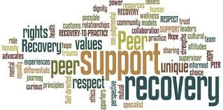

**GOAL TEN**

Provide community-based, individual peer support services to individuals experiencing substance use

disorder and family members.

SHORT-TERM ACTIONS

1. Ensure all staff providing services are utilizing the Recovery Data Platform (RDP)
2. Ensure all staff are certified peer support specialists by the state of South Carolina
3. Ensure all staff are receiving appropriate and effective supervision
4. Educate the communities we serve about what peer support is and how they can receive it when needed
5. Ensure all staff are providing services following CARPS SC’s values
6. All services will be provided to anyone living in Darlington, Dillon, or Marion who needs them.

LONG-TERM ACTIONS

1. Expand peer support services into Lancaster, Lee, and Kershaw in year three.
2. Expand peer support services into Chesterfield, Marlboro, and Williamsburg in year four.

|  |  |
| --- | --- |
| **Category** | **Budget Amount** |
| Personnel | $27,928.00 |
| Fringe | $8,379.00 |
| Travel | $5,334.00 |
| Supplies | $2,064.15 |
| **TOTAL SHORT-TERM ACTIONS BUDGET** | **$43,705.15** |

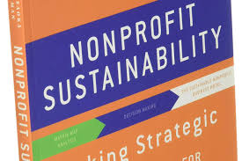

**GOAL ELEVEN**

Program and organizational sustainability.

SHORT-TERM ACTION

1. Keep job descriptions accurate and current
2. Ensure all staff receive consistent, appropriate, and effective supervision
3. Ensure all staff participate in appropriate training to keep them current and strong in their skill set
4. Keep strategic plan updated. Make sure it is reviewed consistently and updated annually
5. Ensure the board of directors meets quarterly at a minimum.
6. The board will receive financial reports monthly via email for review
7. CARPS SC will be good partners with all funding organizations, including adhering to all reporting requirements
8. We will have a fundraising committee in place and active
9. We will host one major fundraising event each year
10. We will host two small fundraising events each year
11. We will offer sponsorship opportunities for each community event
12. We will work to spread awareness in the community of our work and recognition of our brand
13. Years one and two of this action plan will focus on Dillon, Darlington, and Marion Counties

LONG-TERM ACTIONS

1. Expand efforts listed above into Lancaster, Lee, and Kershaw in year three.
2. Expand efforts listed above into Chesterfield, Marlboro, and Williamsburg in year four.

|  |  |
| --- | --- |
| **Category** | **Budget Amount** |
| Personnel | $7,500.00 |
| Fringe | $2,250.00 |
| **TOTAL SHORT-TERM ACTIONS BUDGET** | **$9,750.00** |

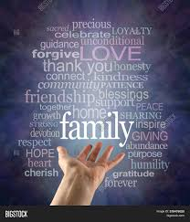

**GOAL TWELVE**

Provide family services to support the entire family as we know that SUD impacts the entire

family.

SHORT-TERM ACTIONS

1. Have a trained family peer support specialist on staff part-time
2. Provide individual peer support to family members
3. Offer one family-focused meeting per week. This meeting will be 80% education and 20% connection
4. Ensure family peer support specialist receives consistent, effective, and appropriate supervision

LONG-TERM ACTIONS

1. Expand family peer support services into Lancaster, Lee, and Kershaw in year three.
2. Expand family peer support services into Chesterfield, Marlboro, and Williamsburg in year four.

|  |  |
| --- | --- |
| **Category** | **Budget Amount** |
| Personnel | $17,680.00 |
| Fringe | $5,304.00 |
| **TOTAL SHORT-TERM ACTIONS** | **$22,984.00** |



|  |  |
| --- | --- |
| **Category** | **Budget Amount** |
| Personnel | $237,560.00 |
| Fringe | $71,268.00 |
| Travel | $26,671.25 |
| Supplies (Office/Program) | $13,761.00 |
| Contractual (Rent) | $15,600.00 |
| Supplies (Furniture) | $1,000.00 |
| Utilities | $1,500.00 |
| Xylazine and Fentanyl Test Strips | $30,000.00 |
| Outreach Supplies | $10,000.00 |
| **TOTAL SHORT-TERM ACTIONS** | **$407,630.25** |

**ANNUAL BUDGET**

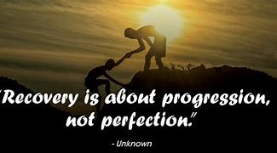

We use our lived experience to support individuals with substance

use disorder and their families in their wellness journey. We meet

people living in underserved rural parts of South Carolina where

they are both mentally and physically with love and acceptance.

The individuals and families we serve have a place where they

understand they are safe and not alone. Our advocacy efforts

work toward creating recovery-friendly communities where

individuals and families can find the support needed to progress

on their wellness journey right in their community. If you would

like to help, please consider donating through our website

or becoming a volunteer.

TOGETHER, LET’S HELP RURAL SOUTH CAROLINA RECOVER.

[FACEBOOK](https://www.facebook.com/people/CARPS-SC/61553645041947/)

[CARPS SC Website](http://www.carpssc.com/)

[Donate here](https://www.paypal.com/donate/?hosted_button_id=8CHD2VBASKJBW)

Emails: [ncriss@carpssc.com](mailto:ncriss@carpssc.com) or [gjacobs@carpssc.com](mailto:gjacobs@carpssc.com)

Phone: (410) 459-3477 or (854) 208-3638