I would not normally ever ask for help in such matters, but I believe my Civil Rights are being violated by the local government.  I hope by putting this on GoFundMe that it will help spread the word of the unjust process the village is pursuing and help cover my legal fees (already in excess of $10,000 in less than 6 months) and hopefully news of this will put public pressure on them to act in a more reasonable and responsible manner.  If I should be so fortunate to garner your support any excess funds will be donated to the Mid-Ohio Foodbank ([www.midohiofoodbank.org](http://www.midohiofoodbank.org)).  
  
The Village of Sunbury, OH is suing me to take one over half of the land I purchased just 3 years ago without compensation.  They refuse to proceed or pursue eminent domain as they assert they do not have to purchase the property and that it already belongs to them.   Though the lawsuit has been taking place since the summer, they have yet to: 1) produce or provide any evidence to support their claim, 2) answer any of the questions my attorneys have requested (all their answers have been "Will Supplement", 3) acknowledge that the deed and title were transferred without  clouds or any other encumbrance from the previous owners of record to the LLC of which my father and I are partners, 4) explain why the village map that was provided to Delaware County by them in January of 2018 does not show it belonging to them, but now (for whatever reason) it now does.  
  
**Property Location:** 157 S Vernon St.  (the old Cellar Lumber location, just south of the town square and north of the high school).  Subject area is .56 acres and is over half of the total acreage purchased in Dec 2015.  The 2 parcels purchased originally had an adjacent 3rd parcel which was subdivided just prior to my purchase and sold to Preservation Parks to extend their bike path through Delaware County.  
  
PLEASE NOTE:  Both the Sunbury Village Mayor & Village Attorney own property adjacent to one or more of these 3 parcels. See attached aerial image.  Their houses are circled.  Yes, the subject parcel is very oddly shaped, but it used to have the parcel to the south as well.  It makes more sense when all three parcels were owned by the same entity.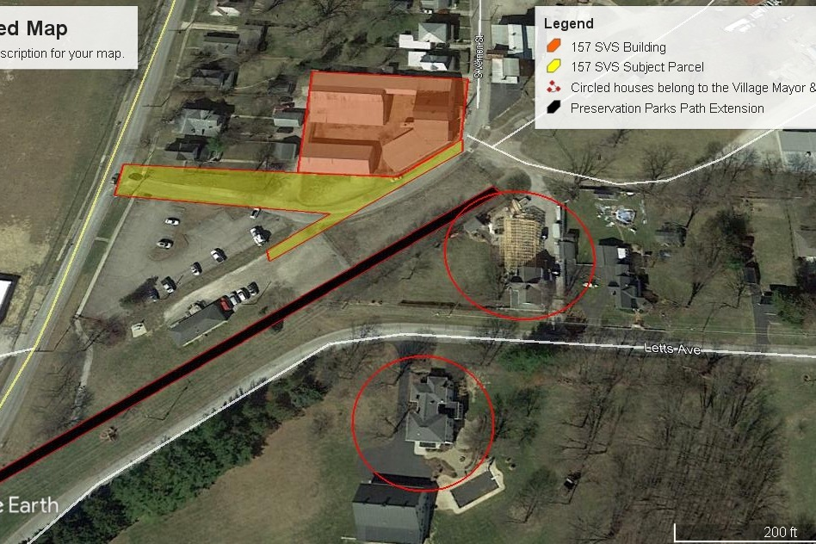

**Basic Info:**  Property sat empty for several years as Cellar Lumber had it for sale.  It was originally 3 separate parcels.  One of which was subdivided and sold to Preservation Parks to extend their bike trail.  I purchased the other 2 parcels in Dec of 2015: One of them has the building on it, the other the “driveway” … which is now claimed by the village to be an unofficial extension of S. Vernon St.  Although, from what I understand, in almost  all circumstances, it is illegal to cut through private property or a parking lot to get to another street, the village does not consider this to be the case apparently ONLY for this situation.  
  
The purchase was made for 2 reason: 1) to house my small asphalt maintenance business, 2) for future development as the Village of Sunbury has been experiencing tremendous growth in the last several years.  (To have over 1 acre within a short walk of downtown would be very attractive for a mix use development or a residential project; and beneficial to the community).    
  
PLEASE NOTE:  In late June of 2018, a $2 billion park was announced for development just 4 miles down the road which may bring as many as 15,000 jobs to the area. Clearly, the village knew about this even though the general public did not.  
  
Timeline of Events:  
  
**Dec 2015:**  Purchased Property  
  
**Spring 2016:**  Sat with village council with architect, Dave Pontia, to discuss redevelopment of property to a 3 or 4 story mixed use or residential building and the reconfiguration of the driveway on the south side of the building to "square off" the intersection and move the asphalt surface away from the corner of the building (as it sits only approx 20" away from it presently and is now a hazard as a blind corner for through traffic).   Though doing this would cause me to lose approx .25 acres, it would allow for a larger contiguous area for parking once redeveloped.  Also, moving the drive surface away from the corner of the building would extend it closer to the property owned by the village mayor.  Maps made on Google Earth Pro were shown to the village council.  My employees and I experienced at least a half dozen "close calls" with speeding vehicles coming around the corner in 2018.    
  
**Summer 2016:** My company patched potholes in the asphalt along the south side of the building on the parcel in question.  
  
**Summer 2017:**  I moved out of Ohio for approx 8 months to help my aging parents.  I quickly realized I was not happy living outside of Ohio and moved back in Feb 2018.  
  
**Feb 2018:**  I notice that the mayor has started building a new pole barn or detached garage almost exactly to the area where I suggested the drive surface be squared off to continue to S. Columbus St.   
  
**April 2018:**  Attended a Sunbury Village Council meeting to ask for a variance to remodel an unfinished 2nd floor space into a living space.  At this meeting the village attorney, David Brehm, told me that if I did not give the parcel containing the building driveway to the village that the village would sue me and take it from me anyway.  I offered to discuss eminent domain, but he rudely laughed.  Audio of this can be found on the Village of Sunbury website (<https://sunburyohio.org/>).  
  
**May 2018:**  I bring legal representation to the village council meeting to communicate to the council that I do not want to go to court and I that am still willing to sit and discuss alternatives including eminent domain.  The discussion between my attorney & Mr. Brehm took place away from the microphone and was not considered official business of that meeting.  When asked about the conversation, my attorney informed me that discussion was “still on the table”.  
  
**June 2018:**  Feeling like I cannot trust the judgement of the village council, I order a survey to be completed of the parcel in question by surveyor, Steve Fox.  
  
**Late June 2018:**  Blue Horseshoe Ventures/Planet Oasis announces plans for a $2 billion dollar development approx 4 miles away from the downtown Sunbury.    
  
**April - July 2018:**  My company continues to patch potholes in the asphalt and reinforce drive surface edge lines that have eroded from rainfall; 2018 has been one of the rainiest years in recorded weather in Ohio.  Cars continue to speed around the corner of the building cutting through to S. Columbus Street.  My employees have 3 close calls, I have one.  Most of these are high school students as the high school is less than a quarter mile south of my property.  I visit the high school to talk with administration about the speeding on my property to see if an announcement can be made to slow down, reduce or eliminate the student traffic.  I am told there is nothing they can do about it. I eventually have to contact Big Walnut School District to tell them I do not want school traffic crossing my property. I am so rudely treated I also decide not to allow bus traffic.  
  
**July 2018:**  Cars continue to speed around the corner.  I decided to install 2 speed bumps approximately 100 feet from each other (one on each side of the area my employees and I are most often working or loading equipment).  Approximately halfway through completing the first speed bump, we notice the mayor (Tom Hatfield) taking pictures of us working; about 10 minutes later the village zoning commissioner & assistant commissioner arrive to ask what I am doing.  I tell him.  He informs me that I am performing working on property owned by the village without their permission and without a permit.  I inform him that the property does not belong to the village (it is not titled to them) and I have been paying the full amount in taxes on it since it was purchased in 2015.   They leave.  As we are finishing the first speed bump the zoning commissioner returns with a Cease & Desist Order.  The Order contains language instructing me to remove the speed bump from "their property".  Clearly, I cannot remove the bump since if I do, then I am agreeing that it is their property.  
  
**August 2018:**  I am served with a lawsuit naming my LLC and all of my neighbors who have easements as defendants.  Ironically, this also includes the mayor and his wife as their home is on the southeast corner of the property, though their property does not touch mine and they do not have any easements. This was likely done to make it look like the suit is legitimate.    
  
Here is a link to just one article about the growth of the area (<https://www.delgazette.com/news/72183/village-of-sunbury-renovating-expanding>).  Near the end of the article it mentions the proposed expansion of the schools, traffic issues and nearby road extensions.    
  
It is also interesting to note that all of the homes west and north of my property all the way to the south side of the village square are zoned "Light Industrial".  When I inquired with the assistant zoning commissioner as to why, she replied that she didn't know.