**Christian Healing Center**

**India**

MONTHLY REPORT-September-2020

Dear brothers and sisters in Christ,

We are so happy to report to you what God has done in and through us. God is so faithful in answering our prayers. He honors those who honor Him. Please read this report and join us in thanking God. We pray for you all every day.

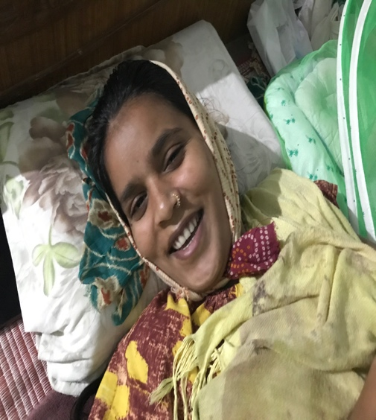 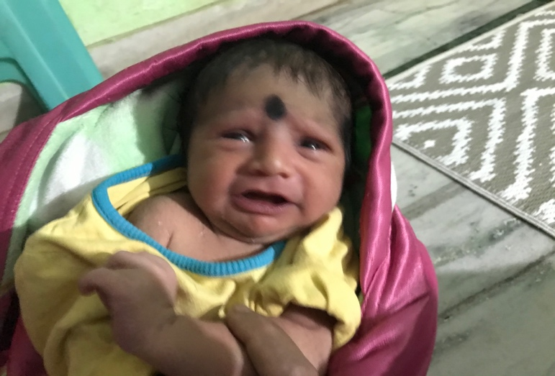

Pari and Sankar came to me for prayer 5 years ago in Medchal. They were married for 5 years by then yet no kids. She was possessed by evil spirits. We prayed and casted them out. She was delivered. We have been praying that they will have kids. Dr. Gary prayed with her when he visited us in 2019. God opened her womb and she gave birth to a baby boy last week. They acknowledge that the baby is a gift from God and an answer to prayers. Glory to God and thanks to Gary.

**GOD HELPED COVID-19 AFFECTED PEOPLE.**

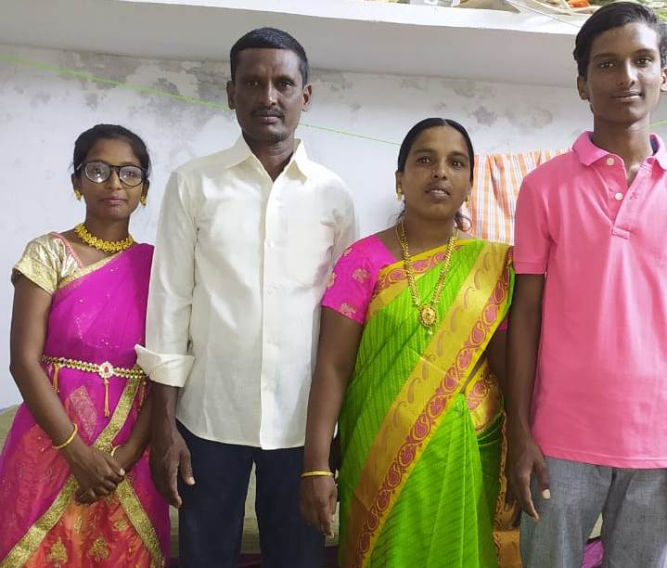Mahima is a student of one of our CHC prayer ministers. Recently Mahima and her family were affected by Covid-19. This family has gone through a very rough time. Mahima’s mother is a nurse and she was affected first and they all were affected. Mahima shared it with the local CHC. We prayed for the family. She also started praying for their healing. But problem is, mahima’s father has kidney related issues and when he was affected by Covid-19 he became so ill and whole family was worried. But they all trusted God and believed that God will deliver and heal them. God miraculously shown mercy and they are healed. The entire family is so thankful and became strong in Christ. Let’s continue to pray for this family.

Narsamma was found Covid-19 positive. She was so worried about her situation. She was abandoned and there is no one to help her. She called the local CHC and requested for prayer over phone. The team of CHC prayed for her. She felt a touch as they were praying and was healed instantly. She went for a check-up the very next day and the report showed ‘negative’. Glory to Jesus Christ. The news spread all over the village. Through her healing, many are attracted to Christ, and now they have faith that Jesus can help them in every situation. Pray for them, so that they can accept Christ as their saviour.

**GOD SAVED COUPLE OF SOULS TO HIS KINGDOM**

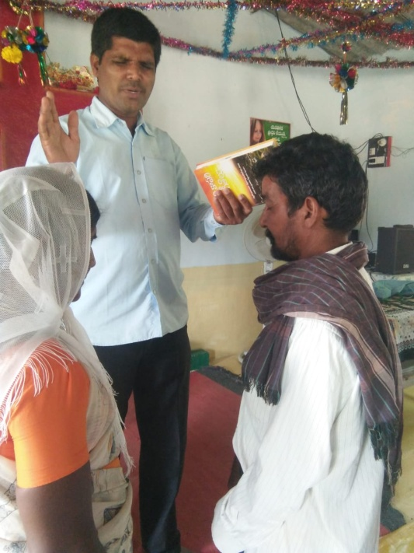Linga is from Hindu background. He used to worship idols and practice all kinds of rituals. Recently our prayer minister shared the gospel and asked him to believe in Christ. Pastor continued to pray for him and his family. God touched his heart, and now he accepted Christ and took baptism. Please pray for him that he may grow in faith.

Jagadhamma is also from Hindu background. They used to live in a tribal area. Doing ministry is very challenging in those areas. But our CHC prayer minister is so burdened to go there and preach gospel. He shared about Christ with this woman, she was very aggressive and didn’t want to listen to him. But pastor prayed for her and left the village. On his next visit, she invited him to her house and offered a cup of tea and said that, she was so sorry for her actions. She saw Jesus in her dream and filled her heart with peace. She remembered the truth. Finally, she accepted Christ as her savior. She is part of the church now. Thanks to Jesus!

**A couple of more healings**

**“Jesus turned hurting knees to praying knees”**

Gangamma lives in a village called Lakarva Thanda. She is a believer. She had a serious problem with her knees. She could not stand straight. CHC team anointed her with oil and prayed for her. God miraculously raised her and healed her. She joins the team for prayer and she kneels down all the time.

**“God honors those who honor Him”**

Kanakaraju is a young boy; he is a believer. Recently, he suffered with severe stomach pain. His parents took him to the hospital and brought some medicine as doctor suggested. He refused to take the medicine. He believes that Jesus can heal him. His parents challenged him and gave him 24 hours. Our CHC team prayed for him. God honored his faith. He was healed completely. His parents started to come to church. Glory to God!