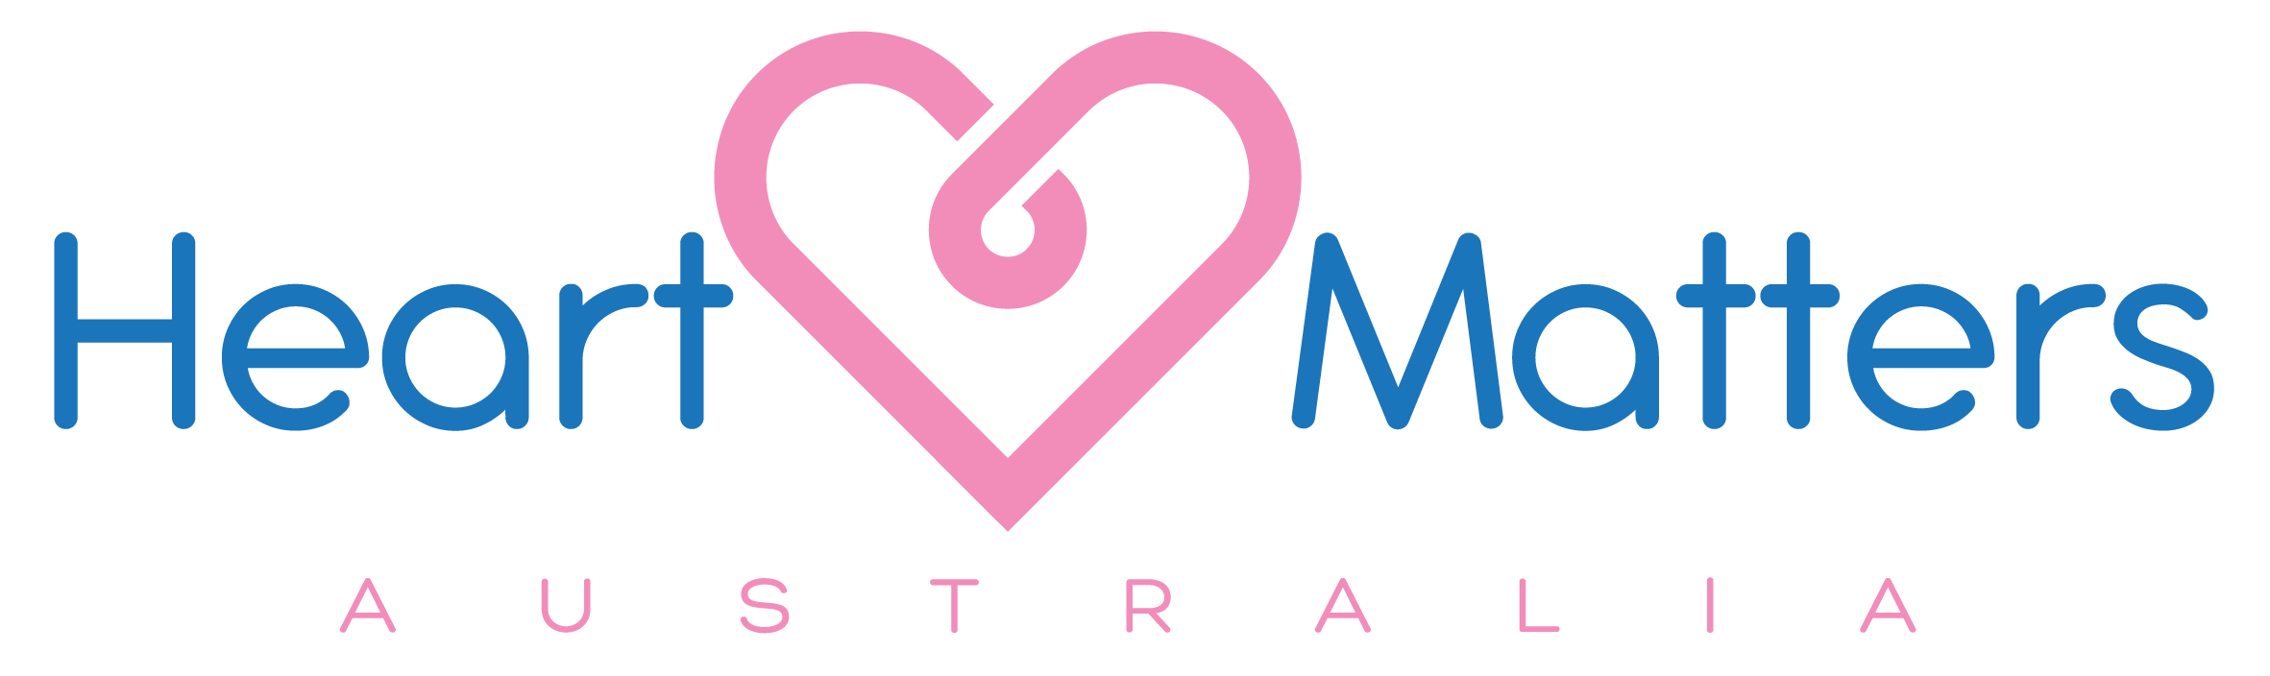

Automated External Defibrillator Donation Nomination Form

Heart Matters Australia is committed to raising awareness, educating and equipping local communities in Victoria with the tools to help increase the survival rate of Out of Hospital Sudden Cardiac Arrest (OHSCA).

In Australia, 9 out of 10 people die from OHSCA. The only way we can increase the survival rate is for all community members to learn how to perform Cardiopulmonary Resuscitation (CPR) and for there to be easy access to Automated External Defibrillators (AEDs). If CPR and defibrillation start within 3-4 minutes, survival rates can increase to over 70%.

Please answer the questions below and return the completed form to info@heartmattersaustralia.com.au

Local community/community group you would like to nominate:

Why do you believe this community/community group should receive an AED?

_____________________________________________________________________________

_____________________________________________________________________________

_____________________________________________________________________________

Local community/community group contact name, number and email if one:

___________________________________________________________________________

If your nomination is successful, we would love to share the wonderful news with you. However, we do understand that some people prefer to remain anonymous. If you would like us to share the news with you, please provide us with your name, contact number and/or email.
Your personal details are our top priority and will not be share with any other party unless approved by yourself.

___________________________________________________________

Thank you for nominating a local community/community group.
We appreciate your time.

