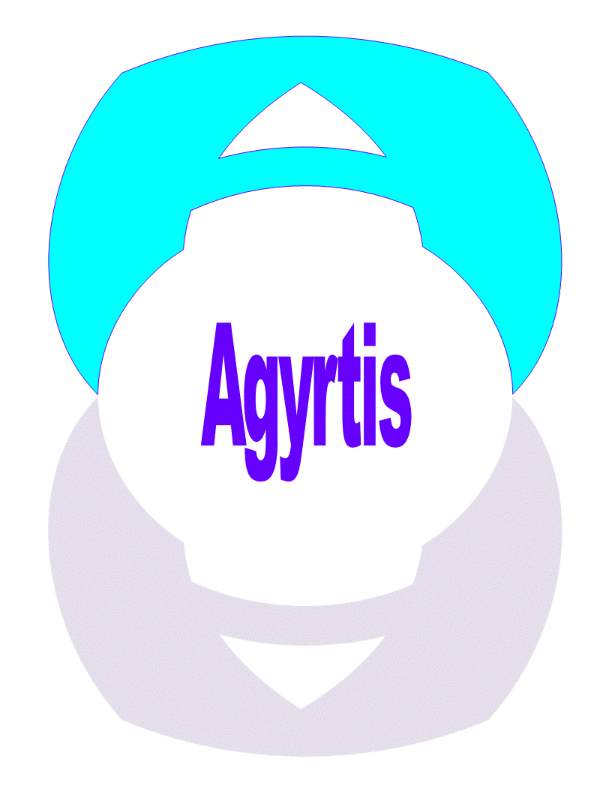
4 Steps to Processing a Private Money Loan

1. Pre-Approval
When a potential borrower applies for the pre-approval process at Agyrtis, LLC, they go through a series of steps ensuring they receive the financing that best tailors to their investment needs. After evaluating whether the project fits our lending criteria, we assess their previous experience, credit, and financial background.

All prospective borrowers should be prepared with their documentation of their purchase agreement, project needs and location, acquisition price and proof of funds.

Our application and pre-approval process can easily be determined after a quick conversation with a leading Agyrtis, LLC Loan Officer. Upon pre-approval a prospective borrower will pay the application fee of $197.00 which includes a background check and CDNA aka: collateral DNA report which confirms the value range of the asset to assure youre in a good range of value to further ensure your success.

2. Processing & Underwriting
When a prospective borrower’s application goes through the underwriting & loan process, it goes through a review of the borrower’s documentation as well as a written proposed scope of the project plan.

Once the application has met our underwriting criteria [needs list] we will schedule an appraiser to inspect the property.

As we proceed, we will ask for additional documentation that relates to the borrower’s experience, cash availability, income and credit. This process runs parallel to an evaluation and review of the project contractor/builder and the overall history of the property title and insurance.

At Agyrtis, LLC, our loans can fund entities, therefore we request our applicants to have the required formation documents and EIN for the entity.

3. Funding
After all the prospective borrower’s application and documents have been approved, we move on to the closing and funding process.

During this process we require all of our borrowers to complete and sign the following documents; a mortgage, security agreement, personal guarantee, investment affidavit, ACH for draws and assignment of rents and leases.

Once everything is completed to the satisfaction of the underwriter and closing agent, the allocation of funds will be disbursed to the seller of the property or directly to the borrower.

4. Fix and Flip Draw Schedule
On a Fix and Flip loan, the Agyrtis, LLC team will develop a Draw Schedule with the borrower that is utilized for the construction funds part of the requested loan.
​
Throughout this stage, an inspector will release the portion of the loan dedicated to the renovation or construction project in stages.
​
Once the Draw Schedule is approved by all parties, each payment installation will be transferred to the borrower or entity‘s bank account, after completion of each inspection.
​
The transfer of the funds after the draw request is usually 3-4 days to the designated bank account.

