**DAILY STRETCHES 20 SECOND HOLD 2 SETS ATLEAST ONCE A DAY**

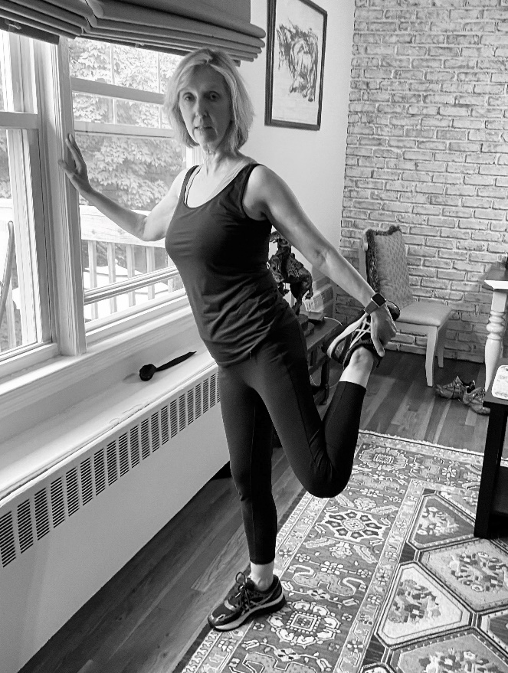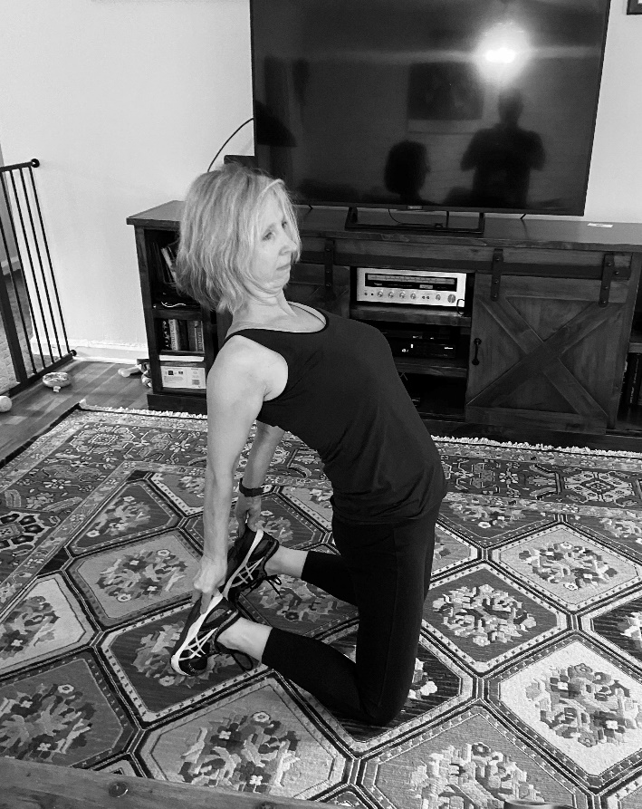**QUAD STRETCH ADVANCED QUAD 1**

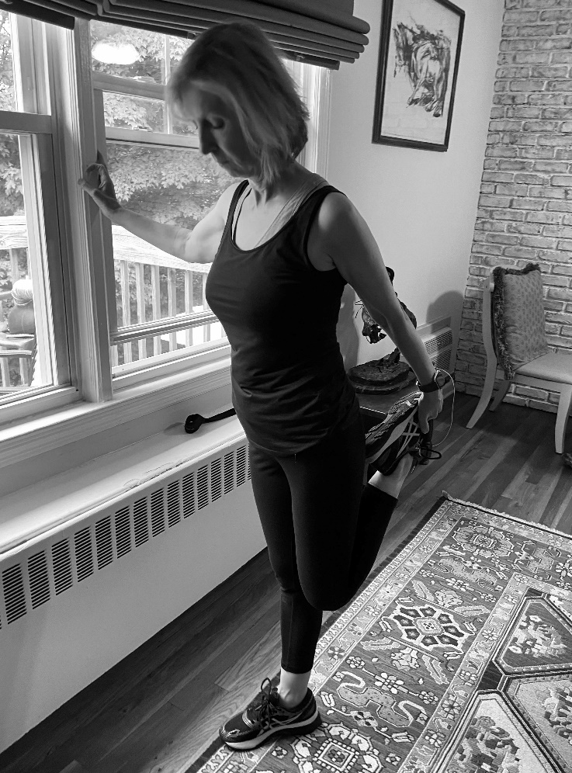**QUAD SHOULDER DOORWAY 3X A DAY**

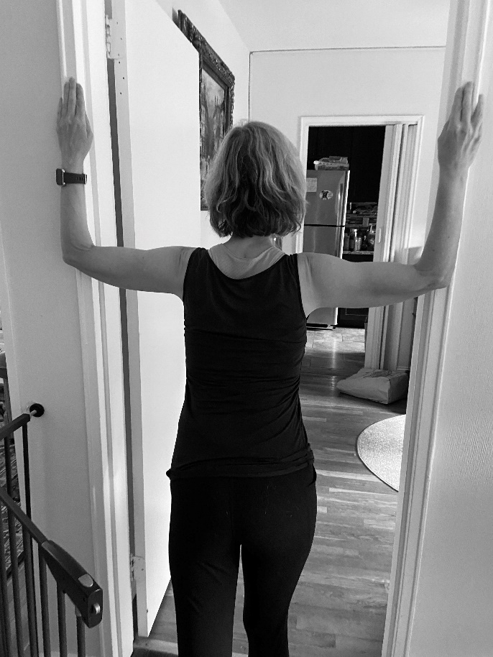

DOORWAY