**DAILY STRETCHES 20 SECOND HOLD 2 SETS ATLEAST ONCE A DAY**

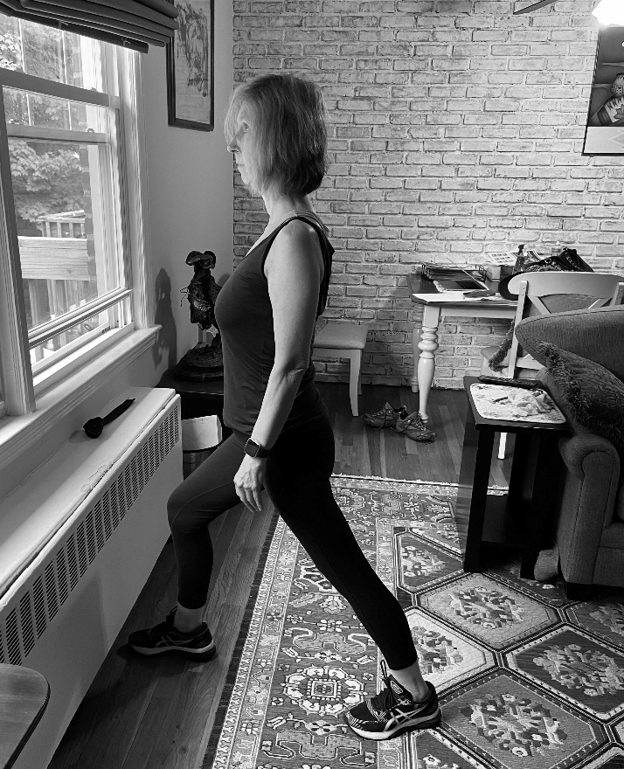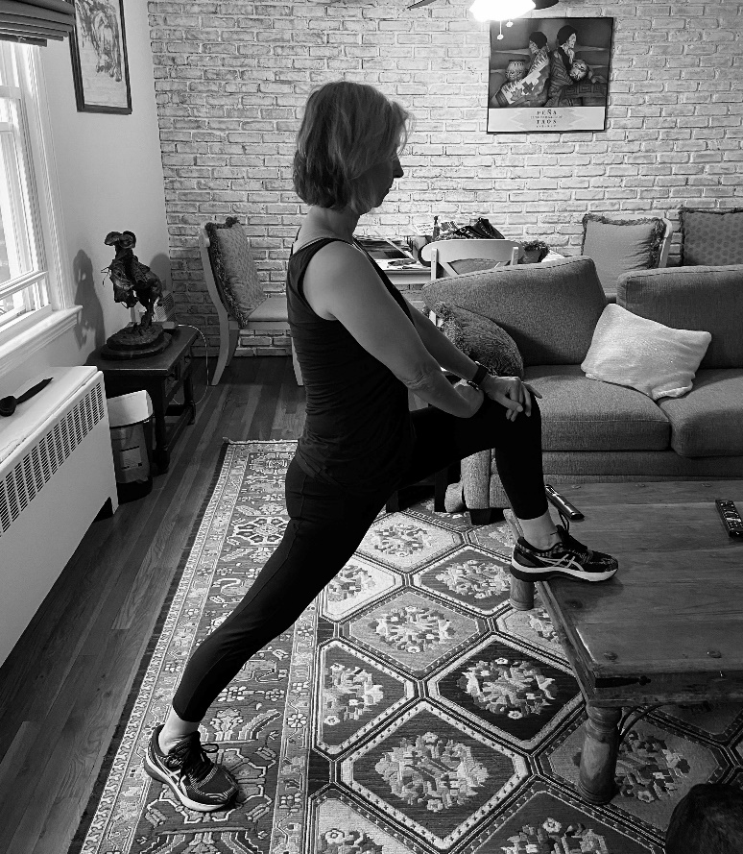**HIP FLEXOR CALF STRETCH**

**QUAD SHOULDER**

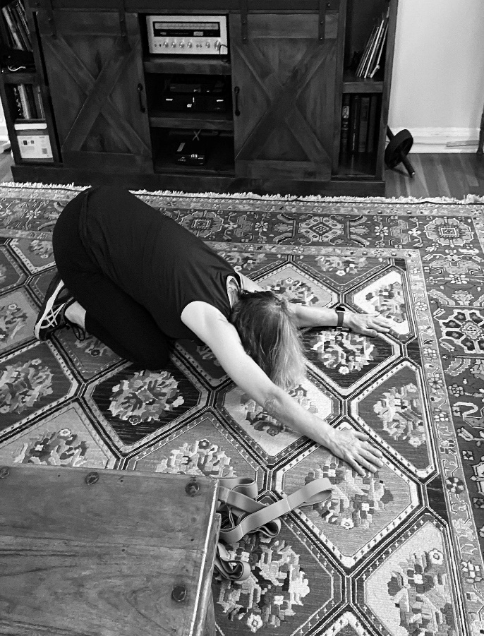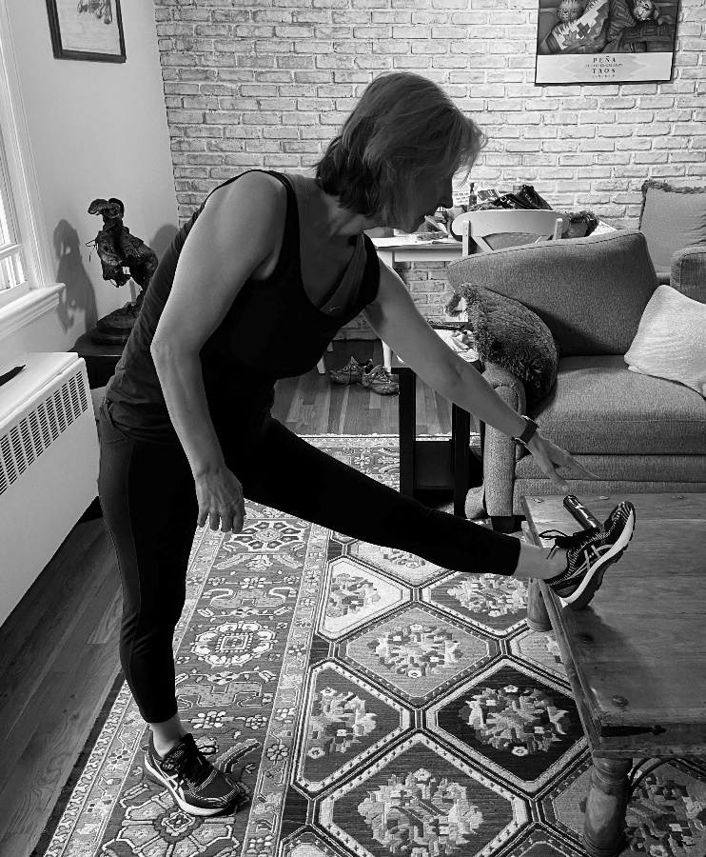

HIP FLEXOR