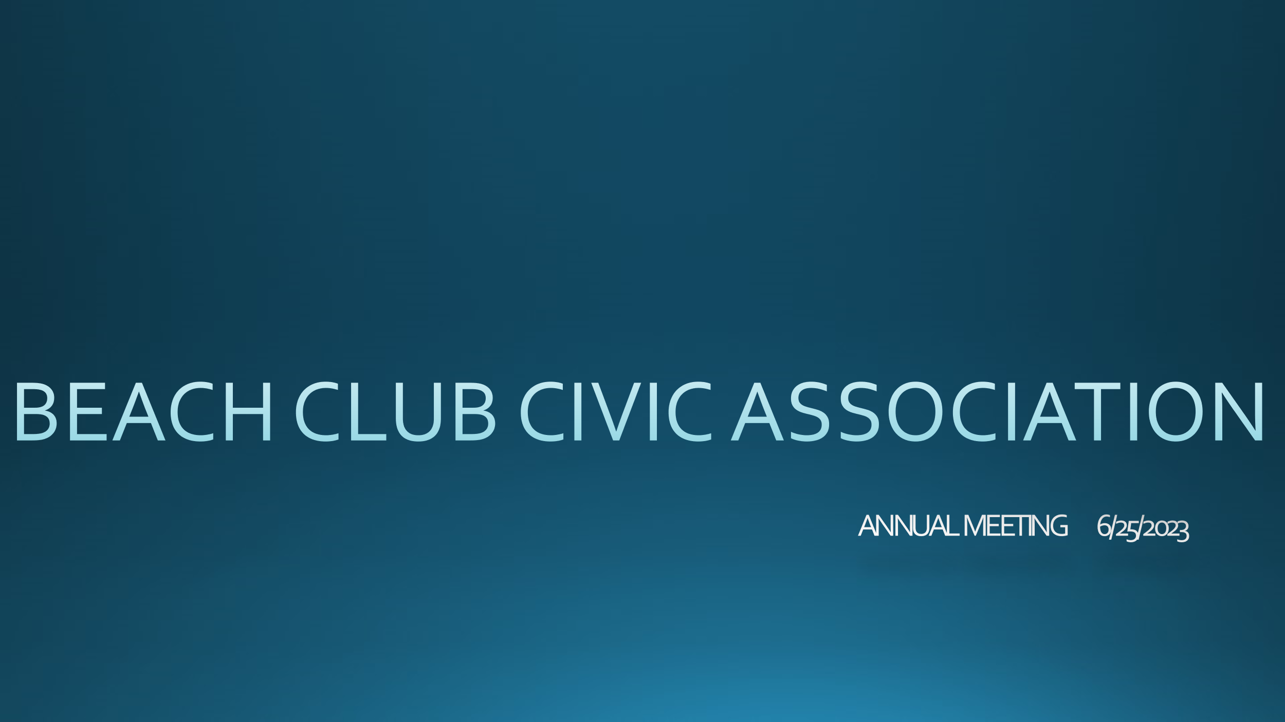

**AGENDA**

**Community Update**

**Oak Lane Stairs**

**Boat Storage**

**Annual Dues**

**Finance Update**

**Communications**

**June 25, 2023**

The annual meeting of the Beach Club Civic Association was called to order on 6/25/2023 at 4 PM by Suzanne Rader Kinkel.

**COMMUNITY UPDATE**

Discussion entailed various community updates and property updates. The Board supports working with people to support them as vacant landlords.

Driving at excess speed of 10 MPH on our roads was discussed as our roads are also our sidewalks and there are children in our area who either live here or are visiting. Caution was advised for all.

The Beach Club Lane deck will be treated and sealed by volunteers s/p the 2023 season. Matt Maccaro noted he has a sprayer to administer the sealant.

Signage around the community was discussed. People are in favor of signage, both around the private roads and at the Oak Lane Stairs. The Board will find a signage specialist and develop appropriate signage for the area.

Discussion entailed discussion with an insurance specialist that having a barbecue located at the Beach Club deck was a liability so there will be no barbecue. People may bring their own but must take it home when finished for the day.

Dues have been paid in full by 47 homeowners as well as boat fees.

Discussion was held around the sluiceway at the end of Beach Club Lane as concern has been raised about the overgrown nature of the weeds in the area and the debris located at the end of the sluiceway. Larry Darcy has been doing this but is now sidelined with medical issues that prevent him shoveling. Pat Clarkin noted that if it is cleaned out every month by him and that it is not an issue. It is felt that the area needs to be designed as “beachy”.

Discussion was had after a question from Fred Lipinski, regarding recognizing the Leaders/Founders of the Beach Club Civic Association. A review will be done and perhaps a plaque will be ordered and placed on the Beach Club deck.

As noted previously, additional keys for the beach will be charged at $25.00 per key.

Discussion was had regarding the road cleanup that occurred last December secondary to hazardous conditions on our roads with leaves. An email will be sent in September regarding the need to keep our properties free of leaves that could present a hazard to walking and driving. If people do not respond, a bid will again go out to have the roads maintained. We will need to clean the sluiceway no matter what conditions the roads present.

Discussion was held after a question from Bill Behrens, regarding voting within the community on various projects through our voting process which is now offered to all homes in the Civic Association and is sealed. After voting, a list of homes who voted and a list of homes who did not vote will be created and posted but there will be NO listing of how homes in our community voted, just that they did or did not vote.

**OAK LANE STAIRS**

Discussion was held around the status of Oak Lane Stairs. There are 3 bids by different vendors for the stairs/trail. The Board has voted to address the stairs only at this time. Permits will need to be obtained. All bids are more than our treasury has in it at present. Based upon our finances at this time, the stairs will not be addressed this year. Signage was discussed and agreed upon for the stair area based upon potential liability.

**BOAT STORAGE**

Discussion was had with the meeting attendees regarding boat storage. In the first survey the Board asked about boats stored in the parking lot area. As noted previously in board minutes, a majority of the survey respondents noted that they did not want boats stored at that location. A minority of the survey respondents responded that they did not mind boats stored at that location, as long as boat fees were paid to the Civic Association and that the boats were secured on trailers and covered. A majority of the respondents who did not mind boats stored at the location also responded that the boats should be moved during the summer season when the boats normally would be placed into the water and parking was needed for beach goers in our community. Therefore, boat storage would be allowed at the location, with the boat fee paid prior to storage, and that the boats could be stored covered and secured on trailers from 10/1-5/15 of each year at the location. As we have passed this season, the boats in the parking lot at present will be able to be stored covered and on trailers until 5/15/2024, at which point they will need to be moved/placed in the water. Boat storage fees will be collected prior to the time frame for storage of the boat.

**ANNUAL DUES**

Discussion was held around the topic of annual dues. Our dues go into paying for our taxes, and various insurances we must have. There are also the “what ifs” - that if they happen the community is responsible for fixing them. Due to the financial shortfalls, we could experience, the dues will be increased to $300.00 annually in 2024. There was no opposition raised to this. Dues will be able to be paid electronically next year to make it easier for all members of our community.

**FINANCE UPDATE**

Frank Gasparo, Treasurer, provided an update on our financials. The financials are now on QuickBooks. There is approximately $24,000.00 in our bank accounts at present. Our Property Taxes are $750.00. Our Liability Insurance is ~ $2,500.00, and our insurance is $704.00. Frank will also provide reports of our assets/liabilities quarterly on the website so that all community members can be aware. Frank is reviewing electronic methods of dues payment.

**COMMUNICATIONS**

Communications are posted to the website. All Board Meeting minutes are posted on the website.

The Board of Directors is committed to having better communication with the community. Please feel free to let us know how you feel we can improve communications.

The meeting was closed by Suzanne Rader Kinkel at 5:10 PM.