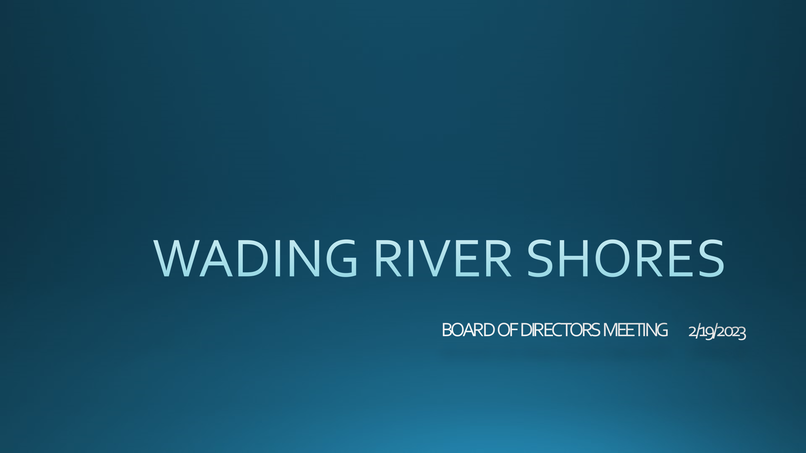

**AGENDA**

**Dues**

All Board Members

**Oak Lane Stairs**

All Board Members

**Demographic Listing Of All Members**

All Board Members

**Town Hall Meeting**

All Board Members

**February 19, 2023**

The meeting of the Beach Club Civic Association was called to order on 2/19/2023 at 6 PM .

**DUES**

The Treasurer has utilized Quickbooks to send multiple invoices to people. Various ways to get checks into the bank account were discussed. Victoria Larson will deposit all checks at a point in the future. Various other methods of payment were discussed to include electronic payment. Flyers will be delivered to mailboxes of people who have not paid.

**OAK LANE STAIRS**

The Board has 2 bids by different vendors for the stairs/trail. The Board has voted to address the stairs only at this time and work on the trail after the stairs are completed and made safe. The Board will get another bid by a new resident of Wading River Shores. The bids will be presented at the Town Hall Meeting

**DEMOGRAPHIC LISTING OF ALL RESIDENTS**

The demographic list of all residents has been updated. If anyone gets information that is sent to an unused email or if demographic information changes, please contact Laura Page-Greifinger at [Laura2PG@msn.com](mailto:Laura2PG@msn.com) with the changes so the listing can be kept up to date.

**TOWN HALL MEETING**

The meeting is scheduled for Sunday, April 16, 2023 at 6 PM via Zoom. All community members will be invited. An invitation will go out shortly with additional reminders before the meeting. Questions will be taken and answered at this meeting.