Visit website stopmarlvirginia.com

*Subscribe for updates check back for news and actions you can take*

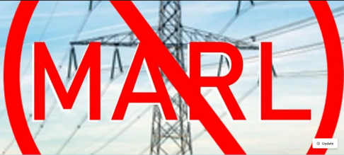

**UNDERGROUND HVDC one solution for BOTH MARL/Gore-Doubs Goose Creek 500kV and Valley Link 765kV**

Is HVDC underground feasible for the MARL/ Gore-Doubs Goose Creek 500kV and valley link transmission 765kV lines?

The short answer is yes!

For the PATH 765kV transmission line Black & Veatch did a study that proved HVDC underground was a feasible solution through our area. Although it was more expensive (at that time)

• The full title of that study was : Black & Veatch, "PJM Interconnection Potomac-Appalachian Transmission Highline (PATH) Project, HVDC Conceptual Study, B&V Project No.164996, B&V File 42.2004 , FINAL November 17, 2009 This was entered into the record as part of the Virginia SCC Case PUE 2009-00043 Application of PATH Allegheny Virginia Transmission Corporation

• Concept 2 was to use HVDC Underground along the Jefferson County, WV through Loudoun County segment of the Mt Storm - Doubs line

• This is the same location PJM has proposed to locate MARL (500kV) and Valley Link (765kV) through Jefferson County, West VA and Loudoun County , VA and into Frederick , MD

• The HVDC with underground Concept 2 (~25 miles underground ) would have cost 2x the overhead HVAC 765kV option ($1, 767M vs $3,595M) The additional $1,828M amounts to an extra $73.12M per mile

• Recent studies by NextGen Highways indicate the price has come down significantly and the installation space is smaller now.

• The Aspen/Golden Underground alternative proposed by Loudoun County to put 3 miles underground would be an additional $480M over the cost of the overhead line. $160M extra per mile!

=> The HVDC underground solution proposed in 2009 costs less per mile that what the county proposed for the Aspen/Golden HVAC underground alternate route

=> Data Center impact fees and taxes can be used fund the additional cost of under grounding Loudoun County must set aside funds for this purpose . At this point many of these companies are worth hundreds of billions to trillions in market caps (Amazon reached a $2 Trillion Stock Value on June 27, 2024 ) . Their executives and boards are paid 100's of billions of dollars . There is more than enough money to cover the cost of using HVDC and undergrounding these lines

**=> FirstEnergy is now responsible for two massive transmission lines targeted through our communities (Valley Link and Gore-Doubs-Goose Creek).** **Its time to re-evaluate and look at ONE single solution - figure out how much power can be reasonable imported from West Virginia and build A SINGLE INCLUSIVE HVDC Underground solution to solve it.**

**=> PJM TEAC Charts on the concept are attached, the full engineering study (B&V Project No.164996, B&V File 42.2004 , FINAL November 17, 2009) was filed during the Virginia SCC Case PUE 2009-00043 Application of PATH Allegheny Virginia Transmission Corporation**

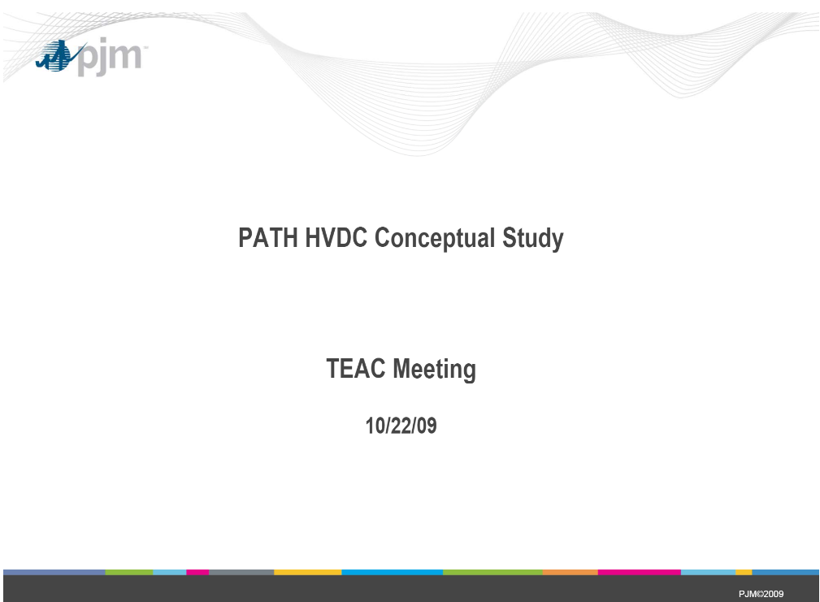

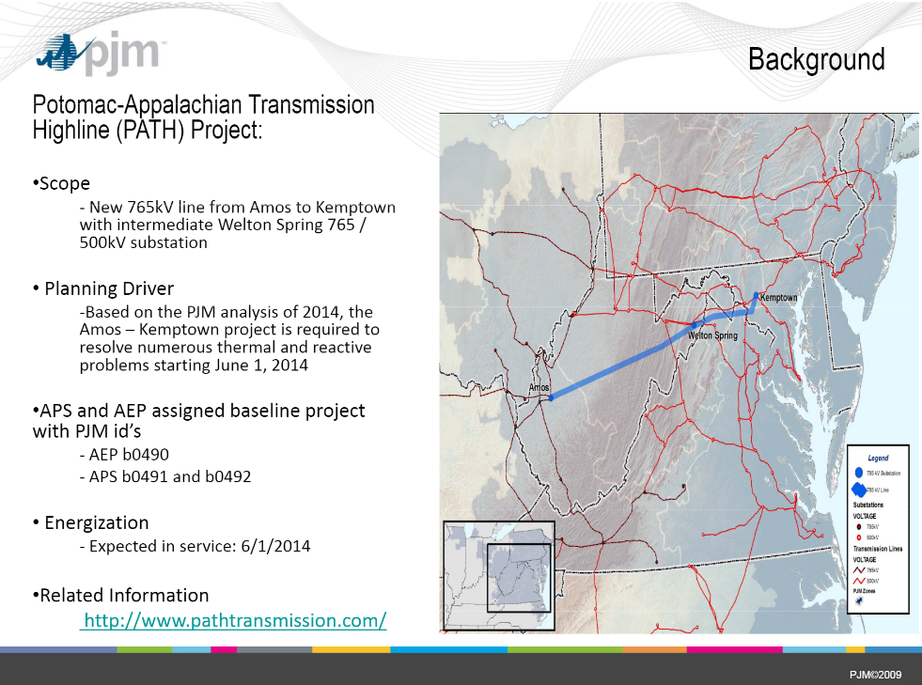

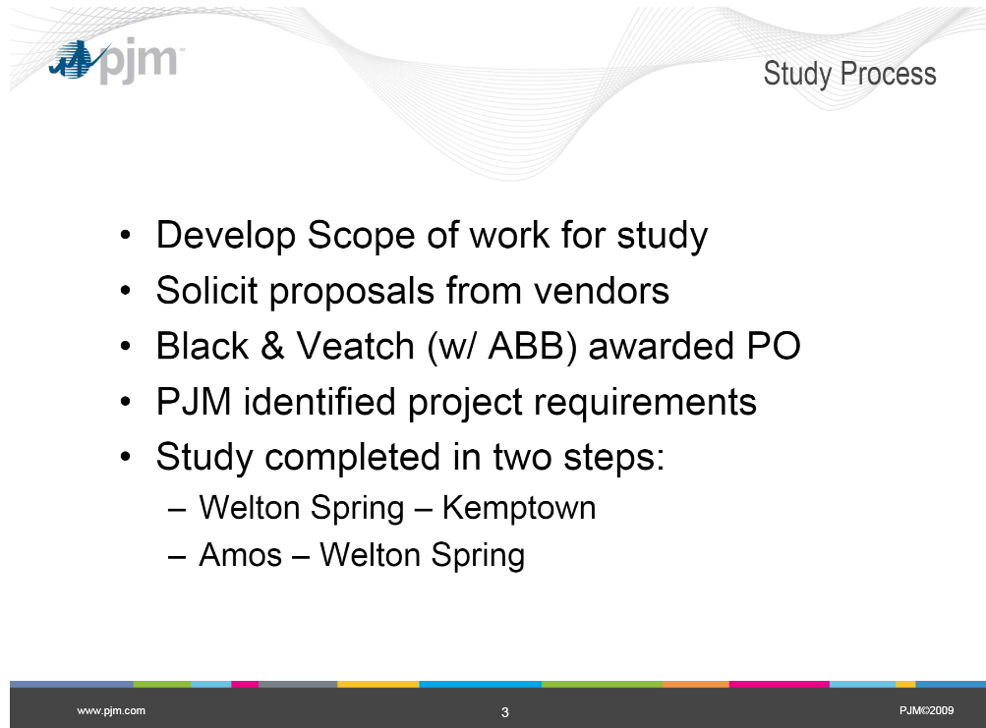

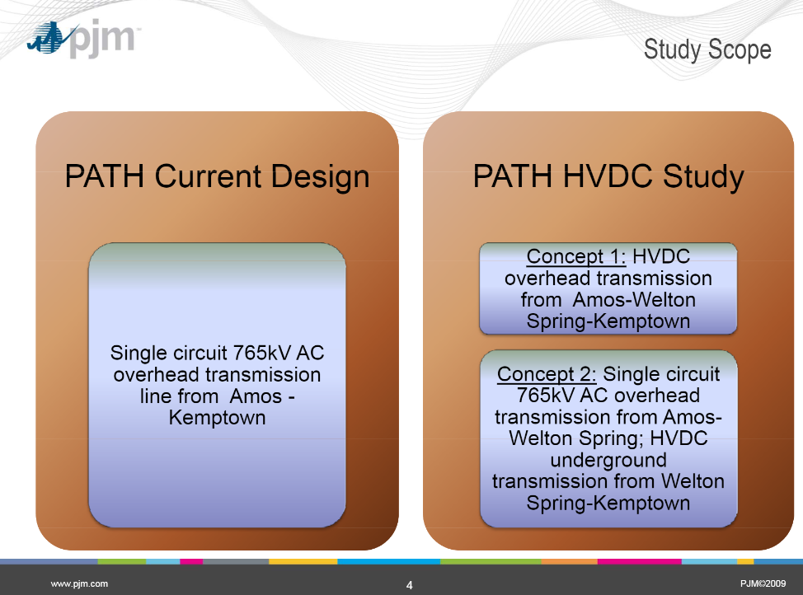

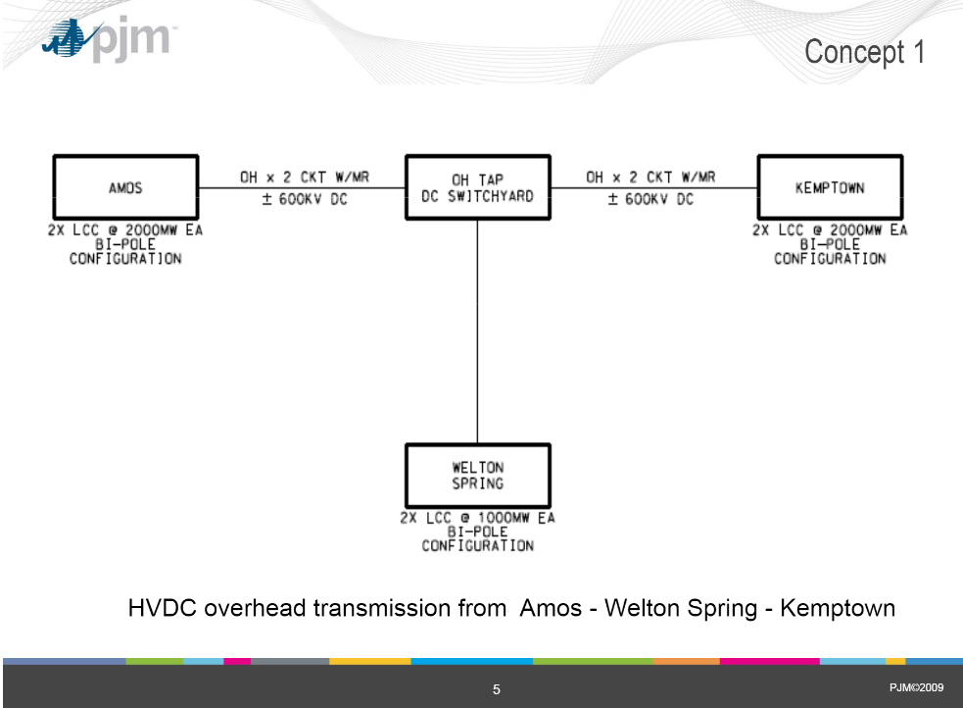

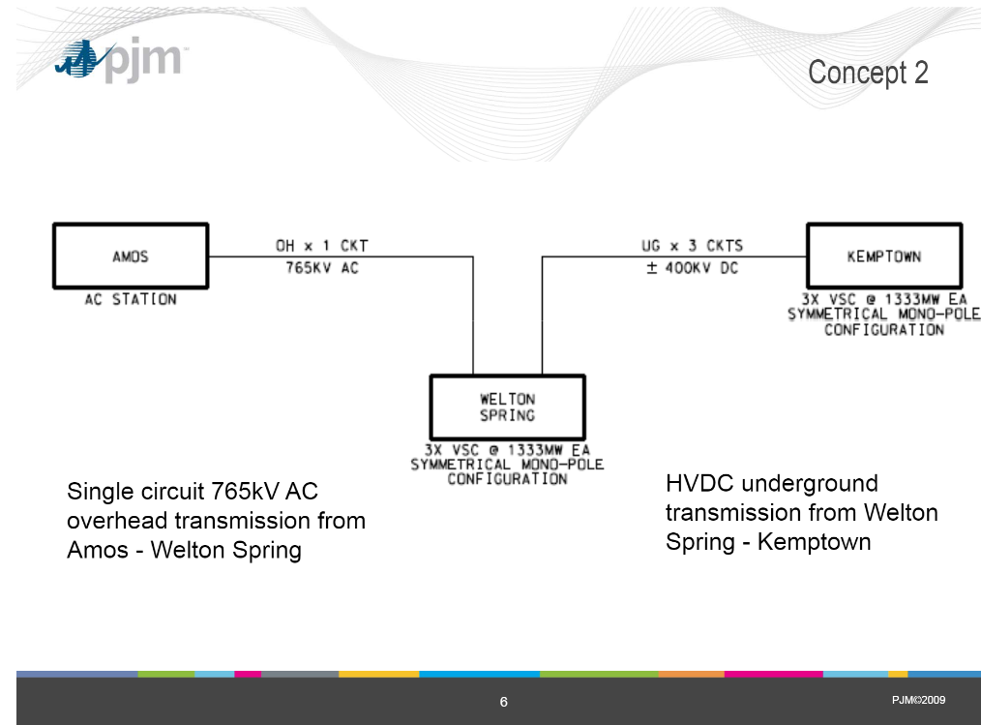

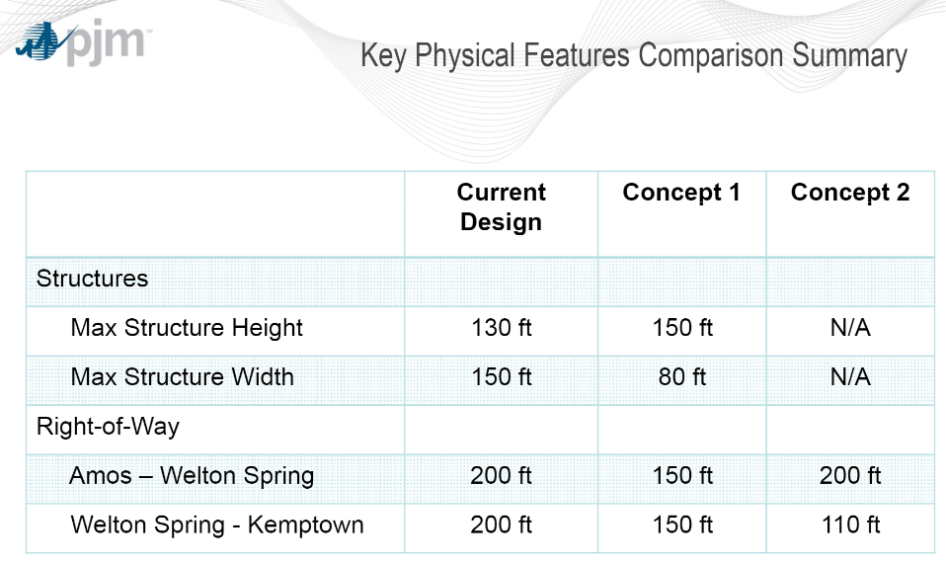

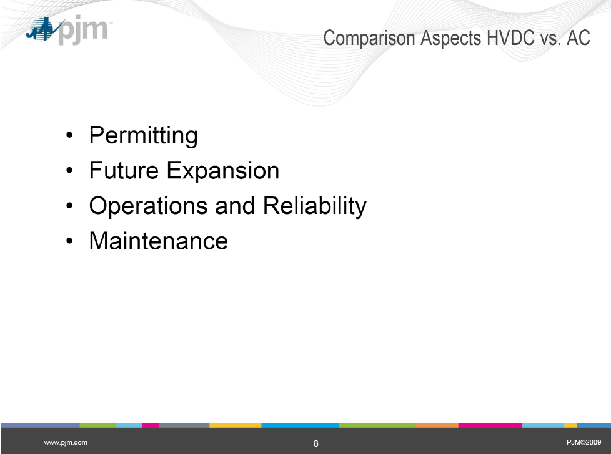

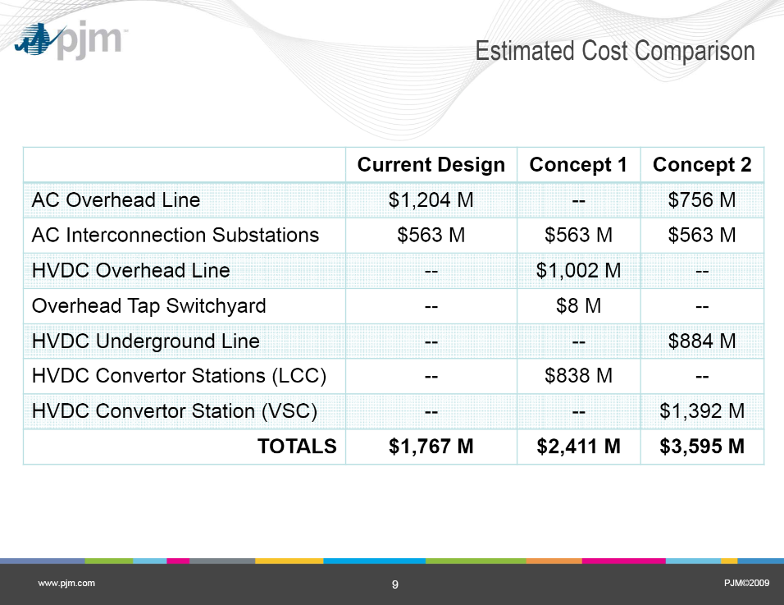

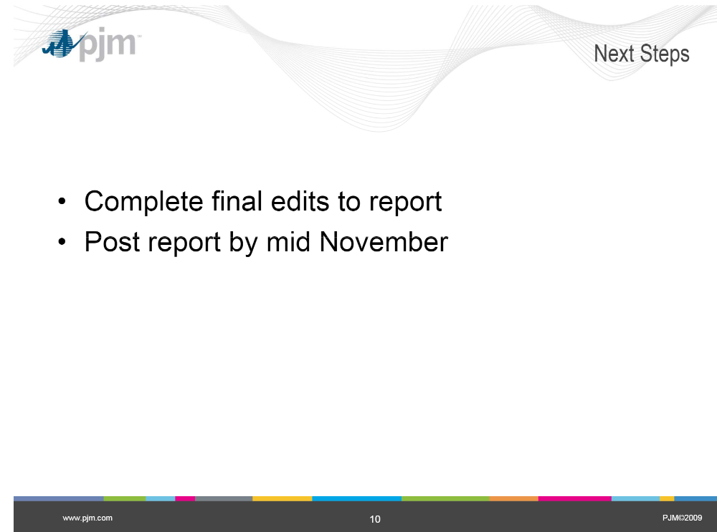

HVDC Transmission Lines & Links:

<https://www.spglobal.com/marketintelligence/en/news-insights/latest-news-headlines/merchant-developers-fill-void-in-us-interregional-grid-build-out-76447354>

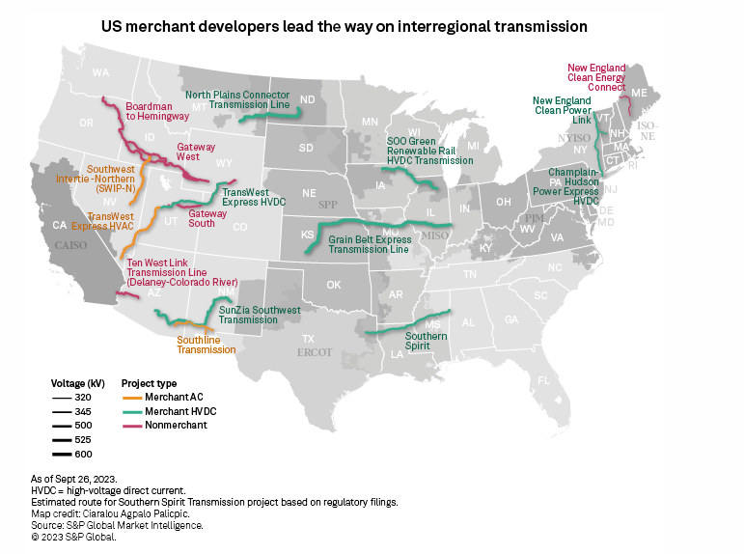

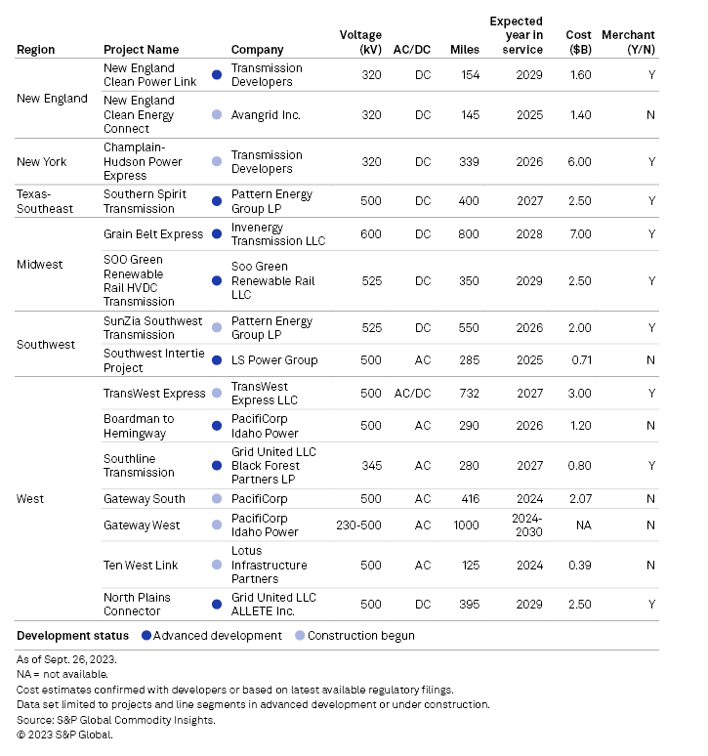

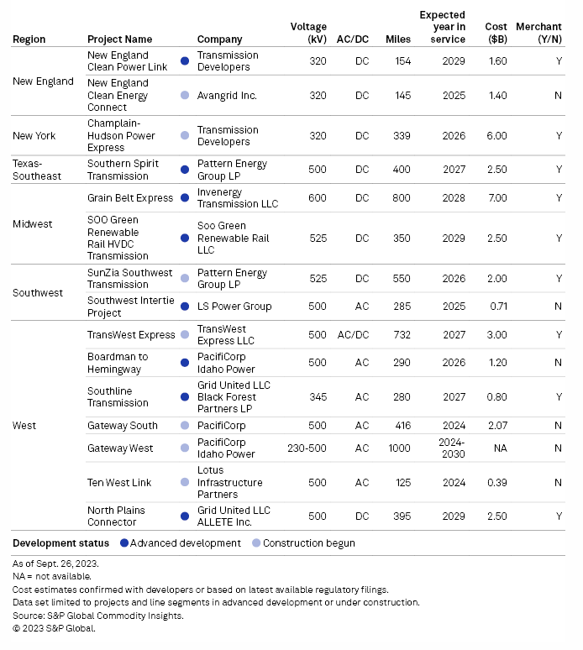

**Unites States:**

1) New York HVDC Underground (September 2023) : **Champlain Hudson Power Express**, “About the Project,” <https://chpexpress.com/project-overview/>

* HVDC
* 400kV (https://chpexpress.com/news/champlain-hudson-power-express-announces-contractor-selection-process-complete/)
* 1250MV of power
* 339 miles with 60% in waterways and 40% buried underground
* $4.5 Billion

Another source: <https://waterfrontalliance.org/2022/04/27/canadian-renewable-energy-transmission-line-is-approved-nyc-residents-cant-wait-for-peaker-plants-to-close/>

2) New York , New Jersey (2013, 2007) : HVDC entirely Underground and undersea.

* **The Hudson Project**: 660MW between NY & PJM **completed 2013** entirely underground and underwater HVDC.

[https://hudsonproject.com/project/](https://hudsonproject.com/project/%20%20)

* + "The Hudson cable is entirely underground and underwater, using high voltage direct current (“HVDC”) technology. The route begins in Ridgefield, New Jersey, the site of the Hudson converter station, where it interconnects with the PJM system at a PSE&G substation. The line follows existing railroad rights-of-way, through an inactive railroad tunnel to the edge of the Hudson River in Edgewater. It is then buried beneath the Hudson for approximately three-and-a-half miles to a landfall point near Pier 92 in Manhattan. The final stretch of cable is routed beneath the West Side Highway and ultimately into the ConEdison W. 49th Street Substation."
* 345kV
  + https://hudsonproject.wpengine.com/wp-content/uploads/2010/09/NYPSC-Press-Release-09.08.10.pdf
* **NeptuneTransmission**: 660MW, 65 mile HVDC underground and undersea cable - New Jersey to Long Island NY, **completed 2007** - ahead of budget and ahead of schedule.
* https://boundlessenergyllc.com/project-development/neptune-regional-transmission-system/

<https://neptunerts.com/>

* + "Neptune Regional Transmission System, LLC (Neptune RTS) developed, permitted, financed, built, and now owns and operates the Neptune Project, a 65 mile undersea and underground high voltage direct current (HVDC) transmission line that extends under water and underground from Sayreville, New Jersey to Nassau County on Long Island.  Neptune provides up to 660 MW of power to Long Island electricity consumers – enough for 600,000 homes — and supplies more than 20 percent of Long Island’s typical electricity demand. Neptune began construction in June 2005 and was completed in June 2007, on budget and ahead of schedule."

3) Vermont (2023) : HVDC Underwater & Underground: **New England Clean Power Link**

<https://electricityforum.com/news/NEW-ENGLAND-CLEAN-POWER->

"The New England Clean Power Link is a proposed 1,000 MW High Voltage direct current (HVdc) underwater and underground transmission cable that will bring clean, low-cost energy from the U.S.-Canadian border to Vermont and the New England marketplace. Once completed, the project will lower costs for consumers, reduce environmental emissions, create jobs, increase tax revenues, and diversify fuel supply in New England, all while respecting Vermont's natural beauty by burying the cable.

4) New Hampshire (2015 -2023 was ultimately rejected ) : **Northern Pass**

<https://www.nhpr.org/environment/2015-09-03/meet-the-cable-that-made-burying-52-miles-of-northern-pass-possible>

"Eversource took the money that it saved by switching to HVDC Light, and plowed it into burying the line through the White Mountain National Forest."

* + 192 Miles
  + 1.6 Billion
  + HVDC at least 52 miles proposed to be underground
  + (I believe this Northern Pass was rejected in June of 2023. The technology is still relevant)

5) New Hampshire (2023) : HVDC Underground & Along existing Easements : **Twin States Clean Energy Link**

<https://www.wbur.org/news/2023/10/31/vermont-new-hampshire-national-grid-twin-states-canada-hydropower>

The Twin States Clean Energy Link project is utilizing roadway burial and existing transmission corridors in Vermont and New Hampshire. Where new corridors are being placed, the project will bury about 75 miles of underground HVDC line.

HVDC

@75 miles underground

(I believe the Twin States Clean Energy Link was withdrawn recently)

6) **SOO Green underground transmission line between MISO, PJM**

<https://soogreen.com/>

"The SOO Green HVDC Link is a first-of-its-kind electricity transmission project that will install state-of-the-art high-voltage direct current (HVDC) transmission cable underground along existing railroad corridors. SOO Green is pioneering an innovative model for developing transmission infrastructure to deliver renewable energy long distances to customers across the Eastern U.S. that virtually eliminates the visual, land and environmental impact of above-ground transmission lines. SOO Green will enable the development of new, low-cost renewable energy resources while enhancing the power grid’s reliability and resilience."

Other sources:

<https://www.utilitydive.com/news/soo-green-transmission-miso-pjm-interregional-big-wires-act-hickenlooper/693916/>

<https://www.utilitydive.com/news/soo-green-pjm-grid-operators-helping-or-hurting-energy-transition/616966/>

7) Minnesota : **The NextGen Highways Feasibility study for the Minnesota Department of Transportation**

In 2022, NextGen Highways did a thorough and in-depth study for the Minnesota Department of Transportation which concluded that burying High Voltage Direct Current transmission lines along existing highway and railway easements is cost competitive.

<https://nextgenhighways.org/resources/ngh-resources/>

<https://nextgenhighways.org/wp-content/uploads/2023/01/NGH_Buried-HVDC-Cost-Competitive.pdf>

<https://nextgenhighways.org/wp-content/uploads/2024/02/NexGen-Highways-Analysis-Report-2.1.24.pdf>

Other sources:

<https://www.utilitydive.com/spons/why-hvdc-cables-are-poised-to-provide-valuable-alternatives/651800/>

<https://www.powermag.com/the-vital-link-how-hvdc-is-modernizing-the-grid/>

8) California 2023 - 2028:

a)**Power By the South Bay Project**: <https://www.lspgridcalifornia.com/newark/>

"The Power the South Bay Project (also known as the Newark – Northern Receiving Station HVDC Project) is a reliability-driven project that will strengthen the electrical grid in the South Bay area by providing a strong, new source to the area. The project will support economic development and provide better access to cost effective, renewable energy to meet the needs of residents and businesses. The project is located in Alameda and Santa Clara Counties, California and is anticipated to enter into service in 2028.

The project includes two new 320 kV high voltage direct current (HVDC) terminals, which provide the ability to control power flows. Each terminal also includes a 230 kV alternating current (AC) gas-insulated switchgear (GIS) switchyard. The Albrea terminal will interconnect to the existing Newark substation via a new 230 kV AC transmission line. The Baylands terminal will be located near the existing Los Esteros substation and will interconnect to the existing Northern Receiving Station via a new approximately four miles 230 kV AC underground and overhead transmission line.  A new approximately eight mile ±320 kV HVDC underground and overhead transmission line will connect the two terminals."

b) **Power Santa Clara Valley Project**: <https://www.lspgridcalifornia.com/metcalf/>

"The Power Santa Clara Valley Project (also known as the Metcalf – San Jose B HVDC Project) is a reliability-driven project that will strengthen the electrical grid in central San José by providing a strong, new source to the area. The project will support economic development and provide better access to cost effective, renewable energy to meet the needs of residents and businesses. The project is located in Santa Clara County, California and is anticipated to enter into service in 2028.

The project includes two new high voltage direct current (HVDC) terminals, which provide the ability to control power flows. The Skyline terminal will include a 115 kV alternating current (AC) gas-insulated switchgear (GIS) switchyard and will interconnect to the existing San Jose B substation. The Grove terminal will include a 500 kV AC GIS switchyard and will interconnect to the existing Metcalf substation via a new approximately one mile 500 kV underground transmission line. A new approximately 13 mile ±320 kV HVDC underground transmission line will connect the two terminals.

Construction is planned to begin in early-2026 after necessary permits, agreements and land rights are received. The construction phase of the project is anticipated to be approximately 2 years in duration, concluding with the energization and testing of the new project facilities."

