Visit website stopmarlvirginia.com

*Subscribe for updates check back for news and actions you can take*

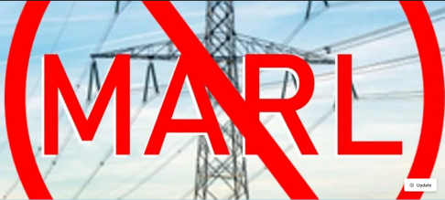

**UNDERGROUND HVDC one solution for BOTH MARL/Gore-Doubs Goose Creek 500kV and Valley Link 765kV**

**Is HVDC underground feasible for the MARL/ Gore-Doubs Goose Creek 500kV and valley link transmission 765kV lines?**

**The short answer is yes!**

For the PATH 765kV transmission line Black & Veatch did a study that proved HVDC underground was a feasible solution through our area. Although it was more expensive (at that time)

• The full title of that study was : Black & Veatch, "PJM Interconnection Potomac-Appalachian Transmission Highline (PATH) Project, HVDC Conceptual Study, B&V Project No.164996, B&V File 42.2004 , FINAL November 17, 2009 This was entered into the record as part of the Virginia SCC Case PUE 2009-00043 Application of PATH Allegheny Virginia Transmission Corporation

• Concept 2 was to use HVDC Underground along the Jefferson County, WV through Loudoun County segment of the Mt Storm - Doubs line

• This is the same location PJM has proposed to locate MARL (500kV) and Valley Link (765kV) through Jefferson County, West VA and Loudoun County , VA and into Frederick , MD

• The HVDC with underground Concept 2 (~25 miles underground ) would have cost 2x the overhead HVAC 765kV option ($1, 767M vs $3,595M) The additional $1,828M amounts to an extra $73.12M per mile

• Recent studies by NextGen Highways indicate the price has come down significantly and the installation space is smaller now.

• The Aspen/Golden Underground alternative proposed by Loudoun County to put 3 miles underground would be an additional $480M over the cost of the overhead line. $160M extra per mile!

=> The HVDC underground solution proposed in 2009 costs less per mile that what the county proposed for the Aspen/Golden HVAC underground alternate route

=> Data Center impact fees and taxes can be used fund the additional cost of under grounding Loudoun County must set aside funds for this purpose . At this point many of these companies are worth hundreds of billions to trillions in market caps (Amazon reached a $2 Trillion Stock Value on June 27, 2024 ) . Their executives and boards are paid 100's of billions of dollars . There is more than enough money to cover the cost of using HVDC and undergrounding these lines

**=> FirstEnergy is now responsible for two massive transmission lines targeted through our communities (Valley Link and Gore-Doubs-Goose Creek).** **Its time to re-evaluate and look at ONE single solution - figure out how much power can be reasonable imported from West Virginia and build A SINGLE INCLUSIVE HVDC Underground solution to solve it.**

**=> PJM TEAC Charts on the concept are attached, the full engineering study (B&V Project No.164996, B&V File 42.2004 , FINAL November 17, 2009) was filed during the Virginia SCC Case PUE 2009-00043 Application of PATH Allegheny Virginia Transmission Corporation**

