!! Protect Your Property Rights !!

TWO Transmission Lines are proposed through Frederick, Clarke and Loudoun Counties in Virginia!

The 500kV Mid-Atlantic Resiliency Link / Gore-Doubs-Goose Creek transmission line and a new 765kV transmission line called Valley Link North!

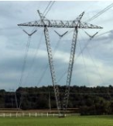

Both lines are huge extension cords to West Virginia's aging coal generation plants to serve the new and expanding data centers in Loudoun County's Data Center Alley.

These lines do not benefit any of the communities they pass through, or the general public.

Property Owner Concerns

- Use of eminent domain by a private-for-profit corporation
- Loss / restrictions on the use of property taken for an easement
- Loss or devaluation of Private Property
- Generational destruction of the value of rural private property
- Personal sacrifice for corporate gain
- Diminished Quality of Life
- Increased risks from electromagnetic field produced by TWO 500kV plus a 765kV transmission line
- Contamination of groundwater
- Damage to Land/Livestock/Crops
- Environmental consequences due to tree clearing and pesticide use
- Destruction of scenic viewsheds
- Increased electric rates

Virginia provides limitations on the use of eminent domain: section § 1-219.1. Section D: " ... property can only be taken where: (a) the public interest dominates the private gain and (b) the primary purpose is not private financial gain, private benefit, an increase in tax base or tax revenues, an increase in employment, or economic development."

If your property is impacted, protect your property rights! Get involved!

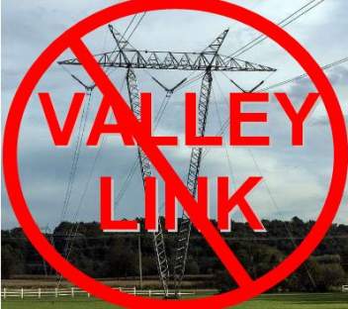
Valley Link 765kV
This is a 261 mile, 765kV line from the John Amos power station in Putnam County, West Virginia a 765kV substation in Hardy County West Virginia through to a new 765kV substation south of the existing Doubs substation in Frederick, Maryland. In Virginia Frederick, Clarke and Loudoun counties are affected! As proposed, the 765kV line would be strung on V-structures with guyed-wires. This is the biggest, most land use restrictive HVAC structure and line available! It will require an all new 200'cleared right of way
Open Houses
from 4:00pm - 7:30pm
- June 29, 1500 Volunteer Dr, Brunswick Firehall, Brunswick MD
- June 29, James Wood High School, 161 Apple Pie Ridge Road, Winchester, VA
- June 30, Lovettsville Game Club, 16 South Berlin Pike, Lovettsville, VA
- June 30, Shepherd University Storer Ballroom (student center), 210 North King St, Shepherdstown, WVA
- July 7, Clarke County Fairgrounds Ruritan Building, 890 West Main St, Berryville, VA
OVER =>
Underground HVDC

Underground High-Voltage Direct Current is an alternative to overhead HVAC powerlines

- For the PATH 765kV transmission line a Black & Veatch study that proved HVDC underground was a feasible from the Woodside station through Frederick, Clarke and Loudoun Counties in Virginia and through Jefferson County, West Virginia to the Potomac River It was part of the Virginia SCC Case PUE 2009-00043

- In January of 2026 PJM approved a Dominion proposal to build a 185 mile all underground HVDC transmission line from the Heritage substation in Southern VA to the Mosby substation in Northern VA. This line is proposed to be buried in existing easements in an eight by 10-foot trench!

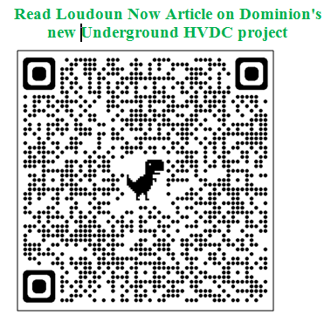

- Recent studies by NextGen Highways indicate the price has come down significantly and the space needed to install it is also smaller.

Underground HVDC can be installed along highway or railway easements as well as along existing utility easements.

For more information on Underground HVDC see stopmarlvirginia.com



- The Data Center's should be paying the cost difference between overhead and underground transmission lines. Many of these companies are worth hundreds of billions to trillions in market caps (Amazon hit $2 Trillion stock value on June 27, 2024). Their executives and boards are paid 100's of billions of dollars . There is more than enough money to cover the cost of using HVDC and undergrounding all of these lines.





OVER =>

