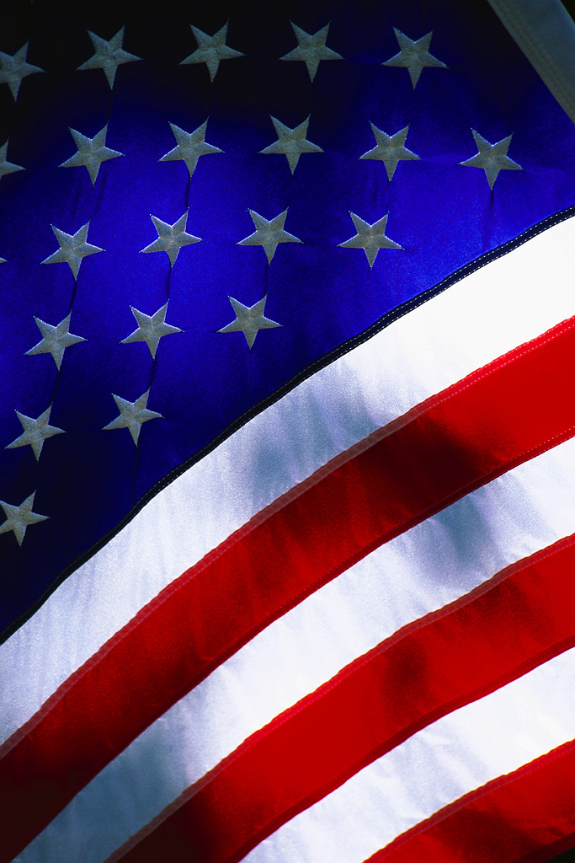
Sponsored by the

American Legion Auxiliary

ALA 156 Mother’s Day Craft & Bake Sale

May 12th – Saturday 10-4 PM

Leonard H. Hawkins Post 156

550 City Island Avenue, Bronx, NY

Bake Sale & Children’s Activities, Face painting.

Joanne Valletta

646 321 8902 for further information.

