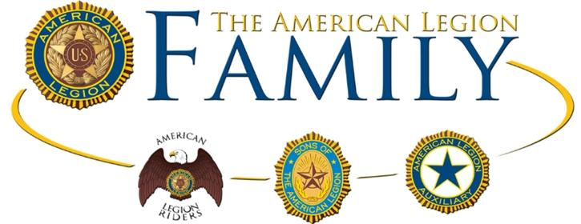

**American Legion Juniors Program**

**Boys and Girls Grades K-8**

*Come this Saturday to learn more about us!! We will be doing a poster contest with all the kids!! All are welcome to the following events:*

March 10th  Poppy Poster Contest (Noon-2)

April 22nd Purple Heart Day (11am-Noon)

Beekeeping Presentation (Noon-1)

May 19th Craft Fair, Bake Sale, Face Painting, Kids Crafts!

May 28th Memorial Day Parade

Location: Post 156 @ 550 City Island Ave Bronx, NY 10464

*Please contact Meaghan Clancy(914-819-8917) or Jane Gelsi (*[*janeggg@verizon.net*](mailto:janeggg@verizon.net)*) with any questions*