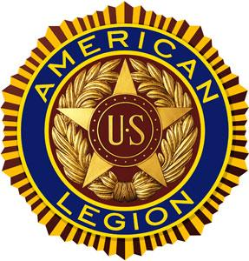**Leonard H. Hawkins Post 156**

**550 City Island Avenue, City Island NY 10464**

**Phone: 718-885-0639**

**MEETINGS FIRST SUNDAY OF THE MONTH**

“To have always in our hearts those we love and cherish”

We proudly celebrate Juneteenth, the day slavery finally came to an end throughout the South — historically a monumental feat for American History and now a Federal Holiday.

On June 19, 1865 Major General Gordon Granger arrived with Union soldiers in Galveston, Texas and announced, “The people of Texas are informed that, in accordance with a Proclamation from the Executive of the United States, all slaves are free.” This was more than two years after President Abraham Lincoln issued the Emancipation Proclamation abolishing slavery at the end of the Civil War.

Juneteenth is known as Emancipation Day, or Juneteenth Independence Day. The holiday has been celebrated in Galveston and across the country since 1866 with food, festivals, and song.

We hope that you use this day to honor those who've helped to build this country, reflect on the history of our freedom, and celebrate how far we have come.

Happy Juneteenth Weekend from all of us at the American Legion Family, Leonard H. Hawkins Post 156.