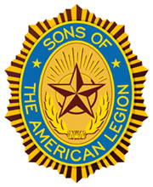

Commander Thomas Vivolo
1st Vice Membership Fred Ramphl
2nd Vice Americanism Peter Chadwick
3rd Vice Activities James Livingston
Adjutant Steven Ragan
Historian Gene Valesio
Treasurer Walter Natiw
Sergeant at Arms Joe Scotti
Chaplain Victor Anderson

Advisor Michael Jawski

Past Detachment Of New York Commander
William "Bill" Clancy

