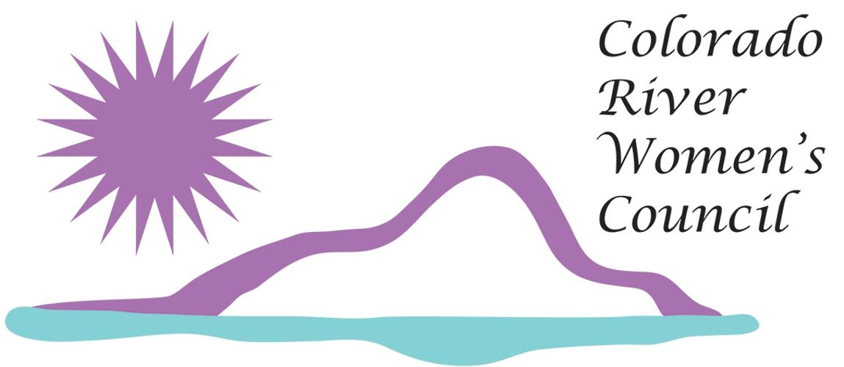

Corporate Partnership Opportunities

About Colorado River Women’s Council (CRWC)

**Our Mission**

The Colorado River Women's Council (CRWC) will provide a community leadership role through business, education, networking and service.

**Our Purpose and Objectives**

* To promote and support the business community
* To develop participation and opportunities for women in our community
* To promote civic and community projects
* To promote youth involvement and recognition
* To provide a forum for education, leadership, networking and communication in our community

The CRWC also contributes to the Boys and Girls Club, Shop with a Cop, Local Schools and Teachers, Quilts of Comfort, Milemarkers, Bullhead City Saint, CASA Council, Gary Keith Park, River Fund, McKinney-Vento Homeless Act, Kiwanis, Rotary, Historic Society, Colorado River Concert Association and other worthwhile causes.

**Membership**

Membership is open to anyone in the community over the age of eighteen. Our meetings are held on the second Thursday of each month. Meetings usually feature a guest speaker(s) addressing our current topics or relevant issues. We love our community, so feel free to attend one of our many events.

**Contact Information**

Web-Site - [**https://coloradoriverwomenscouncil.info/**](https://coloradoriverwomenscouncil.info/)**sponsorship**

Facebook – Colorado River Women’s Council

Mailing Address - P.O. Box 22114 Bullhead City, AZ 86439

Phone Number – 928-583-2397 (President – Jennifer Ronan)

The CRWC is a 501(c) 3 nonprofit organization. Your donation should be tax deductible under section 170 of The Tax Code. Tax ID # 20-2191245.

**What is CRWC – Corporate Partnership Opportunities?**

Corporate Partnership Opportunities (CPO). The program started with the idea of how can we give back to the businesses that give to us? We began to “***Think Bigger***”. How can we help get the word out about who helps support our community? What can a non-profit give to a business? We already encourage our members to “Shop Local and Support Local”. Then like a light bulb coming to life with bright light, it hit us, a joint partnership. Let’s partner up with our businesses and support them like they support us. ***Advertisement***! We have over 100 members, 12 luncheons, a 9-month leadership program, 3 signature events that include Boom Box Parade, Western Auction, Women Helping Women, and 4 annual programs of P.O.K.E., G.A.T.E., Scholarships, McKinney Vento Christmas Party and so much more. It is at all of these widely recognized and highly attended events that our sponsors will see how proudly we are to advertise for them with their company logos.

So, in conclusion, why should your business be a Corporate Sponsor?

1. You may get a tax deduction by giving to us. We are a 501C3.
2. Your business will receive advertising benefits for a year.
3. Pride in knowing you are giving back to our community.

**{Annual Events}**

**Signature Events**

**Boom Box Parade Event**:

The Spirit of Giving parade is held the first Friday of December. The parade route is along Hancock from River Gardens to Trane. It benefits the entire community and provides an opportunity for everyone to come together and focus on "giving", while celebrating the wonders of the season.

**Women Helping Women Event:**

This event was established to help women prepare for a new beginning in their life after falling victim to domestic violence or similar tragedy. Volunteers provide a day of pampering and self-esteem building for female residents of the local safe houses. Guest speakers encourage and motivate participants to give them hope for their futures. The women receive clothing, makeovers, help in writing a resume, and interviewing tips- all in preparation to assist them in re-entering the work force. This successful program has nurtured positive results in many hopeless women's lives. Women Helping Women program also supports the need many needs in the community all year long.

**Western Auction Event:**

This event is our largest and most important fundraiser of the year, that is held each year. The Western Auction is a fun filled, western themed event that auctions donated items to raise money that funds our projects throughout the year.

**Monthly Meeting Luncheon Event:**

Our meetings are held on the second Thursday of each month. The purpose of the monthly meetings is to communicate information and to vote on issues brought to members by the Board of Directors. Membership input shall be allowed as a designated agenda item. Meetings usually feature a guest speaker(s) addressing our current topics or relevant issues. Members must RSVP in advance to attend the meetings. Lunch is $15.00* including three tickets to the 50/50 raffle. *Cancellations must be made 48 hours prior to a meeting to avoid the $15 fee.

**{Annual Programs}**

**Signature Programs**

**Leadership Program:**

The mission of the Leadership Program is to promote community leadership by developing knowledgeable, skilled leaders who are committed to building bridges of understanding across diverse segments of our community. The nine-month program consists of an integrated series of sessions, designed to build leadership skills and awareness of issues affecting our community. Participants learn how the Colorado River community governments and agencies operate, who makes them work and why. The program offers many perspectives on issues of critical concern. The process takes place through a series of panel discussions, group discussions, tours, and dialog among class members with area leaders. Together, the class votes on and completes a class project benefitting the community. This program is open to anyone over eighteen and applications are available by contacting Colorado River Women’s Council.

**Protect Our Kids Environment - P.O.K.E Program:**

The CRWC is committed to the safety of school-age children enrolled in schools within the Tri-State area of the Colorado River. Our mission is to assist school districts in improving and funding established safety protocols with supplies and/or equipment to increase safety in schools and to enable the schools to be better prepared for any disaster, natural or otherwise. Together, we can make a difference in the safety standard.

**Scholarship Program:**

Scholarships are available for youth and adults to aid in continuing their education. The CRWC gives out a minimum, of $5,000 each school year, provided funds are available.

**Grant Assistance for Teachers and Educators – G.A.T.E Program:**

As a teacher have you wanted something for your classroom you couldn't afford? Have you wanted to complete a project with your classroom butdidn't have the materials? How creative can you become with a new project for your students? One of our newer programs, G.A.T.E., was developed to provide much needed materials for local classrooms. By continuing to enhance our children's educational experience and provide them with the opportunities that a better education offers. Last year G.A.T.E. awarded two (2) $500 grants and ten (10) $350 grants to deserving pre-K to 12th grade teachers.  These grants were used to purchase materials, equipment, and supplies for special projects.

**{Annual Events Sponsorships Available}**

**All Signature Event Title Sponsorship**

**Cost of $2,500 (4 total available)**

**Boom Box Parade (2 available):**

* Your business would be the title event sponsorship of one of our signature events Boom Box Parade
* Signature Event Banner displayed at all CRWC luncheon meetings, leadership classes and any other sponsored events by CRWC - Value - $1,200

WHO WILL BE THE SPONSORS FOR THIS YEARS BOOMBOX PARADE?

* Placement on CRWC web-site for full year – Value - $500
* One Participants eligible for Leadership Program - Value- $250
* Personalized sponsorship plaque for your business – Value - Priceless
* Boom Box Parade - Value - $1,000 – (One of two title sponsor)
  + Marketing Exposure to include: logo on flyers, posters and printed media by CRWC
  + Sponsor name mentioned on all PSA, TV, Newspaper, Radio, Facebook, CRWC website and Promotional events
  + VIP Placement and entry in parade with live TV Coverage with sponsorship mentioned
  + Two VIP’s seating tickets for the parade
* Western Auction – Value - $725
  + ½ page ad in Auction guide program
  + PowerPoint Presentation during event
  + Table at event for eight (8) with dinner included, with table topper logo & drawing tickets

**Western Auction (2 available)**

* Your business would be the title signature event sponsorship for Western Auction.
* Signature Event Banner displayed at all CRWC luncheon meetings, leadership classes and any other sponsored events by CRWC - Value - $1,200
* Placement on CRWC web-site for full year – Value - $500
* One Participants eligible for Leadership Program - Value - $250

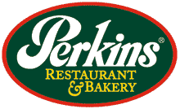 **& Bressman Construction**

* Personalized sponsorship plaque for your business – Value - Priceless
* Western Auction – Value - $1,000 – (One of two title sponsor)
  + Marketing Exposure to include: logo on flyers, posters and printed media by CRWC
  + Sponsor name mentioned on all PSA, TV, Newspaper, Radio, Facebook, CRWC website and Promotional event
  + Full page ad in Auction guide program
  + PowerPoint Presentation during event
  + VIP Table at event for eight (8) with dinner included, with table topper logo & drawing tickets
* Boom Box Parade - Value - $100
  + Placement in parade with live TV Coverage, Sponsorship mentioned
  + Two VIP’s seating tickets for the parade

**Women Helping Women ($3,000)Limited to 1**

* Your business would be the title event sponsorship of one of our signature events, Women Helping Women
* Signature Event Banner displayed at all CRWC luncheon meetings, leadership classes and any other sponsored events by CRWC - Value - $1,200



* Placement on CRWC web-site for full year – Value - $500
* One Participants eligible for Leadership Program - Value- $250
* Personalized sponsorship plaque for your business – Value - Priceless
* Boom Box Parade - Value - $1,000 – (One of two title sponsor)
  + Marketing Exposure to include: logo on flyers, posters and printed media by CRWC
  + Sponsor name mentioned on all PSA, TV, Newspaper, Radio, Facebook, CRWC website and Promotional events
  + VIP Placement and entry in parade with live TV Coverage with sponsorship mentioned
  + Two VIP’s seating tickets for the parade
* Western Auction – Value - $725
  + ½ page ad in Auction guide program
  + PowerPoint Presentation during event
  + Table at event for eight (8) with dinner included, with table topper logo & drawing tickets

**Partnership Event Sponsorship**

**Cost of- $1,000**

* Partnership Event Banner displayed at all CRWC luncheon meetings, leadership classes and any other sponsored events by CRWC - Value - $1,200
* Two Facebook page advertising your business with email blast sent to all of CRWC membership
* Placement on CRWC web-site for full year – Value- $500



* Personalized sponsorship plaque for your business – Value – Priceless

**WE LOVE OUR COMMUNITY AND THANK THEM FOR ALL THEIR SUPPORT YEAR AFTER YEAR!!**



**Exclusive Monthly Meeting Luncheon Event Sponsorship**

**Cost of- $600 – Limited to Eight (8)**

* One monthly luncheon supplied in your business name – Value - $600
* Table Toppers with your company logo at each luncheon – Value $300
* Opportunity to supply giveaways by your business during one luncheon – Value – Priceless
* During one luncheon you will be able to give a 15-minute presentation of your business (Only one available per business per year) - Value -Priceless

WHO WILL BE OUR AMAZING SPONSORS?

**{Annual Program Sponsorships Available}**

**Leadership Program:** 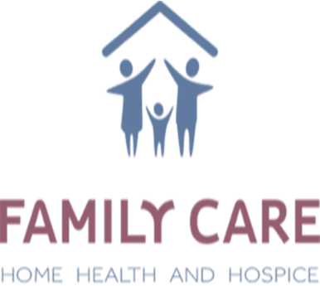

**Exclusive Leadership Luncheon Program Sponsorship**

**Cost of- $3,000 – Limited to one (1)** 

* Exclusive Program Banner displayed at all CRWC luncheon meetings, leadership classes and any other sponsored events by CRWC - Value - $1,200
* Placement on CRWC web-site for full year – Value - $500
* Lunch supplied in your business name – Value - $300 x 11 Events = Value - $3,300
* Name tag for each participant with your company logo – Value $300
* Personalized sponsorship plaque for your business – Value - Priceless
* Opportunity to supply giveaways by your business during one luncheon – Value priceless
* During one luncheon you will be able to give a 10-minute presentation of your business - Value priceless

**Protect Our Kids Environment - P.O.K.E Program:**

**Exclusive P.O.K.E Program Sponsorship**

**Cost of- $3,000 – Limited to one (1)**

* Exclusive Program Banner displayed at all CRWC luncheon meetings, leadership classes and any other sponsored events by CRWC - Value - $1,200
* Sponsor name mentioned on all PSA, TV, Newspaper, Radio, Facebook, CRWC website and Promotional events for the POKE Program
* Placement on CRWC web-site for full year – Value - $500
* During one luncheon you will be able to give a 10-minute Two Facebook page advertising your business with email blast sent to all of CRWC membership
* Event media press release of exclusive sponsorship

KEEPING OUR KIDS SAFE IS PRICELESS

* Personalized sponsorship plaque for your business – Value - Priceless
* Western Auction – Value - $725
  + ½ page ad in Auction guide program
  + PowerPoint Presentation during event
  + Table at event for eight (8) with dinner included, with table topper logo & drawing tickets
* Boom Box Parade - Value - $750
  + Logo and Name on Parade Gold Sponsor Banner
  + Placement in parade with live TV Coverage, Sponsorship mentioned

**Scholarship Program:**

**Exclusive Scholarship Program Sponsorship**

**Cost of- $3,000 – Limited to one (1)**

* Exclusive Program Banner displayed at all CRWC luncheon meetings, leadership classes and any other sponsored events by CRWC - Value - $1,200 S
* Sponsor name mentioned on all PSA, TV, Newspaper, Radio, Facebook, CRWC website and Promotional events for the Scholarship Program
* Placement on CRWC web-site for full year - $500
* During one luncheon you will be able to give a 10-minute presentation of your business - Value priceless
* Two Facebook page advertising your business with email blast sent to all of CRWC membership
* Personalized sponsorship plaque for your business – Value - Priceless
* Event media press release of exclusive sponsorship

BUILDING ON EDUCATION FOR THE NEXT GENERATION

* Western Auction – Value - $725
  + ½ page ad in Auction guide program
  + PowerPoint Presentation during event
  + Table at event for eight (8) with dinner included, with table topper logo & drawing tickets
* Boom Box Parade - Value - $750
  + Logo and Name on Parade Gold Sponsor Banner
  + Placement in parade with live TV Coverage, Sponsorship mentioned

**Grant Assistance for Teachers and Educators – G.A.T.E Program:**

**Exclusive G.A.T.E Program Sponsorship**

**Cost of- $3,000 – Limited to one (1)**

* Exclusive Program Banner displayed at all CRWC luncheon meetings, leadership

classes and any other sponsored events by CRWC - Value – $1,200

* Sponsor name mentioned on all PSA, TV, Newspaper, Radio, Facebook, CRWC

website and Promotional events for the GATE Program

* Placement on CRWC web-site for full year - $500

HELPING THOSE WHO HELP OUR CHILDREN

* During one luncheon you will be able to give a 10-minute presentation of your

business - Value priceless

* Two Facebook page advertising your business with email blast sent to all of CRWC membership
* Event media press release of exclusive sponsorship
* Personalized sponsorship plaque for your business – Value - Priceless
* Western Auction – Value - $725
  + ½ page ad in Auction guide program
  + PowerPoint Presentation during event
  + Table at event for eight (8) with dinner included, with table topper logo & drawing tickets
* Boom Box Parade - Value - $750
  + Logo and Name on Parade Gold Sponsor Banner
  + Placement in parade with live TV Coverage, Sponsorship mentioned

As the Chairwoman for this program, I will be your personal contact for any questions you may have throughout the year. Below is my contact information.

Again, everyone with CRWC wants to **thank you for your consideration**; we look forward to an AMAZING 2022-2023 year together with your support!

Together We Achieve Miracles!

Jennifer Ronan

928-583-2397

2021 – 2023 President / Chairwomen Corporate Partnership

Colorado River Women’s Council

[jennifer.ronan@cit.com](mailto:jennifer.ronan@cit.com)

[president@coloradoriverwomenscouncil.info](mailto:president@coloradoriverwomenscouncil.info)

**Additional Contact Information**

Web-Site - [**https://coloradoriverwomenscouncil.info/**](https://coloradoriverwomenscouncil.info/)**sponsorship**

Facebook – Colorado River Women’s Council

Mailing Address - P.O. Box 22114 Bullhead City, AZ 86439

Phone Number - 928-5832397

Sponsorship Details 

Selected Event/Program Name:

__________________________________________________________________________________________

Company Name:

__________________________________________________________________________________________

Mailing Address:

__________________________________________________________________________________________

Contact Name:

__________________________________________________________________________________________

Phone:

__________________________________________________________________________________________

Email:

__________________________________________________________________________________________

Make checks payable to:

Colorado River Women’s Council (CRWC)

P O Box 22114

Bullhead City, AZ 86439

Please email company logo to: [jennifer.ronan@cit.com](mailto:jennifer.ronan@cit.com) **or** president@coloradoriverwomenscouncil.info

Your contributions will be for one (1) year fiscal year. The Fiscal year of the CRWC is July 2021 – June 2022. Because so much of Colorado River Women’s Council’s budget yearly is given back to the community it is important to let our donors know that funds may be used at the discretion of the board for other causes, events or such as deemed by the board. The board reserves the right to vote and use funds as they deem necessary within the scope of the CRWC mission statement. The values listed are estimated and subject to change. The CRWC is a 501(c) 3 nonprofit organization. Your donation should be tax deductible under section 170 of The Tax Code. Tax ID # 20-2191245.