22A You can also do the “door stretch” “sock stretch” (Ask us)
www.MassageTherapyHouston.com “Focused, effective therapy in comfortable clothes” 713-861-2411
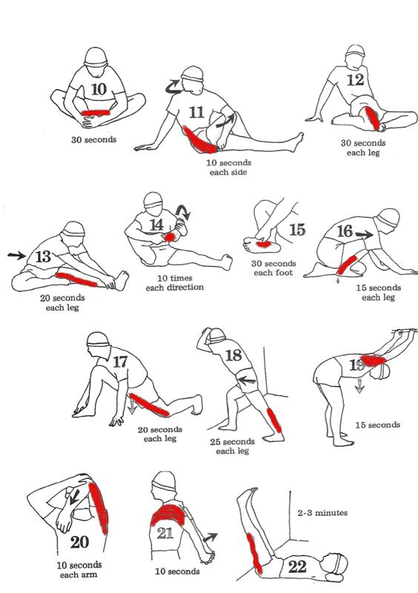
Also, try the “sock stretch” (ask us)

