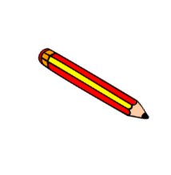
My Writing Checklist
- Fantastic Vocabulary- adjectives.
E.g- strong, beautiful, spooky, powerful, enormous, astonished etc
- Similes- As cold as ice, the cobwebs hung like lace from the ceiling.
- Conjunctions- because, however, but, so, when, where as, then.
- Adverbs- slowly, quietly, softly, angrily, loudly, quickly, gently, frantically.
- All Punctuation- .A ? ! “
- Fronted Adverbials- Later that day,
one sunny day, after, finally, the next day…
- Any missing words? The boy went^ the farm.

- Have you written in paragraphs?
Leave a line
Don’t forget to use the correct tense.

