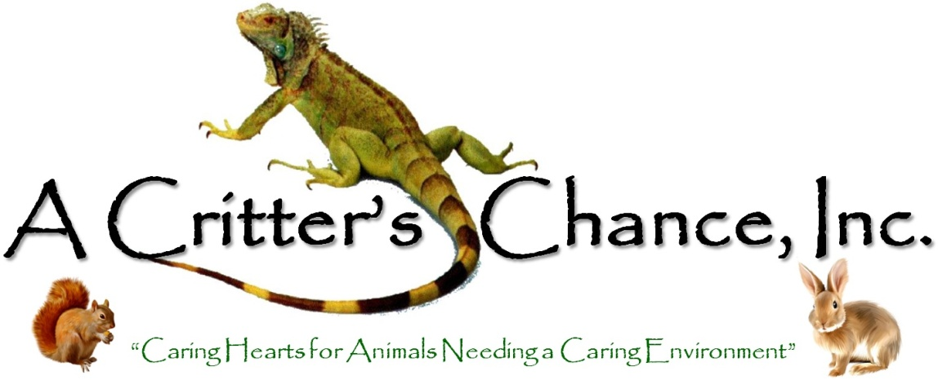

Adoption Contract

Animal’s name__________________ Species____________________ Color_______________________

Sex______ Weight_______________ Age________________ Spay/Neuter date___________________

Veterinarian__________________________________ Vet phone number_________________________

- In assuming responsibility for the adopted animal, I agree to never physically, verbally, or mentally harm the animal, not will I allow anyone else to do so. I will always supervise the animal in the presence of children.

- I understand and agree to give the animal exercise time in a safe environment and agree to animal-proof the areas of my home where the animal will be free. This animal is being adopted as an indoor pet (unless previous arrangements have been made or it is a farm animal such as a horse, cow, pig, etc.) If I allow the animal outdoor time, I understand the animal MUST ALWAYS be monitored and protected from the weather and predators. MAKE SURE your animal is properly vaccinated, de-wormed, etc before taking out. I understand some animals are more heat sensitive and I need to monitor temperature closely.

- I agree to give this animal the diet it must be on to remain healthy. (This is gone over with individual adoptions.) I also agree to get regular veterinary care, if necessary, to maintain the continued good health of this animal.

- I agree not to breed this animal, or allow it to be used for breeding.

- I will keep the animal in my private residence only and have permission from my rental agency or property owner, if applicable.

- Once the animal is adopted, the Adoption Agency/Individual is not liable for any damage or injury that could be caused by the adopted animal. I understand that the Adoption Agency/Individual, to the best of his/her knowledge, has disclosed any and all health problems that are known about. I understand that health problems may arise in the future for which the Adoption Agency/Individual will not be held responsible.

- I agree that the Adoption Agency/Individual is authorized to remove the animal if s/he is not receiving adequate home care, is not receiving proper veterinarian care, a violation of the adoption contract has occurred, or any local anti-cruelty laws have been broken.

- I understand that I will be contacted for further verification of this animal’s welfare and will cooperate by providing any and all information requested, which could include a visit into my home by the Adoption Agency/Individual. The Adoption Agency/Individual reserved the right to investigate the living conditions of the animal and may remove the animal being kept in violation of the requirements in this contract.

- I will notify the Adoption Agency/Individual immediately if the animal gets lost or passes away. If I can no longer keep the animal, the animal MUST be returned to the Adoption Agency/Individual for re-adoption. I will never abandon this animal or put it outside to fend for itself, give to another person, rescue, shelter, animal control or sell to labs for experiments, or any other such institute, or legal action will be taken. If I have to give the animal up for any reason, I agree to return the animal to the Adoption Agency/Individual within 24 hours of phone call.

- I agree to pay the adoption fee, which I understand is non-refundable, NO EXCEPTIONS!!
Amount of adoption fee/donation: $_______._____

- I have read this contract and will abide by its terms.

Adopter Information

Signed____________________________________________________ Date________________________

Printed name_________________________________________ Phone (_____)______________________

Address___________________________________________________________ Apt. #_______________

City__________________________________________ State_______________ Zip__________________

Adoption Agency/Individual Information

Signed____________________________________________________ Date________________________

Printed name_________________________________________ Phone (_____)______________________

Address___________________________________________________________ Apt. #_______________

City__________________________________________ State_______________ Zip__________________

