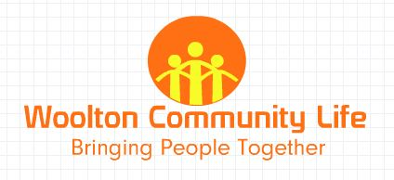

BEFRIENDING ROLE

|  |  |
| --- | --- |
| **Role:** | To visit socially isolated housebound people in their homes on a regular basis to provide conversational activity and friendship aiming to prevent/relieve loneliness. |
| **Where:** | South Liverpool locality |
| **When:** | Regular slots |
| **Commitment:** | Must be able to visit regularly probably on weekly or fortnightly basis.  Agreeable to initial and on-going training as necessary. |
| **Duration:** | Several months commitment or ideally longer. |
| **Requirements:** | Committed  Friendly  Reliable  Disclosure (DBS formerly CRB) clearance this will be arranged by Woolton Community life.  Undertake induction and training |
| **What’s In It For You:** | To encourage social engagement and prevent loneliness  Personal fulfilment  Fun  New focus  Friendship  New skills |
| **Why We Want You:** | Many people, particularly the elderly, struggle to attend social/ leisure activities due to mobility issues and access to public transport etc  This is a barrier to social inclusion & a cause of loneliness and isolation and poor health.  Volunteering to visit people will help provide human contact, friendship & prevent loneliness  We are looking for friendly reliable people who can volunteer some of their time on a regular basis to visit and converse with a person or persons. |
| **Support and opportunities** | Trustees and appointed personnel to answer questions and provide support as needed. Opportunities to be involved in working relationships of the Charity. |