**Worcester Surf Casting Club**

**1947 – 2022**

Join us for a fun filled weekend of excitement, games, entertainment, and delicious food as we

Celebrate our 75th Anniversary!

**July 2nd - 3rd, 2022**

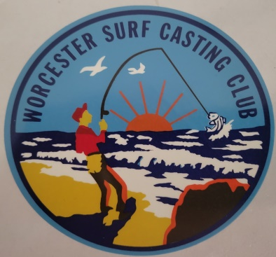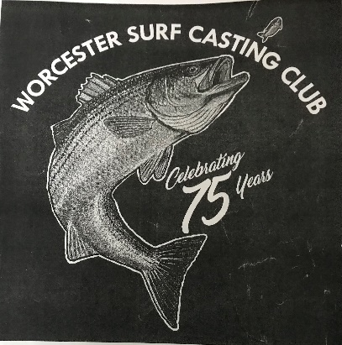 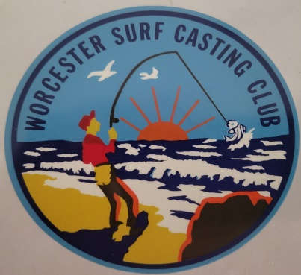

**Saturday 11 AM - 5 PM**

**Family Fun**

***Family Activities* Ring Toss *Photo Booth Carnival Games*   Fishing Derby *Kids Fun Run***

**Human Foosball *Face Painting*  Giant Jenga & Connect 4 *Frog Launch*      Cornhole**

*Kids Boxed Lunches with choice of chicken fingers, grilled cheese, or PB & J Kone, chips, drink, and a variety of Ice Cream treats*

**Adult events**

**Cornhole Tournament- event limited to 50- 2 person teams- entry fee required**

**Food Truck featuring-**

*BBQ Brisket, Ribs and Beans, Roasted Veggies, Potato Salad, Cornbread & Rolls*

**5 PM - 10 PM at the Main Building and Fire Pit**

Karaoke        Comedians (adults only) 50/50 Raffle

**Sunday 12 - 4**

**Classic New England Pot-Style Clambake**

*(choice of) Lobster, Steak, or Chicken, served with Clam Chowder,*

*Mussels & Linguica, Red Bliss Potatoes, Corn on the Cob, Coleslaw, Watermelon*

Kids- *(choice of) Hamburger, Hot Dog, or Mac-n-Cheese, Chips, Watermelon*

**Music Recognition Ceremony  Time Capsule   Raffles**

**Worcester Surf Casting Club**

**Worcester Surf Casting Club 75th Anniversary Celebration**

**July 2 – 3, 2022**

**Registration Form**

Registration and non-refundable payments must be postmarked by June 4th. We regret, due to required communication with outside vendors, we will be UNABLE TO ACCEPT LATE PAYMENTS.  Any reservations postmarked after June 4th, will be placed on a waitlist. Should an opening become available due to a cancellation, individuals on the waitlist will be contacted by phone and be given the option to register/pay within a 24 hour timeframe.

***Space is limited and advanced reservations are required***

**Reserve your Spot for the WSCC 75th Anniversary Celebration today!**

Member Name________________________________________Phone_________________________________

***Member’s Only Gift –*** *Flex fit Baseball Hat* Size (Circle one) S/M L/XL

**WEEKEND OPTION**

**Sat/Sun**   **Member/Guests (13+)** ________ @ $60.00 per person =  _________*

Food selection and quantity -1 ¼ lb. Lobster _____ 10 oz. Choice Sirloin ______ BBQ Bone-In Chicken Breast______

**Children (2 -12)** ________ @ $30.00 per person = _________*

Food selection and quantity Chicken Fingers_________ Grilled Cheese__________ PB & J Kone__________

Food selection and quantity Hot Dog_____________ Hamburger______________ Mac-n-Cheese___________

**ONE DAY ONLY OPTION**

***Saturday***- **Member/Guests (13+)** ________ @ $35.00 per person =  _________*

**Children 2 -12**        ________ @ $15.00 per person = _________*

Food selection and quantity Chicken Fingers_________ Grilled Cheese___________ PB & J Kone _________

***Sunday***  **- Member/Guests (13+)** ________ @ $35.00 per person =  _________*

Food selection and quantity - 1¼ lb. Lobster _____ 10 oz. Choice Sirloin ______ BBQ Bone-In Chicken Breast______

**Children 2 -12**        ________ @ $15.00 per person = _________ *

Food selection and quantity Hot Dog_____________ Hamburger______________Mac-n-Cheese___________

**Saturday Cornhole Tournament** -_______ people @ $10.00 per person = _________*

**Weekend *Entertainment Only* Fee**- ***NO meals/food***

_______Adults @ $10 per person = ________ * ________Children @ $ 5 per person = ________*

Total Amount Enclosed $ _________*

***Please mail completed form and check(s) payments to-***   
**WSCC**

**75th Anniversary Committee**

**PO Box 70059**

**Worcester, MA 01607**

Completed forms and cash payments may be given to Bob or Kate Muhr

Venmo payments may be made to @linda-luthman

***Members ONLY***

I regret that I am unable to attend the WSCC 75th Anniversary Celebration and would like my baseball hat to be

____*Picked up by ______________________________

____*Mailed to my address on file – enclosed is the postage/handling fee of $10.00

**Pricing**

***Saturday***-

$35 per person, member/guests (ages 13+) -includes Barbeque Food Truck and events

$15 Children (ages 2 -12) - includes boxed lunch, ice cream, face painting, and carnival games

***Sunday*** -

$35 per person, member/guests (ages 13+) -includes Clambake and events

$15 Children (ages 2 -12) – includes lunch, chips, watermelon

***Two-Day Pricing***

$60 per person, member/guests (ages 13+)

$30 Children (ages 2 -12)

**Weekend *Entertainment Only* Fee**- ***NO meals/food***

*Includes admittance to all non-food activities including carnival games, face painting, photo booth, kids run, karaoke, (*adult only*) comedians, music, Recognition Ceremony, and raffles*

$10 per person, members/guests (ages 13+)

$5 Children (ages 2 -12)

**Cornhole Tournament professionally managed by Wicked Cornhole of Tewksbury (wickedcornhole.com)–**

$10 per person Limited to 50- 2 person teams Team participants will be randomly selected

***Cash Prizes to top 2 winning teams***

**Worcester Surf Casting Club apparel, including, T-shirts, tanks, sweatshirts, and polos will be available for**

**pre-order beginning at the Annual Banquet to be held on April 23, 2022 at the Tuttle Post in Auburn. Pre-orders with payments (cash/check) will be accepted through Sunday, May 29th. A limited number of styles, sizes, and colors will be offered during the Weekend Anniversary celebration.**

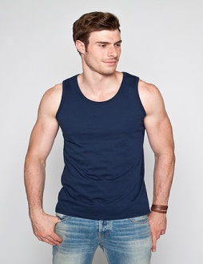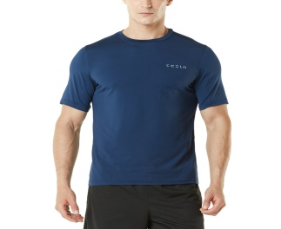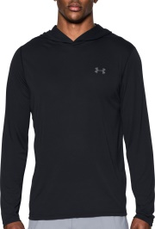

*Above photos are not actual products and meant for visualization purposes only

***Old Photos***

A **digitized slide-show presentation** is in the process of being created for viewing at the 75th Anniversary Celebration. Recent Facebook picture postings have been downloaded and you are encouraged to keep on posting! Everyone is also welcome to forward photos depicting Worcester Surf Casting Club memories to Noreen Barton at [noreenbar219@gmail.com](mailto:noreenbar219@gmail.com)

***Member Group Photo***

A professional photographer will be on-site **Saturday afternoon** to take a group photo of current members. Time to be announced.

***Time Capsule***

More information will follow.

***Questions?***

Please feel free to **contact Bob Muhr at 508-965-3797**

**We look forward to seeing you at the 75 Anniversary Celebration!!!**