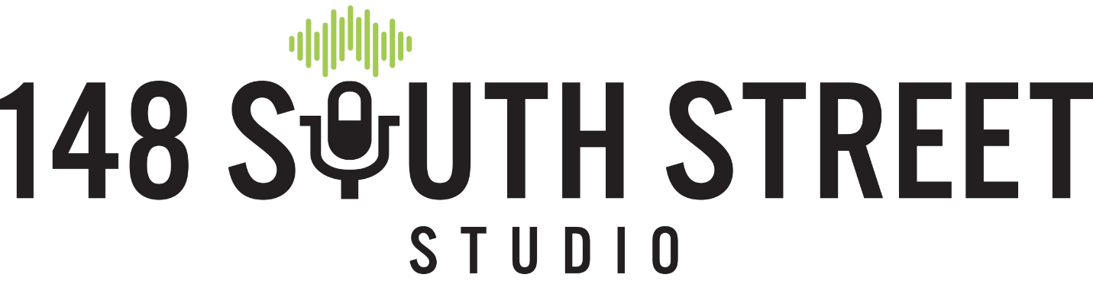
Internship Application
All internships are unpaid.

SECTION 1) General Information
NAME: _________________________________________________
MAIN PHONE NUMBER: __________________________ E-MAIL_________________________________
ADDRESS: ______________________________________________________________________________________________________
How did you hear about our internship opportunities?
Friend Social Medial Website School Other
If “other” please explain: _______________________________________________________________________________________________
Do you have reliable transportation? YES NO

SECTION 2) ACADEMICS
Are you currently enrolled in school? (circle one) YES NO
If yes, what is the name of your current school? ________________________________________________________________
Are you seeking an internship for Academic Credit? (circle one) YES NO
When do you need to start and complete your internship? ____________________________________________________
If yes, what is your main area of focus or degree track? _________________________________________________________
What is your anticipated graduation year? ______________

Academic Advisor overseeing your internship credits:
NAME: ______________________________________________ PHONE:_______________________________
EMAIL:______________________________________________________________
My Advisor is aware that I am applying for this internship to fulfill needed credits: YES NO
It is important that your advisor is aware that you are seeking an internship. Please let them know prior to filling out an application. We will contact your advisor so we can understand the requirements needed for you to complete your internship successfully.
SECTION 3: EXPERIENCE
Do you have experience working in a video/sound studio? YES NO
Have you ever operated a sound or light board? If so, explain: ____________________________________________________________________________________________________________________________________________________________________________________________________________________________________________________________________________________________________________________________________________________________
Do you have general knowledge of sound equipment like amps, mics and cables? If so, explain: ____________________________________________________________________________________________________________________________________________________________________________________________________________________________________________________________________________________________________________________________________________________________
Do you have experience with sound mixing? What software have you used? If so, explain: ____________________________________________________________________________________________________________________________________________________________________________________________________________________________________________________________________________________________________________________________________________________________
Do you have experience setting up or running Live Sound? If so, explain: ____________________________________________________________________________________________________________________________________________________________________________________________________________________________________________________________________________________________________________________________________________________________
Do you have experience with Adobe Premier? If so, explain: ____________________________________________________________________________________________________________________________________________________________________________________________________________________________________________________________________________________________________________________________________________________________
Do you have general knowledge of cameras? If so, explain: ____________________________________________________________________________________________________________________________________________________________________________________________________________________________________________________________________________________________________________________________________________________________

Do you have experience and/or general knowledge of instruments? If so, which ones: ____________________________________________________________________________________________________________________________________________________________________________________________________________________________________________________________________________________________________________________________________________________________

SECTION 4: TEAM PLAYER
Our studio is a family, and everyone pitches in with “chores” that help keep our facility clear for our customers. “Chores” garbage, dusting, cleaning the coffee station, restocking paper products, sanitizing surfaces and microphones (after bands) and running the UV light (to name a few!)
Are you comfortable with performing these kinds of tasks if needed? YES NO
We move and load sound equipment. Are you able to lift 40-50 pounds? YES NO
Are you comfortable on an 8’ ladder? YES NO
We have an 8lbs “studio dog” who is a registered Emotional Support Animal with us daily.
Are you ok with a furry co-worker? YES NO
Are you willing to play fetch with him? (He won’t leave you alone if you don’t!) YES NO
Our facility does not have a Handicap Accessible Restroom. Is this a problem for you? YES NO

SECTION 5: AVAILABILITY
Our studio is open 7 days a week from 10AM- 11PM. Please let us know the best hours for you to work. Most live-sound is done in the evenings between 6pm-10pm. Video recordings like Live Stream Events are usually on Saturday or Sunday (with some exceptions). Most equipment maintenance, housekeeping, meetings and marketing work is done between 9AM-5PM.
Sunday______________ Monday-_________________ Tuesday-__________
Wed- _____________ Thurs- __________________ Friday- ____________ Saturday-___________

SECTION 6: WRITTEN RESPONSE
On a separate page, please respond to the following: Why would you like to Intern at 148? What would you like to learn, and how can we help prepare you for a future in these related industries?

SECTION 7: PERSONALITY ASSESMENT (We won’t judge! Just want to get an idea of how you work.)
On a scale of 1 to 10 (1 being “NO WAY” and 10 being “ABSOLUTELY”) rate the following about yourself:
I learn best with verbal instruction
1 2 3 4 5 6 7 8 9 10
I learn best when I’m shown how to do something
1 2 3 4 5 6 7 8 9 10
I can self-start and stay on task
1 2 3 4 5 6 7 8 9 10
If I see something needs cleaning, I do it
1 2 3 4 5 6 7 8 9 10
I am intimidated to ask questions
1 2 3 4 5 6 7 8 9 10
If I suggest something and people don’t like my idea, I feel hurt
1 2 3 4 5 6 7 8 9 10
I’d rather wait for someone to tell me what I should do before I stat anything
1 2 3 4 5 6 7 8 9 10
I can find ways to stay busy and helpful when others are busy or in meetings
1 2 3 4 5 6 7 8 9 10
I like using Social Media platforms
1 2 3 4 5 6 7 8 9 10
I’d rather sell something then make something
1 2 3 4 5 6 7 8 9 10
I am intimidated to call people I don’t know
1 2 3 4 5 6 7 8 9 10
I like meeting people and talking to them
1 2 3 4 5 6 7 8 9 10
I can sell a red popsicle to a lady in white gloves
1 2 3 4 5 6 7 8 9 10
I like to know what my job is and get it done as soon as possible
1 2 3 4 5 6 7 8 9 10
I like to tackle one project at a time until it is done
1 2 3 4 5 6 7 8 9 10
I like being busy
1 2 3 4 5 6 7 8 9 10
I am respectful of other people’s property
1 2 3 4 5 6 7 8 9 10
I like to share my ideas
1 2 3 4 5 6 7 8 9 10
I would rather do a job correctly then quickly
1 2 3 4 5 6 7 8 9 10
I would rather get out on time then finish a project
1 2 3 4 5 6 7 8 9 10
When I’m asked to check a microphone I say, “Check! Check!”
1 2 3 4 5 6 7 8 9 10

If you would like to Intern, but do not need Credits, please fill out this application (minus SECTION 3) and include 3 references (Teacher, Employer, Church Leader, Volunteer Coordinator, Coach, etc.) with names and phone numbers with your application.
Thank you so much for applying for an internship at 148 South Street Studio. It is important that you communicate with your Academic Advisor regarding an internship with us. We will be reaching out to your Advisor when we receive your application to insure we will be able to meet the requirements set by your institution. Please submit this completed application, in addition to your short answer response for Section 6, to Assistant Producer, Kelly Brock via e-mail (Kelly@coccomusic.com) Or USPS: (Attn: Kelly Brock, Assistant Producer 148 South Street Studio Rochester Hills, MI 40307).

