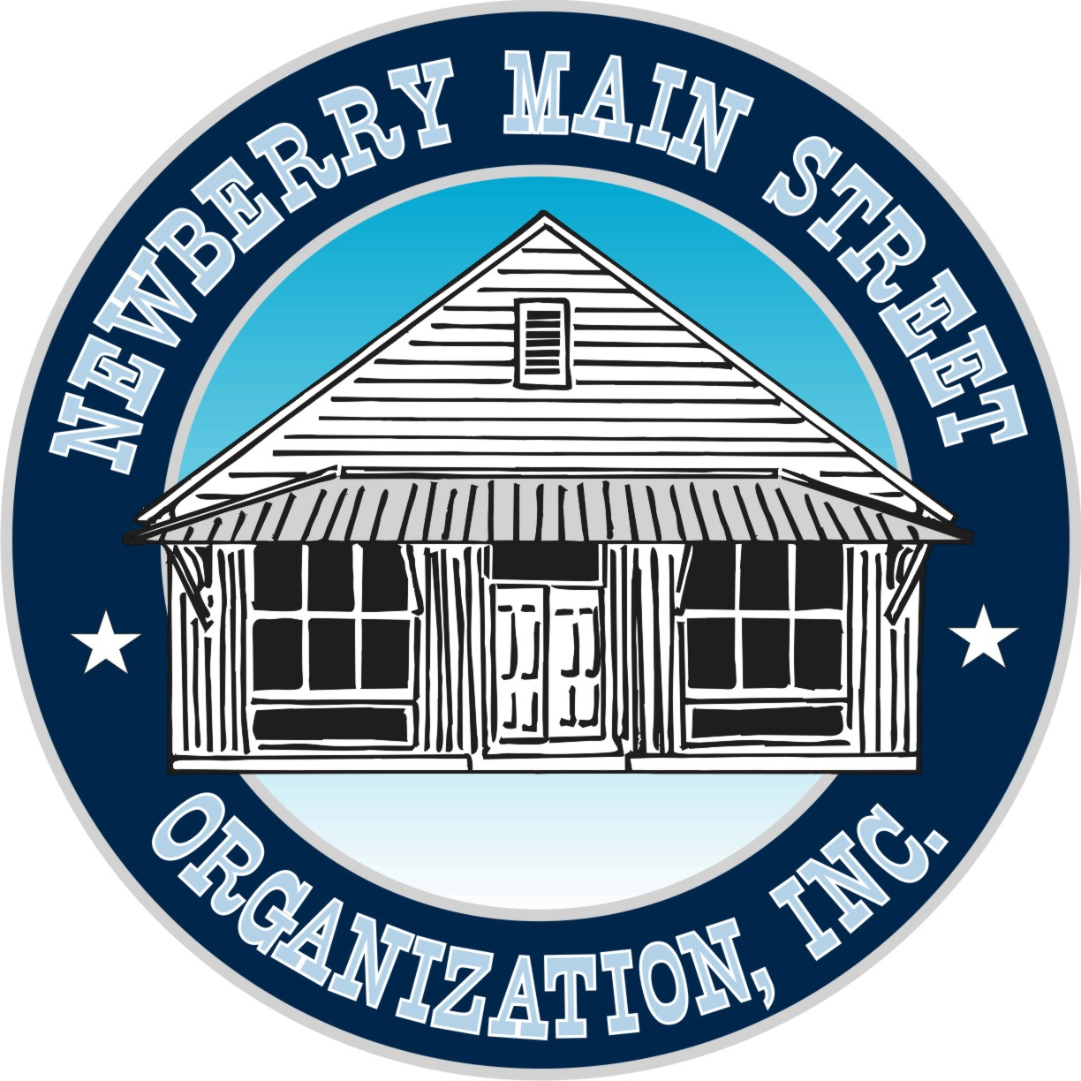

Newberry Main Street Organization, Inc.
501(c) 3 Not-for-Profit
25435 W. Newberry Rd.
P.O. Box 39
Newberry, Florida 32669

NewberryMainStreet.com

We invite you to become a partner of the Newberry Main Street program or renew your commitment to this great program. Your contribution will again be applied to the efforts that will positively affect the community where we live, work and raise our families. This is your opportunity to help grow a greatly enriched town into a more walkable, enjoyable and beautiful place.

Business Name

Individual Name

Address

Phone ______ _ E-mail _______________

Business web site

Please mark box next to partnership level you choose. Make check payable to ‘Newberry Main Street Org.’
Mail to PO Box 39, Newberry, FL 32669

 | New Individual Community Partnership (New Members) |  |  |  |  | $ 25.00
 | Renewal Individual Community Partnership (Renewing Members) |  |  |  |  | $ 20.00
 | New Family Community Partnership ( 2 adults, 2 children) (New Family) |  |  |  |  | $ 50.00
 | Renewal Family Community Partnership (Renewing Family) |  |  |  |  | $ 40.00
 | Small Business Partnership (1 to 24 employees) One free space at either the Spring or Fall Annual Festivals. |  |  |  |  | $ 75.00
 | Large Business Partnership ( 25 or more employees ) One free space at both Spring & Fall Annual Festivals |  |  |  |  | $ 125.00
 | Sponsor Level Membership  Logo in Sponsor level section of website • Business logo placed on banners for both of the Main Street Festivals • Business gets one FREE booth space at the Spring & Fall Festivals |  |  |  |  | $ 500.00
 | Corporate Level Partnership  Logo placed in Corporate members section • Business logo placed on all banners, flyers, notices • Business gets one FREE booth space at the Spring & Fall Festivals • Business logo placed on flyers sponsoring (4) Artists Meet & Greet at the Fire House Gallery |  |  |  |  | $ 1,000.00
 |  |  | 

