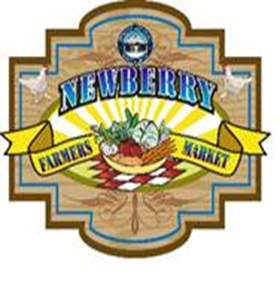
Newberry Main Street Farmers Market
Vendor Application and Information

When: Every Saturday from 12pm – 4pm year-round
Where: Downtown Newberry - Kincaid Lot, corner of 254th Street & Newberry Road/SR 26

Name of Business or Agent:__________________________________________________________________________
Contact Person:________________________________________________________________________________________
Address:_________________________________________________________________________________________________
Address:_________________________________________________________________________________________________
City, State, Zip Code:____________________________________Phone:______________________________________
Sales Tax #(for business)_____________________________E-Mail Address:____________________________
Description of Product(s) to be sold: (Attach separate sheet as needed ) ___________________________________________________________________________________________________________
___________________________________________________________________________________________________________

Available spaces are 10’ x 10’. I would like (number) ________ Space(s)
Fees: Booth fees are $10 per space per market, payable at each market. ($5 for NMSO members)
Super second Saturday Market (the second Saturday of each month) will be open to any vendors. Fees for Second Saturday Market are $15 per market space for non-members.
If paying by check make payable to: Newberry Main Street Organization. SEND Application AND copies of any applicable documentation to: 25435 W Newberry Rd, Newberry, FL 32669.

We reserve the right to assign locations according to product being sold. As long as you consistently come and remain current in payment, you will get to keep your assigned spot. There is electric service available.
You will receive confirmation by email that we received your application – Please provide us with a valid email address on your Registration Form.

GENERAL RELEASE:

The Vendor as undersigned below agrees to the rules stated in this agreement between myself, Newberry Farmer’s Market and Newberry Main Street Organization (NMSO). The vendor agrees to indemnify, defend and hold harmless, Newberry Farmer’s Market, Newberry Main Street Organization, the City of Newberry, any and all sponsors, and any and all members or agents from all claims, injuries, damages or actions caused or suffered by the vendor arising out of the activity or participation of the vendor in connection with this event. Vendor also agrees to save and hold harmless Newberry Farmer’s Market, Newberry Main Street Organization, the City of Newberry, and any and all sponsors, any and all members or agents for the damage of or loss of personal property and or effects of the vendors stored, used or sold during this event.

Signature:_______________________________________________________________Date:________________________________

Contact us: nmsoinfo@gmail.com , (352-472-2112), Facebook: Newberry Farmers Market
www.newberrymainstreet.com (look under the farmers market tab)

