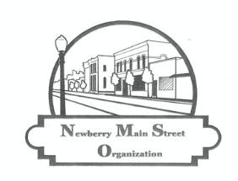
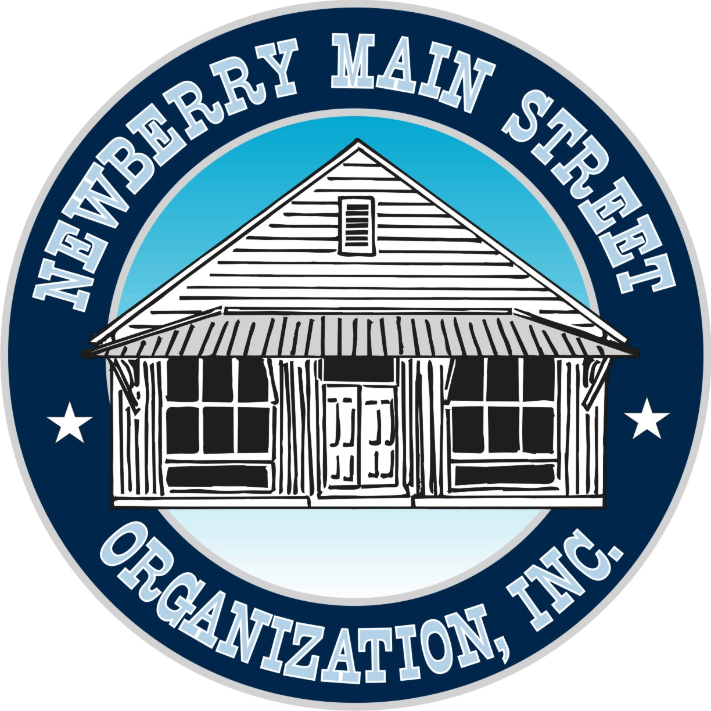

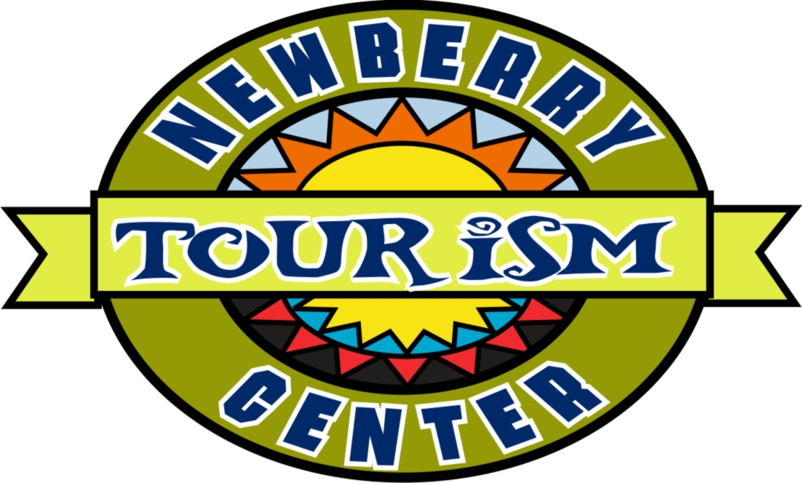
Newberry Main Street Organization, Inc.
501(c) 3 Not-for-Profit
25435 W. Newberry Rd.
Newberry, Florida 32669
PH: 352-472-2112
NewberryMainStreet.com
EM: nmsoinfo@gmail.com
We invite you to become a partner of the Newberry Main Street program or renew your commitment to this great program. Your contribution will again be applied to the efforts that will positively affect the community where we live, work and raise our families. This is your opportunity to help grow a greatly enriched town into a more walkable, enjoyable and beautiful place.


Business Name

Individual Name

Address

Phone ______ _ E-mail _______________

Business web site
Please mark box next to partnership level you choose. Make check payable to ‘Newberry Main Street Org.’
Mail to: 25435 W Newberry Rd, Newberry, FL 32669. Can also be paid via PayPal to nmsoinfo@gmail.com

 | New Individual Community Partnership (New Members) Individual listing in the membership section of website. www.newberrymainstreet.com under member section. Attend monthly/annual meetings and vote at annual meeting for Board of Directors. |  |  | $ 25.00
 | Renewal Individual Community Partnership (Renewing Members) |  |  | $ 20.00
 | New Family Community Partnership ( 2 adults, 2 children) (New Family) |  |  | $ 50.00
 | Renewal Family Community Partnership (Renewing Family) |  |  | $ 40.00
 | Small Business Partnership (1 to 24 employees) Business name listed in the business membership section of website. www.newberrymainstreet.com under member tab. Discounted space at the Annual Festival. Attend monthly/annual meetings and vote at annual meeting for Board of Directors. |  |  | $ 75.00
 | Large Business Partnership (25 or more employees ) Business name listed in the large business membership section of website. www.newberrymainstreet.com under member tab. Link to your website from the NMSO page. One free space at the Annual Festival. Attend monthly/annual meetings and vote at annual meeting for Board of Directors. |  |  | $ 125.00
 | Sponsor Level Membership  Business name/logo listed in the sponsor level membership section of website. www.newberrymainstreet.com under member tab. Link to your website from the NMSO page. Business logo placed on banners for the Annual Festival. Business gets up to two free booth spaces at the Annual Festival. Attend monthly/annual meetings and vote at annual meeting for Board of Directors. |  |  | $ 500.00
 | Corporate Level Partnership  Business name/logo listed in the Corporate level membership section of website. www.newberrymainstreet.com under member tab. Link to your website from the NMSO page. Business logo w/link on Social Media pages. Business logo placed on all banners, flyers, notices (includes TV spot for festival). Business gets up to two free booth spaces at the Annual Festival. Business logo placed on flyers sponsoring (4) Artists Meet & Greet at the Fire House Gallery. Attend monthly/annual meetings and vote at annual meeting for Board of Directors. |  |  | $ 1,000.00
