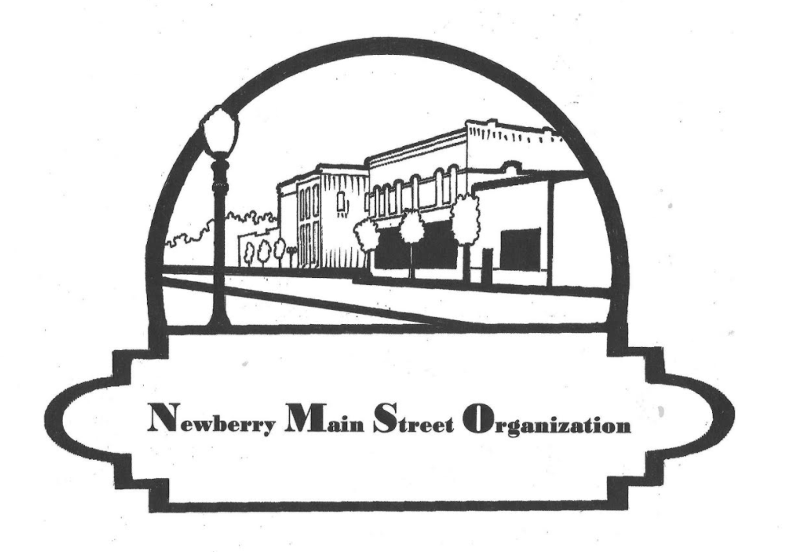
Newberry Main Street Spring Fling Festival
Vendor Application and Information

When: Saturday May 1st, 2021 9am – 4:30pm
Where: Downtown Newberry, along Seaboard Drive (Larry Keane Drive) Just off of Newberry Road / S.R. 26
Setup: 6:30am - 8am (All vehicles out of festival area by 8:30AM)
Vending: Start 9am – End 4:30pm TEAR DOWN: After 4:30PM

Applications received after April 15, 2021 will be subject to space availability and may not be accepted.

Vendors may include food, crafts, services, family activities and entertainment

Name of Business or Agent: _______________________________________________________
Contact person: _________________________________________________________________
Address: _______________________________________________________________________
Address: _______________________________________________________________________
City, State, Zip Code: ____________________________Phone: __________________________
Sales Tax # (for businesses) _________________ E-Mail Address: ____________________________
Type of Product or Display: (services, food, arts, crafts, wearing apparel, other.)
Circle a category and write specifics_______________________________________________________________
___________________________________________________________________________________________
Available spaces are 10’x10’. If you need additional spaces, please specify Number of spaces and Type of vendor space needed.

I would like (number) _______space (s)

Fees: (Please check off all that apply, total, and enclose a check accordingly)
____ $ 90.00 – Food Vendor (food court trucks) (Size of place needed _____________) (Liability Insurance needed)
____ $ 60.00 – Regular Space (Arts, Craft, services, apparel, carnival vendors etc)
____ $ 40.00 – Current Newberry Main Street Member
____ $ 30.00 – Non-profit Groups (Must please include Non-Profit Documentation)
____ $ 0.00 – Newberry Non-profit Groups (Must please include Non-Profit Documentation)

Fees are per space. If requiring more than one space, multiply total by number of spaces.

Total due with Application_______________
To mail application/check: Make check payable to Newberry Main Street Organization SEND check, application and proof of Liability Insurance for Food and Carnival vendor to 25435 West Newberry Rd, Newberry, FL. 32669 by April 15, 2021.
To send electronically: email application and liability insurance if applicable to nmsoinfo@gmail.com and send payment through paypal to nmsoinfo@gmail.com. (PLEASE SELECT FRIENDS/FAMILY WHEN PAYING W/PAYPAL SO FEES AREN’T CHARGED. THANK YOU!)

First come, first serve basis, locations assigned according to size and type. No electric service will be available. Plan to bring your own quiet generator if needed.

You will receive confirmation by email that we received/accepted your application – Please provide us with a valid email address on your Registration form.

To become a Member of Newberry Main Street Organization and receive vendor discounts
Please visit our Website at NewberryMainStreet.com and select Members > Membership Application

GENERAL RELEASE:

The Vendor as undersigned below agrees to the rules stated in this agreement between myself and Newberry Main Street Organization, Inc. (NMSO).The vendor agrees to indemnify, defend and hold harmless Newberry Main Street Organization, Inc. the City of Newberry any and all sponsors and any and all members or agents from all claims, injuries, damages or actions caused or suffered by the vendor arising out of the activity or participation of the vendor in connection with this event. Vendor also agrees to save and hold harmless Newberry Main Street Organization, Inc., the City of Newberry and, any and all sponsors and any and all members or agents for the damage of or loss of personal property and or effects of the vendors stored, used or sold during this event.

Signature: ______________________________________________________Date_______________

Questions? Please write to nmsoinfo@gmail.com or call (352) 472-2112.

Newberry Main Street Spring Fling Festival
Saturday May 1, 2021 9am-4:30pm

Important Information before sending your check and sign up:

Payments and Liability Insurance not received by Registration deadline will result in canceled booth space(s).

Fees are non-refundable.
Event will occur rain or shine. If there is a bigger storm it will be canceled.
Vendors are responsible for securing tents to the ground.
No electric service will be available. Plan to bring your own quiet generator if needed.
Food vendors need proof of State of Florida Health Certificates and liability Insurance.
If you bring a dog, make sure it stays on a leash and you provide a bowl and plenty of water.
Vendors will not be registered before 6am.
Vehicles shall be cleared away from the festival area by 8:30am, no exception, and so plan ahead.
YOU CAN NOT DRIVE IN FESTIVAL AREA UNTIL AFTER TEAR DOWN TIME.
If it is an Emergency, you can leave but you have to walk your items out.
Tear down cannot begin before 4:30pm.
Vendors are responsible to remove all trash from their area and placing in dumpsters provided.
Vendors are responsible to pay all Florida Sales Tax incurred by sales at the festival.
Tables, chairs and tents will not be provided. Bring your own as needed.

These rules will be followed. Anyone not following them, will be asked to leave and will be REMOVED from any future vendor list.

NOTE: If we cancel the festival your registration money will be returned.
ALL VENDORS are asked to encourage social distancing and mask use as necessary. Additionally, please bring hand sanitizer to have in your booth.

