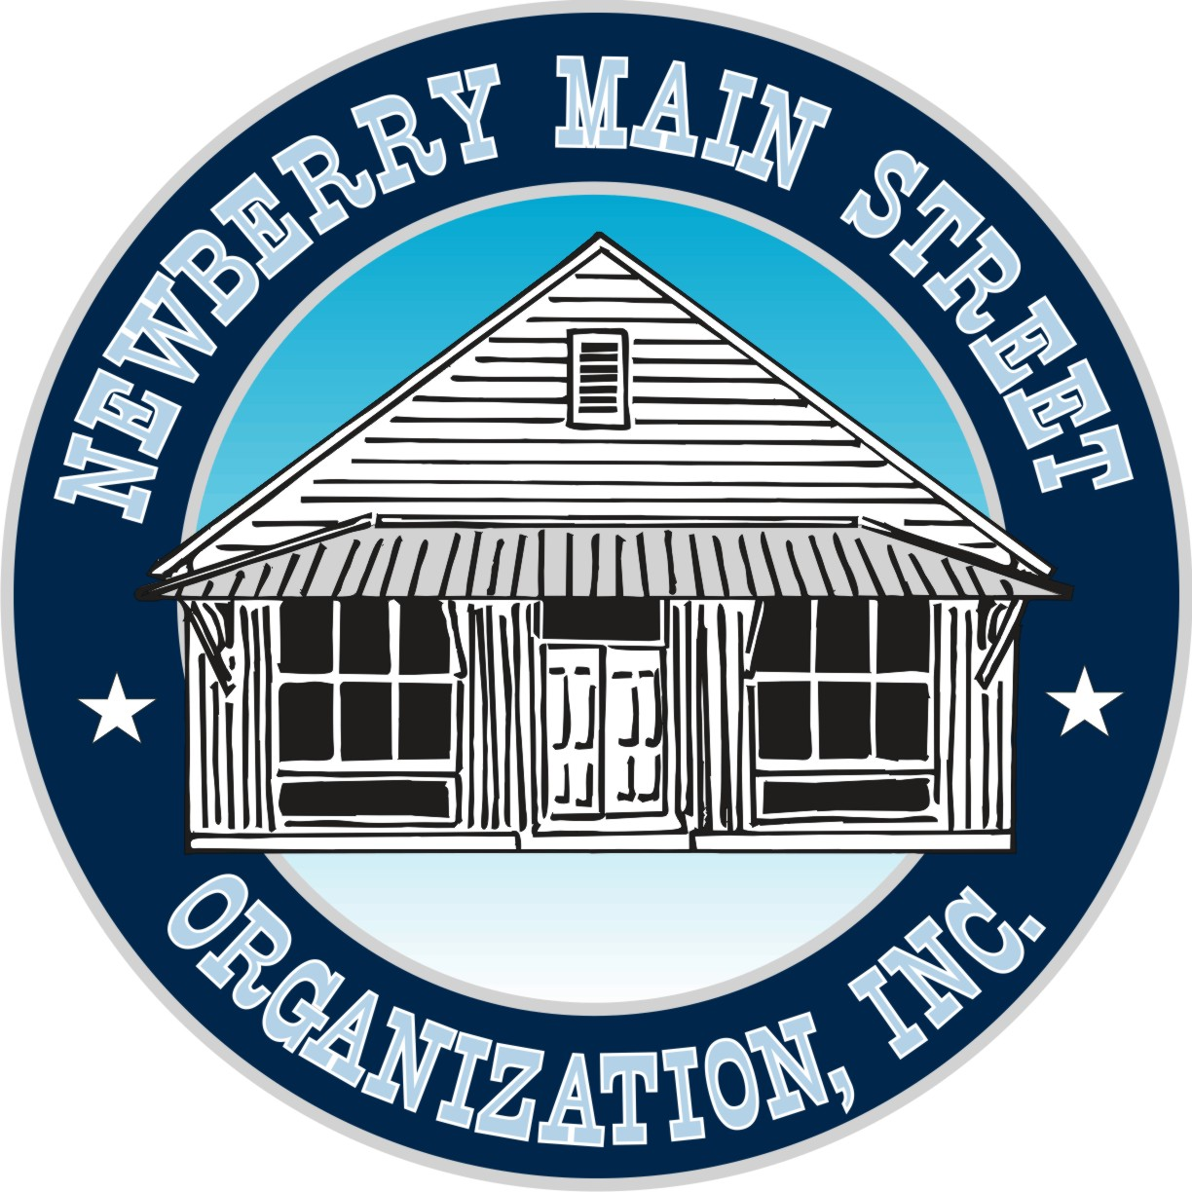

**Newberry Main Street Organization, Inc.**

**501(c) 3** Not-for-Profit

**25435 W. Newberry Rd.**

**Newberry, Florida 32669**

**PH: 352-472-2112**

**NewberryMainStreet.com**

Artist Application for “Iconic Newberry” Exhibit

Please Print

Name: _____________________________________________________________

Phone: ______________________ Email: _________________________________

Address: ___________________________________________________________

___ Check here if images of your artwork may be used for promotional purposes or on our website

**Artwork:**

Title: ______________________________________________________________

Size: ________________________ Medium: ______________________________

Price: _______________________

**Drop-off:** Tuesday, November 12th, 6-8 pm or

Saturday, November 16th, 11am-1pm (Arrangements outside of these times can be made by calling 352-472-2112

**Pick-up:** Sunday, February 2nd, 1-3 pm

Artwork will be exhibited at the Fire House Gallery Wednesday, December 4th through Saturday, February 1st

**Reception: Friday, December6th, 6-8 pm**

**Awards will be announced at 7pm during the reception**

Art Contest Rules

These rules apply for acceptance to the 2019 Newberry Main Street Organization’s 125th Anniversary Celebration Art Contest. The 125th Anniversary Celebration Art Contest is a juried Art Show, presented by the Newberry Main Street Organization, Inc. The purpose of the Art Contest is to create artwork to celebrate the 125th Anniversary of the founding of the City of Newberry.

This contest is open to anyone. Selected artist’s work will be on display in the Main Street Art Gallery located at 25435 W. Newberry Road, Newberry, Florida. All artwork must be the original creation of the applicant. Artwork must be current creations - created in 2017 – 2019 [CREATED FOR THE CONTEST?]. All entered artwork must feature an “iconic” image or scene related to Newberry, Florida. Artists have discretion to decide what an “iconic” image or scene of Newberry would be.

Art accepted include Oils, Watercolor, Acrylics, Drawing, or Photography. Al art works, not on stretched canvas or canvas board must be mounted on matt board. If framed, must be WIRED for hanging. NO EXCEPTIONS. Size limit of artwork - no more than 30" x 40." All works must be finished, dry and suitable for exhibition.

Official Application form required to enter this contest. Identification: Each piece of art must have the artist's name, complete address, phone numbers and title of work firmly attached to the back. SUBMISSION OF ART All art pieces being entered as well as the application must be brought in person to the Newberry Main Street Gallery during on following dates and hours only:

NO EXCEPTIONS TO DEADLINES Art and application will be accepted at PLEASE CLEARLY MARK YOUR ART WITH YOUR NAME ON BACK OF ARTWORK. ENTRY FORMS MUST ACCOMPANY YOUR ENTRIES. The 125th Anniversary Celebration Art Contest Committee maintains the right to review all art work to insure that they are in accordance with the rules. Art work determined as unacceptable or deemed inappropriate will not be accepted for display to the public. Every effort will be made to accept all qualified art pieces into the show. However, if space becomes an issue, the Committee reserves the right to streamline the accepted art. All decisions are final. Newberry Main Street Organization, will make every reasonable attempt to safeguard the artists' work however, Newberry Main Street Organization, assumes no responsibility for loss or damage.