Instructions for hanging clothing:

- Make sure hanger is facing left so that the hook makes the shape of a question mark.
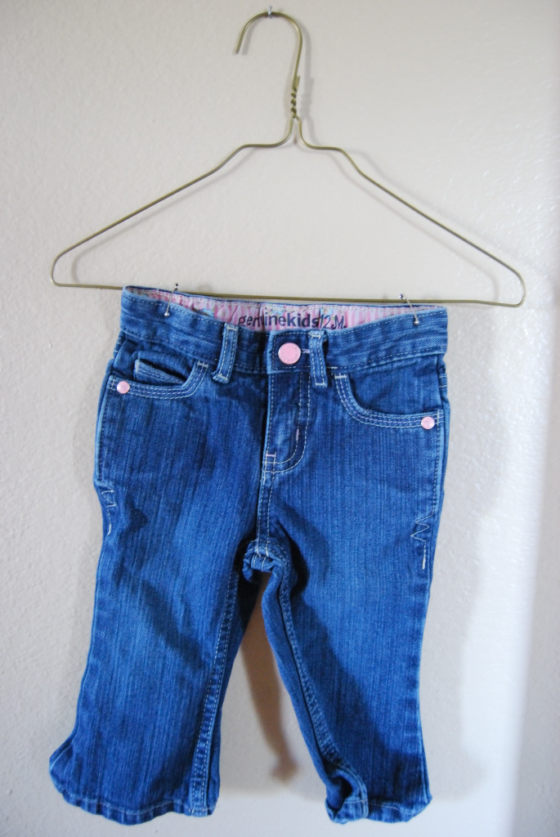
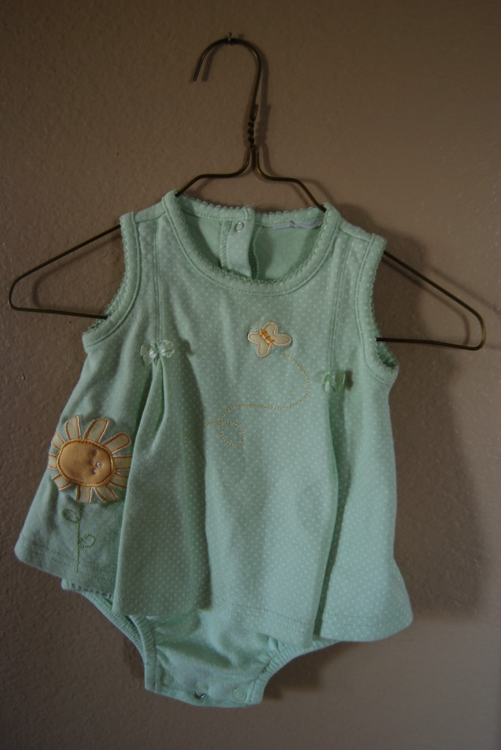
- Hang pants by safety pinning them to the top of the hanger near the hook.

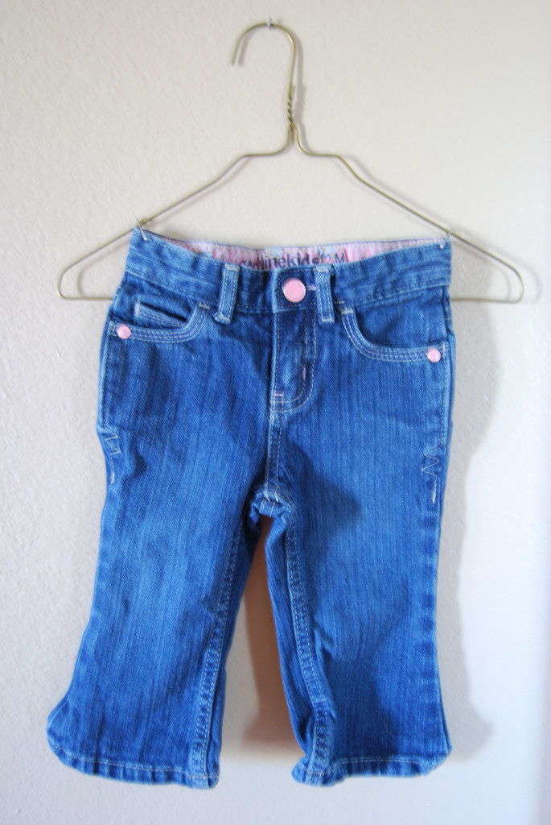

- When hanging outfits, hang the shirt first. Next, hang the pants behind the shirt on the top of the hanger (following the above illustration) making sure that the safety pin not only goes through the shirt, but also the wire hanger (to avoid tearing the shirt).
