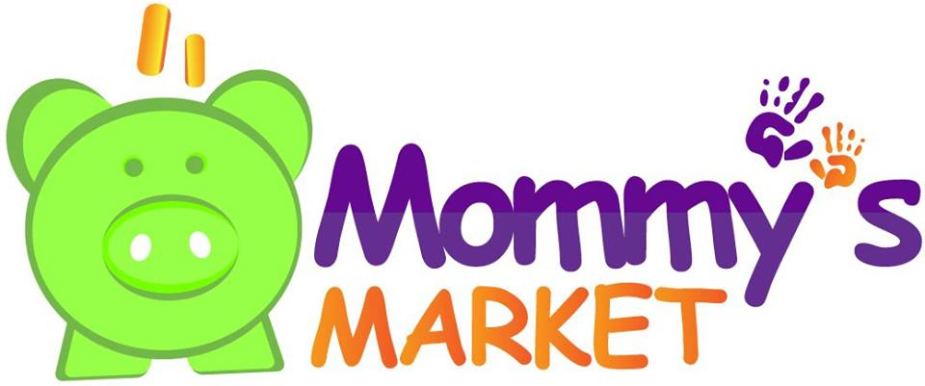
Pricing Guidelines

These are just suggestions; the seller will ultimately decide the price for items. Please remember that items priced too high will not sell and you will be left with a lot of items after the sale. Clothing sells best for around 80% below retail. Other items such as equipment and toys will sell for about 50% -70% below retail.

Items that sell for more Items that sell for less
Boys Clothing 3T and above Clothing under 18 Months
New with Tag Items Garanimals
Higher End Brands (Ralph Lauren, Mini Boden)
Boutique Brands

Bargain Brands Basic Brands Better Brands
Garanimals OshKosh Gymboree
Circo Old Navy Gap
Jumping Beans Crazy 8
Faded Glory Carters (LOW end of Basic)

Children’s Clothing and Accessories

Bargain Brands- Basic Brands Better Brands

Shirts $1.00-$2.00 $2.00-$3.50 $2.50-$4.00
Sweaters $2.00-$3.00 $2.50-$4.50 $3.50-$5.50
Jeans $2.00-$3.00 $3.50-$4.00 $3.50-$5.50
Leggings/Knit Pants $1.00-$2.50 Same Same
Skirts $2.00-$3.00 $2.50-$4.00 $3.00-$5.00
Shorts $1.00-$2.50 $2.00-$3.50 $3.00-$4.00
Dresses $2.00-$6.00 $3.50-$8.00 $4.50-$8.00 *MORE FOR HOLIDAY Jacket $3.00-$6.00 $3.00-$8.00 $4.00-$12.50
Winter Coat $5.00-$10.00 $6.00-$12.00 $8.00-$15.00
Boots $2.00-$5.00 $3.50-$6.00 $4.00-$8.00
Shoes $1.00-$3.00 $3.00-$5.00 $5.00-$10.00
Tights $.25-$2.00
Hats $.50-$3.00

Baby Equipment

Baby sling/carrier $5.00-$12.00 $12.00-$60.00
Baby Swing $15.00-$30.00 $40.00-$65.00
Bassinet $15.00-$45.00
Bouncy Seat $10.00-$15.00 $12.00-$25.00
High Chair $15.00-$50.00
Exersaucer $25.00-$45.00

Playpen $25.00-$60.00
Stroller $5.00-$40.00+
Double Stroller $50.00-$75.00+
Jogger Stroller $50.00-$75.00+
Stroller/Carseat System $50.00-$85.00+
Carseat $15.00-$45.00+ MUST BE WITHIN 5 years and NO ACCIDENTS
Booster Seat $5.00-$15.00
Baby Backpack $15.00-$45.00
Gate $5.00-$15.00
Monitor $8.00-$15.00+
Bedding $1.00-$30.00
Crib Mobile $5.00-$15.00
Boppy Pillow/Pregnancy Pillows
$5.00-$18.00+

Furniture

Crib $50.00-$200.00
Changing Table $15.00-$75.00
Glider $30.00-$80.00
Dresser $30.00-$150.00
Toddler Bed $20.00-$50.00

Toys

Puzzles $1.00-$4.00
Dolls $2.00-$5.00
Games $2.00-$5.00
Action Figure Sets $4.00-$10.00
Little People $5.00-$15.00
Infant Toys $1.50-$10.00
Play Kitchens/Houses etc
$20.00-$65.00+
Toy chests $10.00-$30.00

Outdoor Equipment

Slide $15.00-$20.00
Playhouse $25.00-$75.00+
Sandbox $10.00-$25.00+
Table $10.00-$35.00+
Chairs $3.00-$15.00+
Power Wheels $20.00-$75.00
Bicycle $8.00-$25.00
Tricycle $10.00-$15.00+
Wagon $10.00-$25.00+
Scooter $10.00-$15.00
Walker $12.00-$25.00

Books/DVDs/VHS

Baby Books $1.00-$3.00
Kids Books $1.00-$4.00
Parenting Books $2.00-$5.00
Book Sets $3.00-$8.00+
DVD $2.00-$5.00

