Wisconsin Residents

Did you know that DHS wants to add **ANOTHER** vaccine   
to the schedule for **school requirements**?

**What Will They Add Next?**

[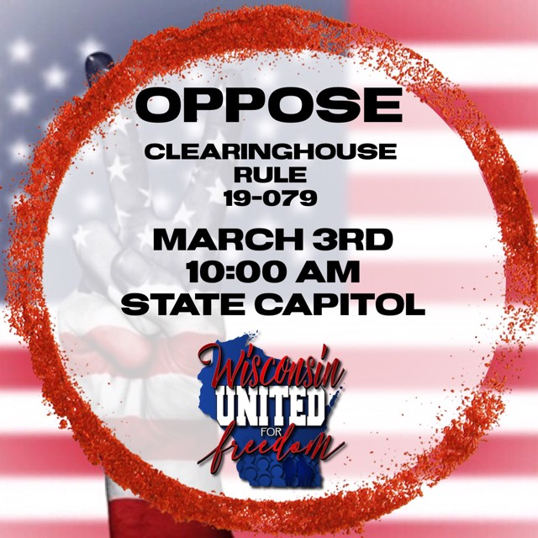](https://ppdcentral.sharepoint.com/sites/DRQ/Finding%20Spreadsheets/8556.Daiichi%20Sankyo%20Pharma%20Development%20(NJ).xlsx?web=1)

…HPV?  
…FLU shot?

**When Is Enough, Enough?**

**How Many is Too Many?**

SOLIDARITY in Numbers.  
  
PLEASE attend to STOP this passive legislation.  
  
We need **everyone** at this hearing.

Public Hearing to Add Vaccine Mandates  
Tue, Mar. 3rd – 10am  
Wisconsin State Capitol - room 300 Northeast  
Wisconsin United for Freedom.org & on Facebook

Public Hearing to Add Vaccine Mandates  
Tue, Mar. 3rd – 10am  
Wisconsin State Capitol - room 300 Northeast  
Wisconsin United for Freedom.org & on Facebook

Public Hearing to Add Vaccine Mandates  
Tue, Mar. 3rd – 10am  
Wisconsin State Capitol - room 300 Northeast  
Wisconsin United for Freedom.org & on Facebook

Public Hearing to Add Vaccine Mandates  
Tue, Mar. 3rd – 10am  
Wisconsin State Capitol - room 300 Northeast  
Wisconsin United for Freedom.org & on Facebook

Public Hearing to Add Vaccine Mandates  
Tue, Mar. 3rd – 10am  
Wisconsin State Capitol - room 300 Northeast  
Wisconsin United for Freedom.org & on Facebook

Public Hearing to Add Vaccine Mandates  
Tue, Mar. 3rd – 10am  
Wisconsin State Capitol - room 300 Northeast  
Wisconsin United for Freedom.org & on Facebook

Public Hearing to Add Vaccine Mandates  
Tue, Mar. 3rd – 10am  
Wisconsin State Capitol - room 300 Northeast  
Wisconsin United for Freedom.org & on Facebook

Public Hearing to Add Vaccine Mandates  
Tue, Mar. 3rd – 10am  
Wisconsin State Capitol - room 300 Northeast  
Wisconsin United for Freedom.org & on Facebook