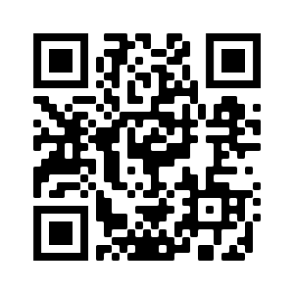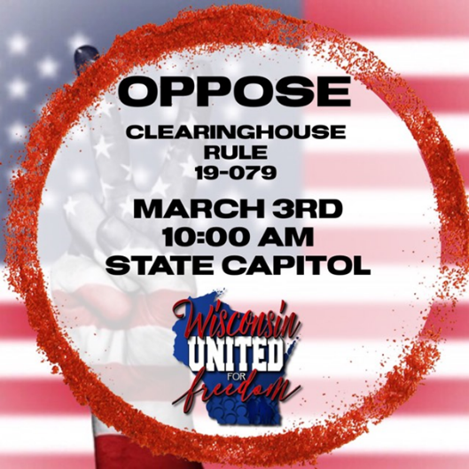

Public Hearing to Add Vaccine Mandates  
Tue, Mar. 3rd – 10am  
Wisconsin State Capitol - room 300 Northeast  
Wisconsin United for Freedom.org & on Facebook

REGARDING Clearinghouse Rule 19-079 relating to the immunization of students.

**Please plan to ATTEND in person.**   
  
**The only way we keep   
ANOTHER VACCINE**

**from being added to the school requirements   
is to stand together and bring   
our concerns to our Wisconsin Legislators.**

*Please visit Wisconsin United for Freedom on Facebook and at WisconsinUnitedForFreedom.org for more information.*

Tuesday, March 3, 2020 at 10 AM

LOCATION: Wisconsin State Capitol Building, Room 300 Northeast

Public Hearing to Add Vaccine Mandates  
Tue, Mar. 3rd – 10am  
Wisconsin State Capitol - room 300 Northeast  
Wisconsin United for Freedom.org & on Facebook

& on Facebook

Public Hearing to Add Vaccine Mandates  
Tue, Mar. 3rd – 10am  
Wisconsin State Capitol - room 300 Northeast  
Wisconsin United for Freedom.org & on Facebook

Public Hearing to Add Vaccine Mandates  
Tue, Mar. 3rd – 10am  
Wisconsin State Capitol - room 300 Northeast  
Wisconsin United for Freedom.org & on Facebook

Public Hearing to Add Vaccine Mandates  
Tue, Mar. 3rd – 10am  
Wisconsin State Capitol - room 300 Northeast  
Wisconsin United for Freedom.org & on Facebook

Public Hearing to Add Vaccine Mandates  
Tue, Mar. 3rd – 10am  
Wisconsin State Capitol - room 300 Northeast  
Wisconsin United for Freedom.org & on Facebook

Public Hearing to Add Vaccine Mandates  
Tue, Mar. 3rd – 10am  
Wisconsin State Capitol - room 300 Northeast  
Wisconsin United for Freedom.org & on Facebook

Public Hearing to Add Vaccine Mandates  
Tue, Mar. 3rd – 10am  
Wisconsin State Capitol - room 300 Northeast  
Wisconsin United for Freedom.org & on Facebook

Wisconsin Residents

**VACCINE ALERT**