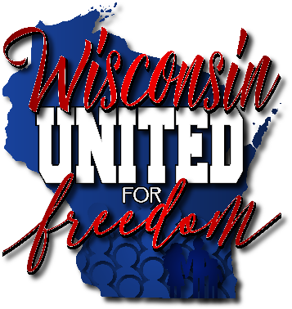

**Protect Health Freedom**

**www.WisconsinUnitedForFreedom.org**  
Free

**CR 19-079**

*Clearinghouse Rule 19-079 formally DHS 144*

**This rule would:**

- Mandate the meningococcal vaccine (MenACWY) for all 7th graders, with a booster dose in 12th grade.

- Parents would no longer be able to report their child’s chicken pox illness and would be required to see a healthcare provider to confirm infection if using an exemption to the varicella immunization requirement.

*And more*

***PUBLIC HEARING SCHEDULED FOR CR 19-079 AT OUR WISCONSIN STATE CAPITAL***

***TUESDAY, MARCH 3, 2020 AT 10AM IN ROOM 300 NORTHEAST***

**LRB 4135** - relating to vaccination of 16-17-year-old minors without parental consent

**LRB 4136** - relating to dentists administering vaccines and granting rule-making authority

**LRB 4137** - relating to purchasing and distributing vaccines for children and making an appropriation

**SB 751** - relating to agency authority regarding public health emergencies and making an appropriation

**SB 262 / AB 248** - removal of personal conviction waivers regarding vaccination for schools and daycare.

***Please see our website for full details on all calls to action and how you can help!***

The Current State of Wisconsin

*Updates on current legislation in the Badger State*