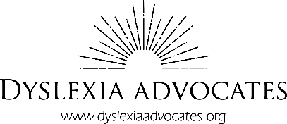

Orton-Gillingham Tutor Training Scholarship

The Orton-Gillingham Approach employs comprehensive, scientifically based reading instruction. Becoming a certified Orton Gillingham (OG) tutor/teacher requires a significant commitment of time, including classroom learning and a practicum for Level One certification.

Dyslexia Advocates is proud to offer scholarships of up to $2000 for tutor training that will lead up to Level One OG certification. Our goal in providing these professional development scholarships is to increase effective reading interventions both within our schools, and in our communities.

**Who are these scholarships available to?**

These scholarships are available to teachers, paraprofessionals, and community members who are interested in offering effective reading remediation to the 15-20% of students who struggle with learning to read. OG certification programs generally require a 4-year Bachelor’s degree.

**How do I apply?**

Simply complete the application below and return it via email ([info@dyslexiaadvocates.org](mailto:info@dyslexiaadvocates.org)) or mail (1700 Hwy 36 West, Ste. 825, Roseville, MN 55113) by **April 24, 2019** to be considered for a scholarship. Finalists will meet with the scholarship committee before a decision is made. Prior to being awarded a scholarship, an applicant will be required to complete a background check.

**How will the scholarship funds be dispersed?**

Dyslexia Advocates coordinates the registration and payment information directly.

Please feel free to contact us at [info@dyslexiaadvocates.org](mailto:info@dyslexiaadvocates.org) with any further questions!

First Name:

Last Name:

Email Address:

Phone Number:

What is your current (or more recent) job title?

Highest level of education:

Institution that granted your highest degree:

Briefly describe your background working with children (max. 500 words):

Please share your experience with Orton-Gillingham or any other type of structured literacy (max. 500 words):

Tell us what made you decide to apply for this certification (max. 500 words):

Please describe your plans for utilizing your certification. Be specific (max. 500 words):

In what county would you provide your services?

Would you be interested in offering free or discounted tutoring to students in need?