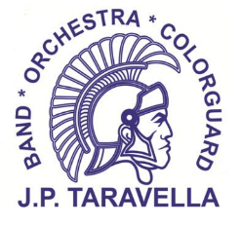 | JP Taravella Band  “B” Uniform Shirt

Student Name:
Grade:
Email:
Contact #:
Band ‘B’ Uniform Shirts are used by the Wind Orchestra and when students volunteer. Cost is $20 per shirt. If your child needs a ‘B’ Uniform Shirt, please indicated the quantity next to the size:

 | S |  | M |  |  | L |  | XL |  | XXL |  | XXXL
Total # of ‘B’ Uniform Shirts _______

Total Price: __________

Payment Method:

Cash Check/Money Order Pay Pal Student Account Credit

*Make Check or Money order out to ‘JP Taravella Band’
*PayPal payment can be made thru JPTMusic.org

