J.P. Taravella Band, Orchestra & Color Guard
Sponsorship Order Form

Business Name:
Address:
City: |  | State/Zip:
Contact Name: |  | Phone
Contact Email

Sponsorship Packages:
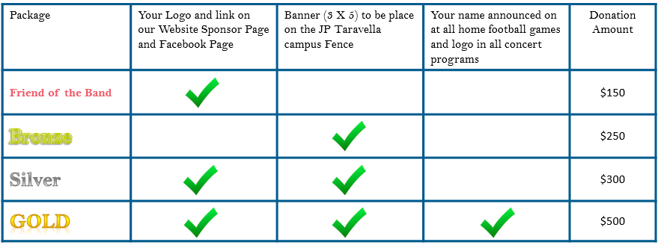

Donation Package:
Other Donation Item(s)/Amount:
Business Name to be displayed:
Web address to be displayed:

Please make your check payable to JP Taravella Band and send it to:
PO Box 934 N University Drive #427, Coral Springs, FL 33071

Thank you again for your support - Any donation amount is greatly appreciated!
We are a 501c3 organization so your donation is tax deductible. For any questions please contact our sponsorship team at fundraising.jptmusic@gmail.com.

