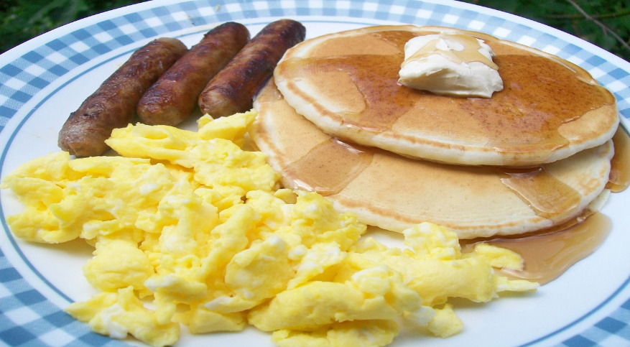

**STUDENT NAME**: ___________________________________________

**TICKETS: $13.00 EACH **CASH OR CHECK ONLY PLEASE!**

**(CHECKS SHOULD BE MADE OUT TO “JPT BAND”)**

**# OF TICKETS SOLD**: _________________________

**TOTAL COLLECTED**: __________________________

FUNDS RAISED WILL GO TOWARDS THE JPT BAND, ORCHESTRA & COLOR GUARD GENERAL FUND TO SUPPORT THE BAND PROGRAM.

**J.P. Taravella High School Band**

**Applebee’s Flapjack Fundraiser Order Form**

Meal includes: Pancakes, sausage, scrambled eggs and a beverage (coffee, juice, soda or tea.) Please contact organization to purchase a ticket. This flyer is only intended for advertising purposes. Ticket valid for pancake event only. Applebee's® menu items are not included as part of purchase.