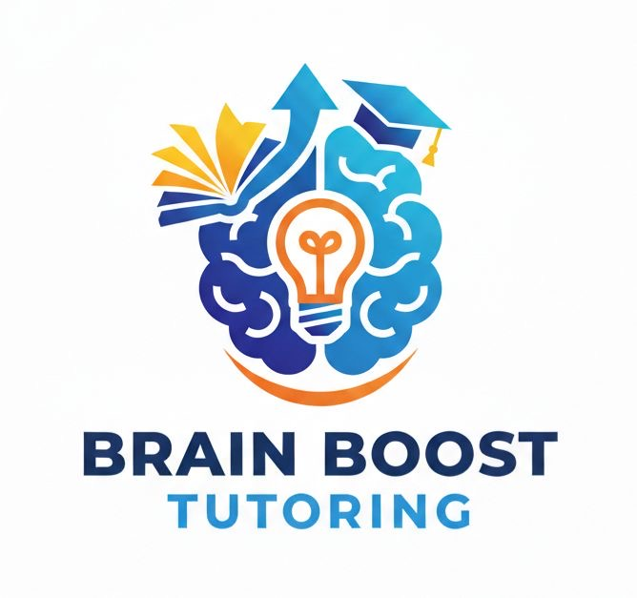

Brain Boost Tutoring

Student Registration Packet
Address: 14624 John Humphrey Dr, Orland Park, IL
Phone: (708) 608-1023

Student Information
Student Name: __________________________________________
Date of Birth: __________________________________________
Grade: __________________________________________
School: __________________________________________
Parent/Guardian Name: __________________________________________
Phone Number: __________________________________________
Email: __________________________________________
Home Address: __________________________________________

Emergency Contact
Emergency Contact Name: __________________________________________
Relationship: __________________________________________
Phone: __________________________________________

Learning Information
Subjects Needing Help (circle): Math | Reading | Science | Chemistry | Arabic | English
Current Challenges: __________________________________________
Student Goals for Tutoring: __________________________________________

Scheduling Preferences
Preferred Days: __________________________________________
Preferred Time: __________________________________________
In-Person or Online: __________________________________________

Medical / Allergy Information
List any allergies or medical concerns: __________________________________________
____________________________________________________________

Tutoring Policies
• Payment is required prior to tutoring sessions.
• 24-hour notice is required for cancellations.
• Students should arrive on time and ready to learn.
• Respectful behavior is expected from all students.
• Brain Boost Tutoring provides a supportive and structured learning environment.

Parent / Guardian Agreement
Parent/Guardian Name: __________________________________________
Signature: __________________________________________
Date: __________________________________________

