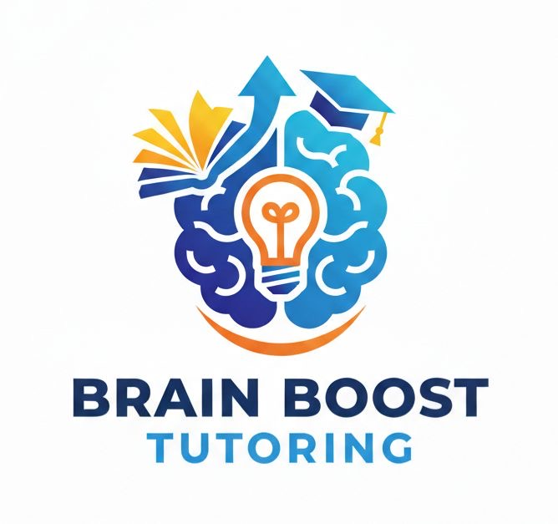

Welcome to Brain Boost Tutoring
Dear Parent/Guardian,
Welcome to Brain Boost Tutoring! We are excited to support your child’s academic journey. Our mission is to build confidence, strengthen academic skills, and help students develop a lifelong love of learning.
At Brain Boost Tutoring, we provide personalized instruction tailored to each student's learning style and academic goals. Our tutors focus on building strong foundations in subjects such as Math, Reading, Science, Chemistry, Arabic, and English.
We believe communication between tutors, students, and families is essential for success. We encourage parents to stay involved and reach out with any questions or concerns.
Thank you for trusting Brain Boost Tutoring with your child's education.
Sincerely,
Brain Boost Tutoring Team
14624 John Humphrey Dr
Orland Park, IL
(708) 608-1023

