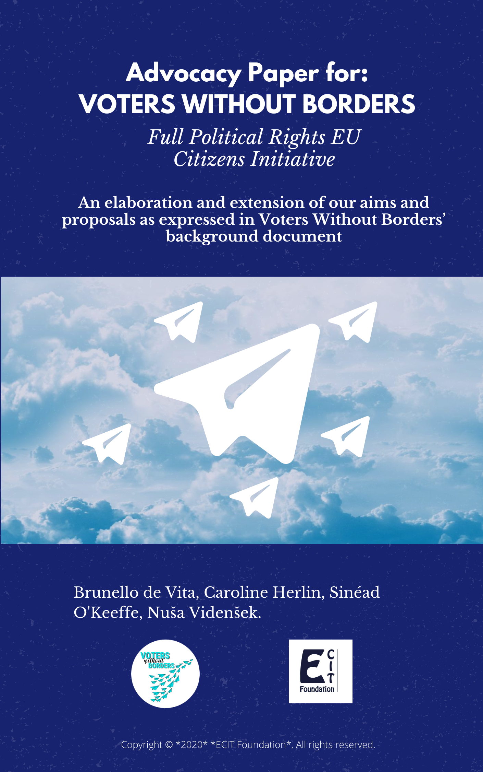
Table of Contents
- Preamble 4
- Introduction 5
- Aims 10
- Existing Voting Rights 15
- EU Elections 15
  - Access to Information 15
  - Registration 17
- Municipal Elections 19
  - Access to Information 19
  - Registration 20
- Additional Voting Rights 23
- Regional Elections 23
- National Elections 25
- Referendums 27
- Accompanying Mechanisms 29
- Help Desk 29
- Innovative Ways to Encourage Turnout 30
- Recommendations and Conclusions 32

Table of Figures
Figure 1………………………………………………………………………………….…….8
‘Percentage of mobile EU citizens in the Member States of the EU (2019)’
Figure 2……………………………………………………………………......………………9
‘Main countries of citizenship of mobile EU citizens as a percentage of the total foreign population’
Figure 3 …………..………………………………………………………………………….13
‘Support for EUMCs to acquire the right to vote in national elections and referendums in their country of residence’
Figure 4 ……………………………………………………………………..……………….14
‘Support for EUMCs to acquire the right to vote in regional elections in their country of residence’
Figure 5 …………………………………..………………………………………………….15
‘Preferences regarding in voting for country of origin vs country of residence’
Figure 6 ………….…………………………………………………………………………..21
‘Number of EUMCs standing as a candidate and elected in their State of residence (Based on data provided by Member States)’
Figure 7 …………….………………………………………………………………………..22
‘Percentage of mobile EU citizens registered to vote in municipal elections (Data provided by Member States)’
Figure 8 ………………..…………………………………………………………………….28
‘Types of referendums in EU Member States since 1993 (Maastricht Treaty)’

- PREAMBLE

The request to register our European Citizens Initiative (ECI) named Voters Without Borders was submitted to the European Commission on 24 January 2020, along with the ECI background document written by our team, supported by the ECIT Foundation. In this document we proposed to reform the existing rights of mobile EU citizens to vote and to stand in municipal and EU elections and their extension to regional, national elections and referendums. On 4 March the Commission adopted the decision to register ‘Voters Without Borders - full political rights’ for EU citizens. The positive response provided by the Commission confirms that all parts of our demand are within its competences and implementable within EU law. The task force has opted for the launch date to be on 1 September. The plan is to collect over 1 million signatures in a minimum of seven EU Member States within one year.
Since the registration of the ECI there have been many developments. We started our research by doing a survey on EU political rights - voting and standing in elections across borders in the EU. This gave us a number of responses and testimonies from mobile EU citizens. The Commission's survey released in July of this year, shows that it is necessary for us to spread awareness about the meaning of EU citizenship. This Eurobarometer survey on EU citizenship and democracy showed that a vast majority of Europeans (91%) are familiar with the term “citizen of the European Union”. This is the highest level of awareness since 2007 and a steady increase from 87% recorded in 2015.
Last year the Commission also proposed a Conference on the Future of Europe, as a new public forum for an open, inclusive, transparent and structured debate, including citizens, a significant role for young people, civil society, and European institutions as equal partners. Due to the COVID-19 pandemic, the launching of this Conference has been delayed, but it will start as soon as possible, supposedly in autumn of this year.
With this paper we are updating and improving our background document, based on the research we have done since registering the ECI. Europe is steadily going in the same direction as our vision; thus this ECI is in the right place at the right time.
- INTRODUCTION

Citizenship of the European Union was established by the Maastricht Treaty in 1992 and is now governed by Articles 20-25, Part 2 of the Treaty on the Functioning of the European Union (TFEU). EU citizenship complements and does not replace national citizenship. The right to vote at European level is acquired with European citizenship, crystallised in the Treaties on European Union and in the Charter of Fundamental Rights, which represent the ‘constitutional’ basis of the EU. Citizens are entitled to vote and stand as candidates in municipal elections in any Member State in which they reside and to vote and stand in European Parliamentary elections, in the same way that nationals of that State can. These rights were put into place with the Maastricht Treaty – though not without some obstacles.
On 1 November 1993, the Treaty of Maastricht came into force, and since then the number of Member States has increased, as well as the number of mobile EU citizens which has reached 14 million. Awareness of European citizenship is also at its highest since 2007. Turnout in the May 2019 European elections reached 50.66%, which is the highest percentage in twenty-five years and an increase of 8% compared to the 2014 European elections. The turnout of young people aged 18 - 25, who are those more likely to benefit and make use of the freedom of movement rights, saw an increase of 55% compared to the 2014 elections. Despite this, a very low number of mobile EU citizens made use of their electoral rights in the 2019 European Parliamentary elections, as highlighted in the Commission’s staff working paper. Figures from Member States collected by the Commission are incomplete but the best estimate is that only 10% voted in their country of residence and 20% in their country of origin. A 2018 Eurobarometer survey on ‘Democracy and elections’ show that most people would prefer to vote in their country of residence. Therefore, this average 10% estimate suggests that there are significant barriers to doing so.
The discrepancy between what people want and actual practice shows that these European rights are not working properly. It is also surprising that in the last European elections, when turnout increased generally, it did not for the group arguably most affected by the EU. Amongst the directives and regulations relating to free movement of people - the elimination of barriers to residence, recognition of professional qualifications and social security entitlements - it is the directives on cross border political rights which are working least well. And yet, political rights are the gold standard of any citizenship status. It is therefore high time, one generation on, to build on the achievements of the Maastricht Treaty by removing the barriers and impediments which hinder the exercise of political rights by these citizens, strengthening their existing voting rights, as well as creating new rights which will contribute to further increasing turnout in future European elections.
On this point it is crucial that further research should be done to investigate the reason why these 14 million EU citizens have not been motivated to vote in their country of residence. The provision of more complete and detailed data on turnout numbers for these citizens would also enable better policy design which would in turn help them make better use of their voting rights in European and municipal elections. The Maastricht Treaty might have seemed like a significant reform on partial political rights but was not perceived this way by these potential voters. The lack of information and various other obstacles of administrative and practical nature severely deter mobile EU citizens from registering and voting, making it seemingly impossible to them. Additionally, in the 27 years since the Maastricht Treaty’s implementation, the right to vote as EU citizens in their country of residence is still not being properly supported. In theory the European rights are well protected by legal means, however the current political climate is not conducive to the exercise of those rights as the anti-immigration rhetoric used by populist right-wing parties has become increasingly taken up by mainstream parties in several European Member States. Despite freedom of movement remaining one of the most popular rights associated with the EU, these forces create a climate which pushes against the good execution of political rights held by mobile EU citizens.
Voting should be an easy thing to do. There is an argument in favour of mandatory voting for mobile EU citizens as some view the low turnout figures as a stance against the denial of voting rights in the more important national elections. This argument can only be made on a case- by- case basis, however. Many EU citizens have relied in a sense on the European Court rather than on politicians – if there is a dispute they can complain in Court and their rights will be upheld. However, the judicial route is not as clear as it used to be, so the importance of having the ability to vote is growing. One must consider the large response this initiative has received from individual EU citizens, particularly on our Facebook page via likes, follows and testimonials.

We would urge readers that such input should be presented also in response to the Commission’s public consultation leading up to the next Citizenship Report and which asks questions both about existing political rights and what new rights people would like to see added to EU citizenship. What we demand is that European electoral law covers all elections - municipal, regional, national, EU elections and referendums and puts these in one piece of legislation. In addition, reform of the existing Directives is needed providing automatic registration and the choice for mobile EU citizens to vote in their country of origin or country or residence. One may regard the 14 million mobile EU citizens as a 28th Member State, and thus the 8th largest population in the EU. ‘Voters Without Borders’ is an initiative that upholds non-discrimination based on nationality and breaks down geographical barriers. It is imperative that 14 million people have their voices heard.

How do the 14 million mobile EU citizens break down geographically?
Figure 1: Percentage of mobile EU citizens in the Member States of the EU (2019):
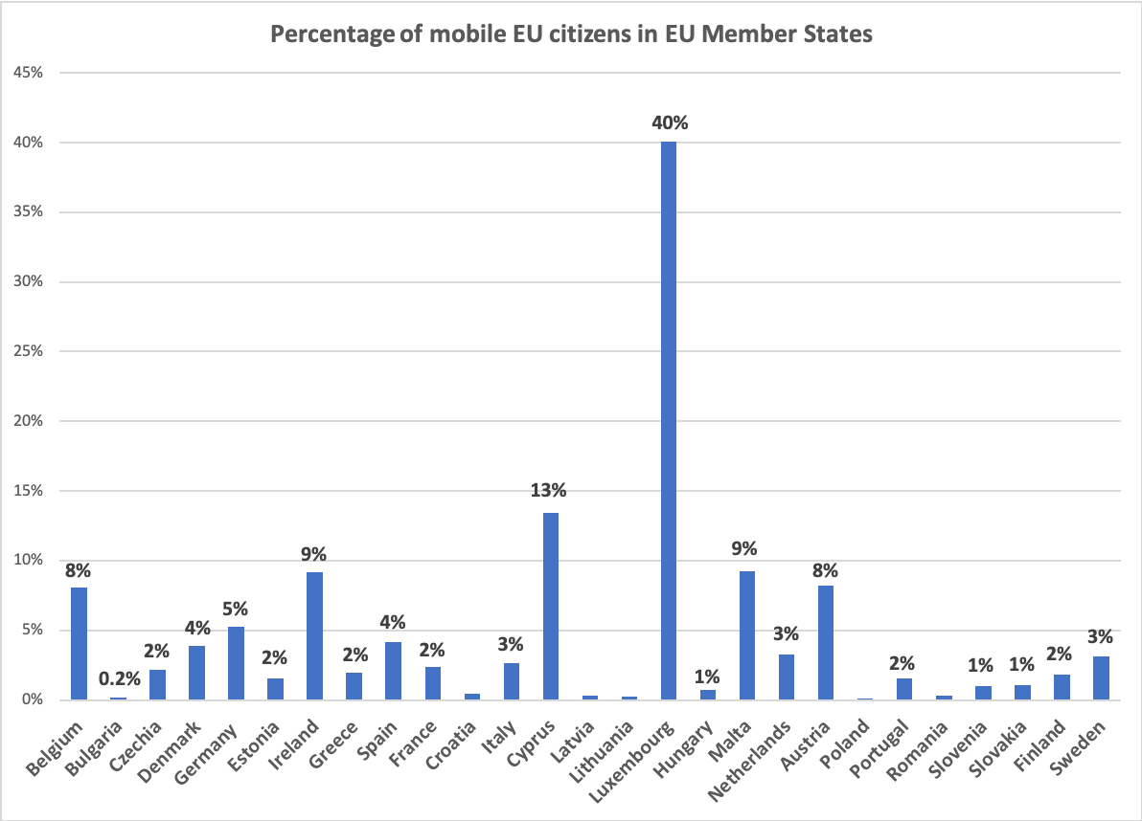

What are the population flows induced by the freedom of movement?
Figure 2: Main countries of citizenship of mobile EU citizens as a percentage of the total foreign population (as of 1 January 2019):
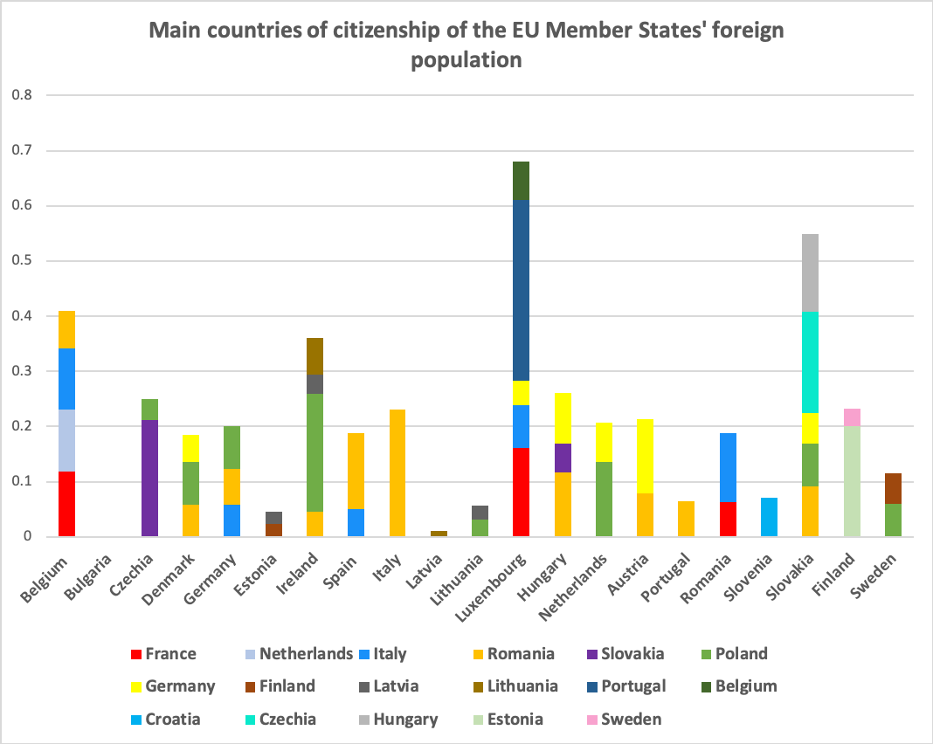

- AIMS

Our ECI strives to give real meaning to European citizenship and achieve better integration of mobile EU citizens in the democratic decision-making process in the EU. More particularly, it aims to:

RECOGNIZE: EU citizens automatically as voters where they reside and remove obstacles to voting and standing in elections across borders.

RENOVATE: Universal suffrage as a fundamental right and European value. EU-citizens should be able to choose whether to vote in their country of residence or in their country of origin for all elections and referendums.

- RESEARCH: The impact of such steps towards Universal Suffrage for EU citizens and how they could include third-country nationals.
There are two Directives governing the right of European citizens to vote and stand as a candidate: one detailing elections to the European Parliament (Directive 93/109/EC), and the other detailing municipal elections (Directive 94/80/EC). Both outline the requirements for access to these rights, the conditions, the exceptions and refer to the national registration processes. The fact that mobile EU citizens have these rights but do not seem to be using them (about 10% voted in the most recent 2019 elections) is a clear problem. This paper will outline why these problems exist, along with proposed solutions. Our proposals to strengthen the existing rights (point 2, Renovate universal suffrage) are:
- The supply of complete data and statistics by the Member States on turnout and registration of mobile EU citizens;
- To raise general awareness of European political rights by the EU and Member States;
- To establish an obligation for Member States to inform mobile European citizens individually and in their own language about their voting and eligibility rights;
- To make registration on the electoral roll automatic for all EU citizens in their country of residence (in good time before elections) in order to remove barriers to freedom of movement, unless they have chosen to vote in their country of origin;
- To create a helpdesk made up of a network of national electoral authorities and the Commission that must coordinate to share best practice and remove obstacles preventing mobile EU citizens from voting;
- To encourage Member States to introduce and share best practice on electoral reforms whilst also introducing the necessary safeguards to prevent fraud (e-voting, postal voting, more scope to vote early and where it is most convenient)
- To scale up partnerships with local authorities and civil society groups to increase turnout by reaching out to those difficult to reach: people in remote areas , mobile EU citizens, minority groups and those who feel cut-off from politics or face difficulties in voting because of a disability.
Our proposals for new rights concern the ability to vote and campaign in regional elections, national elections and referendums. EU citizens have the right to move, freely reside and work anywhere within the Union. However, upon residing outside of his or her country of origin, electoral rights are limited to municipal and EU elections. A gap in the system is evident, the non-national resident has no decision-making power to elect the government of the country that affects his or her life most. It is a clear case of “taxation without representation”. This is especially the case now in that the EU has become something akin to a transfer Union. With the recent €750 billion recovery package borrowed collectively by the EU on behalf of the Member States, the EU signalled its intention to develop new transnational solutions to its existing transnational problems. Applying this approach to the topic of this paper, a citizen whose country of origin is different from his country of residence should be able to vote in elections in his country of residence without facing the hurdles previously mentioned. According to the same reasoning, the case for the creation of transnational electoral lists for the European elections can also be made, a reform which has been widely supported by civil society and in the European Parliament. Should not Dutch citizen also be able to vote in national elections in Spain and an Italian in Belgium.
A 2020 Eurobarometer survey on “European citizenship and Democracy” showed that in 2020, 63% of respondents thought that EU citizens living in an EU country that is not their country of origin, should have the right to vote in national elections and referendums in their country of residence (Figure 3). Compared to the previous years when this question was asked, only small variations can be observed. A similar level of support can be observed in 2015, with 64%, whereas it was higher in 2012, with 67% of respondents who agreed with this statement. In 2020, a majority of countries share this opinion, and the highest level of support can be found in Ireland (77%), Spain (75%) and Portugal (74%). On the other hand, less than half of respondents in Sweden (35%) and Denmark (54%) support the idea. The socio-demographic analysis reveals that a majority of younger respondents aged 15-24 and 25-39 support the expansion of voting rights to national elections and referendums in the country of residence (77% and 68%). Older respondents aged 40-54 and above show a lower level of support (63% and 58%). No noticeable difference can be observed amongst different types of occupation or education, where the level of support fluctuates around 63%. This has important implications for the degree of inclusiveness of our ECI. In fact, this shows that our initiative does not cater to the interests of one particular socio-economic grouping within the population. While the different level of support based on age groups is significant, it is not surprising given that the younger generation of voters are more likely to use and benefit from the freedom of movement granted by the EU.
A similar level of support exists for mobile EU citizens acquiring the right to vote and stand in regional elections – 60% of respondents think they should have this right (Figure 4). Compared to 2015, the same percentage can be observed. However this represents a four percentage point decrease in comparison to 2012 (64%). A majority of countries agree, with 75% of respondents in Ireland, 70% in Cyprus and 69% in Spain. Only three countries do not share this view: Lithuania (43%), Denmark and Sweden (44%). Similarly to national elections, younger voters (68%) are more likely to support the expansion of voting rights in regional elections than older respondents aged 55 and above (56%). All types of occupations show support fluctuating around 60%. A small difference exists between respondents living in rural areas and those in large towns (57% against 63%).
The preference for voting in the country of residence exists also with regards to EU elections. In the same survey, 56% of respondents said that if living in an EU country other than their country of origin, they would rather vote in European Parliament elections organised in their country of residence (Figure 5). The largest proportion of respondents who share this opinion can be found in the Netherlands (73%), Luxembourg (72%), Belgium and Hungary (66%). On the other hand, Malta and Bulgaria show the least amount of support (both 40%) with Denmark (45%). The socio-demographic analysis shows that younger respondents aged 25-39 are more likely to agree (63%) than their older counterparts aged 55 and above (49%). Those who stopped studying aged 20 and above are also more likely to agree with the proposition than those who stopped at age 15 or 16-19 (45% and 54%).
The 2020 flash Eurobarometer on “European Citizenship and Democracy” is complemented by the information collected by a highly relevant, ongoing public consultation on the topic of ‘Justice and Fundamental Rights’. More specifically, on experiences and views on EU citizenship rights, with a focus on the right to vote and stand as a candidate in European Parliament or local elections, as well as experiences with discrimination on the grounds of nationality. Ending in October 2020, the collection of inputs from stakeholders will feed into the upcoming 2020 Citizenship Report.
Figure 3 : Support for EUMCs to acquire the right to vote in national elections and referendums in their country of residence
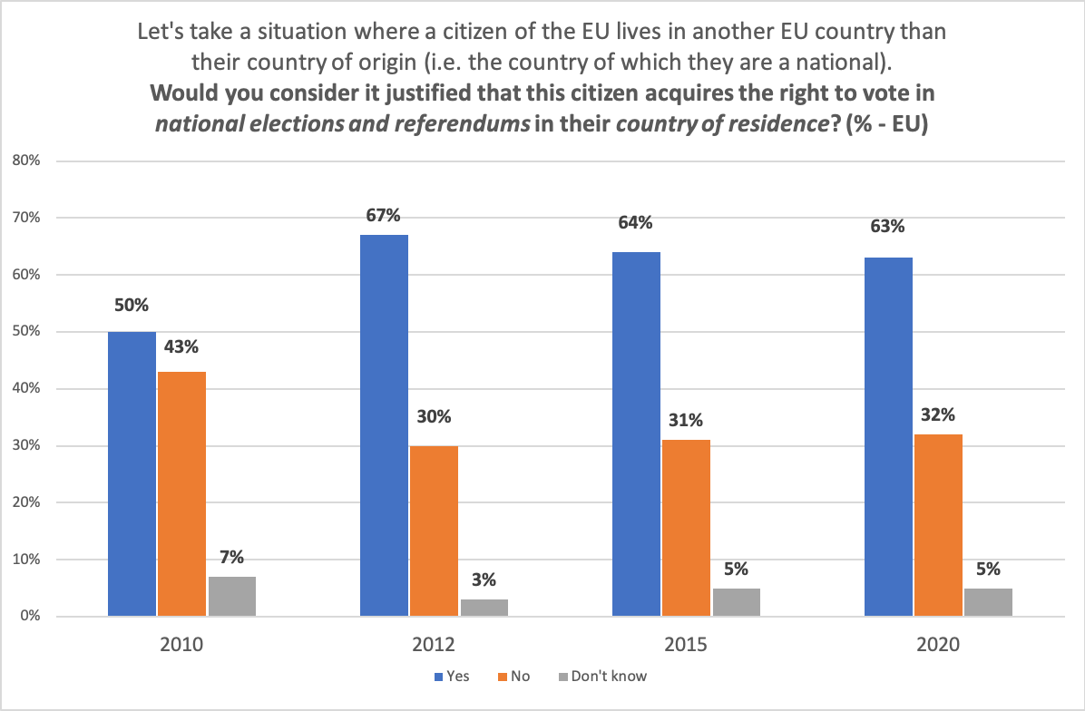

Figure 4 : Support for EUMCs to acquire the right to vote in regional elections in their country of residence
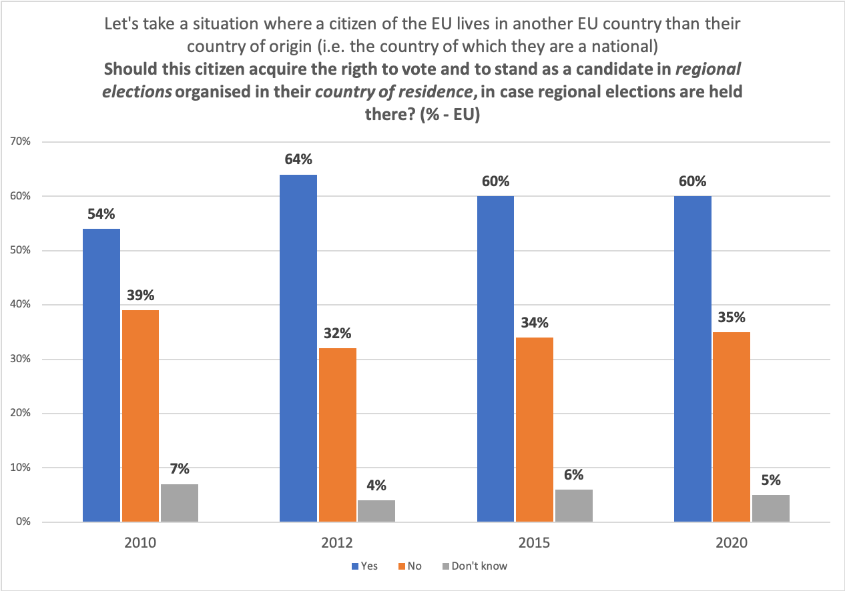
Figure 5 : Preferences in voting in country of origin vs country of residence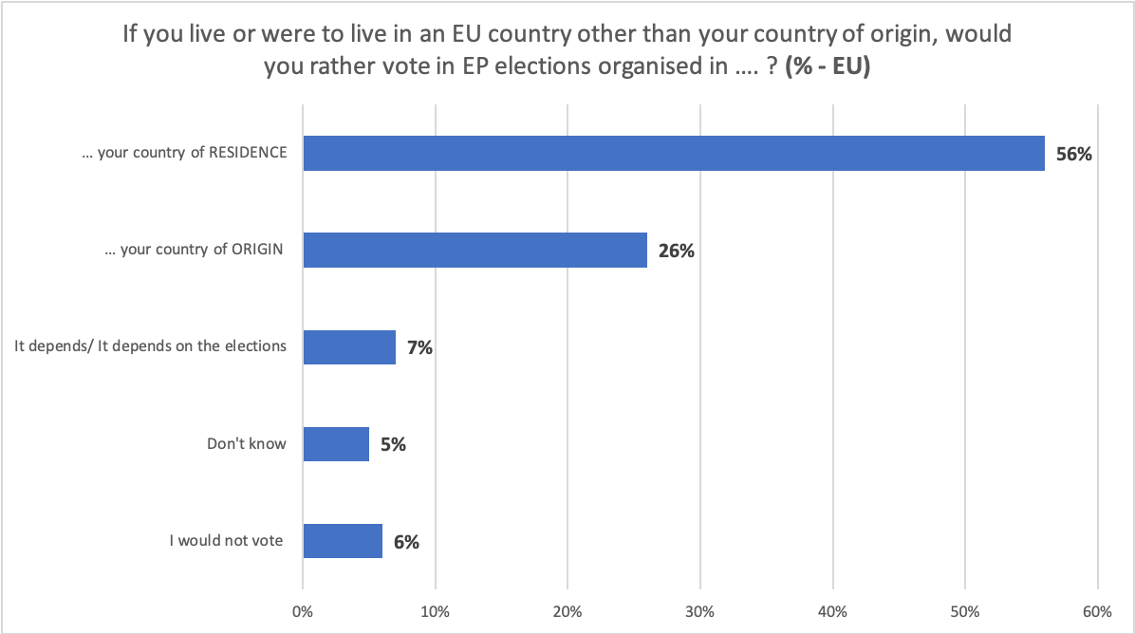Base: all respondents (n=27, 474)

III. EXISTING VOTING RIGHTS

In general, there are three stages for getting people to vote in elections: access to information on elections and registration; registering to vote; and actually voting. When mobile EU citizens come into the equation these three stages turn into a minefield. The two Directives regarding EU and municipal elections are not sufficiently prescriptive to be properly enforced, leaving far too much latitude to Member States.

1. EU Elections

a. Access to Information
There is a lack of information when it comes to mobile EU citizens’ voting rights. Though the Directive contains requirements for information that Member States should fulfil, these requirements are very weak and thus may often not be followed. The Commission recognises that voting is a sensitive issue for national governments, and so the Directives have been written with a light touch to allow each Member State to nationally orchestrate EU elections. Thus there are disparities between the depth of information each state provides, resulting in higher turnout rates in some compared to others.
There is an obligation on each Member State to provide information about elections to the general public (Proposal 2.), however this is seriously lacking, leading to large information gaps. The obligation to the general public is distinct from the proposed obligation to provide information to mobile EU citizens. It is distinct because information to mobile citizens must be individual and personalised rather than general. Despite this distinctiveness however, the provision of information to the general public must be coherent and complete in order to facilitate effective provision of information to mobile citizens.
Other pieces of EU law are a bit more prescriptive and should be looked at as regards what guidance should be provided in the Directive. An EU citizen’s right to vote has the same value as the right to move to and reside freely in another Member State - Directive 2004/38/EC. However, the distance between these two rights in reality is enormous. One is respected, verified, has a Directive, is often updated and is subject to vast research; while the other is gently brushed over. More legislative information is needed so that EU voting can function properly among Member States, especially for mobile EU citizens. 23 of the 27 Member States do not even share their data on mobile citizen voting behaviour, making it very difficult to know whether they are implementing the directives correctly. In addition, the Commission does not require, combine or store this information from the Member States. Hence it is impossible to fully analyse why mobile EU citizens will not and/or cannot vote in either their country of origin or their country of residence. Furthermore, it is difficult to find a way to improve coordination of registration and election information if we cannot access such data from all Member States individually (Proposal 1.).
The following are some real-life examples illustrating how some obstacles can prevent voters from accessing information:
- Daniela, born in Slovakia and living in the Netherlands, was unable to vote for Slovak candidates in recent European elections due to a lack of information and miscommunication from embassy officials. She stated that public authorities in the Netherlands were unhelpful. Despite voting by post in Slovak national elections, many postal votes for these elections got lost, miscounted or the official envelope was delivered too late.
- Jonathan Jacquemart was a candidate for a local election in Belgium two years ago. He went door to door to speak about a small party he joined at the time. As Brussels is at the heart of the EU, he expected the mobile European citizens to be exercising their right to vote in local elections. He was surprised to see that most of the people he talked to were actually not registered and did not really want to register. As a convinced European he thought this was a real shame because he believed that these citizens could bring change to local issues. He wrote to our ECI campaign to express that more incentives should exist for mobile European citizens to vote in their country of residence for local elections.
In our campaign with the Young European Federalists (JEF) Belgium, we also encountered dozens of EU citizens resident in Belgium who did not know that they could vote in Belgium rather than in their home country for EU elections. Many were also unaware of the early deadline,or did not know whether to go to the Belgian authorities or to their Embassy or consulate in order to register.
Member States often do not provide easy access to voting information. Mobile EU citizens encounter language barriers on national websites. The 2014 Parliamentary elections saw only six Member States address letters to mobile EU citizens in their native language to inform them of their rights. Greece differed and created an online platform to make it easier to access information. This means that 21 Member States did not fully follow the Directive.
The 2014 elections saw the European Citizen Action Service and European Alternatives work on a campaign to inform mobile EU citizens on how to access their rights. During the 2019 Parliamentary elections EU institutions also invested in providing better and more information to citizens on their voting rights. More comprehensive campaigns were organised this time around, such as ‘ThisTimeI’mVoting’. This helped to promote engagement with the elections, as well as the help desk ‘Your Europe’, which informed citizens of their rights (including, but not limited to mobile EU citizens). Though a step further in the right direction, there were still information gaps, especially for mobile EU citizens. This gap shows how vital it is that EU political parties extend their partnerships to civil society organisations that represent minorities and hard to reach groups (Proposal 3.).
b. Registration
Many people who have the relevant information encounter obstacles in the next step – actually registering to vote – and so just give up. In general, when an EU citizen is resident in another Member State he has to manually re-register to vote in that country. The problem with this is that as well as language barriers, there are other hurdles which deter a substantial number of potential voters from EU elections. Deadlines are often not communicated clearly, nor is the administrative process to complete registration, e.g. mobile EU citizens may not know where they can actually register if they are voting in their host country; or they may not know where to register if they are voting via post in the country of origin (embassy, consulate etc.).
The following are some real-life examples showing obstacles to registration.
- Katarzyna Hooks was born in Poland but lives in Toulouse, France. She tried to register to vote in Toulouse last year, sending all of the necessary documents through the government website. She received a reply from her local City Hall expressing that proof of her address was not acknowledged. No explanation was provided for this. They also stated that she could not re-apply during the following two weeks which in fact prevented her from being able to vote in the first tour of elections. Alas, despite her knowledge of the French language and the procedures, she was prevented from registering to vote.
- Claire, born in France and living in Latvia wanted to vote in her country of residence for local and EU elections, but she was not allowed to vote in local Latvian elections. She did not receive information about voting and the administration responsible simply said that “it is not possible” when asked about this. She was thus not able to register.
- Laura Caputo was born in Italy and is a resident in Ireland. She discussed the difficulties she faced in Ireland, especially the ones in relation with the office hours when she could go and register. The hours that the office was open made it so that she could not vote in the most recent elections. Further, the previous year she could not vote because the register for Italians abroad was very slow in updating addresses when a citizen moves to live abroad. She states how her voting papers physically were sent to her old address in France – her previous country of residence.
Currently only three countries in the EU implement automatic registration: Lithuania, Romania and Latvia. A majority (60%) of Member States employ one-off registration for its citizens and 15% of European countries still require citizens to systematically re-register when they wish to vote in local and European elections. Therefore, registration systems vary greatly across Member States, leading to much difficulty for mobile EU citizens. As outlined already, information on registration for these citizens is often sparse, not easily accessible or not available in their mother tongue (Proposal 3.). With the appropriate safeguards and transitional periods in place, harmonising methods of registration across Member States would therefore help mobile EU citizens make use of their voting right.
A caveat to automatic registration is that mobile EU citizens should have the choice of whether they want to register for an election at home or in their country of residence. Automatic registration can have the effect of denying citizens this choice. There is a risk that if one becomes registered automatically in one’s country of residence, one can find oneself disenfranchised in all elections back in the home country due to the way Member State electoral authorities cooperate to avoid double-voting. It is important to insist on automatic registration in the country of residence whilst still preserving the right of the citizen to vote where he or she wishes (Proposal 4.).
Innovative solutions have to be implemented in order to facilitate the registration of mobile EU citizens on the electoral roll for EU elections. Automatic and online registration methods in all Member States would greatly encourage the participation of non-national EU citizens and reduce the difficulties associated with the administrative processes. In the 2020 European Citizenship and Democracy Eurobarometer, 68% of respondents said that if “voter registration could be easily done online” they would be more likely to vote in European elections. Extending automatic registration of EU citizens newly residing in a different Member State is made possible by the Directive on European Parliament elections, which details that “Member States have the option to allow automatic registration for non-citizen residents, provided that voting is not compulsory”. This “option” should be an obligation on Member States to allow for automatic registration (Proposal 4.).

2. Municipal Elections

a. Access to information
Every citizen of the Union has the right to vote and to stand as a candidate at municipal elections in the EU country in which he or she resides under the same conditions as nationals of that country. The main problem with the existing rights to vote and to stand in municipal elections is the deficit of information. There is even less of a requirement on Member States to provide certain information for mobile EU citizens for municipal elections, than what is required in the directive for EU elections.
In 2012, 66% of respondents in an Eurobarometer survey on electoral rights demonstrated awareness of the right for a mobile EU citizen to vote and stand as a candidate in municipal elections. In a 2020 survey, only 54% of mobile EU citizens know of their right to vote and stand as a candidate in municipal elections. This means that almost half of EU citizens do not. In comparison, 71% of respondents are aware of their right to vote and stand in European Parliament elections. This difference shows the necessity for EU citizens to be educated and informed on their political rights. It also shows the need to spread awareness on the topic, with more data and research done on exactly how many mobile EU citizens exercise their rights for municipal elections (Proposal 2.).
- Pasquale Lisena was born in Italy but resides in France. For local elections he voted in France. He had to compile an online form and send some documents for registering. He states his doubt about how this process worked as he did not find any ‘instructions’ on the web.
- Kevin Wyckmans is a Belgian citizen but lives in Sweden as a full tax resident. Even though he may not stay there long-term, he thinks that he should be able to influence local government for the time he remains, since what they decide can have a large impact on him. It is clear from Kevin’s statement that the information hasn’t been clearly available to him as to what his rights are in terms of voting locally and what the procedure is.
In coordination with our proposals for EU elections, personalised emails or letters should be sent to mobile EU citizens to ensure that they can also engage with their municipal voting rights, as well as the establishment of awareness raising campaigns (Proposal 3.). Further, our idea of a help desk (detailed in Section V.1.) will be fundamental to informing such voters (Proposal 5.).
b. Registration
If you want to vote in municipal elections in the country where you live, you first need to express your intention to do so and apply to be put on the electoral roll in that country. You will be asked to supply information such as your nationality and address. Registration on electoral rolls is automatic in Austria (except Burgenland), Denmark, Estonia, Finland, Germany, Hungary, Latvia, Lithuania, Malta, the Netherlands, Romania, Slovakia, Slovenia and Sweden. So once registered as a resident, you are on the electoral roll for municipal elections. In countries where voting is compulsory, you are included on electoral rolls upon your own request.
The conditions to vote and stand in elections differs between Member States. For example, in Sweden you can vote in the municipal and county council (regional) elections if you are: a Swedish citizen aged 18 or over; an EU citizen; a citizen of Iceland or Norway; or are a citizen of a country other than those listed above and you have been registered in Sweden for 3 consecutive years before the day of the elections. You must meet the same conditions as the right to vote in order to stand for elections. To stand you must make a declaration that you are not disqualified from standing as a candidate in your home country. In some Member States you may be asked to support this declaration with proof issued from your home country. Also, in some Member States you may be elected to a counsellor’s position, but only nationals can become mayors. In some states, the positions of deputy mayor and member of the mayor’s executive committee are also reserved for nationals. Data provided by Member States shows that an overall low number of mobile EU citizens make use of their right to stand in local elections in their country of residence, as shown by the graph below (Figure 5). It can be observed that the numbers of mobile EU citizens elected are also very low despite the high total number of EUMCs who presented themselves as candidates. Very little data is available on the number of EU citizens who are non-nationals standing as candidates. Except for the 8 Member States presented in the graph below, data is missing for the 19 other Member States in the EU. As explained by a 2018 Commission Report, Member States indicated that they do not collect such data, as it is very difficult to obtain.

Figure 6 : Number of EUMCs standing as a candidate and elected in their State of residence (Based on data provided by Member States)
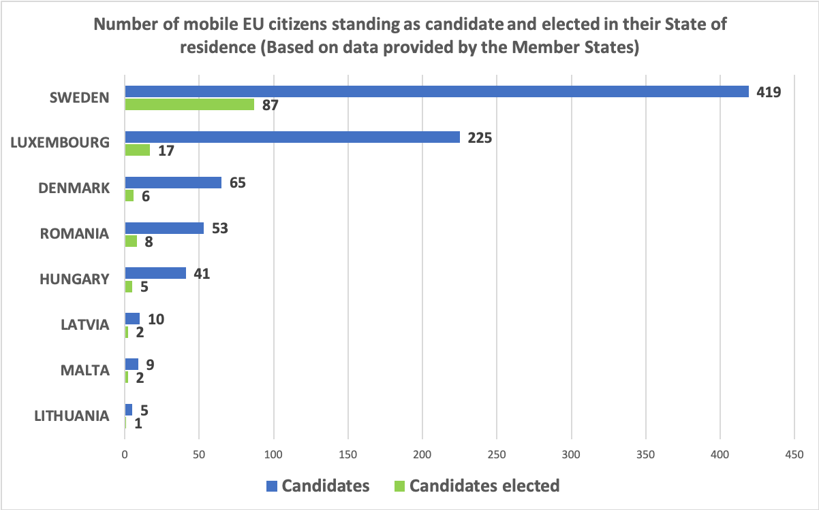
The following is a real-life example showing obstacles to registration in municipal elections:
- Mal Murphy is an Irish woman living in Spain. When she initially registered (part of the empadronamiento help system in Spain) she was told that she would be on the register within a month. However, she received news that since she was not Spanish, it would take a year and not a month for a non-Spaniard to be put on the register. She was thus not able to vote in that year’s local elections. She added that she also had a problem with voting in regional elections in Ireland as there is no postal voting system for Irish citizens abroad.
Data from 2018 provided by Member States shows a large discrepancy between registration rates for mobile EU citizens in municipal elections in countries which do not enrol citizens automatically and the ones that do. In Member States where registration on the electoral roll is not automatic, data shows that only 18.5% of mobile EU citizens, who were residents requested to be on them. This low number is representative of the difficulties encountered by mobile EU citizens when registering on the electoral roll. On the other hand, in countries where registration is automatic, a registration rate of 100% can be observed for these citizens in some countries (e.g. The Netherlands, Hungary, Latvia) (Figure 6).
Figure 7 : Percentage of mobile EU citizens registered to vote in municipal elections (Data provided by Member States)
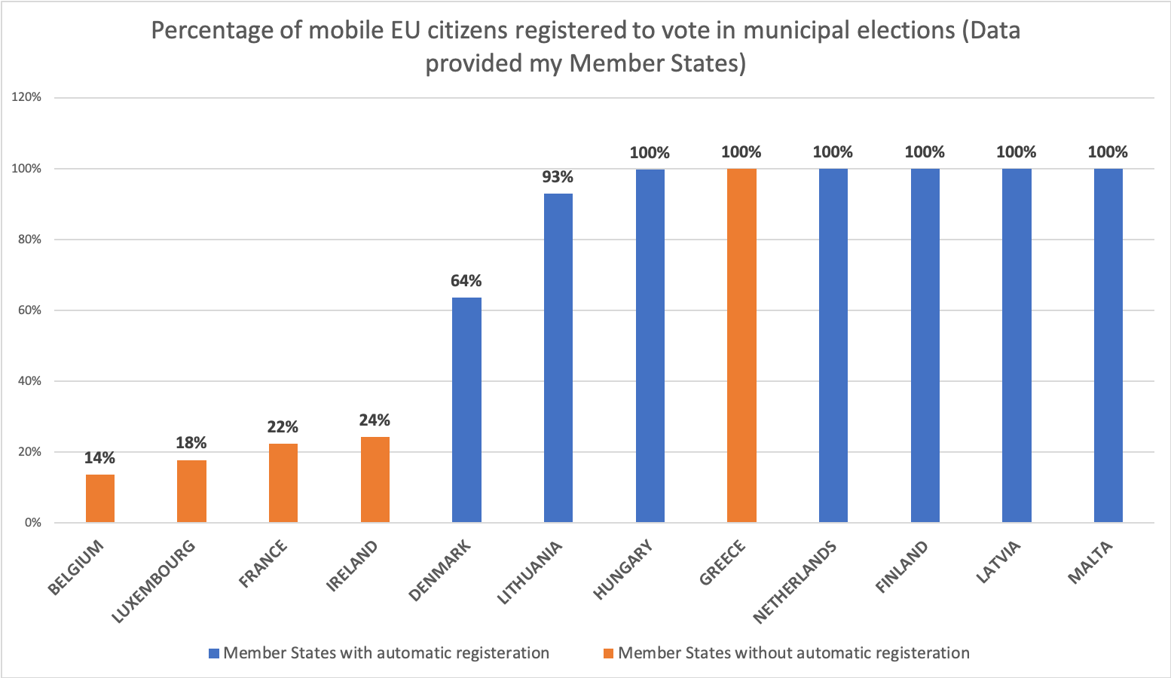

Currently, only 13 countries in the EU implement automatic registration for non-national EU residents in local elections. Some Member States which practice automatic enrolment oblige mobile EU citizens to register their residence, others do not. Therefore, in Member States where registration is not obligatory the number of mobile EU citizens on the electoral roll will differ from the number of who are residents. In coordination with EU election proposals, harmonisation of automatic registration for municipal elections would greatly improve the democratic process for mobile EU citizens (Proposal 4.). However, the need for adequate safeguards has to be acknowledged as regards providing choice to mobile EU citizens, facilitating transitional periods prior to implementation, and respecting the fact that municipalities vary greatly between and within each Member State (Proposal 6.).

IV. ADDITIONAL VOTING RIGHTS

1. Regional Elections

Since the Maastricht Treaty, regions have gained more importance. Many services are done on regional or city boundaries, for example transport, which functions better on a larger economic scale. EU cities are competing against each other rather than just nationally. Localities are moving to city level, therefore, it is natural that politics should catch up. Mobile EU citizens should be able to vote at regional level. This is especially important considering the fact that most mobile EU citizens are concentrated in larger cities. For example, in Brussels there is an argument for extending the vote from 19 communes to 1 – this is now in the hands of the Federal Government to decide. Giving such a right to vote and stand in regional elections would essentially be an extension of municipal voting rights. It is well-established that if living in a place, one should be able to vote there. Indeed, in the past ‘place’ was defined as the locality, however now the locality is larger, and so ‘living in a place’ often refers to their region. While mobile EU citizens are entitled to vote in their municipalities, some exceptions exist in larger cities. As an example, Vienna is both a province and a municipality, as are Berlin and Hamburg. Since mobile EU citizens are not allowed to vote in regional elections, they are therefore stripped of their right to vote in these cities. In terms of the number of voters impacted by this disenfranchisement, Berlin is the European capital with the second most mobile EU citizens after Paris. A total of 240,000 EU non-nationals resident in Berlin are unable to have a say in matters that impact them directly. Similarly in Vienna there are around 210,000 EU non-national residents - this is almost 50% more mobile EU citizens than it’s national percentage. The personal stories collected through our facebook page presented below illustrate this situation:
- Peter, born in Denmark but living in Austria wrote to us explaining his position. In Austria one has to be an Austrian citizen to vote at provincial level. However, Vienna is both a city and a province, and therefore he cannot vote in either municipal or provincial elections. In addition, Denmark does not allow non-resident citizens to vote for local elections. As a result, he is not eligible to vote anywhere.
- William is also a Danish citizen, resident in Austria. He has faced problems when voting in local/regional elections. Due to Vienna being both a city and a province he could not vote. Again, Denmark does not allow citizens not living in Denmark to vote in elections, thus he was stripped of the right to vote in both countries.
The role of the region was emphasised as early as 1993, when the Maastricht Treaty established the Committee of the Regions. Provisions of the Lisbon Treaty also increased demands for parliamentary participation by sub-national parliaments. In practice, more and more authority is becoming decentralised to sub-national levels of government. If we look at last year’s regional elections across Europe, turnout was very high: Faroes (Denmark) 90%, Brussels (Belgium, which has obligatory voting) 84%, German speaking community (Belgium) 86%, Flanders (Belgium) 92%, Wallonia (Belgium) 87%, Navarre (Spain) 72% and Sardinia (Italy) 54%. This year, even despite Covid-19 the percentage was quite high. In the Basque country the turnout was 53%, in Galicia 59%, and in Vojvodina (Serbia) it was 51%.
By removing the barriers to vote in regional elections residents will have a better say on how their lives are organised and on how significant decisions are made. In countries such as Sweden and some cities elsewhere the franchise of voting in regional elections has been extended to mobile EU citizens. In the Brussels Region, a motion has passed entitling both European and non-European voters resident in Belgium for at least five years to vote at regional level. Though a great feat individually, this is not enough for all of the mobile EU citizens living outside of the Brussels Region. The exclusion of mobile EU citizen residents in any region undermines the legitimacy and accountability of the region’s institutions, as well as the social cohesion within that community.

2. National Elections

Member States have different restrictions on national voting as well as conditions for naturalisation. Non-national residents, who are also European citizens, who pay taxes and contribute to the development of their community, should be able to participate in public life through the electoral process. For instance, in Luxembourg mobile EU citizens represent approximately 40% of the population. For them, giving the right to vote would considerably change the results of the national elections.
Article 18 of the TFEU reminds us that “within the scope of application of the Treaties, and without prejudice to any special provisions contained therein, any discrimination on grounds of nationality shall be prohibited”. In general, the principle of non-discrimination is fundamental to the EU. It is what makes freedom of movement possible, to ensure equal rights for mobile EU citizens and nationals. However, here lies a democratic deficit: they are discriminated against when it comes to having a political say.
- Victor is a Belgian citizen living in Madrid since 2004. He thinks one should be able to vote in the country where they live, work and pay taxes, as this is where a resident’s interest, time and money is being invested as a member of the community. He stated that he would rather vote in Spain than in Belgium (where he is still legally obliged to vote) as he is not up to date with Belgian politics.
- Danielle Gouwens is a Dutch woman living in a small village in the Lecrin Valley in Spain. She has been a resident for 18 years, and has paid her taxes there ever since. She owns a house and runs a business, however she does not have any say in what her taxes are spent on. She has no possessions in The Netherlands, yet is allowed to vote there. “So yes, it is about time something is changed”.
- Monique Zondag is a Dutch woman also living in Spain. She has lived and worked there since 1985, paying taxes and owning property. Still, she is only allowed to vote in EU and municipal elections. What happens on national political level in Spain concerns her very much and she feels that it is completely unfair that after 35 years living in Spain she cannot have a say in things that concern her directly. “Let’s see if we can make a change all together”.
- Julie Pelce, from France but living in Luxembourg expressed how she did not vote in the local French elections since she does not feel like their outcome would affect her, and she is not aware of local issues there. She is aware that she can vote in local elections in Luxembourg, but not in national elections where she would like her voice to be heard.
- Anne, from Denmark but living in Spain expressed the problems she has voting in regional and national elections. As she was not sent by a Danish company nor is she a government official, she does not have the right to vote in elections held in Denmark. She understands the policy of her country and does not intend on moving back so it makes sense to her that she should not have a say in the politics there. She wishes that EU citizens would be able to vote in Spain, when they live there permanently, work and pay their taxes, without having to acquire Spanish citizenship.
Not being able to vote in [regional,] national elections [and referendums] has left mobile EU citizens on the edge of the society that they contribute to. The main danger is that voters who are initially eager to vote become apathetic through facing insurmountable obstacles to exercise their democratic right. We have to remember that voting is not a privilege, it is a right. Member States should remove the restrictions of nationality and enable voting for residents in order to work towards a more modern and inclusive democracy.
The opposing argument for allowing mobile EU citizens to vote in national elections essentially is that they should just acquire citizenship if they want to vote. Brexit showed how naturalisation across different EU countries greatly differ. The Commission issued a recommendation that people should be allowed to at least vote in national elections back home. Some mobile EU citizens face disenfranchisement because they can no longer vote in their country of origin and also cannot vote in their country of residence. In Ireland for example, after being resident in another country for 18 months, one cannot vote back home. In the UK, expats cannot vote back home either after living for 15 years and over in another country. This was a major issue that influenced the Brexit referendum. Although no longer in the EU, a recent law was introduced in Scotland and Wales that allows citizens of another country living there to register to vote. This makes it clear that allowing resident non-citizens to vote is not a major change to introduce.
- Ralph Smith was born in the UK but lives in Spain. He has been in Spain for over 15 years and so has lost the right to vote in UK elections. In addition, as a non-Spanish citizen he cannot vote in National and Comunidad elections in Spain. He has exhausted all domestic remedies (i.e. every possible avenue in Spain to access the right to vote). He brought a case to the Spanish Supreme Court which he lost as the Spanish Constitution states that only citizens have the right to vote in those elections. He has stated that his point wasn’t really to get at the Spanish, but to get at the UK government. He then lodged a case with the European Court of Human Rights. The ECHR has told him that the case is in the queue and not to contact them, as they will contact him when there is an update. There is a 5 year wait to have an ECHR case heard, and his case was submitted 3-4 years ago.

3. Referendums

From 1992 until 2020, 63 out of the 121 referendums held in Member States in the EU have been directly related to the EU or to EU shared competences (Figure 7). In addition to not being able to vote in national referendums, mobile EU citizens were stripped of their right to have a voice in EU-related referendums, which represents 52% of the total number of referendums that were held since the implementation of the Maastricht Treaty in 1992. In addition to being deprived of their say on national matters that directly affect them in their country of residence, mobile EU citizens cannot influence matters on which all European citizens should have a say on. During the same period, Ireland has organised a total of 6 referendums, while Denmark and Switzerland have organised 4 each.
Figure 8 : Types of referendums in EU Member States since 1993 (Maastricht Treaty)
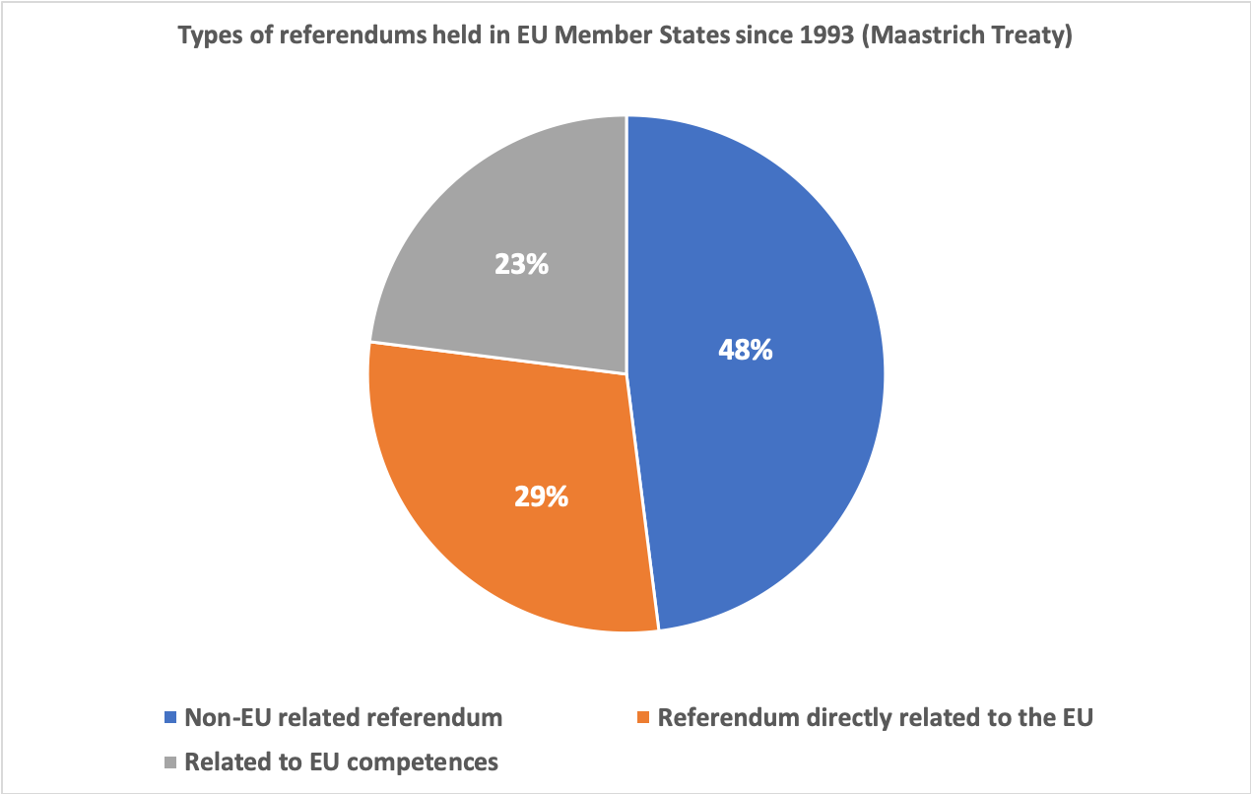

At the time of the 2016 referendum for UK membership of the EU, an estimated 1.3 million of British citizens born in the UK lived in other EU countries. Those who live abroad for more than 15 years lose their right to vote in UK elections and referendums. 60% of these 1.3 million British citizens living in the EU were not able to have a say on the subject of Brexit. In addition to that, about 3.7 million non-national mobile EU citizens resident in the UK did not have a say either on a matter that wholly affects them - only Maltese and Cypriot residents could vote as they are members of the Commonwealth. This kind of legislation not only infringes the right to vote, but also the freedom of movement. The result of the referendum could have been different if mobile EU and UK citizens had had the right to vote.

V. ACCOMPANYING MECHANISMS

1. Help Desk

There is a cascading system of help desks for rights within the EU. The idea is if you have a basic information question, you go to ‘Europe Direct’; if the question is more difficult you are transferred to ‘Your Europe Advice’ (a team of about 60 legal experts operating very centrally); if that does not work your query is sent to ‘SOLVIT’. With ‘SOLVIT’ you submit a request, for example, saying that you were refused registration in your country of residence. ‘SOLVIT’ has ten weeks to come up with a remedy by contacting the authorities in both your state of origin and residence. This list of help desks deals with EU rights generally, and so needs to be updated by setting up another help desk to deal very specifically with political rights of the 14 million mobile EU citizens (Proposal 5.). The idea was flagged by the Commission in the 2019 Commission report on the EP elections, and public attitudes towards it were later explored in the Eurobarometer Survey on European Citizenship and Democracy. In it 65% of respondents say that if “citizens can contact a helpdesk that provides information on European Parliament elections and voting procedures”, they would be more likely to vote in the European election. Younger respondents aged 15 to 24 are more likely to share this opinion (74%), compared to their older counterparts (66%).
Cooperation and information-sharing practices between Member States needs to be strengthened in order not only to enable help desks but also to collect better data on the registration and turnout of mobile EU citizens in elections. As the staff working paper accompanying the Commission Report on the 2019 European elections highlighted, most Member States do not collect data on effective turnout of mobile EU citizens that registered to vote. In addition, a number of Member States have failed to respond to the Commission’s 2019 questionnaire aimed at collecting important data, especially on resident non-national EU citizens and those on the electoral roll in their host country. The provision of this type of data is crucial for the Commission to design more efficient policy solutions (Proposal 1.).
Member States are already obliged to share information on mobile EU citizens’ voting and candidacy behaviour to combat issues like double-voting, election interference, as well as the spread of disinformation across the EU. In the election package adopted by the Commission in September 2018, particularly in its Communication and Recommendation, it encourages Member States to create national election networks, which would include national authorities with relevant competences for electoral issues and authorities in charge of monitoring and enforcing rules related to online activities relevant to the electoral context. These networks serve to exchange information on best practices and reinforce coordination amongst Member States (Proposal 6.). It can thus be assumed that they would also be able to improve their coordination efforts and control the proposed help desk via national electoral authorities.

2. Innovative Ways to Encourage Turnout

The Covid-19 pandemic has resulted in many obstacles for managing elections and sustaining fair democracy in 2020. Fears associated with the propagation of the virus as well as the various measures taken, had an undeniable impact on the turnout for the elections that went ahead, such as the French municipal elections in June. These featured a very low turnout compared to the 2014 municipal elections. The first round of the elections was held the day before the implementation of the nation-wide lockdown in France and reached a turnout of 44.6%. It decreased even further in the second round to 41.6%. During this crisis many elections and referendums have been held by postal vote, postponed or put on hold. By doing so, some governments suspended some of the most important democratic freedoms of movement and assembly. It could be argued that the pandemic undermined the exercise of democracy in a number of Member States. The situation we are currently facing therefore calls for the development of new, innovative ways which will ensure that the voice of EU citizens count, and that they will be able to exercise their political rights at every level, (Proposal 6.). In the second decade of the 21st century the internet should no longer be an alternative, but a main course of action. As new technologies are becoming increasingly prominent in our current society, there is great potential for the digitalisation of electoral processes and represents a crossroads for representative and participatory democracy.
‘E-voting’ refers to the use of electronic means for voting and counting in a controlled or uncontrolled environment. The use of e-voting in political elections and referendums is covered in Recommendation CM/Rec(2017)5 of the Committee of Ministers to Member States. Four in five young people (80%) in the EU aged 16 to 24 have basic or above basic digital skills. A Special Eurobarometer survey showed clear preference for e-voting, a majority of 42%, if they lived or were to live in an EU country other than their own. Voting in their country of origin’s embassy or consulate remains to be the preferred way of voting for 27% of respondents, and 14% favour postal voting. A socio-demographic analysis reveals that 55% of respondents aged 15 to 24 are likely to favour e-voting to other methods. In almost all Member States the percentage of individuals with digital skills is above 50%, especially in Germany (70%), Sweden (72%), Belgium (61%) and the Netherlands (79%). In Estonia 26% of citizens use the internet for taking part in online consultations or voting. It is the most prominent case of successful implementation of internet voting. In the 2015 Estonian parliamentary elections around 30.5% of participating voters chose to vote online.
E-voting increases political participation. It makes voting less costly and more convenient especially for minority groups like voters with limited accessibility to traditional polling places: disabled citizens, elderly, citizens who work on election day, voters living further away from polling places and voters from abroad. A number of concerns surrounding the practice of e-voting are highlighted by public opinion in the Special Eurobarometer 477 survey: the potential for fraud or cyberattack; difficulties of use for certain people, such as the disabled or elderly; voters being influenced by third parties; and, the secrecy of the ballot. These are legitimate concerns which need to be acknowledged when designing new electronic methods of voting. It has become clear that an e-voting system can only be introduced in a country if voters have trust and confidence in their electoral system and in electoral administration. The present recommendation does not require Member States to introduce e-voting. Rather, it establishes standards which harmonise the implementation of principles of e-voting for elections and referendums. More could be done to encourage such usage. Our suggestion is that Member States should promote advance voting, postal voting, electronic voting and internet voting (Proposal 6.). Where they do so, they must ensure the reliability of the result, the secrecy of the vote and the protection of personal data
To reach hard-to-reach groups such as EU citizens (proposal 7) such innovative ways to make voting easier and overcome barriers of distance, language or physical barriers such as disability are particularly relevant. It is not so much a question of special measures for minority groups: if measures work for them they will be useful for the rest of the population as well. But more targeted grass-roots outreach is also needed. There are examples from the campaign and volunteering in the run-up to the European and other elections of best practice by local authorities and civil society going out to meet voters rather than expecting them to participate. If this practice was encouraged and included in the reform of the EU directives on political rights, it could be scaled up and make more impact.

VI. RECOMMENDATIONS AND CONCLUSION

Reforming Rights

The following is a sum up of our proposals as outlined and elaborated on throughout this paper.

- Member State Supply of Data and Statistics
Member States should set up a system to supply data and statistics on turnout and registration of mobile EU citizens in order to design more efficient policy solutions.

- Raise Awareness of European Political Rights
There should be general awareness raising campaigns organised by the EU and by each Member State in which mobile EU citizens are encouraged to exercise their right to vote. These campaigns should be similar to the ones that encourage young people to vote, like those before the 2019 European Parliament elections.

- Inform EU Citizens Individually in their Own Language
The establishment of an obligation for all EU Member States to inform mobile EU citizens individually, in their own language about their voting rights and eligibility. Information should be personalised, whereby every eligible citizen gets a reminder to register to vote by post or by email.

- Automatic Registration and the Choice of Where to Vote (Origin or Residence)
Having automatic and online registration in all Member States would greatly encourage the participation of non-national EU citizens and reduce the difficulties associated with the administrative processes. Mobile EU citizens should have the choice to register, as they wish, either in their country of residence or in their country of origin for each type of election. It is important to state at this stage that we are not proposing complete harmonisation for municipal elections, as this would neither be effective nor efficient because municipalities vary greatly, not only across the EU but even within some Member States.

- Create a Help Desk
Our proposal for a help desk is essential in order to facilitate the spread of information and awareness of voting rights amongst mobile EU citizens. The help desk should deal precisely with mobile EU citizens and should be inserted directly into the new legislation. Migration flows should influence where exactly the help desk should be in each state or region, and which regions do not require a help desk due to lack of mobile EU citizens present. It should be proactive in informing mobile EU citizens of their rights, by hosting information sessions and reaching out to mobile EU citizens individually. The help desks should coordinate with their counterparts in other regions and Member States and work together to provide advice to people on voting at home or in their country of residence (quite like ‘SOLVIT’). The network should consist of the country of origin help desk, country of residence help desk (both set up by the national electoral authority) and the Commission, with an 8-week deadline for solving cases, except if finding a solution is more urgent in the run-up to an election .

- Introduce and Share Best Practice for Electoral Reforms and Safeguards
In pursuit of a more general appeal to make voting easier, renewing the current voting legislation should encourage Member States to develop new voting methods. There are a number of concerns around the practice of electronic methods of voting, these being the potential for fraud, cyberattack and GDPR issues. We recommend that in the transition to e-voting, Member States should put safeguards in place relevant to the particular Member State’s citizens’ concerns. As the first generation to have grown up with the internet it is clear to us that voting via the internet is the way forward. Although new forms of safeguards need to be developed and put in place, it does not mean that e-voting is any way less safe than current systems in place, it is merely a different system that requires different watchdogs.

- Introduce New Voting Methods for Greater Scope and Convenience and Other Ways to Reach Minority Groups.
Inaccessibility of voting facilities and low turnout is not only a problem with mobile EU citizens, ethnic and religious minorities, but with all minorities at all elections. This includes voters with disabilities, voters residing in retirement homes or remote geographical areas, patients in hospitals, voters from disadvantaged backgrounds and voters who work on election day. Often disabled people are excluded from activities in the community, this does not mean that it is okay to exclude them from building a democratic society. For example, braille templates for ballot papers, audio recorders at polling booths, and voting instructions written and read in different languages could be provided. Most Member States do not realise that by forgetting to facilitate these needs in basic voting processes, they are losing voters.

Full political rights will only be secured when everything necessary has been done to ensure that the rights introduced by the Maastricht Treaty are used and that the problems of lack of universal suffrage and disrespect for the principle of no taxation without representation are overcome.

Extending Rights

In order to fully affirm a non-discriminatory voting system in the EU, mobile EU citizens need to be able to vote in regional, national elections and referendums.

- Regional voters are contributing to an important part of developing a connected EU.
Since 2010 public opinion (a majority of 60%) has been in favour of mobile EU citizens voting and standing in regional elections. As implied by the 2019 Commission post-election report, it is clear that the current system in place does not work. As long as voting rights for mobile EU citizens are only partial, they will never be fully used and they will not be able to tap into the potential that these offer for a fairer and better democracy (as seen in the personal stories throughout this paper).

- The coronavirus pandemic heightened the need for more solidarity within the EU. The recent €750 billion recovery package borrowed collectively by the EU on behalf of the Member States will help develop transnational solutions to its transnational problems. A similar approach should then be taken in the face of the obstacles mobile EU citizens encounter when voting. An EU citizen whose country of origin is different from his country of residence should be able to vote and have an actual stake in society. It is a clear case of taxation without representation.

- In relation to referendums, 63 out of 121 referendums held in Member States have been directly related to the EU or to EU shared competences. As a result, mobile EU citizens have been stripped of their right to have a voice on EU related matters because the matters were dealt with in referendums. Not being able to vote in referendums has had a large effect on particular issues, like Brexit in the UK, as well as for Ireland where ratification of any significant amendment to the Treaties of the European Union requires an amendment to the Constitution of Ireland. Legislation that does not allow mobile EU citizens to vote in referendums not only infringes upon the right to non-discrimination on the grounds of nationality, but also on the freedom of movement.

EU citizenship does not replace national citizenship. Not being able to vote in regional, national elections and referendums has left mobile EU citizens on the edge of the society that they contribute to. The danger associated with a lack of inclusivity in a democracy is that its participants become increasingly disinterested and apathetic. Although much can be done to improve enforcement of existing rights, it is only when people have full political rights that they become more invested in elections and gain more attention from political parties. The impact of extending rights will be very different from one place to another, and so these additions need to be developed over a period and with great care.

ECIT Foundation 2020, viewed 17 August 2020, < https://ecit-foundation.eu/eci-proposal-1>
Given the difficulties of collecting signatures face-to-face because of COVID-19, the Commission might grant a further six months.
European Commission, 2020, Flash Eurobarometer 485, Eurobarometer surveys. [online] European Commission. Available at: <https://ec.europa.eu/commfrontoffice/publicopinion/index.cfm/ResultDoc/download/DocumentKy/90368> [Accessed 22 July 2020]
Voters Without Borders 2020, Background Document - Why this European Citizens’ Initiative?, <https://app.luminpdf.com/viewer/5f3ba436286c5000147d41a9> [Accessed 18 August 2020]
The right to propose a European Citizenship Initiative (ECI) is derived from citizenship, introduced by the Lisbon Treaty. It consists of the right of EU citizens to submit a proposal to the Commission, after collecting at least one million signatures, on a legal act of the Union.
Article 22 TFEU. This right to vote and stand for election in municipal and European elections in the country of residence is in itself based on the principle of non-discrimination on grounds of nationality, according to which the resident citizen has the same rights as the national citizen.
Although governments were enthusiastic, public opinion was very much concerned about where this step forward to European integration would eventually lead, thus making the ratification of the Maastricht Treaty more difficult. After Denmark’s initial ‘no’ to the Treaty other countries saw opposition to the Treaty grow. In France, Britain and Germany there were concerns over the Treaty not safeguarding national sovereignty, thus showing the opposition to non-nationals obtaining the right to vote. In France this was highlighted by a pro/anti-integration divide, which even split the centre party movements down the middle (- a split which reared its head again in 2005 on the Treaty establishing a Constitution of Europe). In Luxembourg the Maastricht Treaty also gave rise to controversy regarding the right to actively and passively participate in EU and local elections in the EU citizen’s country of residence. This new right unsettled conservative and nationalist members of Luxembourg society. In a sort of compromise Luxembourg’s government supported Belgium’s request for exemptions regarding the qualifying period in which non-national EU residents could access the voting and standing rights. This exemption has been relaxed but still partially exists. See Gaëtane Ricard-Nihoul, 2018, ‘The French “no” vote on 29 May 2005: understanding and action’, Notre Europe Studies and Research No. 44 ; Presidency of the Council of the European Union, Grand Duchy of Luxembourg, 2015, ‘Luxembourg and Europe, from the ECSC to the Treaty of Lisbon’ <http://www.eu2015lu.eu/en/la-presidence/luxembourg-et-ue/lux-eu-ceca-lisbonne/index.html>
Awareness has even increased by four percentage points since 2015 to reach 91% in 2020. See European Commission, 2020, Flash Eurobarometer 485, Eurobarometer surveys. [online] European Commission. Available at: <https://ec.europa.eu/commfrontoffice/publicopinion/index.cfm/ResultDoc/download/DocumentKy/90368> [Accessed 22 July 2020]
European Commission (2020) Report on the 2019 elections to the European Parliament. Brussels: European Commission.
European Commission (2020) Commission Staff Working Document (Accompanying the Report on the 2019 elections to the European Parliament). Brussels: European Commission.
European Commission, 2018, Special Eurobarometer 477, Eurobarometer surveys. [online] European Commission. Available at: <https://ec.europa.eu/commfrontoffice/publicopinion/index.cfm/ResultDoc/download/DocumentKy/84537> [Accessed 22 July 2020]
European Commission, 2019, Standard Eurobarometer 91, Eurobarometer surveys. [online] European Commission. Available at: <https://ec.europa.eu/commfrontoffice/publicopinion/index.cfm/ResultDoc/download/DocumentKy/88420> [Accessed 17 August 2020]
Eurostat (online data code: migr_pop1ctz)
Eurostat (online data codes: migr_pop1ctz and migr_pop3ctb) Important note: Greece, France, Cyprus, Malta, Poland, and Croatia are not displayed because no detailed data by individual countries are available. This further highlights the need for the provision of more detailed data from the Member States on the makeup of the EUMC population.
Cf. Article of Directive 2004/38/EC
A balance needs to be struck here to allow citizens (for those that are still able to vote in their country of origin) to choose to be able to vote from their residence or origin. It depends on which country they have a larger stake in.
Article 21 TFEU
European Commission, 2015, Flash Eurobarometer 430, Eurobarometer surveys. [online] European Commission. Available at: <https://ec.europa.eu/commfrontoffice/publicopinion/index.cfm/ResultDoc/download/DocumentKy/71410> [Accessed 17 August 2020]
European Commission, 2020, Flash Eurobarometer 485, Eurobarometer surveys. [online] European Commission. Available at: <https://ec.europa.eu/commfrontoffice/publicopinion/index.cfm/ResultDoc/download/DocumentKy/90368> [Accessed 22 July 2020]
European Commission, 2020, Flash Eurobarometer 485, Eurobarometer surveys. [online] European Commission. Available at: <https://ec.europa.eu/commfrontoffice/publicopinion/index.cfm/ResultDoc/download/DocumentKy/90368> [Accessed 22 July 2020]
European Commission, 2018, Special Eurobarometer 477, Eurobarometer surveys. [online] European Commission. Available at: <https://ec.europa.eu/commfrontoffice/publicopinion/index.cfm/ResultDoc/download/DocumentKy/84537> [Accessed 22 July 2020]
European Commission, 2020, 2020 citizenship report (Public consultation). [online] European Commission. Available at: <https://ec.europa.eu/info/law/better-regulation/have-your-say/initiatives/12455-EU-Citizenship-Report-2020/public-consultation>.
Directive 93/109/EC which lays out detailed arrangements for the exercise of the right to vote and stand as a candidate in elections to the European Parliament for citizens of the Union residing in a Member State of which they are not nationals.
The Directives allow for Member States to largely be in control of how elections are organised and do not prescribe that states need to reach out to certain groups, i.e. minorities. Nor do the Directives stipulate which voting methods should be used, or how registration should occur. This explains why there is little harmonisation between Member States.
In Belgium, authorities, by way of providing information to registration, send invitations to register to each citizen abroad, and also partner with expat organisations which in turn encourage nationals abroad to register. This is a very good outreach practice, however in addition it would be better if such outreach was done for mobile EU citizens resident in Belgium, to allow them easy access to registration and voting procedures in their country of residence.
These examples were given by members to our ECI Facebook page “Voters Without Borders”. Some of the names used in these testimonials are fake for privacy purposes.
Belgium, Denmark, Finland, Latvia, Lithuania and Sweden.
Council Directive 93/109/EC
It is worth noting that this is supposed to be the role of Member States to provide access to such information.
In Belgium for example there are early deadlines for mobile EU citizens to register. This creates a barrier as it gives mobile citizens less time: to become aware of elections, to educate themselves on how to register, and to complete the registration process.
Globcit, 2019, Global Citizenship Observatory: conditions for electoral rights 2019 database, European elections, viewed 30 July 2020, <https://globalcit.eu/databases/>.
This is currently the case in Croatia, Greece, Finland and Poland.
Younger respondents aged, 15 to 24, are more likely to share this opinion (78%), compared to their older counterparts, aged 55+ (58%). See European Commission, 2020, Flash Eurobarometer 485, Eurobarometer surveys. [online] European Commission. Available at: <https://ec.europa.eu/commfrontoffice/publicopinion/index.cfm/ResultDoc/download/DocumentKy/90368> [Accessed 22 July 2020]
94/80/EC Article 7(3)
Directive 94/80/EC
European Commission (2012) Flash Eurobarometer 430, Eurobarometer surveys. [online] European Commission. Available at: <https://ec.europa.eu/commfrontoffice/publicopinion/index.cfm/ResultDoc/download/DocumentKy/71410> [Accessed 17 August 2020]
European Commission (2018) Report from the Commission to the European parliament, the Council, the European economic and social committee and the committee of the regions on the application of Directive 94/80/EC on the right to vote and to stand as a candidate in municipal elections. Brussels: JUST (DG Justice and Consumers). Available at: <https://eur-lex.europa.eu/legal-content/EN/TXT/PDF/?uri=CELEX:52018DC0044&from=EN> [Accessed 3 August]
ibid
Belgium, Bulgaria, Cyprus, France, Greece, Italy, Lithuania, Poland, Romania, Slovenia.
European Commission (2018) Report from the Commission to the European parliament, the Council, the European economic and social committee and the committee of the regions on the application of Directive 94/80/EC on the right to vote and to stand as a candidate in municipal elections. Brussels: JUST (DG Justice and Consumers). Available at: <https://eur-lex.europa.eu/legal-content/EN/TXT/PDF/?uri=CELEX:52018DC0044&from=EN> [Accessed 3 August]
ibid
Globcit, 2019, Global Citizenship Observatory: conditions for electoral rights 2019 database, European elections, viewed 30 July 2020, <https://globalcit.eu/databases/>.
European Commission, 2018, Report from the Commission to the European Parliament, the Council, the European Economic and Social Committee and the Committee of the Regions on the application of Directive 94/80/EC on the right to vote and to stand as a candidate in municipal elections. European Commission. Available at: <https://eur-lex.europa.eu/legal-content/EN/TXT/PDF/?uri=CELEX:52018DC0044&from=EN> [Accessed 3 August]
As stated, for European Parliament elections, only three Member States offer automatic registration for non-national residents (Romania, Latvia and Lithuania). European University Institute, 2019, Fair EU Synthesis Report: Electoral Rights for mobile EU citizens - Challenges and facilitators of implementation. Available at: <https://cadmus.eui.eu/bitstream/handle/1814/60991/RSCAS_GLOBALCIT_PP_2019_08.pdf?sequence=3&isAllowed=y> [Accessed 3 August 2020]
Valchars, Gerd, (2018) Report on Political Participation of Mobile EU Citizens: Austria. Available at: <https://cadmus.eui.eu/bitstream/handle/1814/58368/RSCAS_GLOBALCIT_PP_2018_05.pdf?sequence=3&isAllowed=y>.
Database - Eurostat. (2020, May 8). Retrieved May 8, 2020, from <https://ec.europa.eu/eurostat/web/cities/data/database>.
Pedroza, Luicy, (2018) Report on Political Participation of Mobile EU Citizens: Germany. Available at: <https://cadmus.eui.eu/bitstream/handle/1814/59407/RSCAS_GLOBALCIT_PP_2018_11.pdf?sequence=3&isAllowed=y> [Accessed 17 August 2020].
Database - Eurostat. (2020, May 8). Retrieved May 8, 2020, from <https://ec.europa.eu/eurostat/web/cities/data/database>.
which consists of local and regional representatives.
<http://www.parties-and-elections.eu/index.html>
ibid
Such as decisions in relation to mobility and public transport, urban planning and heritage, parks and green spaces, waste and recycling, infrastructure and public works, pollution and air quality, energy and sustainable development, family allocations and education as well as budget.
Passed in 2019, the campaign was titled “1Bru1Vote” See <https://www.1bru1vote.be/manifesto-en/>
Of relevance here is the concept of investor citizenship. This is where a state maximises its economic utility and grants citizenship to investors by waiving all other naturalisation requirements. (See Jelena Dzankic, 2012, ‘The Pros and Cons of IUS Pecuniae: Investor Citizenship in Comparative Perspective’, Robert Schuman Centre for Advanced Studies EUDO Citizenship Observatory.) In 2014 the European Parliament affirmed “EU citizenship should not be for sale at any price.” Further, a 2018 study warned Member States against this practice, due to possible negative consequences. The sale of national citizenship is a side-effect of financial globalisation. It is a parallel to tax competition - when countries reduce corporate tax rates to attract foreign investments. This has proved “suicidal” for European states with expensive welfare programmes. These states increasingly depend on taxation of income from immovable property and work, and less so on moveable assets such as the capital of companies and individuals which can be relocated to safe havens. The sale of citizenship of an EU Member State injures democracy because it is sold to wealthy individuals who are primarily interested In exploiting the single European market and national and European voting rights. How can we justify the fact that European citizenship is granted to the wealthy, yet denied to poor individuals looking for work and a new homeland? The author offers resolutions to this controversy, one being that the EU should have the power to grant ‘citizenship of residence’. This would enable newcomers to be integrated into a local community - of course they would only be able to vote in local elections. For more on this see Guido Montani, 2020, ‘The supermarket of citizenship and European democracy’, Social Europe.
Global Governance Programme, 2019, Voting rights of mobile EU citizens in European Parliament elections. Globalcit. <http://globalcit.eu/voting-rights-of-mobile-eu-citizens-in-european-parliament-elections>
Five current EU Member States (Cyprus, Denmark, Germany, Ireland and Malta) deprive their nationals of the right to vote in national elections on account of residence abroad, on the basis of the assumption that expatriates are not affected by political decisions taken in their country of origin. These Member States also disenfranchise their nationals from voting in European elections at home if they live permanently in a third country, and Ireland even does so in respect of nationals who are resident elsewhere in the EU (they must register and vote in their country of residence) (the same was true for UK citizens prior to Brexit).
The UK have promised to repeal the 15-year rule, however this is not the first time that such has been promised. This is not only a problem in the UK, at least five other countries need to have similar policies reviewed.
See UK Government voting guidelines at https://www.gov.uk/register-to-vote
Statistics taken from original research conducted by the “Voters Without Borders” team: Voters Without Borders 2020, Research and data, Voters Without Borders, viewed 12 August 2020, <https://voterswithoutborders.eu/research-and-data/>.
United Nations, Department of Economic and Social Affairs (2015). Trends in International Migrant Stock: Migrant by Destination of Origin, <https://www.un.org/en/development/desa/population/migration/data/estimates2/estimates15.asp>.
This contact centre is run by the European Commission. It answers any general question from the public about the EU, via phone and email. See Europe Direct on https://europa.eu/european-union/contact/europe-direct-answering-your-questions-about-eu_en
This desk is an EU advice service for the public. It is provided by about 65 legal experts from the European Citizen Action Service (ECAS) operating under contract with the European Commission. It offers practical advice and useful tips on issues such a living, studying, working, shopping, travelling, or as a company in the EU. See Your Europe Advice on https://europa.eu/youreurope/advice/index_en.htm
This is a service provided by the national administration of each country in the EU (as well as Iceland, Liechtenstein and Norway). It solves any problems you might have when your EU rights are not respected due to a public administration in another EU country not complying with EU law. See SOLVEIT on https://ec.europa.eu/solvit/index_fr.htm
European Commission, 2020, Flash Eurobarometer 485, Eurobarometer surveys. [online] European Commission. Available at: <https://ec.europa.eu/commfrontoffice/publicopinion/index.cfm/ResultDoc/download/DocumentKy/90368> [Accessed 22 July 2020]
ibid
European-wide database contains the shared information about where mobile EU citizens are voting. Despite this being a positive platform, it is overshadowed by uncoordinated responses to registration and information sharing on mobile EU citizens' right to vote. <https://ec.europa.eu/isa2/solutions/european-parliament-crypto-tool_en)>
European Commission 2018, Commission Recommendation on enhancing the European nature and efficient conduct of the 2019 elections to the European Parliament, Official Journal of the European Union, viewed 24 July 2020, < https://eur-lex.europa.eu/legal-content/EN/TXT/PDF/?uri=CELEX:32018H0234&from=EN >
Ministère de l'intérieur 2020, Elections municipales 2020, Ministère de l'intérieur, viewed 24 July 2020, <https://www.interieur.gouv.fr/Elections/Elections-municipales-2020/Resultats-et-suivi-des-taux-de-participation-au-second-tour-des-elections-municipales-et-communautaires-2020>.
Poland decided to organise presidential elections despite the pandemic, consequently the electoral laws were modified. Bavarian authorities also decided to hold the first round of the municipal elections on the 15 March as scheduled, following strict hygiene rules. In contrast to the first round, in the second round of the Bavarian municipal elections, set for 29 March, votes were cast entirely by postal vote. Generally, the transformation of the election into a postal vote was regarded as a success: the 2020 elections recorded an increase in turnouts across Bavaria (58.8 %), mobilising 4.1 % more voters than in the 2014 municipal elections. Other German states, such as Hessen and Saxony, did not follow the Bavarian example and instead decided to postpone their municipal elections, originally planned for April and May 2020. In the state of Hessen alone, more than 36 municipal elections were pushed back to November 2020. Political leaders of the autonomous regions of Galicia and the Basque Country also decided to postpone, as did Austria for the municipal elections in Volarberg; and Italy for the regional elections in Val d’Aosta, Veneto, Liguria, Campania, Toscana, Marche and Puglia and also for a referendum scheduled on 29th of March 2020.
‘Electronic means’ covers e-voting machines in polling stations, the use of optical scanners to register and/or count paper ballots, as well as remote e-voting.
Among EU Member States, Croatia has the highest share of citizens aged 16 to 24 with basic or above basic overall digital skills (97%), followed by Estonia, Lithuania and the Netherlands (all three 93%), as well as Greece (92%). See Eurostat, 2020, Do young people in the EU have digital skills. Available at: <https://ec.europa.eu/eurostat/en/web/products-eurostat-news/-/EDN-20200715-1>
European Commission, 2018, Special Eurobarometer 477, Eurobarometer surveys. [online] European Commission. Available at: <https://ec.europa.eu/commfrontoffice/publicopinion/index.cfm/ResultDoc/download/DocumentKy/84537> [Accessed 22 July 2020]
Eurostat, 2020, Individuals’ level of digital skills. Available at: <https://appsso.eurostat.ec.europa.eu/nui/show.do?dataset=isoc_sk_dskl_i&lang=en>
Eurostat, 2020, Individuals using the internet for taking part in online consultations or voting. Available at: <https://ec.europa.eu/eurostat/databrowser/view/tin00129/default/bar?lang=en>
Directorate General for Internal Policies, Citizens Rights and Constitutional Affairs Study for the AFCO Committee, 2016, Potential and Challenges of E-Voting in the European Union. European Parliament. Available at: <https://www.europarl.europa.eu/RegData/etudes/STUD/2016/556948/IPOL_STU%282016%29556948_EN.pdf>
European Commission, 2018, Special Eurobarometer 477, Eurobarometer surveys. [online] European Commission. Available at: <https://ec.europa.eu/commfrontoffice/publicopinion/index.cfm/ResultDoc/download/DocumentKy/84537> [Accessed 22 July 2020]
The Finnish Ministry of Justice conducted an experiment with direct recording electronic voting (DRE) in three municipalities during the local elections in 2008. Owing to a usability issue, voting was prematurely aborted for 232 voters. The system required voters to insert a smart card to identify themselves, type in their selected candidate number, then press “ok”, check the candidate details on the screen, and then press “ok” again. Some voters did not press “ok” the second time, and instead removed their smart card from the terminal, resulting in their vote not being recorded. Source: www.vaalit.fi/electronicvoting.
Explanatory Memorandum to Recommendation CM/Rec(2017)5 of the Committee of Ministers to member States on standards for e-voting.
The League of Young Voters (LYV) national campaigns reached out to young people in 25 EU countries, these included activities like debates, videos, bus tours and social media events. In Ireland the “Pledge to Reg” campaign encouraged young people to register to vote prior to the EU elections. The League of Young Voters Malta was also especially active in their campaign efforts.
Registration deadlines should be taken into account.
The ECIT Foundation in its ‘Guidelines’ paper has proposed a “free movement solidarity fund” to ensure that freedom of movement benefits EU citizens, countries of origin and destination alike. This contains objectives that are noteworthy to our help desk proposal, i.e. research, studies and publications in order to encourage informed debate and provide evidence of real needs that must be addressed, as well as the setting-up of local action groups based on multi-sectoral partnerships that are linked across intra-EU migration routes. See ECIT Foundation, 2020, ‘Guidelines for European Citizens’ Rights, Involvement and Trust’. <https://img1.wsimg.com/blobby/go/bb9b9a10-e672-4695-8ddf-228b109f0aec/downloads/Guidelines.pdf?ver=1596113237363>
General Data Protection Regulation
Minority communities form a large cluster of the European population; however, they have been absent from most parties’ election tactics and voting lists. With approximately 60 million ethnic and religious minorities in the EU, they form up about 12 % of the total European population. There is a huge discrepancy between the number of minority politicians represented in the European Parliament and the proportion of the European population belonging to ethnic minority communities. This is also the result of national parties failing to elevate minority candidates to the top of the list, affecting electoral success particularly in countries which do not have preferential voting. The results of 2019 European Parliament elections show that only 5% (approximately 36 MEP’s), are a part of ethnical or racial minorities.
In 2008 Ireland held a referendum for the Lisbon Treaty which was rejected 53.4% to 46.6%, with a turnout of 53%. But in 2009 a second referendum was held accepting the Treaty 67.1% to 32.9%, with a turnout of 59%. The fact that not all Irish citizens or EU citizens living in Ireland could not vote meant there was an unproportionate response in the referendums.
If the vote being extended to all referendums is not suitable, we propose the idea that voting eligibility be qualified by the type of referendum in question, i.e. internal issues in referendums be kept to nationals, whereas referendums related to the EU matters (on average 52%) be available for EU mobile citizens resident in the Member state holding the referendum.
European Commission, 2020, 2020 citizenship report (Public consultation). [online] European Commission. Available at: <https://ec.europa.eu/info/law/better-regulation/have-your-say/initiatives/12455-EU-Citizenship-Report-2020/public-consultation>.

