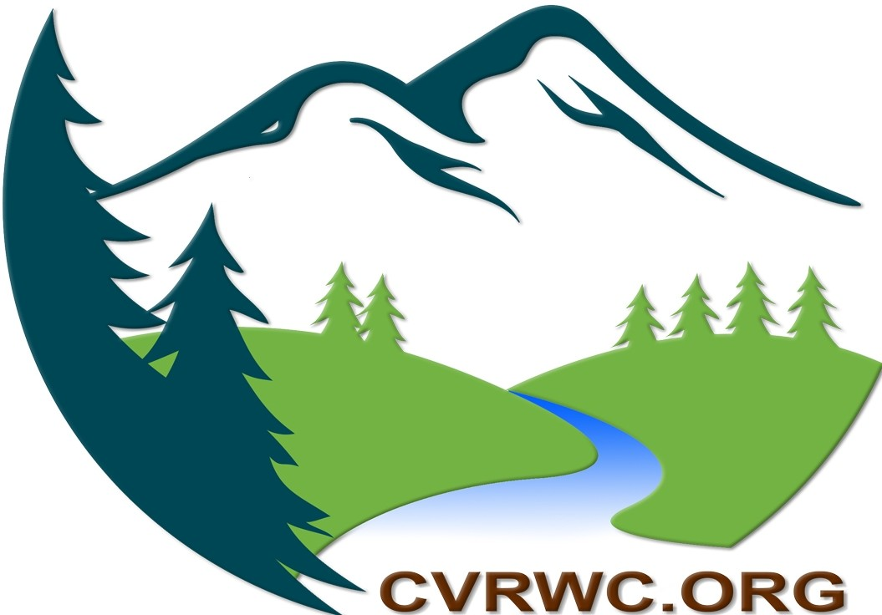
Cimarron Valley
& River Watershed Coalition

Membership Registration

Name:

Email:

Phone Number:

Mailing Address:

Mark One or More Interest:

- Property Owner
- Water Right Holder
- Ditch Shareholder
- Conservation or Conservancy District
- Recreation
- General Public
- Ditch Company
- Professional Engineer
- Communications
- County
- Livestock Grazing
- Forest Service
- BLM
- Water Resources
- Forest Health
- Other

Please return to: allen@cvrwc.org
or mail to:
Cimarron Valley and River Watershed Coalition
400 South 3rd Street
Montrose, CO 81401

\. (970) 624 0110
m info @cvrwc.org
-
; www.cvrwc.org
9 Cimarron Valley & River Watershed Coalition 400 S. 3Rd. St. Suite 300
Montrose, Co. 81401
Allen Distel
President

