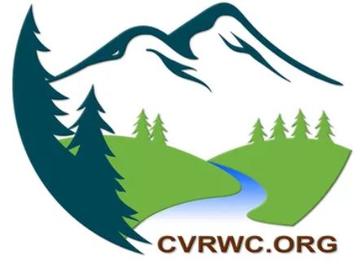
TO ALL CIMARRON RIVER AND BLUE CREEK STAKEHOLDERS:
The Cimarron Valley and River Watershed Coalition (Coalition) is conducting a watershed assessment of the Cimarron River and Blue Creek basins this spring, and you are invited to participate.
The watershed is a precious, shared resource for irrigation, fisheries, drinking water, recreation, and so much more. In recent years, extended drought and challenging irrigation practices have impacted river flows and water temperatures in the watershed. Working together, we can make plans to preserve this precious resource.
This spring, 2022, the coalition is seeking information from all stakeholders in the basin, to identify needs, concerns, and project ideas towards building watershed resilience.
Here’s what you can do to help:
- Tell us what you think. Reach out to Cassandra Shenk with ERO Resources at 970 208 7716 to provide your input, or complete this fact sheet and submit to cshenk@eroresources.com. Information from all our stakeholders will be summarized in the watershed assessment.
- Attend a stakeholder meeting in the summer. If we have your contact information, we will be sure you are invited to participate in discussions with your community and view the draft assessment.
Name: | Email and/or Phone:
Please select:  - Shareholder with irrigation water rights  - Private citizen  - Local, state or federal government entity | Address
Why is this watershed important to you? (for example, irrigation, fishing/recreation, drinking water, general ecosystem heath)

Describe any observations about the watershed’s health, and/or concerns or needs you have.

As a water user or stakeholder in the basin, what key objectives do you think are important?
- _____________________________________(feel free to list what comes first to your mind)
- Irrigation system updates and upgrades
- Projects geared towards ecosystem health/restoration
- Education/outreach towards beneficial irrigation practices/return flow management

What specific future projects or planning steps come to mind? Any ideas or additional information you would like to share (please attach)?

Contact: Cassandra Shenk cshenk@eroresources.com 970 208 7716. Thank you for your involvement!

