River Valley Cluster

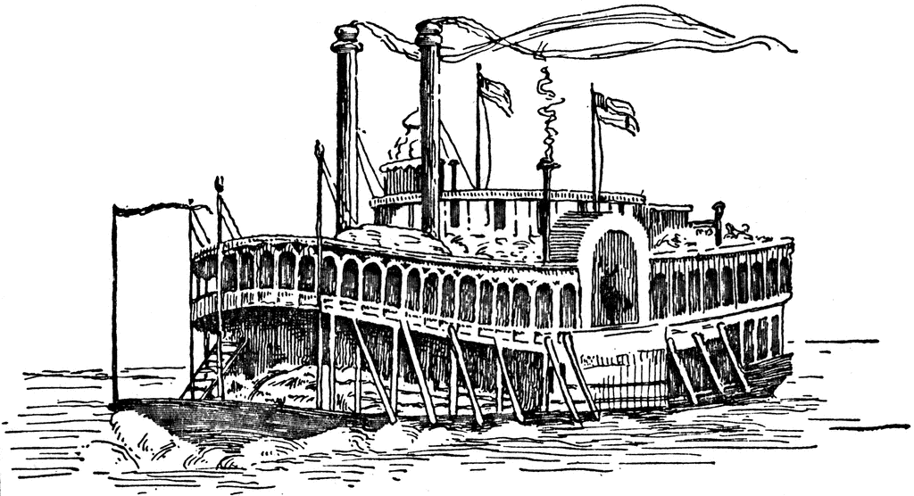

Owensboro, Kentucky

The Owensboro Convention Center does allow trailers to be pulled in for Vendors that operate from a trailer. Part of Kentucky Show Circuit

Immediately Preceding Lexington KY Shows

**August 22-25, 2019**

**4 days – 4 All-Breed Dog Shows**

**2 Days – Obedience/Rally Trials**

**4 Days – AKC Owner-Handled Series**

10 x 10 Booth $200 10 x 20 Booth $450 10 x 30 Booth $700

Contact: Tina Winston (270) 485-3164

We agree to pay the sum of $200 - $450 or $700 for space rental. A deposit of $100 accompanies this agreement with the balance to be due no later than July 31, 2019. Any contract signed after July 31, 2019 requires full payment of the booth rental and is dependent upon availability.

Booth Size __ 10 x 10 $200 Booth Size ___ 10 x 20 $450 Booth Size __ 10 x 30 $700

Vendor Name: __________________________________________

Address: _______________________________________________

City: ____________________ State: ____________ Zip: _________

Telephone :________ Email: ___________________________

*Electricity needed for booth – Additional Charge of $60 for the 4 days

MAKE CHECKS PAYABLE TO RIVER VALLEY CLUSTER

SEND TO Tina Winston, P.O. Box 187, Philpot, KY 42366

Drive in Set Up on Wednesday, August 21, 2019 10:00 am to 12 noon Prompt!

Set up after 12 noon without Drive In

Teardown on Sunday, August 25, 2019

Vendor opportunities – [www.orckc.com](http://www.orckc.com)