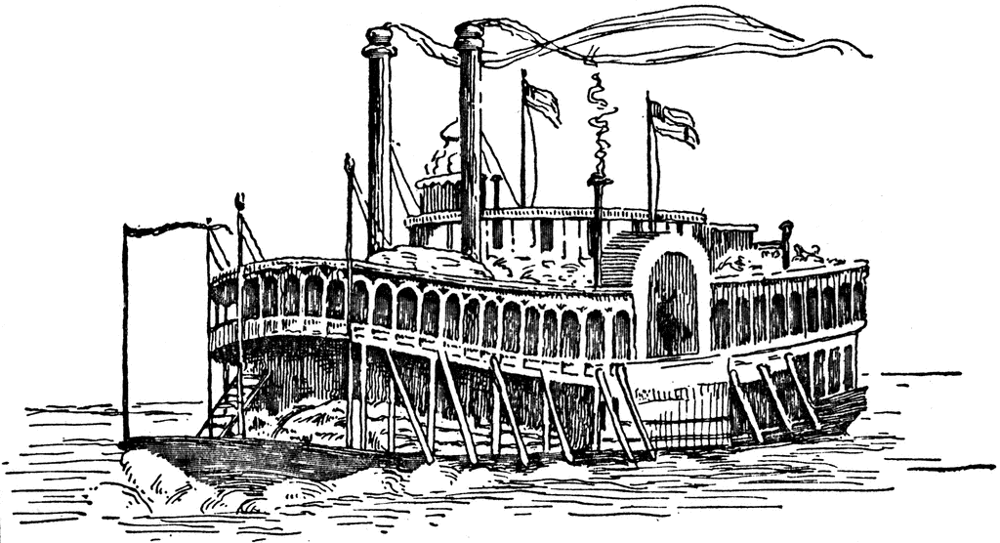

River Valley Cluster
Owensboro, Kentucky
Foy Trent, Superintendent
Part of Kentucky Show Circuit
Immediately Preceding Lexington KY Shows
August 24-27, 2023
4 days All-Breed Dog Shows
4 Days – AKC Owner-Handled Series
3 Days – Beginner Puppy
10 x 10 Booth $200 10 x 20 Booth $450 10 x 30 Booth $700
Contact:
Tina Winston, River Valley Cluster Vendor Chair
P.O. Box 187, Philpot, KY 42366 (270) 485-3164
twinston@mascusa.org
We agree to pay the sum of $200, $400 or $700 for space rental. A deposit of $100 accompanies this agreement with the balance to be due no later than July 31, 2023. Any contract signed after July 31, 2023 requires full payment of the booth rental and is dependent upon availability.
Booth Size __ 10 x 10 $200 Booth Size ___ 10 x 20 $450 Booth Size __ 10 x 30 $700
Vendor Name: __________________________________________ Electricy Needed
Address: _______________________________________________ for booth - Additional
City: ____________________ State: ____________ Zip: _________ $65 for the 4 days
Telephone :________ Email: ___________________________

Vendor opportunities – www.orckc.com

