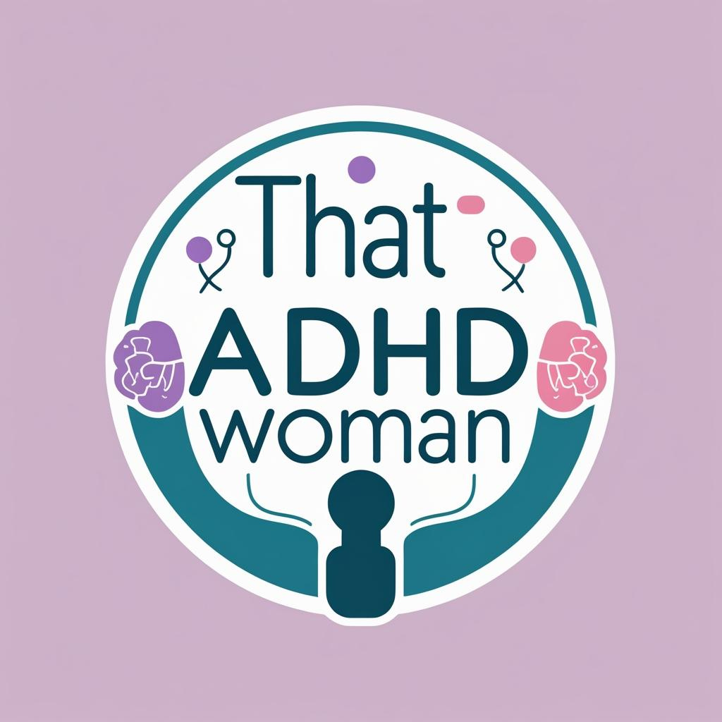

Equality and Diversity Policy
Company Name: That ADHD Woman
Policy Author: Katherine Irvine
Date of Completion: 06.06.25
Review Date: 05.06.26

1. Policy Statement
[Company Name] is committed to promoting equality, diversity, and inclusion in all aspects of its work. We value and respect the differences that individuals bring to our organisation and aim to create an environment where everyone feels welcome, supported, and empowered to achieve their potential.

2. Legal Framework
[Company Name] recognises its responsibilities under:
- Equality Act 2010
- Human Rights Act 1998
- Public Sector Equality Duty (if applicable)
- Employment Rights Act 1996

3. Scope
This policy applies to all staff, volunteers, directors, trustees, service users, contractors, and anyone associated with [Company Name].

4. Key Principles
- Zero tolerance for discrimination, harassment, or victimisation.
- Promotion of equal opportunities in recruitment, service delivery, and partnerships.
- Commitment to accessible and inclusive services.
- Positive action to address barriers to participation.
- Celebration of diversity in all its forms.

5. Protected Characteristics
We are committed to promoting equality for all, regardless of:
- Age
- Disability
- Gender reassignment
- Marriage and civil partnership
- Pregnancy and maternity
- Race (including colour, nationality, ethnic or national origin)
- Religion or belief
- Sex
- Sexual orientation

6. Responsibilities
- Directors and senior leadership are responsible for overseeing the implementation of this policy.
- Managers are responsible for promoting equality and addressing any issues in their teams.
- All staff, volunteers, and contractors are required to uphold the principles of this policy.

7. Recruitment and Selection
- Recruitment processes will be fair, transparent, and based on merit.
- Reasonable adjustments will be made for applicants with disabilities.
- Monitoring data will be collected to ensure diversity and inform improvements.

8. Inclusive Service Delivery
- Services will be accessible to all, with reasonable adjustments provided where needed.
- Communications will be available in accessible formats on request.
- Feedback from service users will be sought to improve inclusivity.

9. Training and Awareness
- All staff and volunteers will receive equality, diversity, and inclusion training during induction.
- Refresher training will be provided at least annually.
- Ongoing learning opportunities will be promoted to build awareness and understanding.

10. Monitoring and Review
- Equality monitoring data will be collected and analysed to identify trends and inform action.
- This policy will be reviewed annually, or sooner if there are significant changes in legislation or organisational practice.

