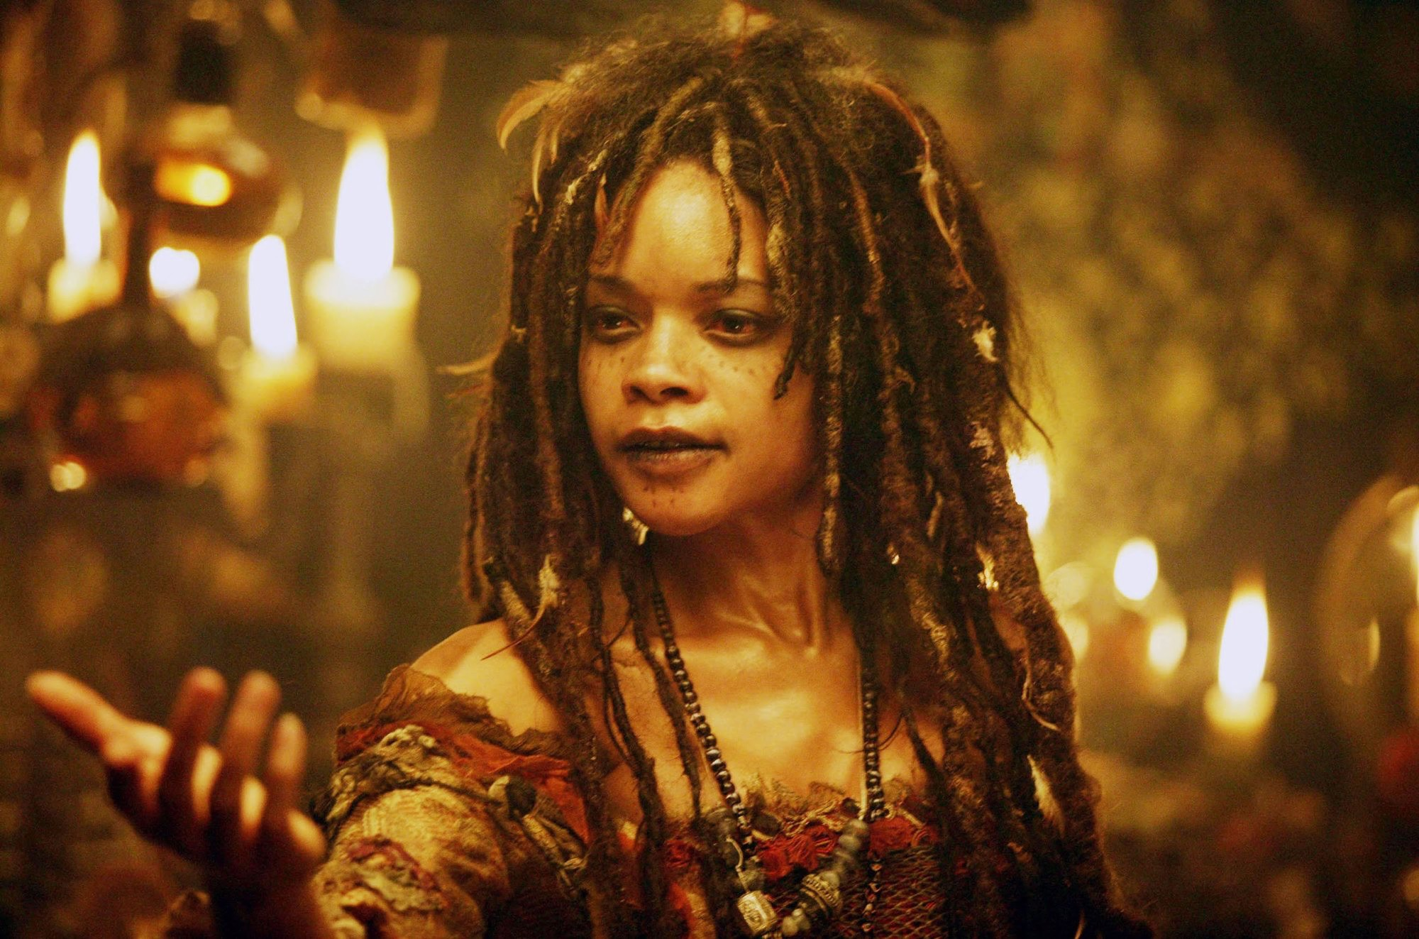
Pirates, Slaves, and Witches: Reading the eighteenth-century
Victoria Barnett-Woods
Email: vabarnett-woods@loyola.edu
Twitter: @VictoriaBWs
Office Hours: MWF: 11:30-12:30 and by appointment
Office: Hum242D

British Caribbean
Fall 2019

Course Description

This course is designed for advanced undergraduates and will critically engage your historical and literary understanding of the eighteenth-century Caribbean. It will discuss issues that have cultural relevance to the present day, from the formation of the “pirate” as a renegade underdog of the imperial frontier, to the more serious matters of racial discrimination and African displacement during the transatlantic slave trade. This course will historically follow the rise and fall of the British imperial reign in the Caribbean, from its start in the late seventeenth century with a discussion of indigenous Caribbean groups, Spanish imperial contact, and Cromwell’s “Western Design.” The course will conclude its literary history with the abolition of slavery in 1836. A final segment of the course will read through pieces by contemporary Jamaican author Jamaica Kincaid. This segment will encourage you to consider how present-day authors wrestle with the legacies of slavery and an imperial past.

Throughout the duration of the course, readers will traverse the Caribbean Sea on pirate vessels, witness the rise of Abolition and the end of slavery, consider the economics of empire, and be privy to moments of African and creole resistance in the form of Obeah. Though a literary course, it will interweave relevant historical and cultural components to create a dynamic understanding of eighteenth-century Anglophone Caribbean literature.

The course is divided into four segments: “Pirates of the Caribbean,” “Gender and Empire in the Atlantic World,” “The Transatlantic Slave Trade,” and “Creole Resistance: Obeah.” The first segment will explore the literary and cultural history of the buccaneer and pirate and his (occasionally her) representation in the transatlantic imagination. Recurring tropes of fraternity, freedom, and anti-authoritarianism aggregate in the pirate’s overall representation in both fictional and factual accounts. We will explore these representations and their connection to the British literary romanticization of the pirate subject. Segment Two will consider the role that women played in the expanding frontiers of the imperial Atlantic. At the same time, this segment will consider the role that epistolary and personal narratives have on the rise of domestic fiction in the late eighteenth and early nineteenth centuries. This segment will also finally consider the representation of women of color in the long eighteenth century, as the novels discussed feature biracial protagonists.

Segments Three and Four mark a thematic shift in the course, considering a literary history generated from the transatlantic slave trade. Segment Three focuses on the cultural power of the slave voice and the political agency of the slave narrative within the Abolition Movement of the late eighteenth century. Writing from Equiano will highlight not only the African American narrative experience but also cement the role of the slave narrative in the African American literary canon. Segment Four will consider the political and literary representation of the African obeah and voodoo practitioner from both a pro-slavery and anti-slavery perspective. Obeah and voodoo, as African-creolized spiritual belief systems, have complicated and rich histories in the Caribbean. The religions’ rituals and dances incited fears of rebellion amongst the planter class, and are represented in the Caribbean gothic, a genre typically written by plantation owners. Voodoo and obeah were also contrarily represented as sites of resistance for abolitionists, most characterized in William Earle’s Three-Fingered Jack. This section will explore these politics of representation as the Caribbean colonies were on the brink of slave emancipation.

Learning Outcomes
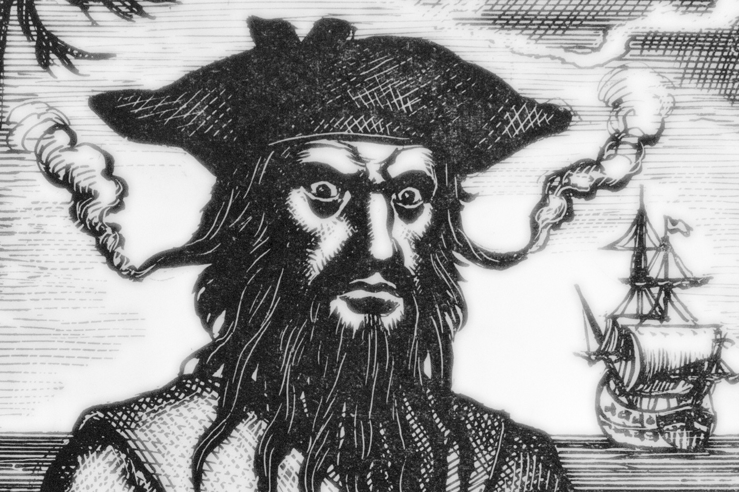
By the end of this course, you will:
- Develop an understanding and appreciation for the rich literary and cultural history of the Anglophone Caribbean.
- Connect contemporary representations of piracy to the literary and cultural history of the “Golden Age of Piracy.”
- Recognize and appreciate the literary history that was constructed out of the transatlantic slave trade and Atlantic slavery.
- Be able to identify and distinguish the nuanced genres of the maritime picaresque, epistolary novel, slave narrative, and colonial gothic and their roles within larger British and American canons.
- Generate an important contextual guide for understanding the present-day Caribbean as a cultural space.
- Critically assess issues of race and gender in colonial and post-colonial environments.
- Be able to integrate historical, economic, and literary analysis into your writing.
- Analyze, process and integrate primary and secondary sources into your research.
- Fine-tune a conceptual understanding of the eighteenth-century Caribbean and its literature, applying varying modes of research and analysis in their argument-driven writing.
- Practice varying modes of writing about a given topic (rhetorical analysis, historical reflection, research-based argumentative).

Course Activities and Assignments:

- Each day’s reading will have 1-2 corresponding “Reading Review Questions.” These questions will be available on Moodle and will steer the course for the day’s discussion. Each response for the questions should be at least 3-4 sentences to receive full credit and submitted 1 hour before class time.

- Students will have three major writing assignments:

Assignment One: Select one pirate from our discussions (Avery, Blackbeard, Roberts, Bonny and Read) and write a rhetorical analysis of the narrative as it is written in A General History. Related questions are: How is your pirate subject represented? What are the social, economic, or literary motivations for this representation? How does this representation feed into the romanticized circulation of the pirate subject today? (3-4 pages, double-spaced)

Assignment Two: On October 16th, the class will jointly excavate a number of digital archives that deal specifically with the transatlantic slave trade (selected from the list below). Based on your own interests, select one material object from any one of these archives. With this object, you will write a conceptual “material history” paper. Related questions are: What is the material made of? What purpose does it serve? What may it say about the people who owned (or were connected to) the object? (3-4 pages, double-spaced). Why did you select this object and how does it speak to you? Some outside research may be required.

Digital Collections:

National Museum of African American History and Culture:
https://nmaahc.si.edu/explore/collection/search?edan_q=%2A%3A%2A&edan_local=1&edan_fq%5B%5D=topic%3A%22Slavery%22

The British Museum Online Collection:
http://www.britishmuseum.org/research/collection_online/search.aspx?place=3112%7C39454%7C37286&from=ad&fromDate=1650&to=ad&toDate=1850&page=1

National Archives of Jamaica:
http://nljdigital.nlj.gov.jm/collections/browse#?c=0&m=0&s=0&cv=0

International Slavery Museum, Liverpool:
http://www.liverpoolmuseums.org.uk/ism/visit/floor-plan/middle-passage/index.aspx

This list is not exhaustive. There are many more museums with digital collections available. If you find something of interest, please let me know!

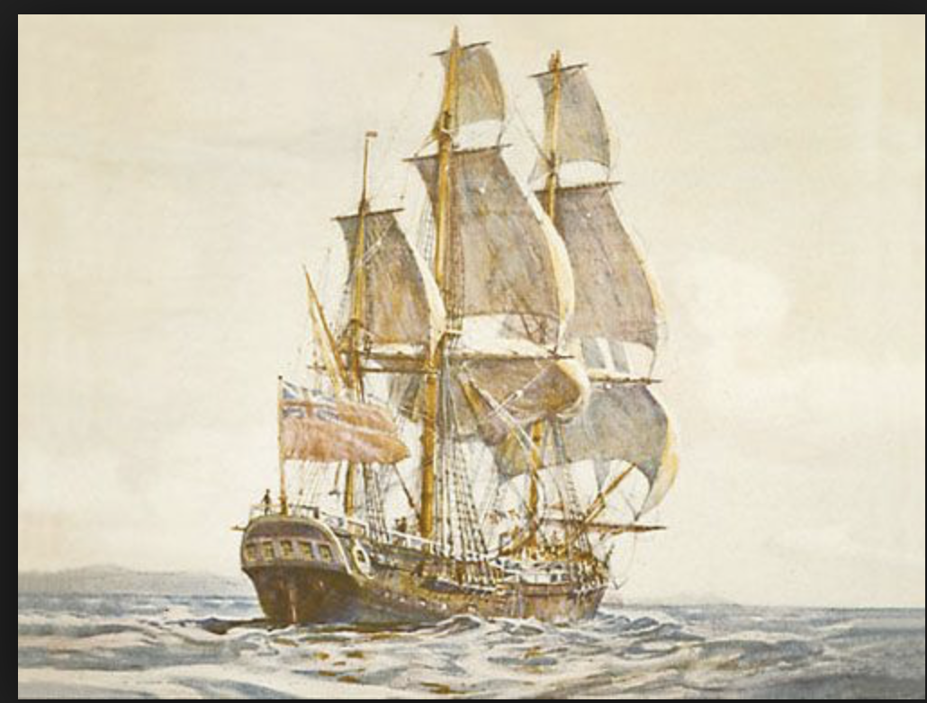
Assignment Three: A final research paper on a topic of your choosing based on what has been studied in the course. This paper will clearly formulate an argument about a topic discussed in class and involve outside research to support this argument. (7-9 pages, double spaced). Topics will need to be newly developed and, while related to an earlier interest, cannot be an expansion of previous writing. Given the importance of this assignment a writing workshop and individual preparation conferences will be integrated into its execution.

Midterm: In lieu of a traditional comprehensive midterm (reading review questions cover reading comprehension), the midterm will be an in-class essay disseminated through Moodle. Select one essay question out of three possible, and write a full and complete response. Essay questions will derive predominantly from material covered in segment two of the course.

Calendar: Subject to Change

September  4 | Introduction to Course and Paper One; Transatlantic Encounters: The Caribbean before & After Contact; Cromwell’s “Western Design”
6 | Segment One: Pirates of the Caribbean  A General History ch.1 (Avery); Villains of all Nations chs. 1-3
9 | A General History, ch. 9 (Roberts); Villains of all Nations ch. 4
11 | A General History ch. 3 (Blackbeard); Villains of all Nations ch. 5
13 | A General History, ch. 7 (Read & Bonny); Villains of all Nations ch. 6
16 | A General History, vol. 2 ch.1 (Captain Mission); Villains of all Nations, ch. 7
18 | The Pirates of the Caribbean: Curse of the Black Pearl; Villains of all Nations chs. 8 and Conclusion.
20 | Segment Two: Gender and Empire in the Atlantic World  The Female American chs. 1-5 (pp. 35-65)
23 | The Female American chs. 6-11 (pp. 66-98)  Paper One Due
25 | The Female American Vol. 2, chs. 1-6 (pp. 101-127)  “Religious Intolerance in The Female American”
27 | The Female American, Vol. 2, chs. 7-12 (pp. 128-155)
30 | Woman of Colour, First Packet (pp. 53-93)
October  2 | Woman of Colour, Second and Third Packet (pp. 94-127)
4 | Woman of Colour, Fourth Packet (pp.128-146)
7 | Woman of Colour, Fifth Packet (pp. 147-189)
9 | Melissa Adams-Campbell, “A Postcolonial Heroine ‘Writes Back’”
11-14 | Class Canceled
16 | Midterm Review
18 | Midsemester Holiday
21 | MIDTERM: In-class essay
23 | Segment Three: The Transatlantic Slave Trade  (Introduction to Paper Two)  The Slave Ship, Introduction and ch. 1  Exploring the Digital Archive
25 | The Interesting Narrative, chs.1-2 (pp. 5-62)
28 | The Interesting Narrative, chs. 3-5 (pp. 63-112)
30 | The Interesting Narrative, chs. 6-7 (pp 113-146)
November  1 | All Saints Day
4 | The Interesting Narrative, chs. 8- 10 (pp 147-193)
6 | The Interesting Narrative, chs. 11-12 (pp 198-236)  Introduction to Final Paper
8 | Segment Four: Creole Resistance: Obeah  “Romantic Voodoo: Obeah and British Culture, 1797-1807” in Sacred Possessions “Colonial and postcolonial Gothic: the Caribbean”  Paper Two Due
11 | Three-Fingered Jack, letters 1-2 (pp. 67-82)
13 | Three-Fingered Jack, letters 3-4 (pp. 82-95)  Three-Fingered Jack, letters 5-6 (pp. 96- 112)
15 | Three-Fingered Jack, letters 7-9 (pp. 112-131)
18 | Three-Fingered Jack, letters 10-13 (pp. 131-149)
20 | Three-Fingered Jack, letters 14-15 (pp. 149-158)
22 | Jamaica Kincaid, “Blackness”
25 | Draft Final Paper Due: Peer Review
27-29 | Thanksgiving Holiday Break
December  2 | Jamaica Kincaid, A Small Place
4 | Final Paper Due
6 | Final Review
9 | Final Exam

Final Paper due: Friday, December 4th 11:59pm

Grading
Reading Responses and Participation (15%)
Paper One (15%)
Paper Two (15%)
Paper Three (20%)
Midterm (15%)
Final (20%)

Course Materials to be purchased:

- A General History of Pyrates, edited by Manuel Schonhorn. Mineola: Dover Press, 1724 (1999).
- Markus Rediker, Villains of All Nations: Atlantic Pirates in the Golden Age. Boston: Beacon Press, 2005
- The Female American, edited by Michelle Burnham. Peterborough: Broadview Press, 1767 (2001).
- Olaudah Equiano, The Interesting Narrative of Olaudah Equiano, edited by Vincent Caretta. New York: Penguin, 1789 (2003).
- The Woman of Colour, edited by Lyndon Dominque. Peterborough: Broadview Press, 1808 (2008).
- William Earle, Obi; Or, Three-Fingered Jack, edited by Srivinas Aravamudan. Peterborough: Broadview Press, 1800 (2005).
- Jamaica Kincaid, A Small Place. New York: Farrar, Straus, Giroux, 1988.

Useful Information:

Office Hours: You are always welcome to visit me during office hours and discuss anything with me related to the course. I will try to be in the office at all times during office hours, but if you know that you will be coming by, please send me an email or a twitter DM so that I will be guaranteed to be there when you arrive. During office hours, I will help out with everything except reviewing full first or rough drafts (but I’m happy to discuss sections of your paper/s).

DSS: To request academic accommodations due to a disability, please contact Disability Support Services (DSS) at DSS@loyola.edu or 410-617-2750. If you have already registered with DSS and have requested an accommodations letter (and DSS sent your professors the letter by email), please schedule a brief meeting with me to discuss what accommodations you may need from me in this class.

Writing Center: While I am unable to review drafts, the university writing center, located in Maryland Hall 057, will help you achieve eloquentia perfecta. Schedule an appointment at lwc@loyola.edu, or by phone. 410-617-5415. You are also welcome to make an appoint with their online system at: https://www.loyola.edu/department/writing-center/overview. I recommend availing of this service!!

**If you are going to miss class, contact me ahead of time to let me know. Absences will be excused for serious medical issues, academic-related events (such as conferences) and Loyola sports-related activities. Verification is required. **

