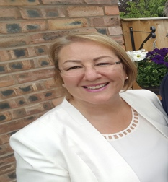
The new Education Inspection Framework.

What you need to know.
The new Education Inspection Framework comes into effect from September 2019.
Click here to download copy
Inspectors will report on:
Overall effectiveness - Quality of Education - Behaviour and attitudes- Personal development &
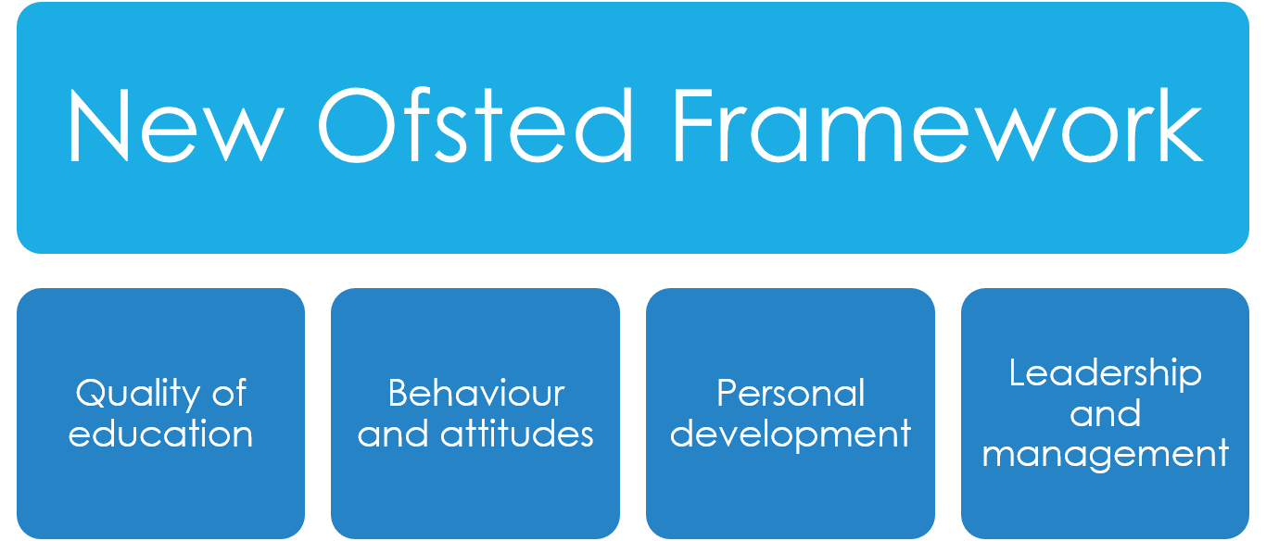
Leadership and management.

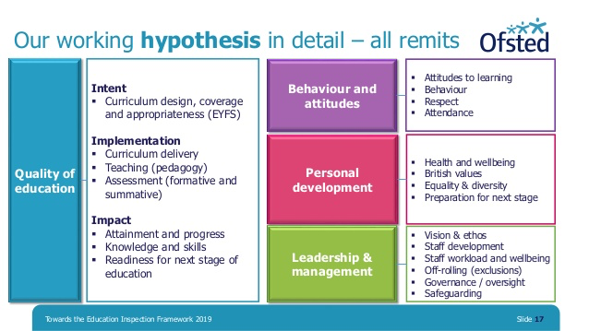
Inspectors will continue to use the same four-point scale to make all judgements.
Outstanding / Good / Requires Improvement / Inadequate.

The new framework no longer includes the standalone “outcomes” judgement.’

KeY themes: Curriculum / educational programme, Learning intentions, and Cultural capital.
It is not enough to put out activities that look good – you have to be able to explain the learning intentions – what you intend children to learn – based on their individual next steps - and to explain how you are supporting children’s learning and progress. Inspectors must discuss with leaders and practitioners what they intend children to learn, know and do as a
result of the EYFS curriculum they offer. Inspectors will follow this discussion through in their observations and discussions with children at play and staff interactions. You should continue to use Development Matters or similar to help you identify learning intentions and next steps in your usual way.

At the heart of the EIF is the new ‘quality of education’ judgement, the purpose of which is to put a single conversation about education at the centre of inspection. This conversation draws together curriculum, teaching, assessment and standards. Ofsted uses the concepts of ‘intent’, ‘implementation’ and ‘impact’ to recognise that the curriculum passes through different states: it is conceived, taught and experienced. Leaders and practitioners design, structure and sequence a curriculum, which is then implemented through teaching. The end result of a good, well-taught curriculum is that children know more and are able to do more. The positive results of children’s learning can then be seen in the standards they achieve. The EIF starts from the understanding that all of these steps are connected.

Intent, Implementation & Impact
Intent = curriculum design, coverage and appropriateness
Implementation = curriculum delivery, teaching (pedagogy), assessment: both formative and summative
Impact = attainment and progress, knowledge and skills, readiness for next stage of education.
Assessment needs to help children to embed and use knowledge fluently, and help staff to identify clear next steps in children’s learning. It is this information that should help shape the development of the curriculum. Inspectors will explore the extent to which leaders engage with practitioners to ensure that curriculum planning and assessment are both effective and manageable.

Settings can be judged ‘inadequate’ if, ‘Assessment is overly burdensome. It is unhelpful in determining what children know, understand and can do.’
Communication and language is key.
Rhyme time, stories and singing should feature strongly in the early years educational programme. As should Music and movement, and I highly recommend yoga, dance, and specific sports activities to boost children’s physical development through a minimum of 3 hours physical activity each day.
I also recommend ‘Story scribing’ – capturing children’s voices as they invent their own stories, re-tell favourite stories, make up a dialogue while playing.
Encourage new vocabulary and make this clear in planning. What new words / vocabulary are you intending children to learn during activities – you need to be able to evidence that children are extending their vocabulary through positive interactions and teaching. E.g. when scribing what children say and how they use new vocabulary during conversations.

Learning walk
Inspectors will complete a learning walk around the premises with the provider or their representative at the start of the inspection. This provides an opportunity for leaders to explain how they organise the early years provision, including the aims and rationale for their curriculum. Inspectors must discuss with leaders and practitioners what they intend children to learn, know and do as a result of the EYFS curriculum they offer. Under the old framework, inspectors would routinely take a tour of the premises to become familiar with the setting.
The inspectors would hold conversations during their initial tour but under the new framework, learning walks require the inspectors to check out what leaders and practitioners know; and to talk about why they do what we do and the approaches they take, which will start to set the scene for the quality of education judgement.

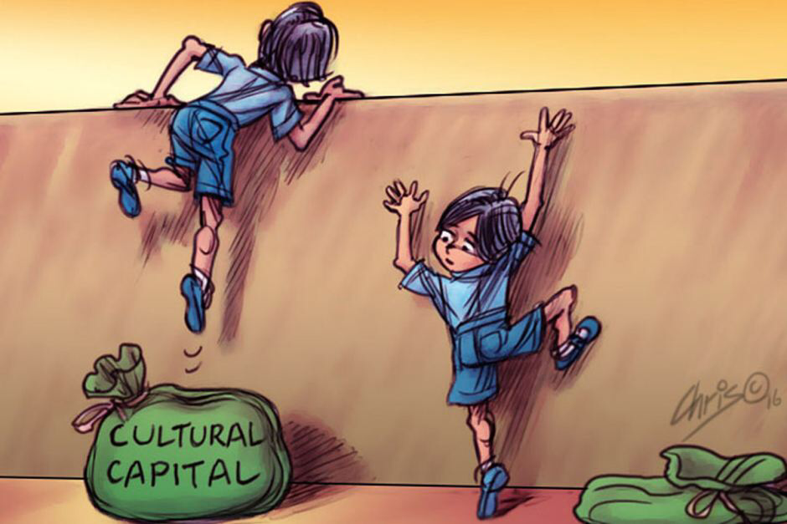
Cultural Capital
Cultural capital forms the foundations of our social lives and dictates our positions within the social order. The more cultural capital you have the more powerful position you could assume within a society.
Ofsted – ‘ to ensure that children experience the awe and wonder of the world in which they live, through the seven areas of learning’.

Cultural capital is the essential knowledge that children need to prepare them for their future success. It is about giving children the best possible start to their early education. As part of making a judgement about the quality of education, inspectors will consider how well leaders use the curriculum to enhance the experience and opportunities available to children, particularly the most disadvantaged. Some children arrive at early years settings with different experiences from others, in their learning and play. What a setting does, through its EYFS curriculum and interactions with practitioners, potentially makes all the difference for children. If you are offering a broad and balanced curriculum that covers the seven areas of learning whilst supporting children to develop the characteristics of effective learning, you will be providing children with essential knowledge and skills that will help them overcome disadvantage and adversity. It is our role to help children experience the awe and wonder of the world in which they live, and to make the most of opportunities to broaden children’s horizons and understanding of the wider world.

To gain Outstanding, we have to show that:
The impact of the curriculum on what children know, can remember and do is strong. Children demonstrate this through being deeply engaged in their work and play and sustaining high levels of concentration. Children consistently develop vocabulary that enables them to communicate effectively. They speak with increasing confidence and fluency, which means that they secure strong foundations for future learning, especially in preparation for them to become fluent readers.

Behaviours and attitudes covers: Attitudes to learning, Behaviour, Respect, and Attendance.
In the new Framework, inspectors will look closely at how the behaviour of children is being managed, and the strategies the setting has developed to support good behaviour.
Under Grade Descriptors for ‘behaviour and attitudes’, to meet Outstanding settings must show:
That children have consistently high levels of respect for others. They increasingly show high levels of confidence in social situations. They confidently demonstrate their understanding of why behaviour rules are in place and recognise the impact their behaviour has on others. That children are highly motivated and very eager to join in, share and co-operate with each other. They have consistently positive attitudes to their play and learning. That children demonstrate high levels of self-control and consistently keep on trying hard, even if they encounter difficulties. Where children struggle with this, leaders and practitioners take intelligent, swift and highly effective action to support them.
Although attendance is not mandatory, inspectors will particularly look at the attendance of children for whom the provider receives the Early Years Pupil Premium.

Personal development Personal development is now listed as a separate judgement.

Personal Development includes: Health and well-being; British values; Equality and diversity; and Preparation for next stage.

In making a judgement about personal development, inspectors will evaluate the intent and quality of what a provider offers, but they will not measure the impact of the providers work on the lives of individual children.
The new judgement is intended to focus on what early years providers are doing to educate children in the broadest sense, including the development of character and preparing them for life in modern Britain.
Having high aspirations of the children and creating a positive enabling environment supported by respectful interactions are key elements of effective education.
Inspectors will continue to consider the ways children demonstrate their attitudes and behaviours through the key characteristics of effective learning: playing and exploring; active learning; and creating and thinking critically.

Leadership & management covers: Vision & ethos; Staff development; Staff workload and well-being; Governance, oversight and safeguarding.
The new Ofsted Education Inspection Framework should be read alongside the revised guidance - ‘Inspecting safeguarding in early years, education and skills’.
Click here to download a copy

There is no specific safeguarding judgement. However, safeguarding will be referenced in the Leadership and Management section of the report.

The EIF handbook says, ‘when safeguarding is ineffective, this is likely to lead to an inadequate leadership and management judgement’. However, if there are minor weaknesses in safeguarding arrangements that are easy to put right and do not leave children either being harmed or at risk of harm then a ‘requires improvement’ judgement may be made.

Early years settings should be safe environments where children, learners and vulnerable adults can learn and develop. Inspectors will consider how well leaders and managers in early years settings have created a culture of vigilance where children’s and learners’ welfare is promoted and where timely and appropriate safeguarding action is taken for children who need extra help or who may be suffering or likely to suffer harm. Inspectors will be looking for evidence that ‘the provider has a culture of safeguarding that supports effective arrangements to identify children who may be at risk; which responds in a timely way; and that staff recruitment is managed and any allegations are dealt with appropriately.

The document Inspecting safeguarding in early years, education and skills was updated in 2018 to take account of the publication of Keeping Children Safe in Education and so there are few changes. Ofsted include their definition of ‘County Lines’: [these are] ‘situations where children may be trafficked within England for the purpose of criminal exploitation by urban gangs that supply drugs to suburban areas, market or coastal towns and/ or other urban areas.

New risks specified in the document include risks linked to using technology and social media including: online bullying; the risks of being groomed online for exploitation or radicalisation;
and risks of accessing and generating inappropriate content, for example ‘sexting’.

Effective safeguarding can be seen when:

Children and learners are protected and know how to get support if they experience bullying, homophobic behaviour, racism, sexism and other forms of discrimination. Any discriminatory behaviours are challenged and help and support are given to children about how to treat others with respect.

Adults understand the risks associated with using technology, including social media, of bullying, grooming, exploiting, radicalising or abusing children or learners.

In cases of peer-on-peer abuse, staff should consider what support might be needed for the perpetrators as well as the victims.

An interesting paragraph that has been added since the last edition of ‘Inspecting safeguarding’ is this one:

‘Adults understand that children’s poor behaviour may be a sign that they are suffering harm or that they have been traumatised by abuse’ . This is an important addition to the documentation as it introduces the idea that there is a possibility that ‘poor’ behaviour might be driven by ‘something’ that has happened.

Settings must have clear systems in place, so that any child whose behaviour is giving a cause for concern is monitored for possible abuse or trauma.

Early Years Inspection Handbook with Grade Descriptors
The handbook describes the main activities inspectors undertake when they conduct inspections of early years providers
Part 1 - How Early Years settings will be inspected
Part 2 – The Evaluation Schedule
Part 1 of the handbook describes the inspection process and also details information about the types of documents that the inspector is likely to want to say, issues to be covered during discussions and the possible focus of observations and the evidence that needs to be gathered.

Part 2 of the document sets out the Grade Descriptors for each judgement.

You must be familiar with these important documents to:
- Understand expectations / regulations
- To ensure your monitoring and QA is in line with Ofsted’s expectations
- To be prepared
- Help to raise standards
- Be able to debate and discuss with Inspector
- To be confident that you know what the inspector will be exploring and that you can provide evidence of Good or better practice.

A well-thumbed Inspection handbook is a welcome sight for inspectors.
Questions to ask yourself …
Do your practitioners know what inspectors look for / know the grade descriptors for Good +? How often do you lead discussions with practitioners about the Grade Descriptors?
If your practitioners do not know the Grade Descriptors well enough, this ought to be a subject of regular discussions in supervisions and team meetings.

To help you be increasingly inspection ready, please visit my website www.deborahudakis.co.uk
And read my blog, ‘An Inspector Calls’.
For further training, advice and support, please contact me on 07983231584.

Kindest regards
Deborah
Deborah Udakis Consultancy Ltd
www.deborahudakis.co.uk
Follow me on Facebook – Deborah Udakis Consultancy Ltd

